Understanding the Universe
Our current understanding of the origin of the Universe is based on the Big Bang theory. The theory proposes the Universe came into existence when a singularity rapidly expanded from an extremely hot dense state to what exists today.
According to current estimates, the Universe is approximately 13·8 billion (13·8 × 10⁹) years old and consists of approximately 100 billion galaxies, each containing approximately 100 – 1000 million stars! That’s a big place and our minds aren’t built to comprehend this.
Before the Universe began, the entire Universe was contained in a singularity. The Big Bang singularity was a point of zero volume, but very high mass, which makes the density infinite. This singularity contained all of the matter and energy in the Universe. At the singularity, all the laws of physics broke down: then it exploded. Time, space and all of the matter and energy we know today began with the Big Bang. In a fraction of a second, the Universe grew this singularity to bigger than a galaxy. And it kept on growing at a fantastic rate. It is still unclear why this happened or what a singularity actually is, but we do know that the Universe is still expanding at an increasing rate.
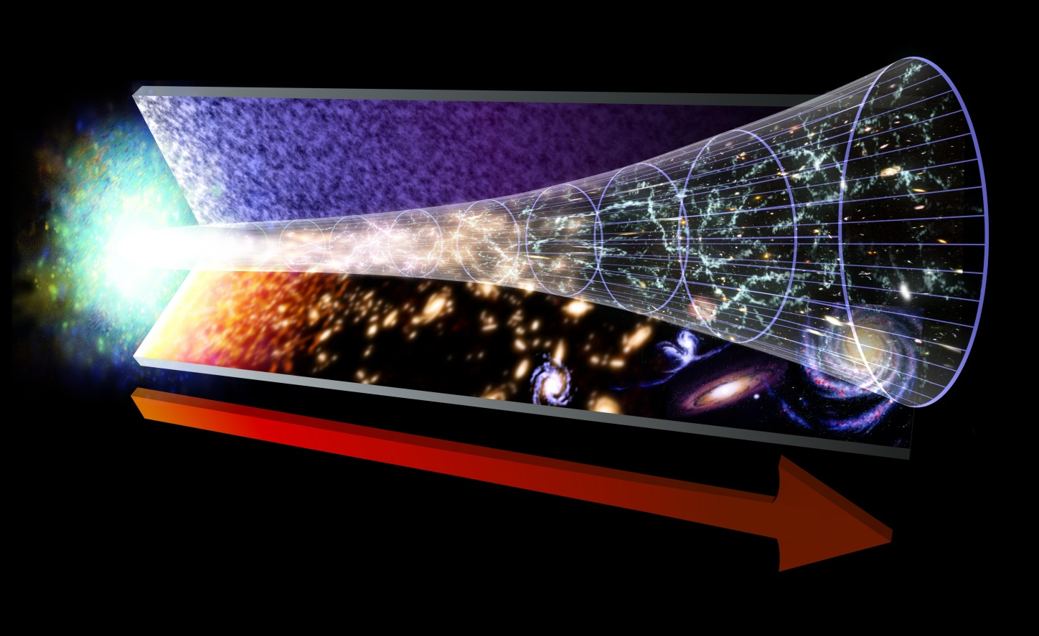
As the Universe expanded and cooled, energy changed into particles of matter and antimatter. These two opposite types of particles largely destroyed each other. But some matter survived. More stable particles called protons and neutrons started to form when the Universe was just one second old.
Over the next three minutes, the temperature dropped below 1 billion degrees Celsius. It was now cool enough for the protons and neutrons to come together, forming hydrogen and helium nuclei.
After 300 000 years, the Universe had cooled to about 3 000 degrees Celsius. Atomic nuclei could finally capture electrons to form atoms. The Universe filled with clouds of hydrogen and helium gas.
Our understanding of the immediate and distant universe comes mainly from two activities, space exploration and looking up.
https://www.esa.int/esaKIDSen/SEMSZ5WJD1E_OurUniverse_0.html
http://www.hawking.org.uk/the-beginning-of-time.html

Surprisingly, despite our huge knowledge of the Universe that has been developed over the life of humans we can only account for about 5 % of the expected mass.

What are dark matter and dark energy?
The majority of the Universe is made up of dark matter and dark energy,
•Dark matter – Scientists aren't exactly sure what dark matter is, but believe it exists due to results from experiments. Dark matter gets its name because it cannot be seen with any type of instrument we currently have. Around 27% of the Universe is made up of dark matter. Dark matter attracts matter.
•Dark energy - Dark energy is something that scientists believe fills all space. It turns out that "empty space" is more than just nothing, it is really dark energy. The theory of dark energy helps scientists to explain why the Universe is expanding. Around 68% of the Universe is dark energy. Dark energy repels matter.

Origin of the Known Universe
Our current understanding of the origin of the Universe is based on the Big Bang model. The model proposes that approximately 13.8 billion years ago, the Universe came into existence as a singularity and rapidly expanded from an extremely hot dense state to what exists today. It is still unclear why this happened or what a singularity actually is, but we do know that the Universe is still expanding at an increasing rate

Evidence for the Big Bang Model
If the start of the Universe was so hot, where has all that energy gone? The Big Bang theory predicts that as the Universe expanded, it cooled. Cosmic Microwave Background Radiation has been detected in space as evidence of this cooling. The average temperature of the Universe is currently around 2.7K or -270.5 ºC.
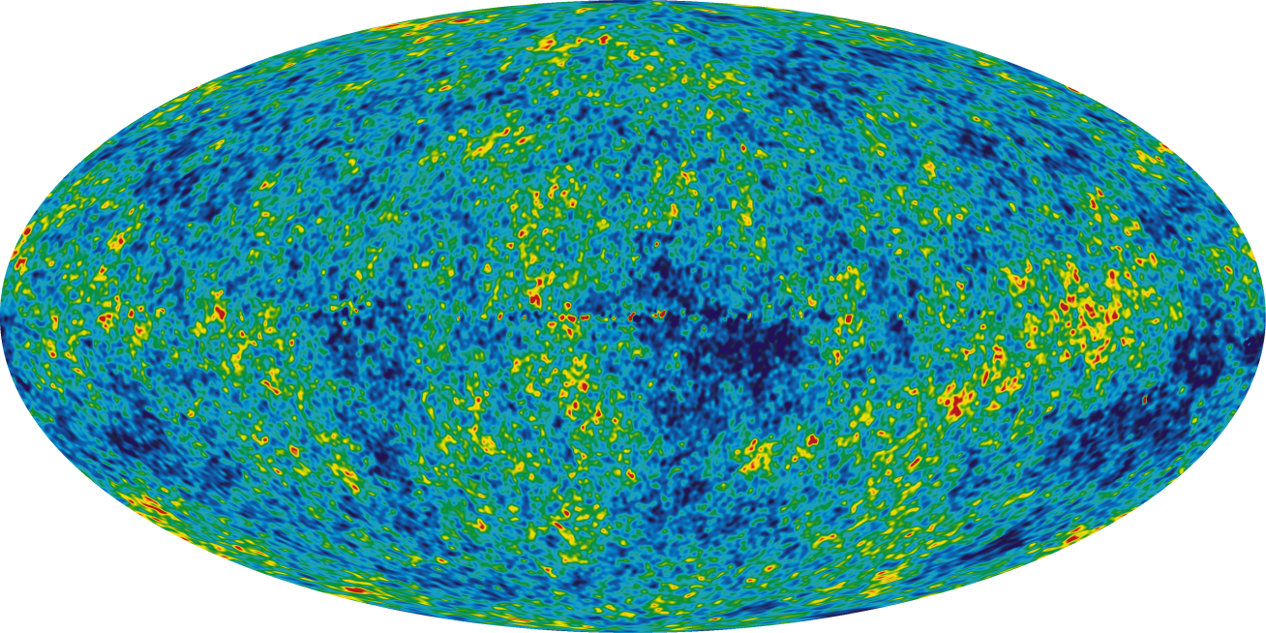
Cosmic Microwave Background Radiation, gathered from 9 years of WMAP data
Observations of distant stars, show what is called a red shift in their colour spectrum. This red shift in galaxies is evidence the galaxies are moving away from us, indicating that they are moving further away from a single point when the Big Bang occurred. This is further covered in Higher.
https://www.youtube.com/watch?v=9B7Ix2VQEGo from 50s
https://www.youtube.com/watch?v=s43lkwCsPPg
https://www.youtube.com/watch?v=HdPzOWlLrbE
https://www.youtube.com/watch?v=0NbBjNiw4tk
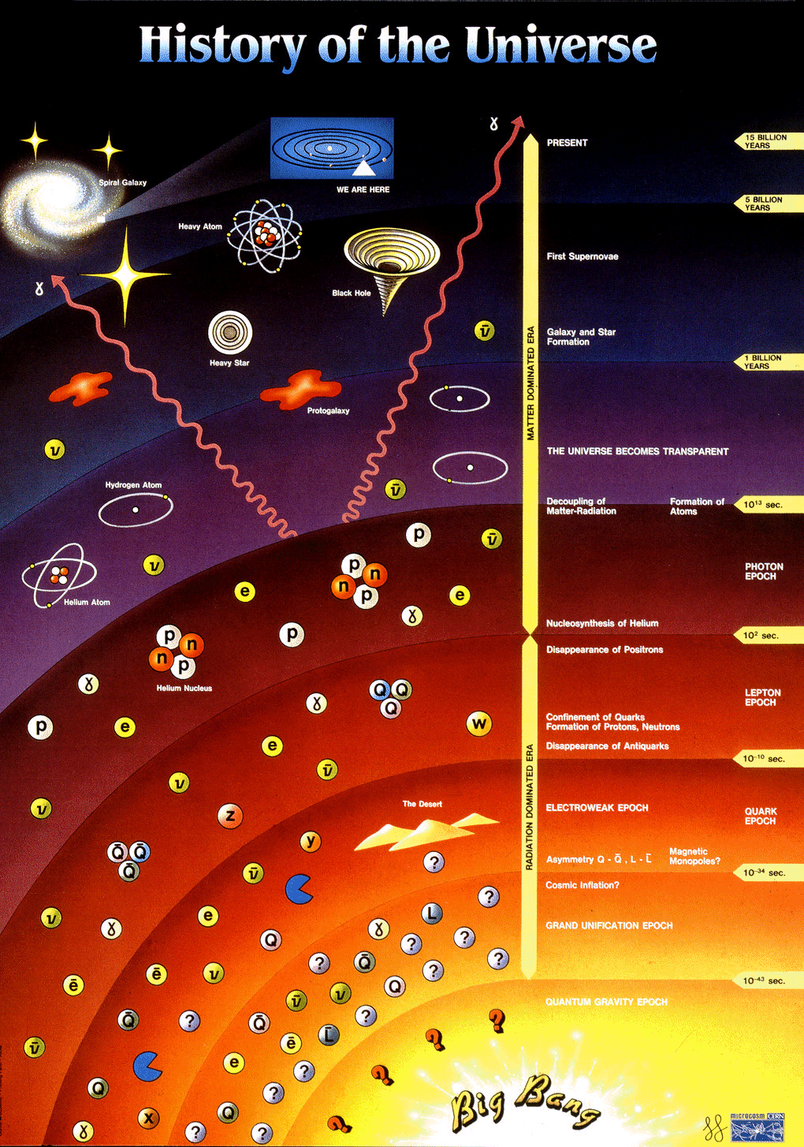
http://eliotche.com/wp-content/uploads/2009/09/history-of-the-universe.gif

evidence for the big bang

Big Bang Theory - Evidence for the Theory
- Galaxies appear to be moving away from us. The greater the galaxy’s distance the greater their speed . This observation supports the expansion of the Universe and suggests that the Universe was once compacted.
- “Doppler red-shift” The light from galaxies appears to be more red than it should be, and the decreased frequency of the light tells us that the galaxies are moving away from us.
- If the Universe was initially very, very hot as the Big Bang suggests, we should be able to find some remnant of this heat. In 1965 this background heat, now termed Cosmic Microwave Background radiation (CMB) which spreads through the observable universe was discovered .
- The abundance of the "light elements" Hydrogen and Helium found in the observable universe are thought to support the Big Bang theory of origins.

A summary of some of the evidence of the Big Bang and its interpretation
Evidence | Interpretation
The light from other galaxies is red-shifted. | The other galaxies are moving away from us.
The further away the galaxy, the more its light is red-shifted. | The most likely explanation is that the whole universe is expanding. This supports the theory that the start of the Universe could have been from a single expansion.
Cosmic Microwave Background Radiation | The relatively uniform background radiation is the remains of energy created just after the Big Bang.

Task
Answer the following questions in full sentences in your jotter
- State the current estimate of the age of the Universe and estimate the number of galaxies it contains.
- We now have evidence to support the Big Bang Theory.
  - State two pieces of evidence that scientists have provided that support the Big Bang Theory.
  - Provide a description of how each piece of evidence supports ideas in the Big Bang Theory.
- Is the Universe expanding, contracting or static?
- Explain how the Universe could expand at such a rate at the Big Bang, when nothing can go faster than the speed of light.
- Draw a table with headings dark matter and dark energy. Try to add as many facts or theories into the table under these two headings.

light years
The Universe is massive, so big it is pretty much impossible to really imagine how big it is! It is estimated that the Universe is at least 9.2 x 1026 metres wide. This number is too large to really comprehend, indeed all distances in the Universe are huge. The Earth is approximately 150 million kilometres away from the Sun and approximately 39.9 x 10¹² km away from Proxima Centauri (the nearest star to our Solar system). These numbers are just too big so astronomers use a longer standard unit of distance – The Light Year.
Light does not travel at an infinite speed. It takes time to travel. It is so fast that we do not usually notice, although out in space the distances involved are so big that light takes a reasonable amount of time to reach us.
Light from our Sun takes approximately eight minutes to reach us.
Given that it takes 8 minutes for light to get from the sun, how far is it away is it from the Earth?
8×60 = number of seconds in minutes
480s =
Each second light travels 3×10⁸m
$$v t= d$$
$$3{10}^{8} 480= d$$
$$d= 1.44{10}^{11}m$$

Astronomical data from observations of galaxies in space involve extremely large distances. The light year is a unit of distance used in astronomy, and it is defined as the distance that light travels in one year.
How far does light travel in one year?
$$1 year= 365days$$
$$365 days= 8760 hours$$
$$8760× 60 ×60= 31536000 s in one year$$
Light travels 300 million metres in one second. (speed of light in a vacuum is 3.0 ×10⁸ ms⁻¹). In one year it will cover a distance of 9.46×10¹⁵ metres.
After the Sun, the nearest star to us is Proxima Centauri which is 4.2 light years from Earth. One light year (distance) can be calculated as follows:
distance = speed × time
distance = 3.0 ×10⁸ × (seconds in one year)
distance =3.0 ×10⁸ × (60 × 60 ×24 ×365)
distance = 9.46×10¹⁵ m
$So 4.2 light years = 9.46×{10}^{15}×4.2=4×{10}^{16}$m
Source | Time taken for light  to reach us | Distance (m) | Working
Moon | 1.2 s
Sun | 8 min
Next nearest Star | 4.3 y
Other side of galaxy | 100 000 y
Andromeda galaxy | 2 200 000 y

NB When we look at the sky we are looking into the past e.g. our nearest star. If we looking at our nearest star we are seeing what happened 4.3 years ago.
REMEMBER LIGHT YEAR IS A DISTANCE
1 LIGHT YEAR IS 9·46 × 10¹⁵ m

