* 1. Is this an accurate diagram? Explain your answer.

Solar System Asteroids

Is this an accurate diagram? Explain your answer.

Solar System Asteroids

|  |  |
| --- | --- |
| Planet | **How far (cm)** |
| Mercury | 1 |
| Venus | 1.8 |
| Earth | 2.5 |
| Mars | 3.8 |
| Jupiter | 13.0 |
| Saturn | 23.8 |
| Uranus | 47.9 |
| Neptune | 75 |
| Pluto | 98.6 |

U

N

M

V

E

M

P

Make your own pocket Solar System

Take a long roll of paper about 100 cm long. Draw a Sun at one end. Mark all the planets on your paper by measuring from the edge of the Sun. The table below tells you how far each planet should be from the edge of the Sun.

|  |  |  |
| --- | --- | --- |
| **OBJECT** | **SCALE DIAMETER** | **SCALE DISTANCE**  Make a model solar system using a pinhead as the Earth |
|  | **(mm)** | **metres** |
| **Sun** | 109.13 | - |
| **Mercury** | 0.38 | 4.54 |
| **Venus** | 0.95 | 8.48 |
| **Earth** | 1.00 | 11.73 |
| **Moon** | 0.27 | 11.73 |
| **Mars** | 0.53 | 17.87 |
| **Jupiter** | 11.21 | 61.02 |
| **Saturn** | 9.45 | 112.06 |
| **Uranus** | 4.01 | 225.39 |
| **Neptune** | 3.88 | 353.13 |
| **Pluto** | 0.18 | 463.77 |

mainbar

1. Label the phases of the moon in the table below.

|  |  |  |  |  |  |  |  |  |
| --- | --- | --- | --- | --- | --- | --- | --- | --- |
| Moon Phase | New  Moon | Waxing  Crescent | First  Quarter | Waxing  gibbous | Full  Moon | Waning  gibbous | Last  Quarter | Waning  Crescent |
| Label | A | B | C | D | E | F | G | H |

|  |  |
| --- | --- |
| Phase of Moon | Phase of Moon |
| 1 | 5 |
| 2 | 6 |
| 3 | 7 |
| 4 | 8 |

Fill in the phases of the moon

Survey

1. Find a standard 12-month, 365-day calendar that also contains information about the phases of the moon. Then use it to answer each of the following questions.
2. On what date will the next new moon occur?
3. On what date will the next full moon occur?
4. How many new moons will occur this year?
5. How many full moons will occur this year?
6. Is there a month with two new moons? If so, which?
7. Is there a month with two full moons? If so, which?
8. During what moon phase will your birthday occur?
9. Think About It
10. Why are lunar calendars not more widely used today?

<https://moonphases.co.uk/moon-calendar>

Worksheets

1. • identify the Sun, the Moon and the stars

Using books, DVDs and the internet, pupils should be able to distinguish the Sun Moon, stars, constellations and the planets. Pupils should also recognise the types of galaxies and nebula. There are many wonderful websites. Note that these rarely look good when printed out. Pupils are better drawing them or writing out their special features.

1. • link the pattern of day and night to the position of the Sun.

Using the globes and torches pupils should work out which way the Earth is spinning (determine from which way the Sun rises and sets) and how we get day and night. Question pupils how our sunrise and sunset might be different if the Earth was flat.

1. • explain day, month and year in terms of the relative motion of the Sun, the Earth and the Moon

Using the globes and motorised solar system work out the motion of the solar system in terms of day, month, year.

| What I need to know | What I now know | What I have learned |
| --- | --- | --- |
|  |  |  |
| the Sun moves across the sky during the day |  |  |
| the “height of the Sum changes during the day reaching greatest height at midday |  |  |
| the Sun is always there even if we can’t see it because of the clouds |  |  |
| the Sun gives us light during daytime |  |  |
| shadows from the Sun change direction and length during the day |  |  |
| the Seasons are caused by the tilt of the Earth |  |  |
| the Earth is made up of rock |  |  |
| the Earth appears flat but is really round |  |  |
| the Earth’s movements explain day and night, years, months |  |  |
| the Sun is a star |  |  |
| the planets are part of the solar system which orbit the Sun due to the Sun’s gravity |  |  |
| the further from the Sun a planet is the slower it moves in it’s orbit. Planets which are closer to the Sun tend to be warmer |  |  |
| There are 8/9 planets in our solar system in the order M,V,E,M,J,S,U,N,P. |  |  |
| Several dwarf have been discovered. It is 200 miles across and orbits far beyond Pluto. However, it does orbit the Sun. It is debateable if it should be called a planet. |  |  |
| the Earth is a planet but not all planets are like the Earth. The Earth is the only planet with the right conditions for life to exist. |  |  |
| the planets and the Sun were formed as was the Sun from clouds of gas and dust about 4.7 thousand million years ago |  |  |
|  |  |  |
| Five of the near planets can be seen with the naked eye. Ancient peoples have watched the movement of the planets and stars for thousands of years |  |  |
| Scientists have evidence that there are other solar systems just like ours. |  |  |
| things have weight because they are pulled down by gravity |  |  |
| the direction of gravity is towards the centre of the Earth |  |  |
| every kilogram on Earth is pulled down with a force of about 10 Newtons |  |  |
| to hold something up you need to use an upwards force equal to the force of gravity pulling it down |  |  |
| falling objects fall at the same rate. |  |  |
| all objects have a gravity effect-the stars and planets being so massive have a gravity effect which is noticeable |  |  |
| it is the gravity between stars and planets which keep them moving around each other |  |  |
| there is gravity on the surface of the moon. There is no atmosphere there. You don’t need to have an atmosphere to have gravity. |  |  |
| the moon’s phases follow a regular pattern every month |  |  |
| the phases of the moon are not caused by the Earth’s shadow |  |  |
| the phases of the moon happen because we can see only a part of the illuminated hemisphere from the Earth |  |  |
| the Moon orbits the Earth every month (Moonth) |  |  |
| The Earth, with the Moon orbiting around it, is itself in orbit around the Sun. Gravity keeps everything in its orbit |  |  |
| Moons are common, many planets have moons |  |  |
| On rare occasions the Moon, Earth and Sun line up in space. When this happens an eclipse of either the Sun or Moon is seen. An eclipse of the Moon is caused by the Earth being in the shadow cast by the Moon |  |  |
| Lunar craters are best seen when the Sun is ‘low’ over them. |  |  |
| the difference between the words Solar System, galaxy and universe |  |  |
| the 3-D nature of space |  |  |
| star patterns, myths and stories |  |  |
| a sense of the scale of the universe |  |  |
| an understanding of the term ‘known Universe’ |  |  |
| an appreciation of how scientists manage to know everything about the distant reaches of the Universe |  |  |
| the mysterious objects in the Universe, including galaxies, exploding stars, black holes etc. |  |  |
| ideas about the formation of the Universe |  |  |
| speculation about the future of the Universe |  |  |

The Big Bang

For or Against

Use evidence from the movie and from outside research to build a case in support of the Big Bang theory. Then come up with arguments for a case against it!

|  |  |
| --- | --- |
| For | Against |
|  |  |
|  |  |
|  |  |
|  |  |

## The Final Frontier

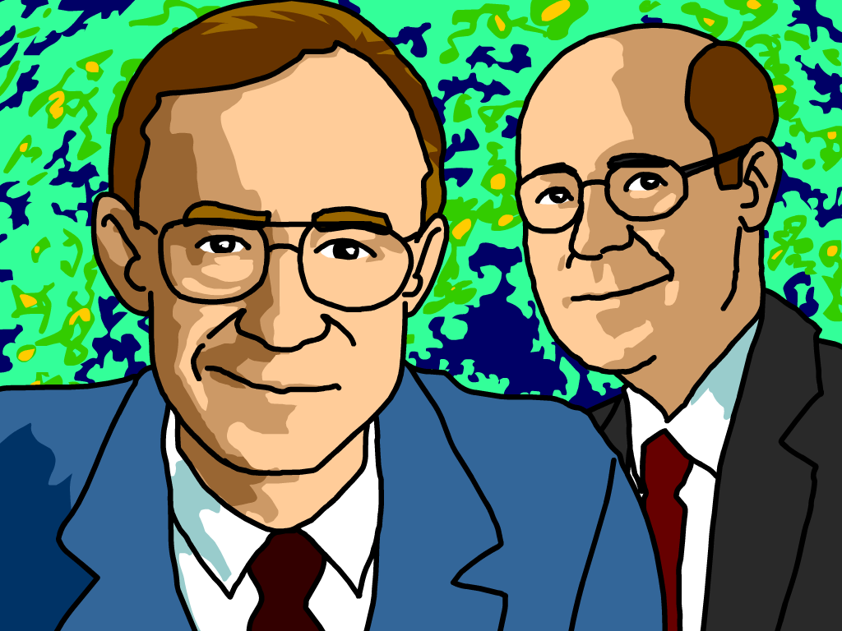One of the best pieces of evidence supporting the Big Bang theory is the presence of something called the **cosmic microwave background radiation** (usually abbreviated CMB). It was discovered in 1965, when two young scientists named Arno Penzias and Robert Wilson (pictured, left to right) were experimenting with a radio antenna at a lab in New Jersey.  
  
The antenna they were working with was incredibly sensitive and designed to pick up electromagnetic signals originating from space. When they first tested it, they kept hearing this weird, unexplained static. It didn’t seem to come from any object in space, but it had the same wavelength, frequency, and energy no matter which way they directed the antenna. For the life of them they couldn’t figure out where the static was coming from.  
  
Finally, another team of scientists stepped in to help out. They realized that the noise Penzias and Wilson were hearing was actually the cosmic microwave background. The cosmic microwave background is located everywhere throughout the universe and has a temperature of only 2.7 degrees Kelvin—just a hair over absolute zero. For their efforts, Penzias and Wilson received the 1978 Nobel Prize!

## Personalities

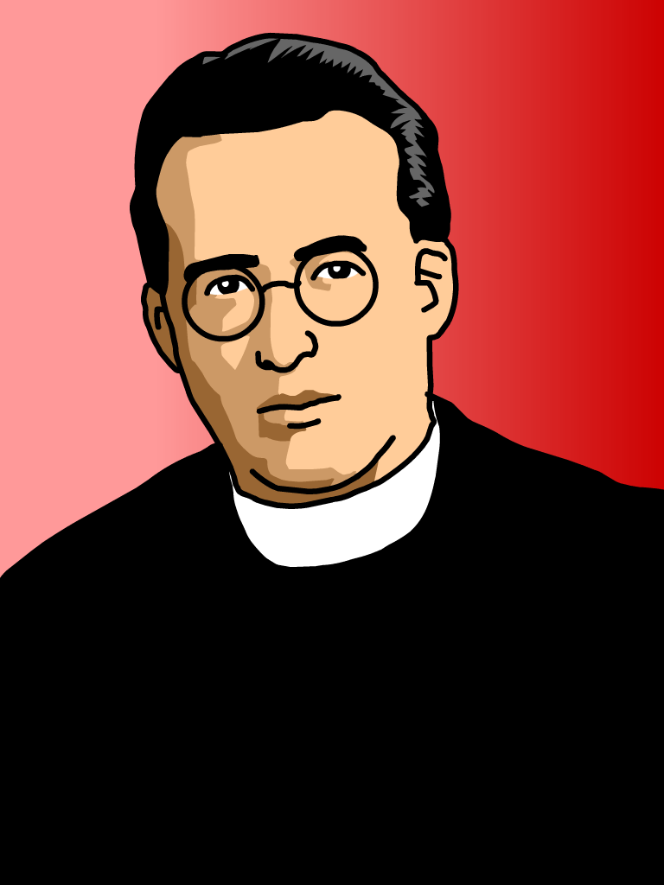The first person to propose the Big Bang theory was a Belgian guy named **Georges Lemaître**. Lemaître earned a doctorate in physics in the 1920s, and he also became a Roman Catholic priest!  
  
Lemaître was one of few physicists at the time who truly understood Einstein’s theories of relativity, but he disagreed with Einstein on a key point. While Einstein believed that the universe was unchanging and stable, Lemaître believed that observations of galaxies proved that the entire universe was expanding.  
  
In 1927 Lemaître published his theory, which said that the universe had a definite beginning, in which all matter and energy were concentrated in one point, and that the whole thing has been expanding since then. Initial reaction to Lemaître’s theory was lackluster. Einstein told him that while his calculations were correct, his “grasp of physics” was “abominable.”  
  
But in 1929, American astronomer Edwin Hubble confirmed that other galaxies were, in fact, moving away from each other. People began to notice and accept Lemaître’s theory, most notably Einstein himself. In 1933, Einstein stood and cheered after Lemaître explained his theory at a lecture in California, and said afterward that, “this is the most beautiful and satisfactory explanation of creation to which I have ever listened.”  
  
Later, Einstein would call his belief in an unchanging universe the biggest mistake of his career.

SUN

Earth’s shadow

EARTH

MOON

ECLIPSE OF THE MOON

a

b

c

d

e

a

b

c

d

e

SUN

EARTH

MOON

ECLIPSE OF THE SUN

SUN

Earth’s shadow

EARTH

MOON

ECLIPSE OF THE MOON

a

b

c

d

e

a

b

c

d

e

SUN

EARTH

MOON

ECLIPSE OF THE SUN