Energy and Sound Need to Know 2022

Energy
- Energy is needed to get jobs done, or make things work.
- The unit of energy is the joule , and has the symbol (J)
- Energy can be transferred from one object to another or can be converted from one form to another.
- Energy transfers can happen in more than one stage.
- The total amount of energy in a transfer is always the same – it is conserved. i.e: the amount of energy before a transfer is always equal to the amount of energy after the transfer, but not all of the energy is useful.
- Energy is wasted as heat during each energy transfer.
Type of energy | About this energy
Kinetic | Makes things move (also called movement energy)
Electrical | Energy that is stored in a charged particle within an electric field)
Heat | Objects can give out heat energy (e.g. a fire)
Sound | Energy can be radiated away as sound (e.g. from a drum)
Light | Energy can be radiated away as light (e.g. in a bulb)
Nuclear | Can generate nuclear power – stored in atoms
Chemical | Stored in substances such as food or fuel
Strain/elastic energy | Stored in an elastic object, e.g spring, rubber band
Gravitational potential energy | Stored in objects above the Earth’s surface

Waves
Transverse | Longitudinal
amplitude  crest  trough | 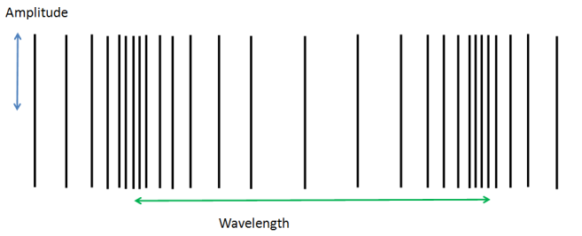
The direction of particle movement is PERPENDICULAR (at 90˚) to the direction of the wave. Examples are water waves and em spectrum waves | The direction of particle movement is parallel (moving the same way) to the direction of the wave. Examples are sound waves
- There are two types of wave – longitudinal and transverse

- There are several features to a wave:
Wavelength | The length of one complete wave( e.g. crest to crest or similar). Measured in metres (m).
Amplitude | The distance from the axis to the crest or from axis to the trough. Measured in metres (m).
Frequency | The number of waves per second. Measured in Hertz (Hz).
Period | The time taken for one complete wave to pass. Measured in seconds (s)
Energy | Dependant on amplitude- the larger the amplitude, the larger the Energy
Crest (sometimes called Peak) | The highest point on the wave
Trough | The lowest point on the wave

Sound
- Sound is a wave which carries energy from one place to another. The greater the energy of the wave the greater its amplitude.
- Sound is caused by vibrating objects.
- Sound travels through air at approximately 340 metres per second. The speed of light in air is 300 million metres per second.
- Lightning and thunder is an example to show that speed of light is very much greater than the speed of sound.
- Sound travels in solids, liquids and gases but not in a vacuum.
- Sound travels fastest in a solid and slower in a gas.
- To measure the speed of sound, measure a known distance. You should record the time it takes for the sound to travel the known distance. To calculate the speed of sound, use Speed = distance ÷ time (written as $v=\frac{d}{t}$)

Hearing
- The range of human hearing is 20 – 20,000 Hz
- Sound levels are measured in decibels dB
- Loud sounds can permanently damage hearing.
- The danger level at which sound can permanently damage hearing is 85dB.
- The louder the sound the shorter the time it will take to permanently damage hearing.

- When looking at sound waves using an oscilloscope:
 | Part | Function
A | Pinna | Funnels the sound waves travelling through the air into the ear canal.
B | Ear canal | Passage from outer ear to ear drum
C | Ear drum | The sound waves make the ear drum vibrate.
D | Middle ear bones | These pass the vibrations to the spiral cochlea.
E | Spiral cochlea | Contains a liquid and nerve cells. When the liquid vibrates it stimulates the nerve endings to create a signal
F | (Auditory) Nerve | Carries the signals from the ear to the brain.
- The frequency of a sound note is given by the pitch. Higher pitched noises have a higher frequency
- Sounds above the range of human hearing are called ultrasounds.
- The volume of a sound note is indicated by the amplitude. The louder the sound is, the greater the amplitude
- If two notes are an octave apart the upper note has twice the frequency of the lower note

- Cupping our ears (giving a curved reflector) results in us collecting more sound and we hear more.
- Cupping our ears with our hands pointing backwards results in us reducing the sound level in our ears.
- Sounds above the range of human hearing are called ultrasounds.
- The parts of the ear and function are labelled below:
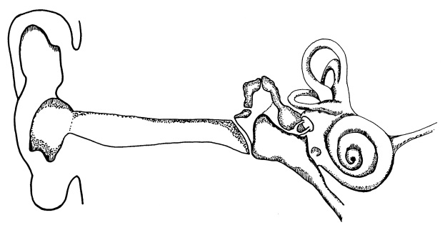
E
F
B
A
C
D

