The Visible and Beyond
S1 Science
Homework Booklet
Complete the homework your teacher tells you to do.
Lockerbie Academy
S1 Physics unit 2
Homework booklet

Homework 1

Review what you have already covered in waves
- Copy and complete the following diagram and write out the definition.
  - ______________: top point of a wave.
  - ______________: bottom point of a wave.
  - ______________ (λ): crest to crest or trough to trough.
  - ___________________: distance from zero position (axis) to crest.
- State the two types of waves and give an example of each.
- Try to draw an image of both types of wave and label each.
- Now try the following questions
  - If 20 waves pass a point in 10 seconds calculate the period of the waves.
  - If 20 waves pass a point in 10 seconds calculate the period of the waves.
  - If 20 waves pass a point in 5 seconds calculate the period of the waves.
  - If 20 waves pass a point in 5 seconds calculate the frequency of the waves.
  - If 8 waves pass a point in 24 seconds, calculate the period of the waves.
  - If 8 waves pass a point in 24 seconds, calculate the frequency of the waves.

Homework 2 Colour Mixing
- State the three primary light colours.
- State what light colours can be used to make yellow light.
- Orange light is made from the same colours as yellow light. Explain how both yellow and orange can be made from the same colours of light.
- State what colour I will get if I mix all primary light colours in the same proportions.
- If I was going to light someone on a stage with a cyan colour, state how I could do this. Explain if there was more than one way.
- Draw a diagram of a rainbow or a spectrum, label the colours and if possible can you find the wavelength of visible light.
- Draw a diagram of the apparatus /equipment that can be used to split white light into a spectrum .

Homework 3 Colour BLINDNESS/ DEFICIENCY

Visit the website https://www.colourblindawareness.org/colour-blindness/
Over a double page spread copy the table from the next page into your jotter. Research and find out about colour blindness/deficiency.
Can you find some jobs/ occupations that you cannot do if you are colour deficient.

Types of colour-blindness |  | Causes of colour-blindness
 | Colour blindness
Living with colour-blindness |  |  | Misconceptions

Homework 4: Uses of convex and concave mirrors and lenses

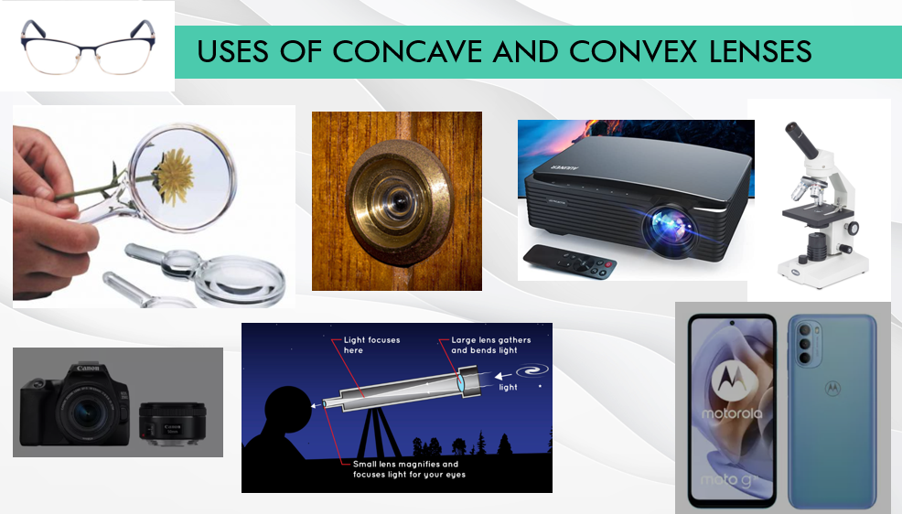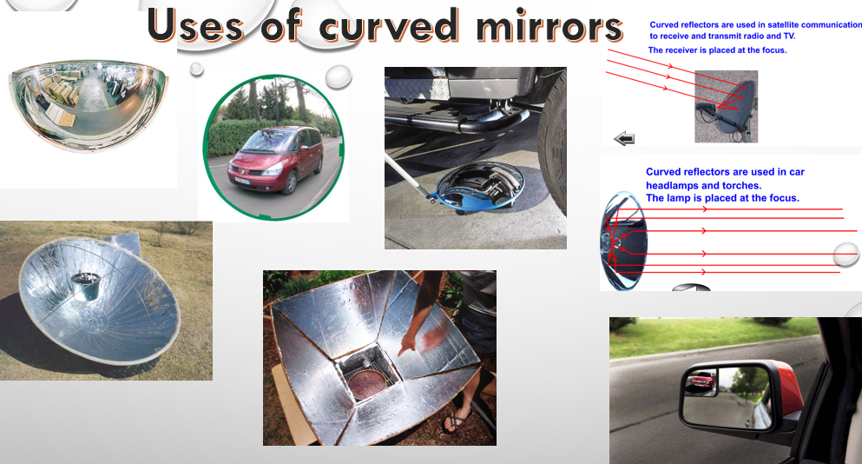

- Find out some places where convex and concave mirrors and lenses are used in everyday life.
- Find out more about them.
- Can you take images and upload them to your team?
  - include where you found them,
  - is it a lens or mirror,
  - is it concave or convex.

ALTERNATIVE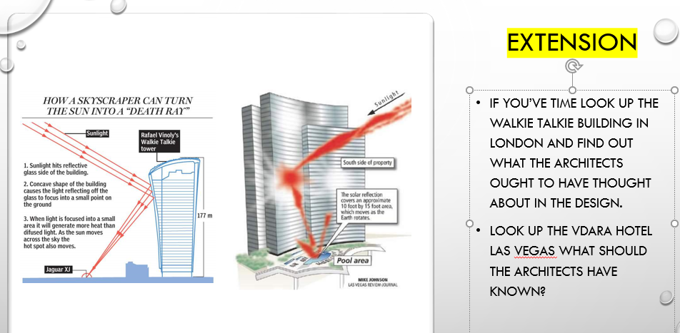

Assessed Homework 5: EM SPECTRUM POSTER
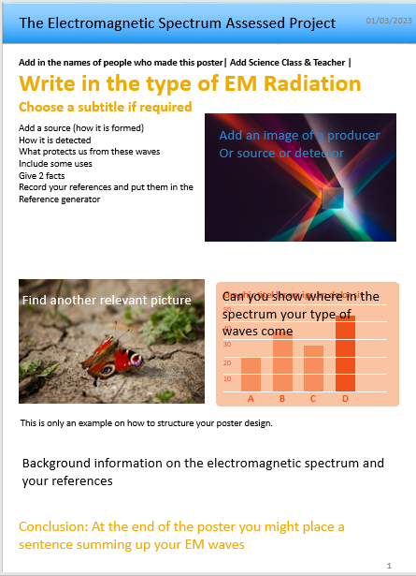
Use the POWERPOINT template to produce a scientific poster on the EM spectrum. Your teacher will show you an example on the visible waveband.
Your poster must cover
- Sources,
- Use
- Detector
- Protector
- 2 interesting facts
- Where your information came from
Research, Cover all areas, Make it clear, Don’t copy, Reference properl.y

Homework 6 : MY Superhero
Design a SUPERHERO who has some superpowers related to the electromagnetic spectrum. There are websites that can help you if you can’t draw.
Your superhero should be:
- Drawn
- Named
- Super powers explained
- Any weaknesses discussed
- Explain how he/she/they can save the world.
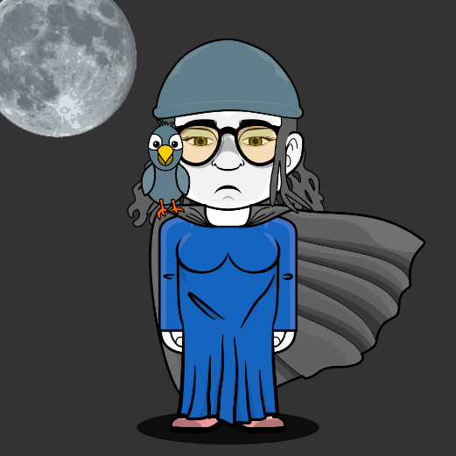
Here are two examples, don’t copy them!
RADIO WOMAN
- Can detect all radio waves and can override what is on the radio.
- Can be in many places at once, but not visible to everyone
- Looses superpowers in a metal tank.
- Can have influence on people via social media and can make social influencers say whatever she wants them to.
Miss Violet
Can see in the UV, flies, travels at the speed of light, is stopped by some glass, cures some cancer, jaundice, and kills bacteria and viruses but causes skin cancer in enemies

