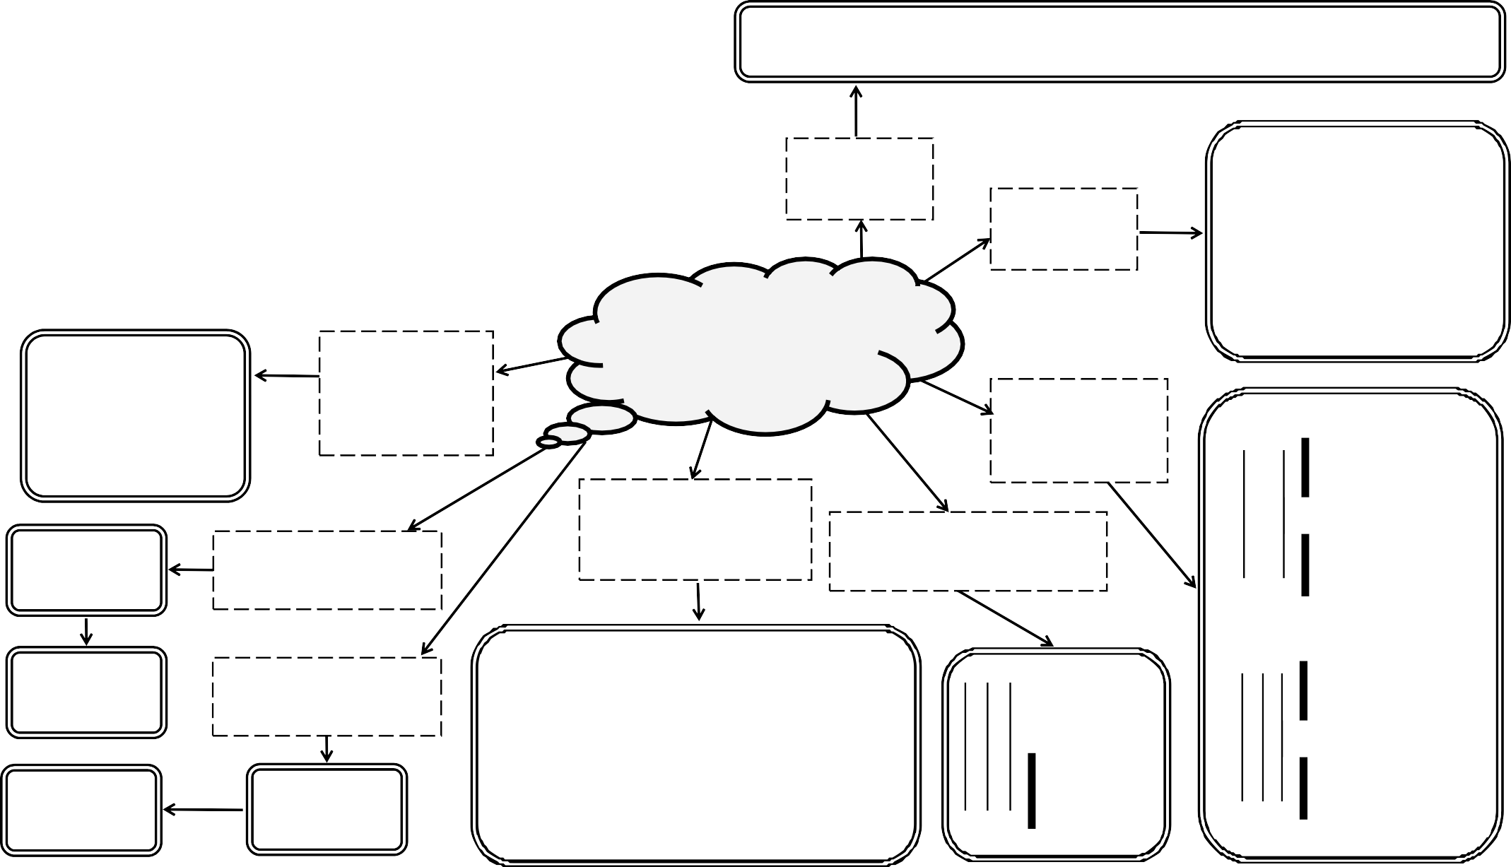 Frequency: The number of waves produced per second, Hertz
The particles vibrate at right angles to the direction of travel of the wave.
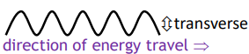

All EM waves are transverse.

The particles vibrate parallel to the direction of travel of the wave.

Sound waves are longitudinal.

Or The number of waves passing a point per second,

Period: The time taken for one wave to pass a point, second

Wavelength: The distance between the same point on waves right next to each other. The distance between successive crests on a wave.

Describe a transverse wave. Give an example.

All waves transfer..
ENERGY.

Describe a longitudinal
wave. Give an example. Give the definition of...

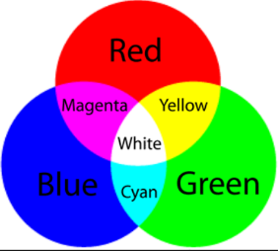

Primary and secondary light colours?
1: RED, BLUE & GREEN
2 Magenta, Cyan, Yellow

What are the units of frequency, period, amplitude and wavelength?
Units
Frequency ⇒Hertz
Period ⇒ second
Amplitude⇒ metre
wavelength⇒metre
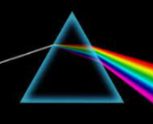

Waves &

reflection

Draw a diagram of a wave and label the;

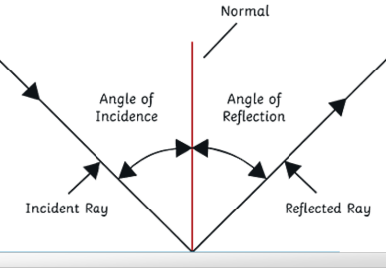
Draw a labelled diagram of a ray reflecting off a plane mirror

Show light through a prism.
crest, trough, amplitude and wavelength
Give uses of curved mirrors
Normal: a line at right angles to a surface at the point where the incident ray strikes the mirror.
Angle of incidence: the angle measured from the normal to the incident ray
Reflected ray: the angle measured from the normal to the reflected ray.

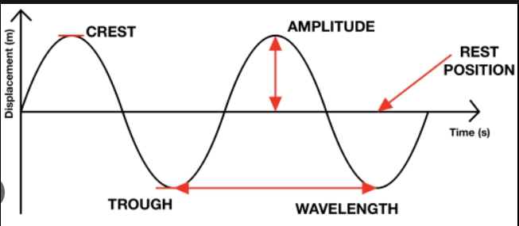
Inspection mirrors
Rear view mirrors
Dental viewing mouths, solar oven
Beauty (magnifying)
Security (shops, buses)
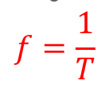
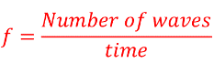
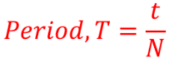
Relationships to calculate frequency and period

Radio & TV | aerial
Microwaves | aerial
IR | photodiode, thermocouple, thermistor
Visible | black bulb thermometer
UV | photodiode, photographic film, retina CCD
X-Ray | photodiode / melanocyte skin cells, fluorescent materials
Gamma | photodiode / photographic film / electrical current detectors

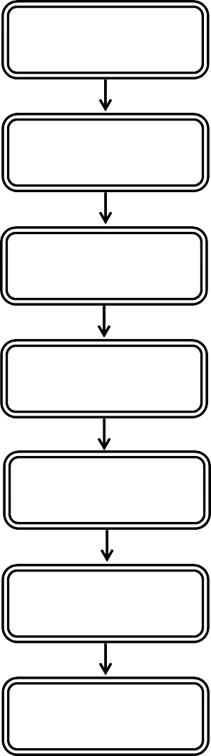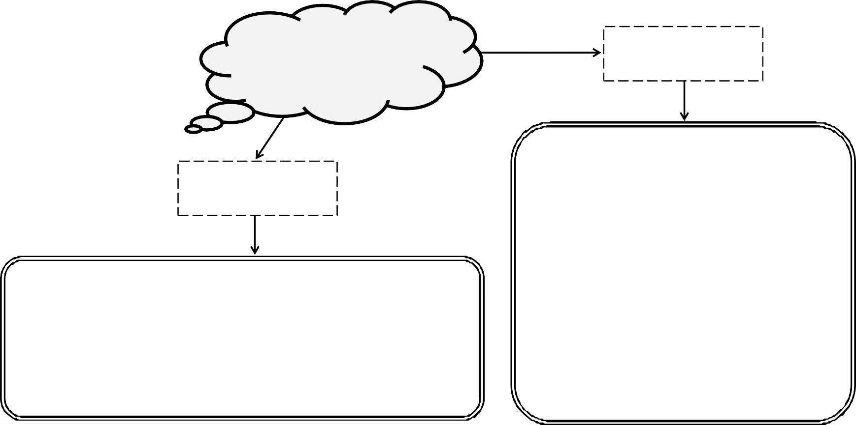

All EM waves, transfer energy, are transverse waves and travel at 300 million metres per second
(3.0 × 10⁸ m/s) in air
They have no mass.
What do all EM waves have in common? What speed do they travel at?
List detectors for each type of radiation

RADIO

MICROWAVES

INFRA RED (IR )

VISIBLE

ULTRA VIOLET (UV)

X-RAYS

GAMMA

Electromagnetic Spectrum
Put the EM spectrum in order of increasing frequency
List applications for each type of radiation

Radio & TV | communication (under the sea, in space) Watching TV programmes, films, listening to the news
Microwaves | heating water molecules to warm food,  communications
Infra Red | remote controls, security systems, automatic external lights  searching for people in dark
Visible | humans viewing the world, photography,
Ultra violet | detecting forged bank notes, causing white shirts to look cleaner  kills bacteria and viruses
X-Ray | detecting broken bones, checking suitcases at the airport,
Gamma Rays | medical tracers to detect cancer, killing bacteria, sterilising intruments, detecting broken pipes underground

List typical sources for each type of radiation

Radio & TV | Micro-waves | Infra Red | Visible | Ultra violet | X-Ray | Gamma Rays
transmitter,  outer space | magnetron,  transmitters,  outer space | warm objects,  sun  convector heaters | stars including the sun, LEDs, cinema screens | Fluorescent tubes, very hot objects, sun | X-ray tubes, stars | Radioactive nuclei,  outer space (stars)

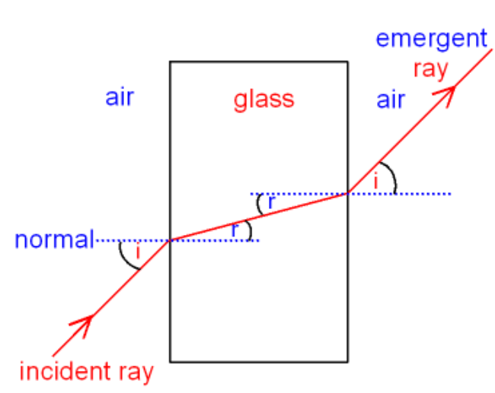
Refraction is a change in the speed and wavelength of a wave as it moves into a material of different optical densities and it can lead to a change in direction of the wave.
Define refraction in terms of wave speed and wavelength
Complete the diagram showing the path of the ray of light

Refraction occurs when a wave moves between material of different optical densities (like thickness)

When does refraction occur?

Refraction of
Light

Label the angles of incidence and refraction; and the normal

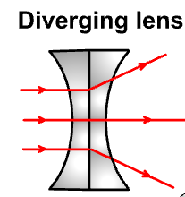
Name this lens.
concave
Complete the diagram
Name this lens.
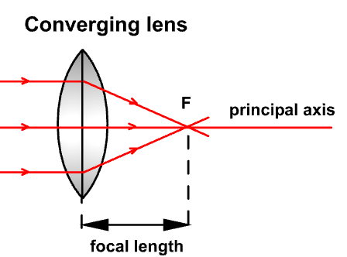
Complete the diagram
convex

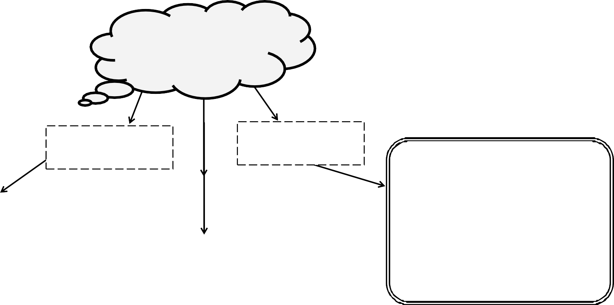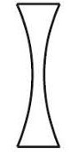
Define

Angle of incidence: the angle measured from the normal to the incident ray

Angle of refraction: the angle measured from the normal to the refracted ray:

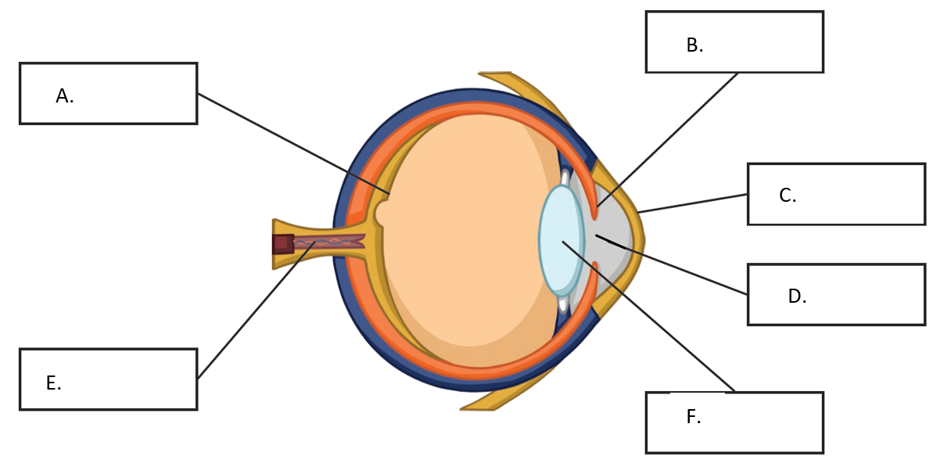

Letter | Part Name | Function (What is does)
A | RETINA | Detects the light
B | IRIS | Controls the size of the pupil
C | CORNEA | Protects the eye and refracts the light as it enters the eye
D | PUPIL | Controls the quantity of light that enters the eye
E | OPTIC NERVE | Carries the electrical signals from the retina to the brain
F | LENS | Fine-tunes the focussing of light on the retina

