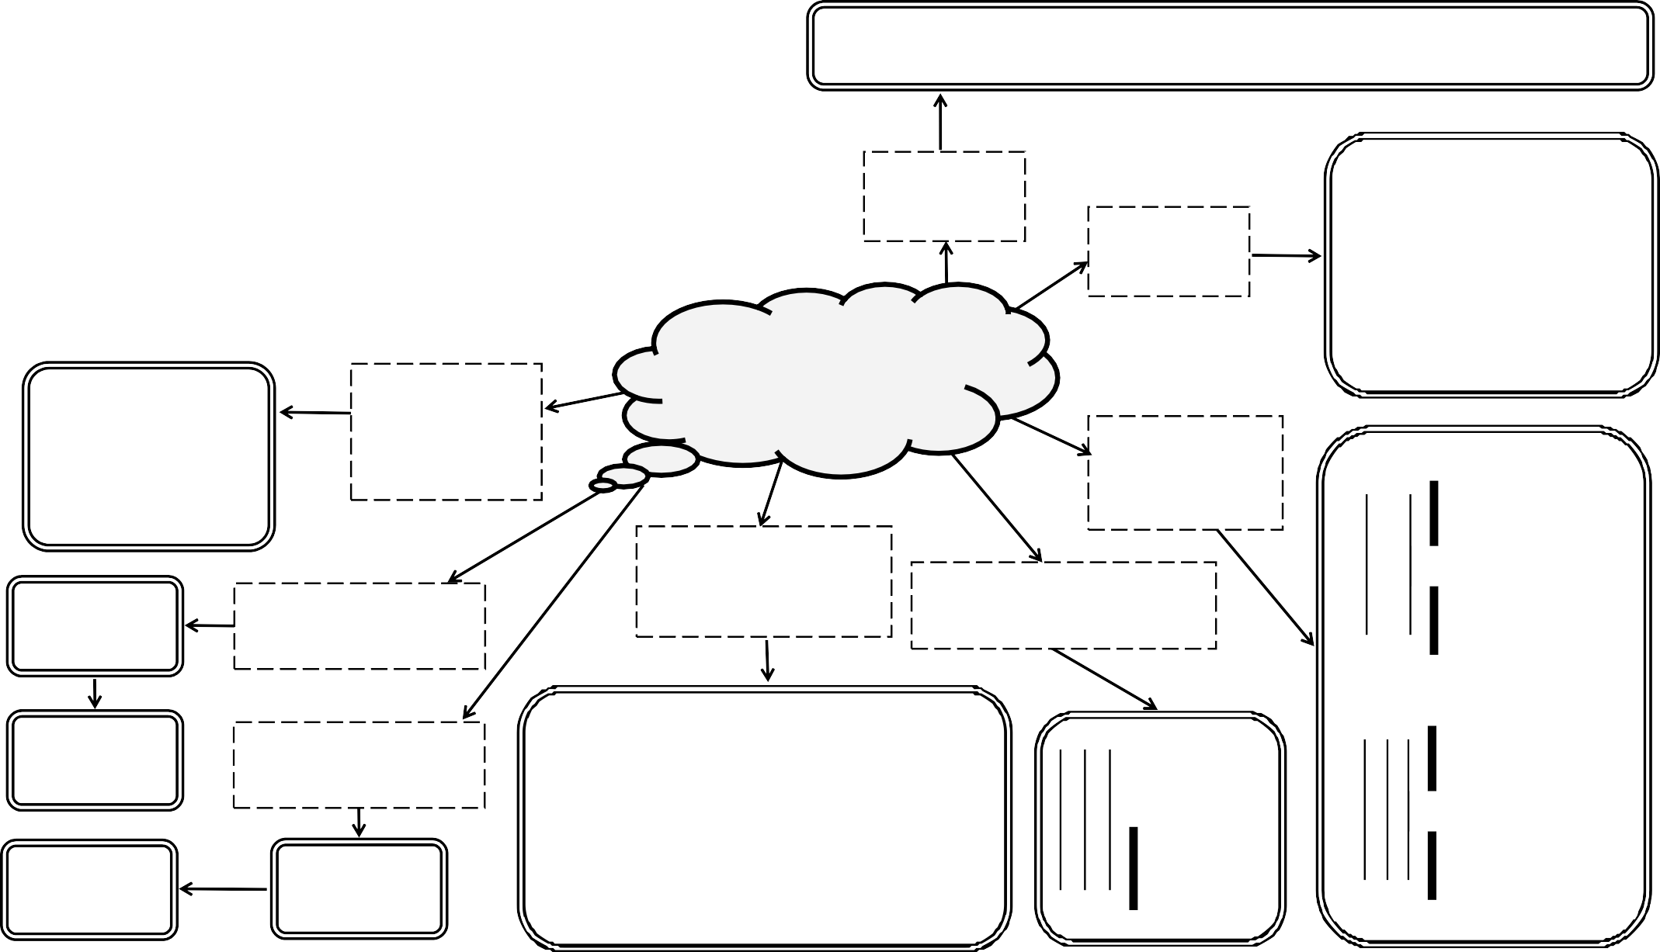Frequency:

Period:

Wavelength:

Describe a transverse wave. Give an example.

All waves transfer...

Describe a longitudinal
wave. Give an example. Give the definition of...

Primary and secondary light colours?

What are the units of frequency, period, amplitude and wavelength?

Waves &

reflection

Draw a diagram of a wave and label the;

Draw a labelled diagram of a ray reflecting off a plane mirror

Show light through a prism.
crest, trough, amplitude and wavelength
Give uses of curved mirrors

Relationships to calculate frequency and period

What do all EM waves have in common? What speed do they travel at?
List detectors for each type of radiation

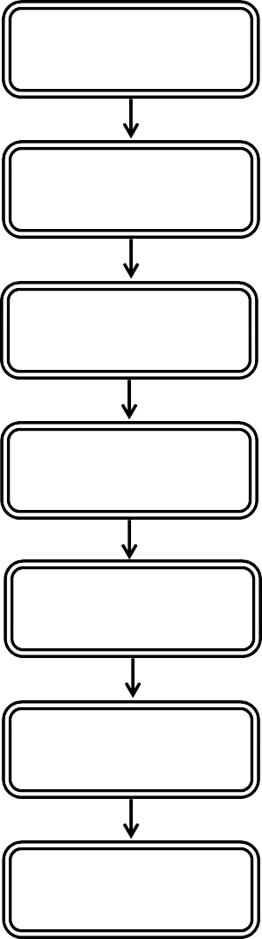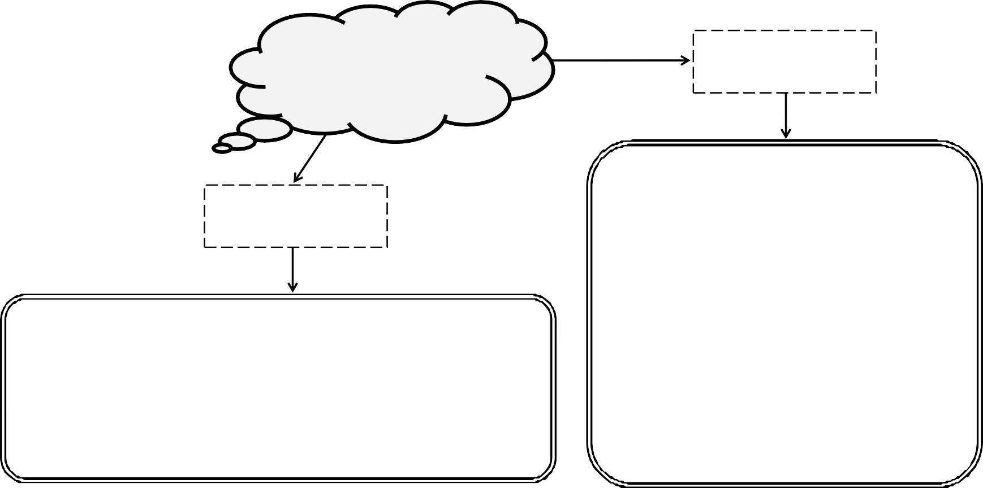Electromagnetic Spectrum
Put the EM spectrum in order of increasing frequency
List applications for each type of radiation

List typical sources for each type of radiation

Define refraction in terms of wave speed and wavelength
Complete the diagram showing the path of the ray of light

When does refraction occur?

Refraction of
Light

Label the angles of incidence and refraction; and the normal

Name this lens.
Complete the diagram
Name this lens.
Complete the diagram

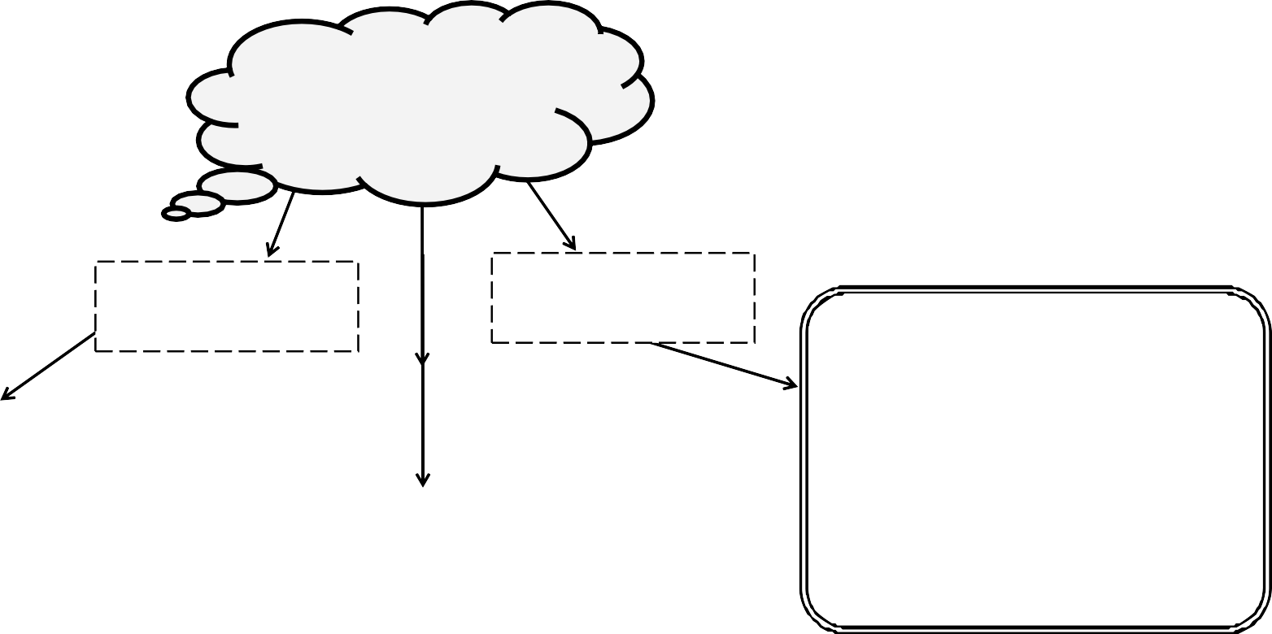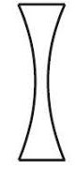

Define...

Angle of incidence:

Angle of refraction:

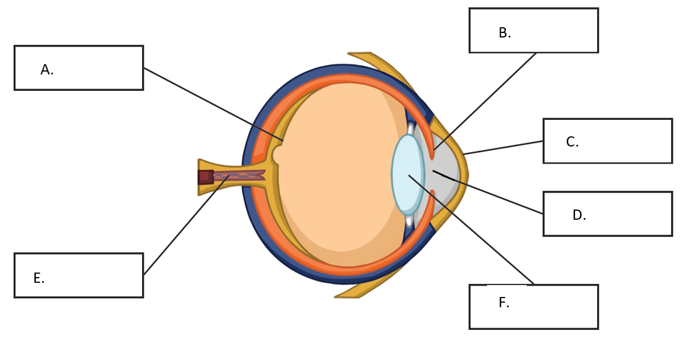

Letter | Part Name | Function (What is does)
A
B
C
D
E
F

