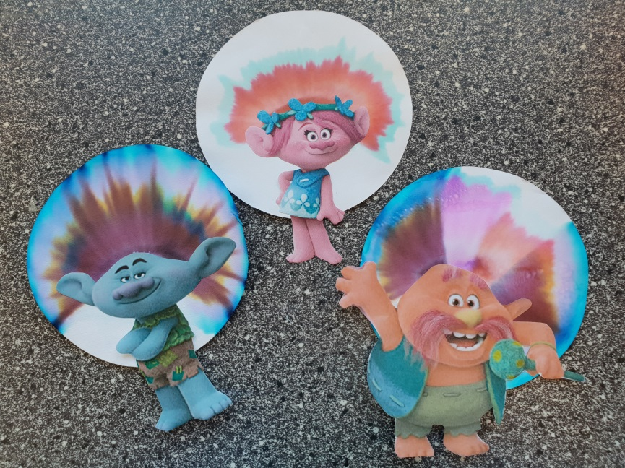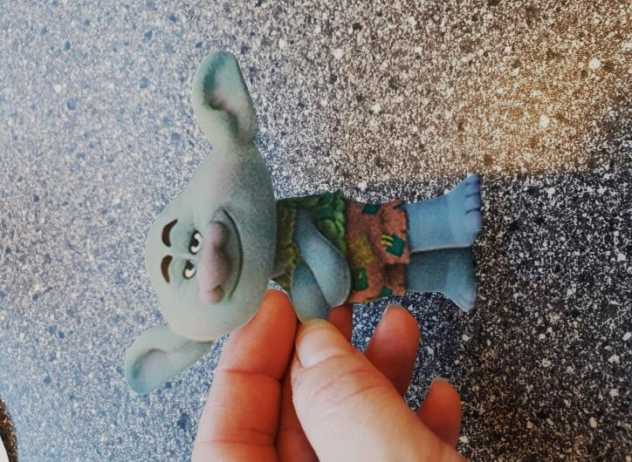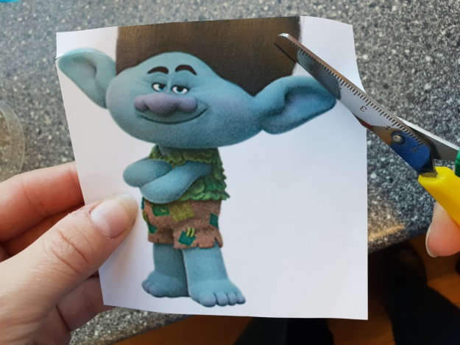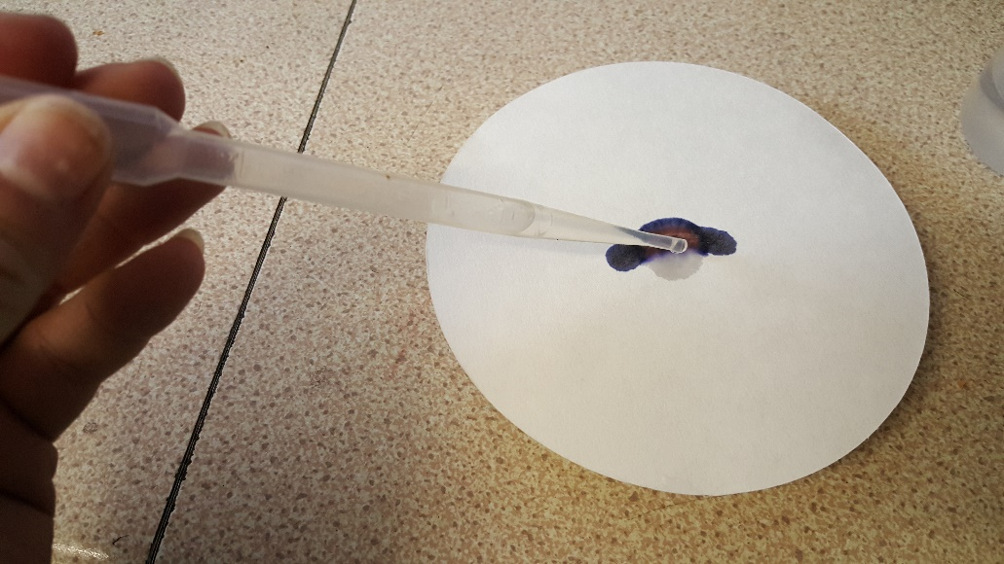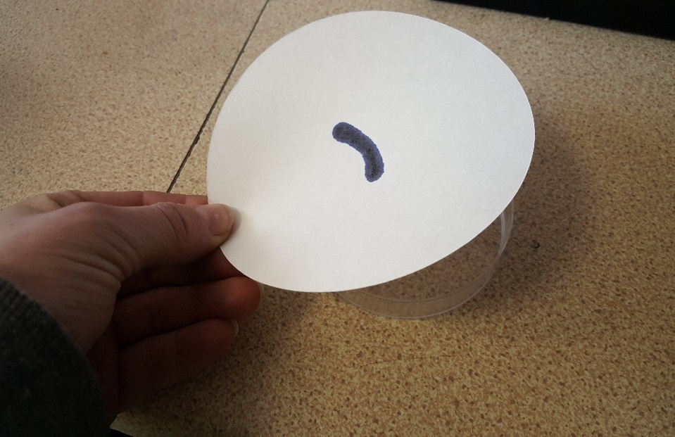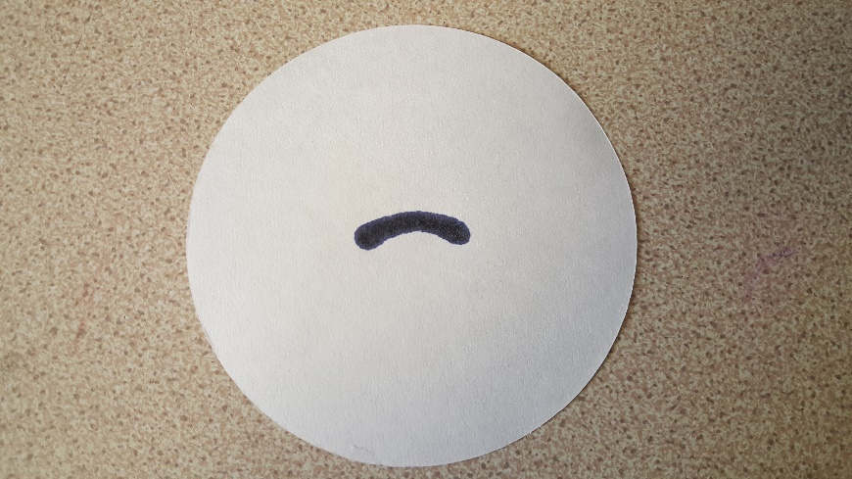

Leave your filter paper to dry

(or use a hairdryer)

Use a glue stick to stick your troll body onto his new funky hair!

What next? Repeat but with a different coloured pen to see what colour hair you can create

While you are waiting for the water drops to absorb choose a troll and cut it out

Make sure you have cut around the body so it looks like this one

**Chromatography Trolls**

Use a felt pen to draw a line or curve in the middle of your filter paper

Place the filter paper onto the petri dish

Use a pipette to add salt water below the line, one drop at a time

Wait for all the water to be absorbed before you add the next drop

Continue doing this until the ink has spread as much as possible