Colour and Light

(Risk Assessments to Add in)

# 1 What is light?

Not for the faint hearted

<https://www.youtube.com/watch?v=1PsHHKwtXQU>

<https://www.youtube.com/watch?v=BUYeQa_-ojk>

<https://www.youtube.com/watch?v=IXxZRZxafEQ>

For primary students:

* Light is a form of energy.
* Light is a range of waves that travel very fast (7.5 times around the Earth every second).
* Light is produced by hot objects.
* Light travels in straight lines

# 2. Colour Mixers

Three primary light colours for additive

## Additive Mixing

* Red
* Green
* Blue

Red and Blue combine to give magenta

Blue and Green combine to give cyan

Red and Green combine to give yellow.

Combining all of these colours produces White light

This is not usually taught as it does not correspond to mixing physical substances.

The absence of any colour in light produces black

E:\PHYSICS GRAPHICS\Clipart\Light & sound\Light\LightCo.wmf

## Subtractive Mixing

With subtractive colour mixing an external light source is required and each primary absorbs some of the light (attenuates)

The primaries are

* Cyan
* Yellow
* Magenta

Cyan and Yellow combine to make green

Yellow and magneta combine to make red

Magenta and cyan combine to make blue

Combining all of these colours absorb all of the light resulting in black.

This is why printer colour cartridges are cyan, yellow and magenta.

<http://hyperphysics.phy-astr.gsu.edu/hbase/vision/newtcol.html#c2>

# 3. Prism

Risk Assessment: Small glass objects. Don’t put in mouth,

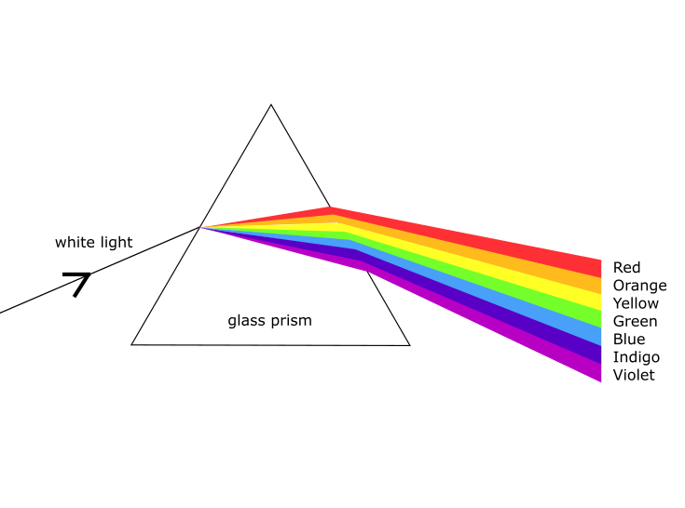

Prisms refract the different wavelengths of light and so disperse the colours.

* Red
* Orange
* Yellow
* Green
* Blue
* (indigo)
* Violet

(NB there is no pink!)

# 4. Colour Spinners

<https://www.youtube.com/watch?v=mZYBYp9HK8k>

B+y Cyrille BERNIZET - Own work, CC BY-SA 3.0, <https://commons.wikimedia.org/w/index.php?curid=7078196>

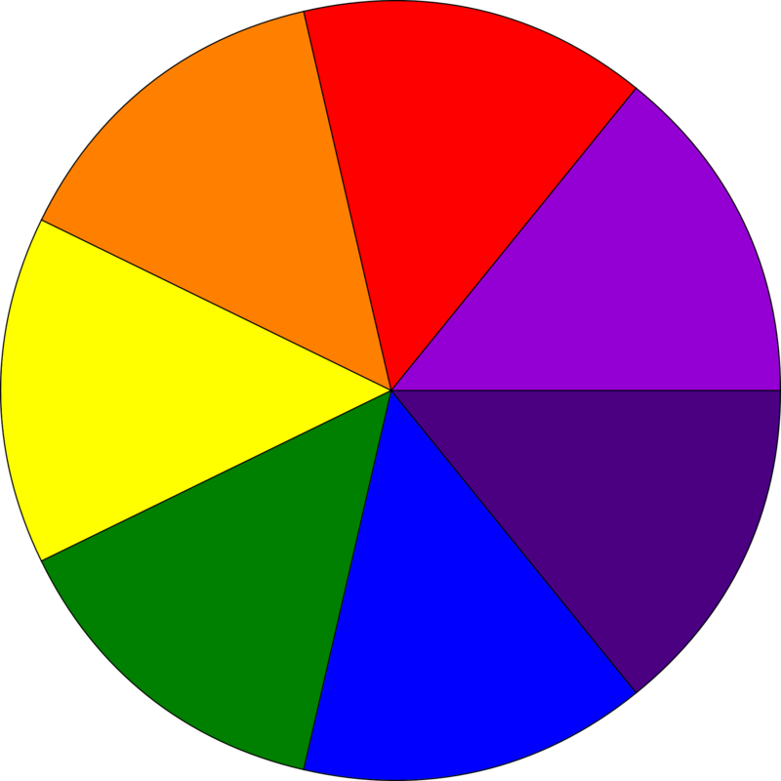

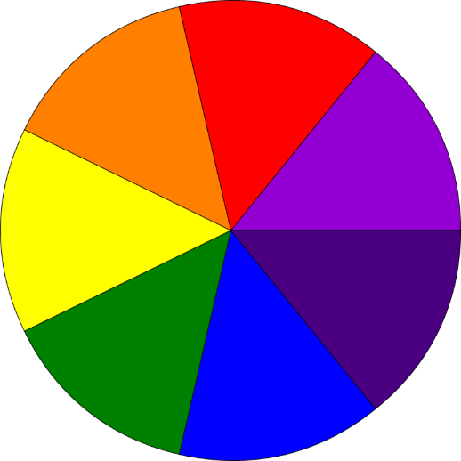  



  



 

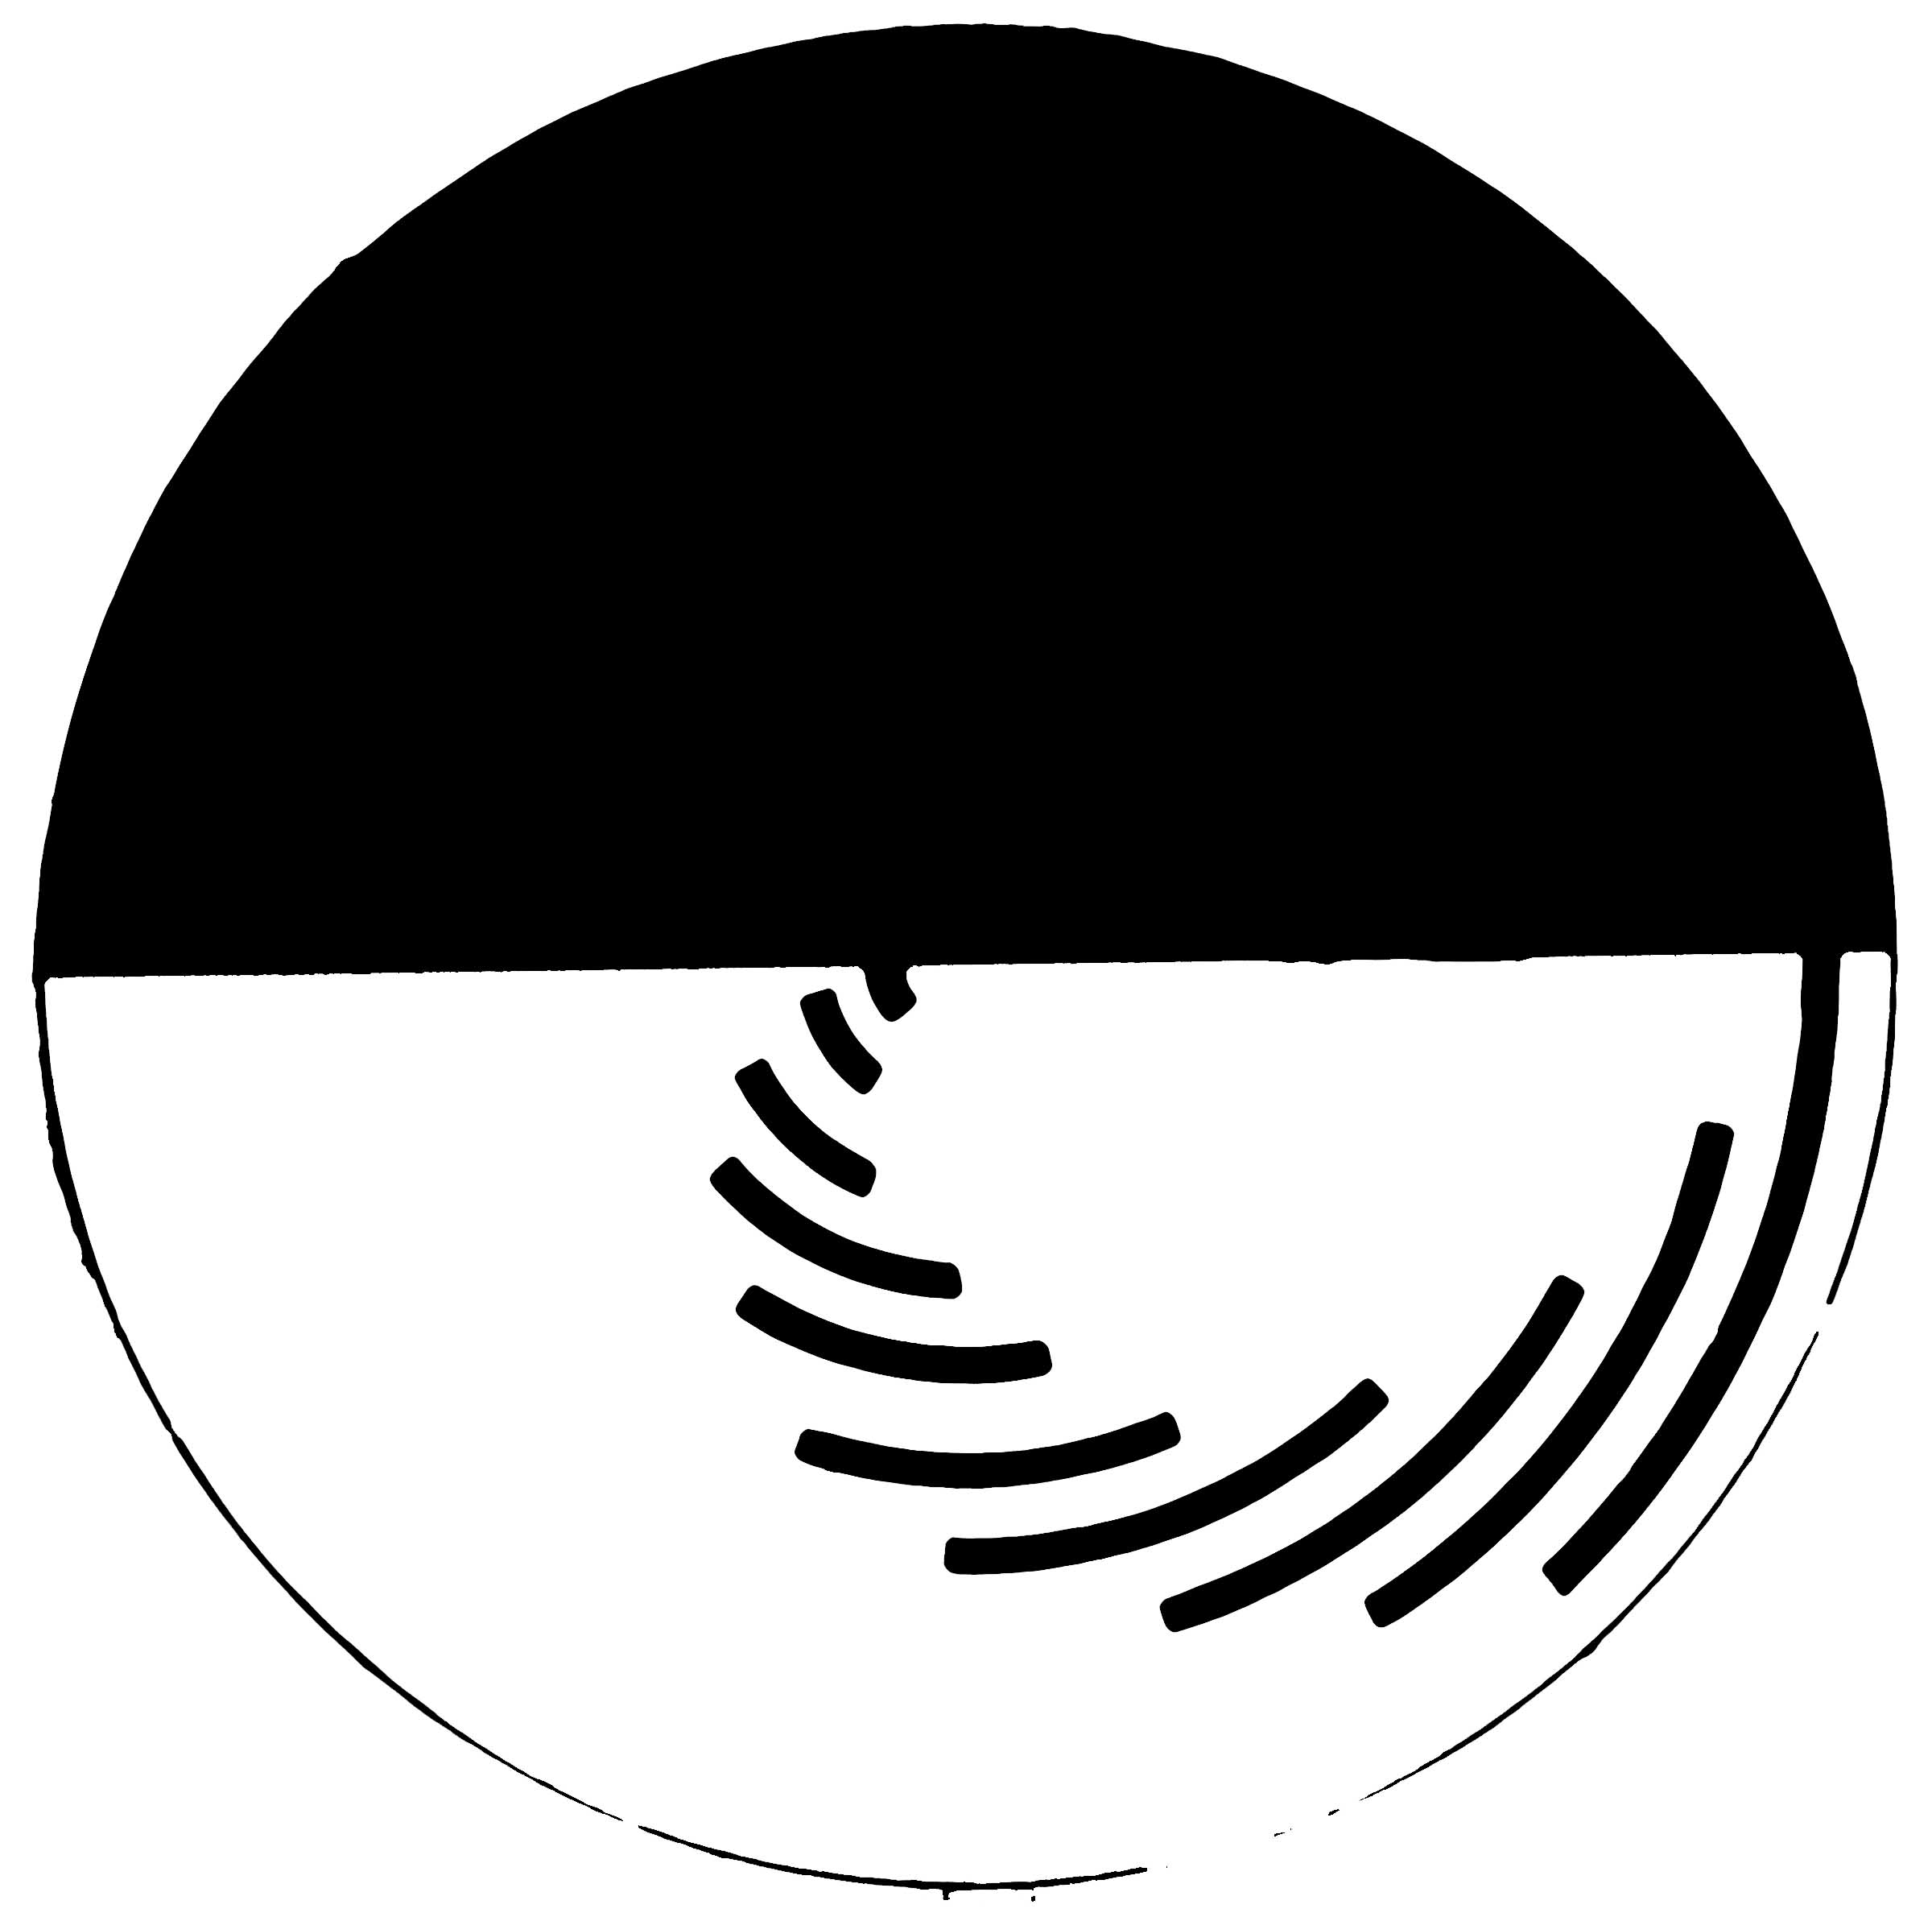

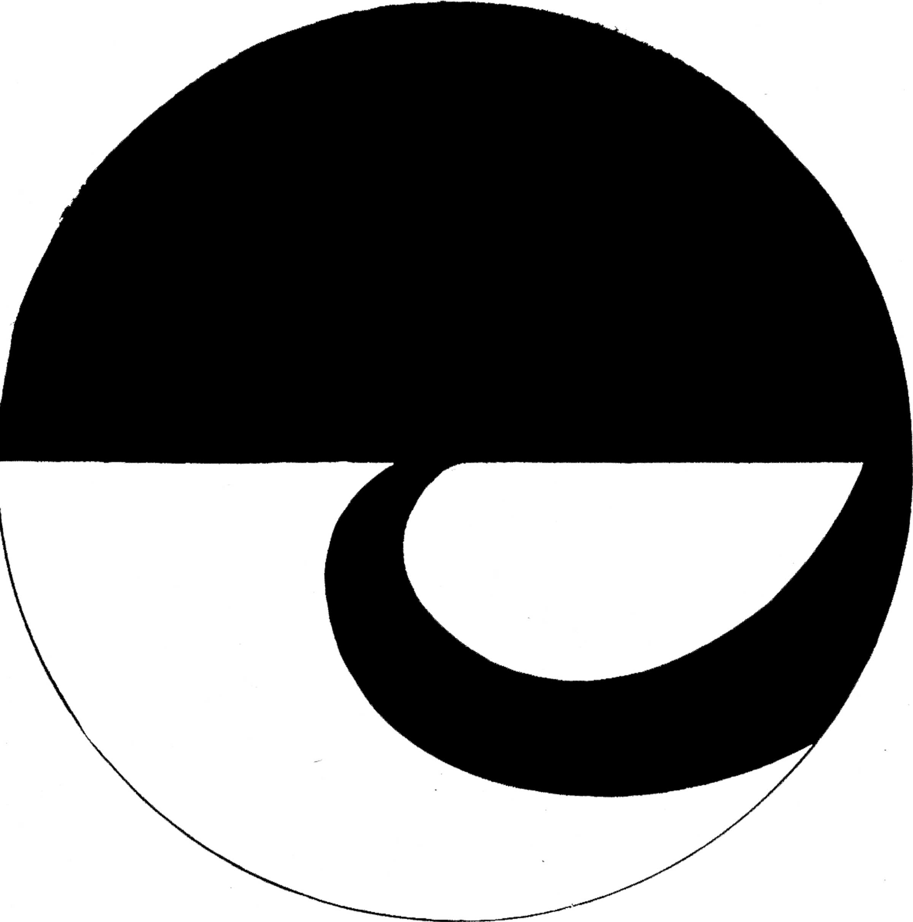

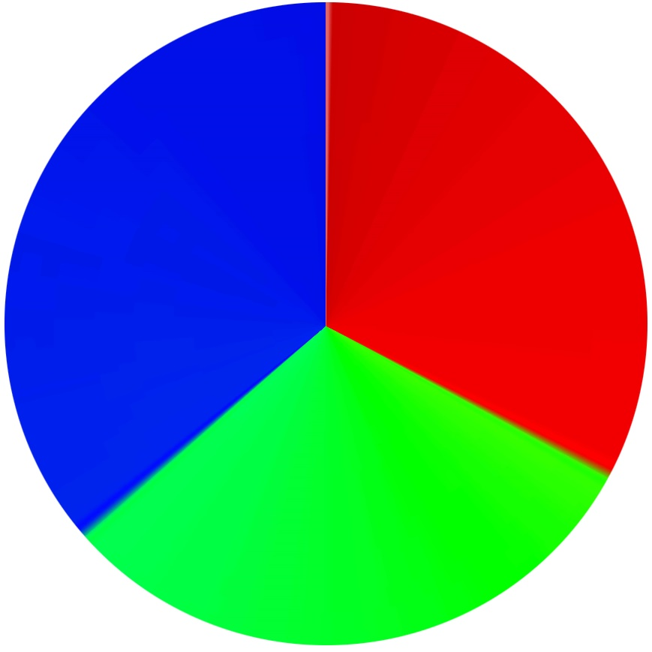 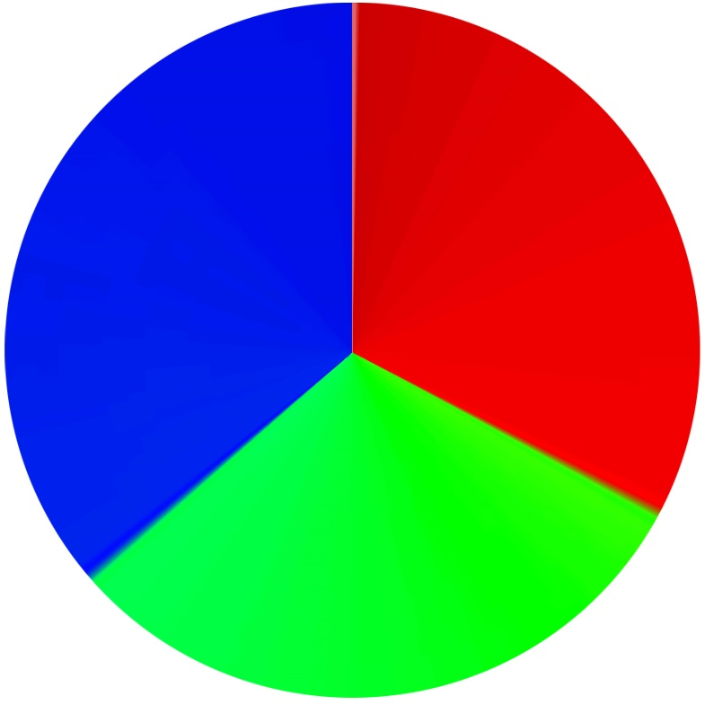 

# 5. Flame Tests

<https://www.thoughtco.com/how-to-do-the-flame-test-3976094>

<http://metallome.blogspot.com/2015/08/colourful-compound-interest.html>

**Wooden Splint or Cotton Swab Method**  
Wooden splints or cotton swabs offer an inexpensive alternative to wire loops. To use wooden splints, soak them overnight in distilled water. Pour out the water and rinse the splints with clean water, being careful to avoid contaminating the water with sodium (as from sweat on your hands). Take a damp splint or cotton swab that has been moistened in water, dip it in the sample to be tested, and wave the splint or swab through the flame. Do not hold the sample in the flame as this would cause the splint or swab to ignite. Use a new splint or swab for each test.

### **How to Interpret Flame Test Results**

The sample is identified by comparing the observed flame color against known values from a table or chart.

**Red**  
Carmine to Magenta: Lithium compounds. Masked by barium or sodium.  
Scarlet or Crimson: Strontium compounds. Masked by barium.  
Red: Rubidium (unfiltered flame)  
Yellow-Red: Calcium compounds. Masked by barium.

**Yellow**  
Gold: Iron  
Intense Yellow: Sodium compounds, even in trace amounts. A yellow flame is not indicative of sodium unless it persists and is not intensified by an addition of 1% NaCl to the dry compound.

**White**  
Bright White: Magnesium  
White-Green: Zinc

**Green**  
Emerald: Copper compounds, other than halides. Thallium.  
Bright Green: Boron  
Blue-Green: Phosphates, when moistened with H2SO4 or B2O3.  
Faint Green: Antimony and NH4 compounds.  
Yellow-Green: Barium, manganese(II), molybdenum.

**Blue**  
Azure: Lead, selenium, bismuth, cesium, copper(I), CuCl2 and other copper compounds moistened with hydrochloric acid, indium, lead.  
Light Blue: Arsenic and some of its compounds.  
Greenish Blue: CuBr2, antimony

**Purple**  
Violet: Potassium compounds other than borates, phosphates, and silicates. Masked by sodium or lithium.  
Lilac to Purple-Red: Potassium, rubidium, and/or cesium in the presence of sodium when viewed through a blue glass.

<http://metallome.blogspot.com/2015/08/colourful-compound-interest.html>

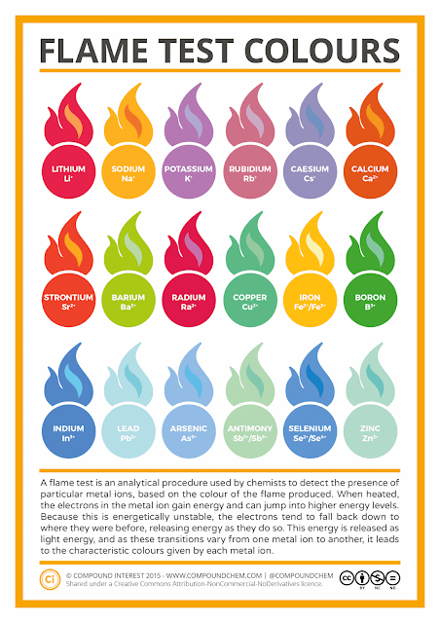

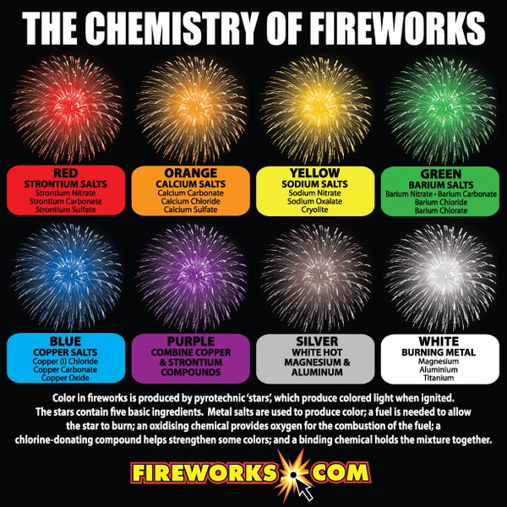

<https://www.explainthatstuff.com/howfireworkswork.html>

It's just as well fireworks were invented in ancient times, because such an outrageous invention surely wouldn't be allowed in our risk-averse society today. Just imagine if fireworks didn't exist and someone suddenly suggested the idea of allowing people to fire lots of explosives into the air! Fortunately, that's not the case and we can still enjoy the dazzling magic of these psychedelic aerial displays every time we feel like a joyous outdoor celebration. Fireworks teach us some interesting physics and chemistry, so let's take a closer look at what they are and how they work!

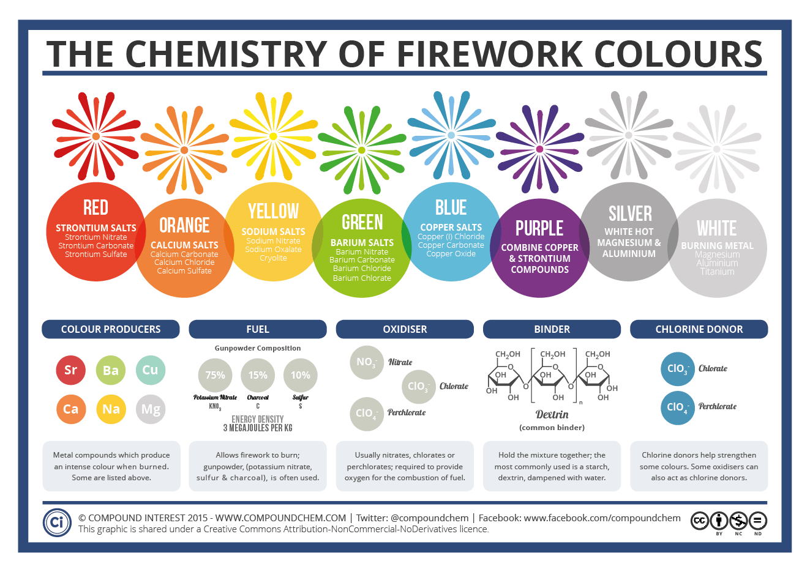

<https://i2.wp.com/www.compoundchem.com/wp-content/uploads/2013/12/Firework-Colours-2015.png>

# 6. Chromatography

Chromatography is a laboratory technique for the separation of a mixture.

Easily done at home. Can be used for “Forensic Days!”

Try it with pens (water soluble)

Smarties and other sweets.

# 7. Rainbows

<https://www.rookieparenting.com/make-your-own-rainbow-science-experiment/>

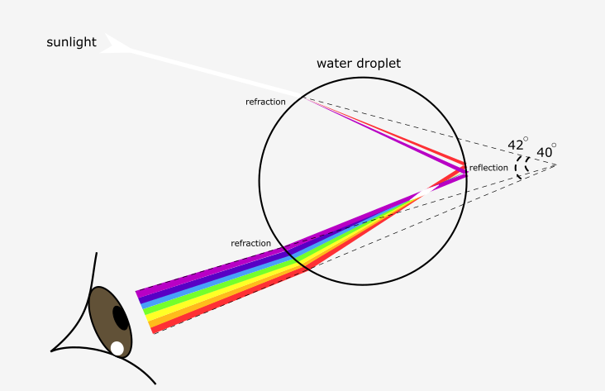

## Why Are Rainbows Arched?

Rainbows [are not two dimensional](http://www.straightdope.com/columns/read/857/why-are-rainbows-curved). A rainbow is seen at an angle that is between 40-42 degrees from the incident sunlight. So all the water drops that produce each color in the rainbow lie on a [three dimensional cone](http://earthsky.org/earth/what-gives-rainbows-their-curved-shape). Our eyes are at the tip of the cone.

That is why rainbows are arched. The circular shape below the ground is invisible.

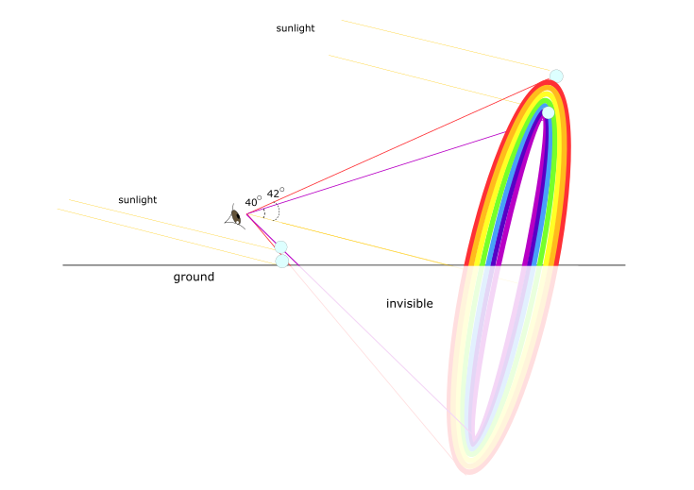

# 8. Diffraction Grating

Glasses, look at a white light source (carefully) and look at a diffuse light source.

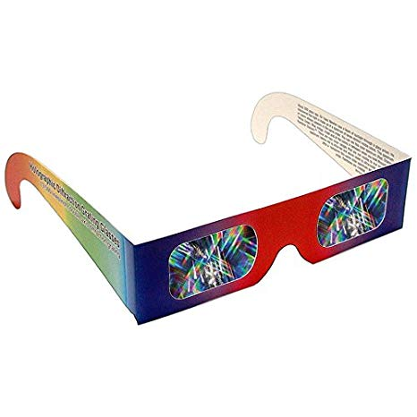

# 9. Travelling Water

<https://www.youtube.com/watch?v=9EUfVIon6t8>