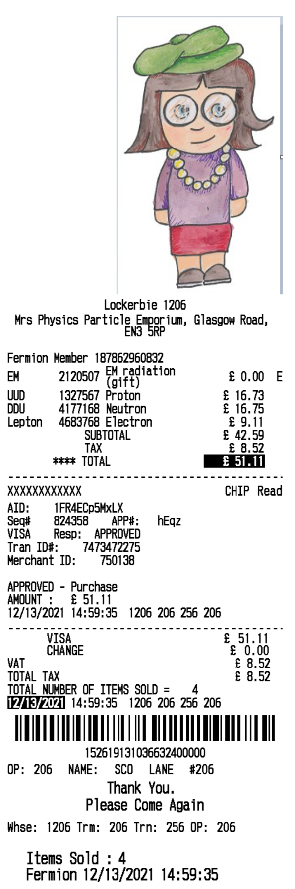
TASK 2: Find the cost to the nearest £ of 2 alpha particles and a beta particle. (advanced)

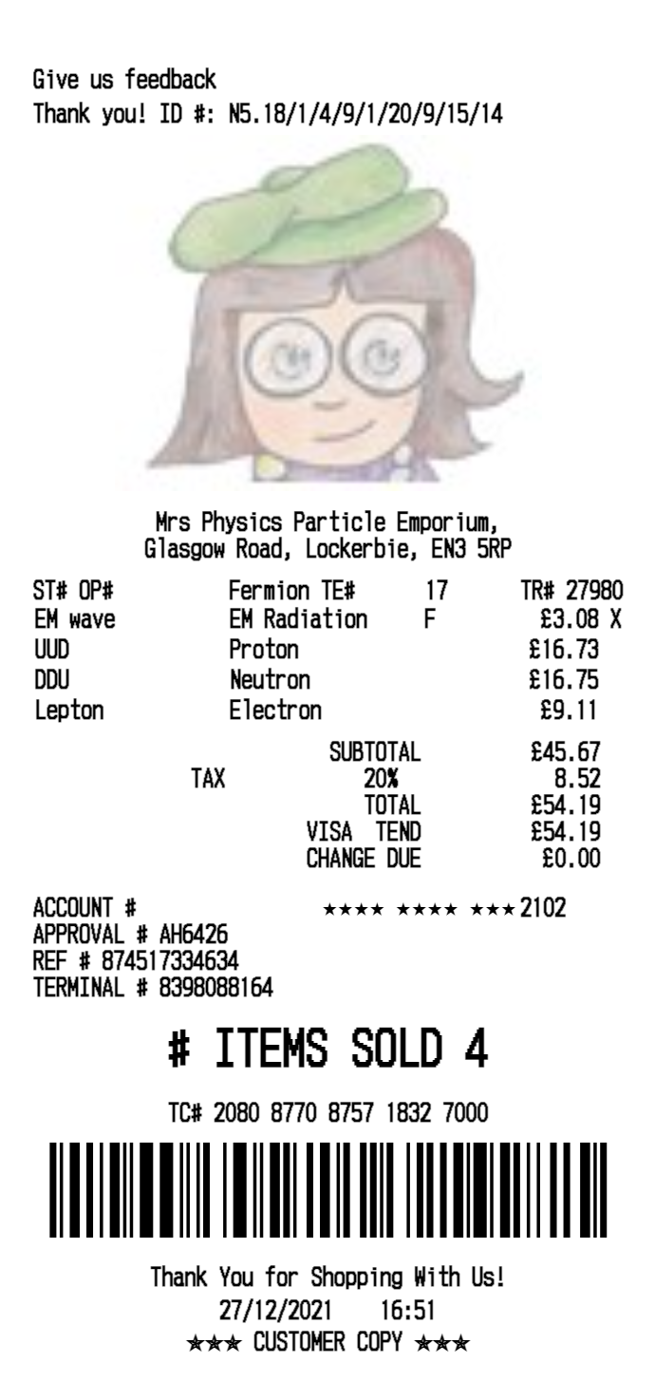
TASK 2: Find the cost, to the nearest £ of 2 alpha particles and a beta particle. (don’t forget the tax)

TASK 2: Find the cost, to the nearest £ of 2 alpha particles and a beta particle (ignore the tax).

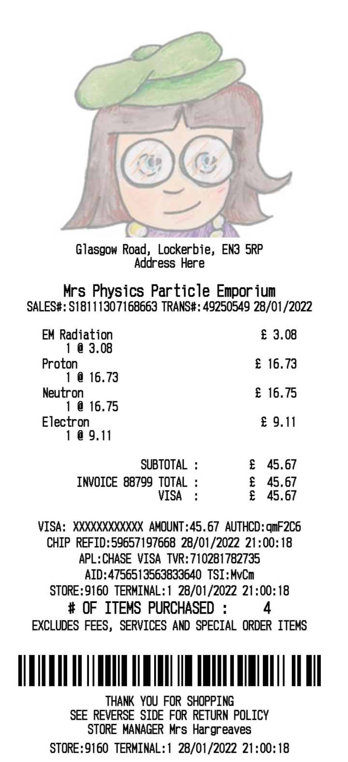
TASK 2: Find the cost, to the nearest £ of 2 alpha particles and a beta particle

