Chapter 1 – ODU – Section B Answers

2. Forces, Energy and Power

3. Collisions and Explosions

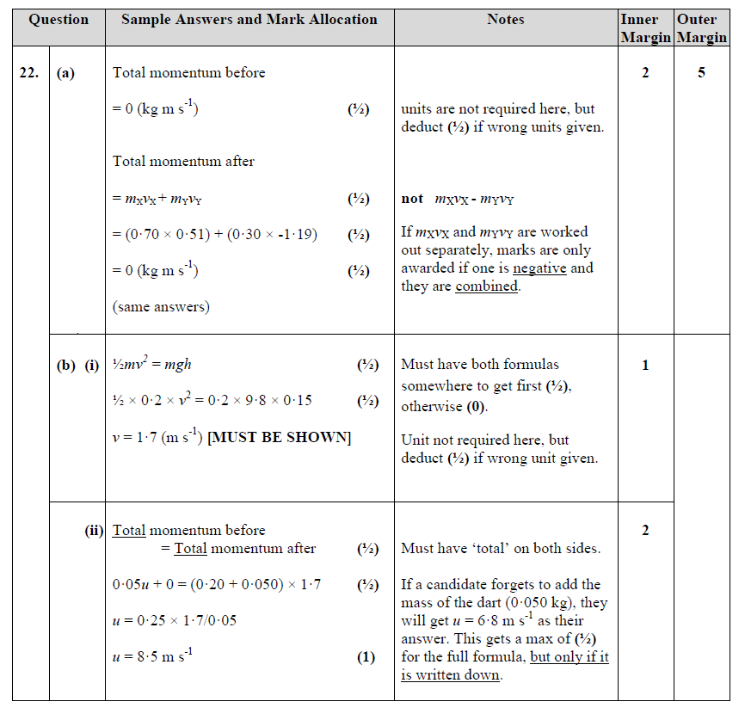

4. Gravitation

5. Special Relativity

6 The expanding Universe

(OPEN ENDED - SEE TEACHER!!)

