Guide for teachers and technicians.

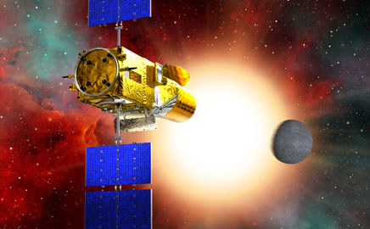

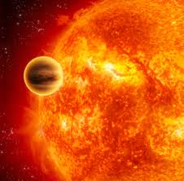

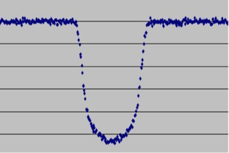



Higher Physics Topical Investigation Skin Cancer—Prevention and Cure

2

Investigation Brief
Suntan creams stop harmful UV radiation reaching the skin. Manufacturers’ products are rated with a Sun Protection Factor (SPF). Suntan creams can have SPF values from 6 to over 50.
UV radiation monitors normally measure irradiance in output intensity per unit area. Thus, a typical low intensity UV lamp may emit approximately 10 mWcm^{-2.}
The aim of this investigation is to determine the effect of various suntan creams on the transmission of UV radiation. In particular, the relationship between SPF and absorption should be found.

Investigation Notes
UV lamps can be harmful. Make sure that you read the safety leaflet which is supplied with the UV lamp. Some cheap UV monitors do not measure the irradiance of UV radiation. Rather, they give an indication of UV index. It is possible to undertake this investigation with such a monitor, but results will be less reliable and accurate. UV radiation does not pass through many transparent materials (including glass). However, UV transparent acrylics are readily available.
3

Exoplanets – detection and properties
Researching Physics

Higher

Introduction

The detection and properties of extrasolar planets (usually abbreviated to exoplanets) provides a wealth of study and investigative material making it very suitable as a topic for the Researching Physics Unit of Higher Physics.

The subject is very topical and there are regular updates and announcements of discoveries in the news media. Indeed, the subject is moving so quickly that it is unwise to state how many exoplanets have been discovered. The number changes almost daily! Of course, the most exciting discovery will be when an Earth-like planet is found. This may even have been achieved by the time this is being read.

Exoplanets are detected by indirect means. There are two main methods.
The gravitational tug of a planet causes the star it is orbiting to wobble. This wobble can be detected by observing the Doppler shift in the spectral lines of the light from the star. The sensitivity of measurement techniques is now so high that the relative motion of stars can be measured to within 1 ms⁻¹. (Comparing this to the speed of light gives an insight into the astounding sensitivity of measuring devices.)
The other indirect way of detecting exoplanets is to measure the change in apparent brightness of a star as a planet transits the star. This method can only be used to detect planets that have their orbit in the same plane as the light from the star travels to us. Approximately one in several hundred planets may have an orbital plane lined up in this way.

There are a number of websites which contain details of exoplanet detection methods. These include:
NASA Planet Quest http://planetquest.jpl.nasa.gov/overview/overview_index.cfm

BBC Science http://www.bbc.co.uk/science/space/universe/sights/extrasolar_planets

Wikipedia http://en.wikipedia.org/wiki/Extrasolar_planet

Model Orrery: http://kepler.nasa.gov/files/mws/LEGOorrery2011.pdf
Detection: http://www.sr.bham.ac.uk/~samuel/schools/Detection_exoplanet.pdf
http://astro.unl.edu/naap/esp/detection.html
Mass of Star/Luminosity/etc: http://cseligman.com/text/stars/mldiagram.htm
http://depts.clakamas.edu/haggart/whatsup/howweknow.htm
Habitable Zone: http://en.wikipedia.org/wiki/Effective_temperature http://www.astro.lsa.umich.edu/undergrad/Labs/extrasolar_planets/pn_intro.html http://www.dangermouse.net/gurps/science/temps.html

The Cosmic Perspective (Pearson International Edition) offers a good overview. (Expensive but very complete.)
The Investigations

Investigating exoplanets in a laboratory inevitably relies on models to simulate the detection and properties of exoplanets. The four suggested practical investigations each consider one aspect of the topic and seek to allow students to gain insights into the practical problems of astrophysics. The investigations are open-ended in as much as there is no one way to carry out the investigation and students will likely develop ideas which are different than those that have been tried out and discussed below. Teachers and technicians may need to advise students that an approach is not suitable because of equipment constraints.

Practical Activity 1

Wobbling Stars

This investigation explores the detection of exoplanets by observing the wobble caused by the gravitational tug of the exoplanet.

The aim of the investigation is to relate the point about which a star and planet orbit with the masses of the star and planet.

At first this may seem a somewhat trivial task because of course the star/planet system orbit around their centre of mass. However, this conclusion is less intuitive for students and it may not be obvious that the system does not need to be rotated in order to take relevant measurements.

Perhaps the most difficult part of this investigation is designing and building the model star/planet system. One possible system was constructed using a light dowel, approximately 30 cm long and suspended as shown using nylon fishing line.
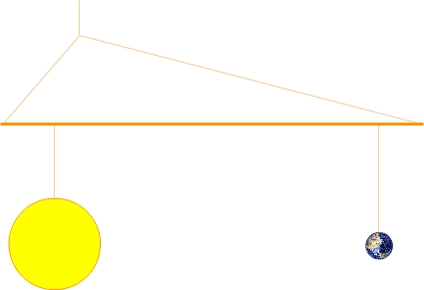

The star and planet were simply constructed from plasticene (of the appropriate colour of course).
The lines that suspend the star and planet should be free to slide along the dowel and it was found useful to cut small notches in the dowel to avoid unwanted and annoying collapsing of the system. Similarly, the single suspension point should be free to slide along the line which is connected to each end of the dowel.

Students should be able to relate the masses of the star and planet with the orbital distance of each from the point about which they orbit. It is tempting to conclude that planets of a certain mass will orbit at a particular distance from the star. This is not the case. The mass of a planet, at a particular orbital radius, causes the star to wobble at a distance from the point about which the star/planet orbit.

It is possible to video the rotation of the system, in the plane of the orbit and observe the wobble of the star. It is even possible to observe planetary transits and eclipses.

Students who complete the investigation may be challenged to work with two planets. Having established the “law” with one planet, they could predict the point about which the system rotates and confirm this experimentally.

Practical Activity 2

Stellar Brightness and the radius of an exoplanet

This investigation explores how the transit of a planet causes a decrease in the apparent brightness of a star.

The aim of the investigation is to use a model star and planets to find the relationship between the decrease in measured brightness and the radius of a planet placed in front of the star.

There are a number of ways of setting up a model star. One method is simply to cut a circular hole in a piece of black card. Translucent paper is stuck over the hole and this is illuminated from behind.

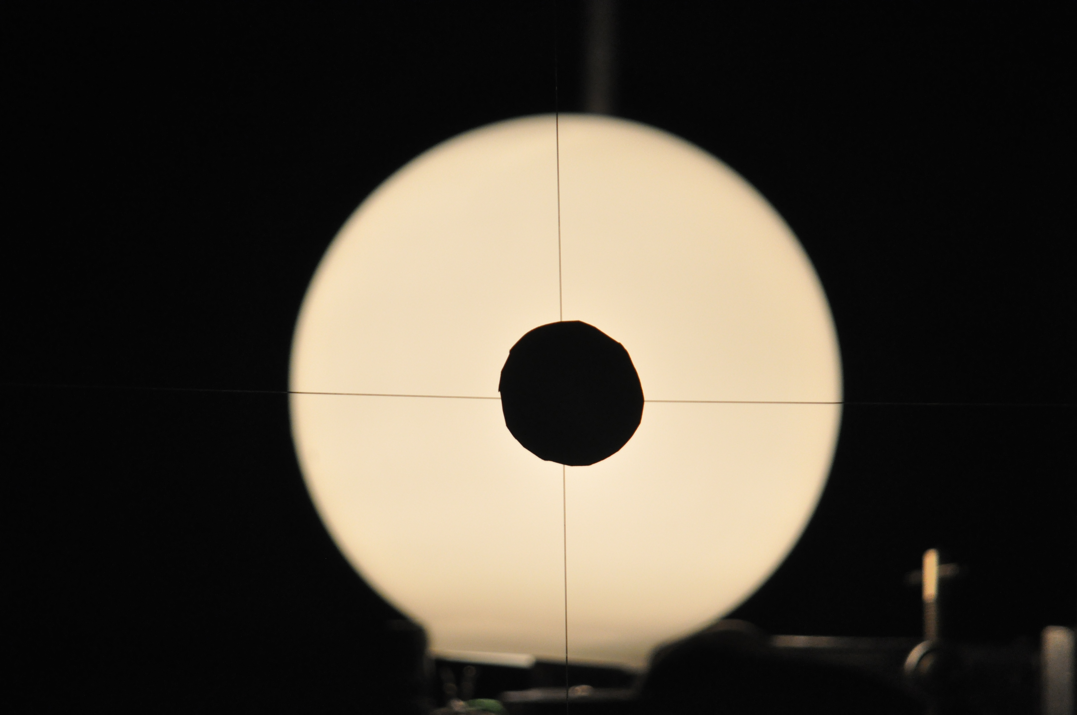

An alternative model is to use a bathroom lampshade to cover a 12V lamp. (Suitable lampshades are available from DIY stores and should cost under £10.)

The model planets can be simply cut out of card – although it is surprisingly difficult to cut “nice” circles using scissors. Students may devise other ways of making the planets. One group has used coins of various sizes.

The planets need to be suspended in front of the star. One method that works well is to make a cross wire from light nylon fishing line. The planets can be attached in the centre using blutak or equivalent.
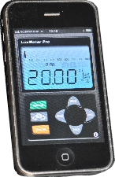

Any lightmeter which gives a numerical output can be used to measure the brightness of the star. If an iphone/itouch is available, a lightmeter app can be used. One suitable app is LuxMeter Pro (cost is 59p).

Students should plot their results on a graph and they may attempt to describe the relationship between the brightness of the star and the radius of the planet.
One possible way of stating the relationship is the expression:

Decrease in brightness = r²/R²

where the decrease in brightness is the relative decrease.

Practical Activity 3

Stellar Brightness and the transit of an exoplanet

This investigation explores how the transit of a planet causes a decrease in the apparent brightness of a star.

The aim of the investigation is to use a model star and planet to investigate how the apparent brightness of a star changes as an exoplanet transits in front of the star.

There are a number of ways of setting up a model star. One method is simply to cut a circular hole in a piece of black card. Translucent paper is stuck over the hole and this is illuminated from behind.
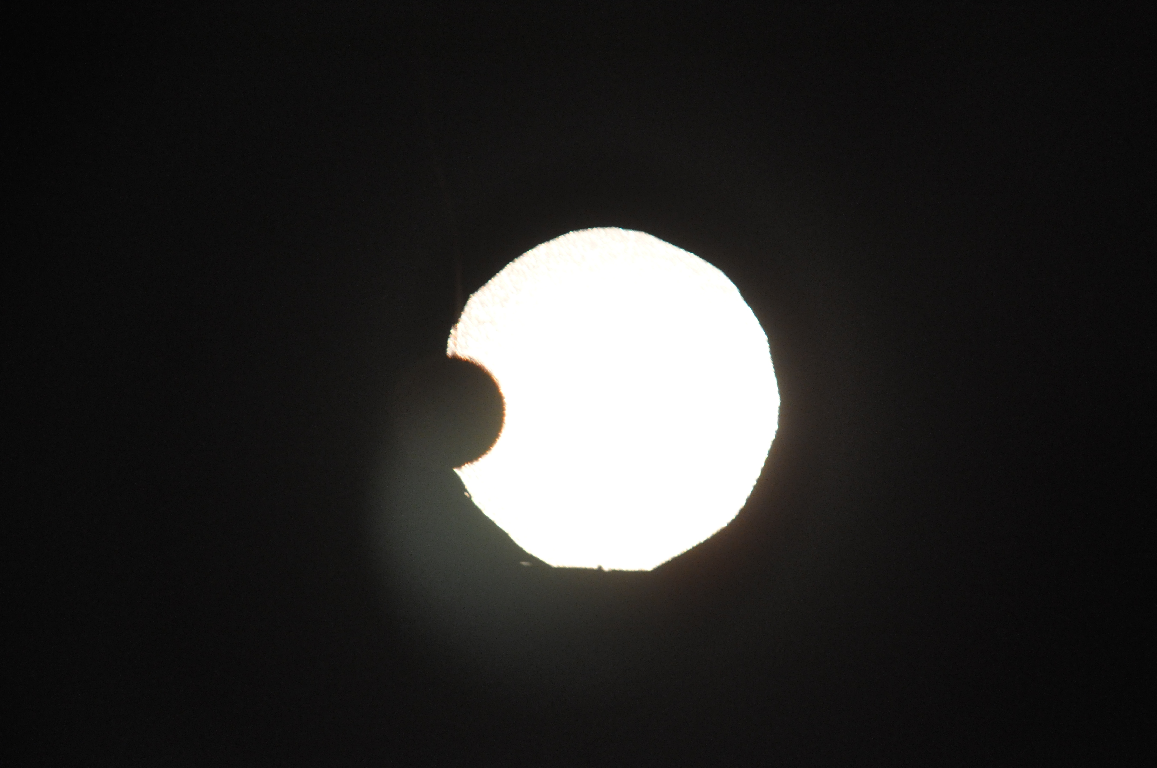

An alternative model is to use a bathroom lampshade to cover a 12V lamp. (Suitable lampshades are available from DIY stores and should cost under £10.)

The simplest solution to modelling the star/planet system is to use a stationary set up. The model planet can be simply cut out of card – although it is surprisingly difficult to cut “nice” circles using scissors. One possibility is to use a coin. The planet can then be suspended in front of the star and moved across the face of the star. One method that works well is to make a cross wire from light nylon fishing line. The planet can be attached in the centre using blutak or equivalent.

Any lightmeter which gives a numerical output can be used to measure the brightness of the star. If an iphone/itouch is available, a lightmeter app can be used. One suitable app is LuxMeter Pro (cost is 59p).

Students should plot their results on a graph and they may attempt to compare the shape of the graph when planets of different radii are used.

An alternative solution to modelling the system is to use a ball suspended on a conical pendulum rotating around a lamp. A globe lamp and cricket ball have been used successfully.
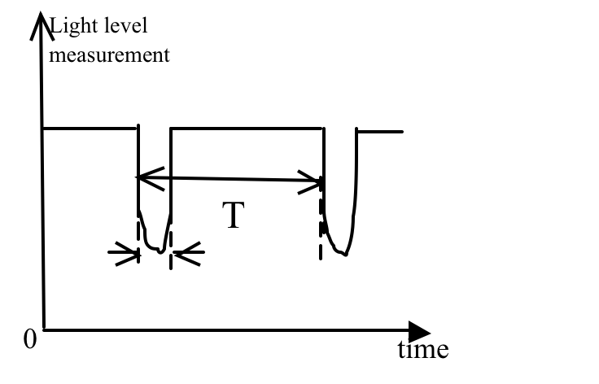
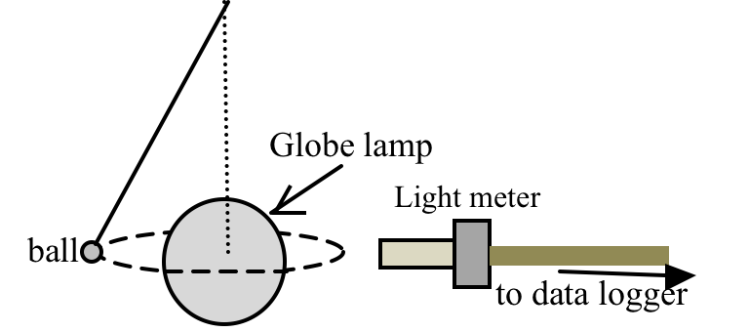

A light meter can be connected to a data logger to record light levels as the ball (planet) transits the lamp (star). The time, t, to transit the star and the time between transits,T, and the diameter of the star, D, allows the orbital radius, r, of the planet to be calculated.

2πr = D
T t
Astronomers deduce the diameter of the star by knowing the star’s classification. This is done by measuring its temperature (colour). Of course, in the investigation, the diameter of the “star” is a simple task of using a rule or measuring tape.

A further possibility is to video the transits and analyse the video file using software such as Tracker (free download). Tracker can be used to analyse the dip in light level in the images during the transits.

Practical Activity 4

The habitable zone and orbital radius (The Goldilocks Zone)

The aim of the investigation is to use a model star and planet to investigate how the temperature of a planet depends on the orbital distance from a star.

For this investigation, a star should be represented by a radiant heater. There are a variety in use in schools and a number have been tried and similar results obtained. A bunsen burner with a gauze covering the flame works reasonably well.
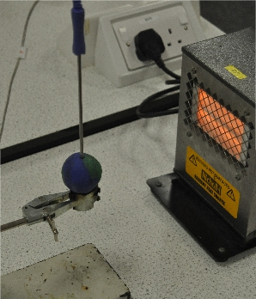
Almost anything can be used to represent a planet although a plasticene sphere (blue and green of course) is quite realistic.

Any temperature measuring device can be used. A probe which can be inserted into the planet works well.

It takes time for the temperature of the planet to stabilise at each distance from the radiant heater. One difficulty with this investigation is that it may require to be undertaken over a number of sessions. Students will need to consider how to ensure all other variables are controlled over the duration of the investigation.

Students should be discouraged from placing the planet too close to the heater. With the equipment used and shown in the picture, the plasticene started to melt at a distance of approximately 15 cm.

Students should plot their results on a graph and they may attempt to describe the relationship between the temperature of the planet and the orbital distance from the star. In trials, an inverse square law was found to hold.

Students may comment on how the results of the investigation give insights into the habitable zone for planetary orbits (the so called Goldilocks zone).

Teachers may wish to point out that there are other factors that determine the average temperature of a planet. Radioactive decay and tidal effects within the core can generate heat.

Equipment:

Radiant heater, 230 V, either 250 W, 300 W or 400 W. Suppliers include:

- Electrosound, Radiant Heater, 230 V, 400 W
- Nicholl, Radiant Heater, 230 V, 300 W
- Quartz Heat Lamp (230 V, 250 W, ES27 base) from Commercial Lamp Supplies costing £17.63. It is sometimes known as a ‘Pig Lamp’ as it can be used to warm piggeries. http://www.commercial-lamps.co.uk/acatalog/Quartz_heat_lamps.htm

