4. Our Dynamic Universe
ANSWERS

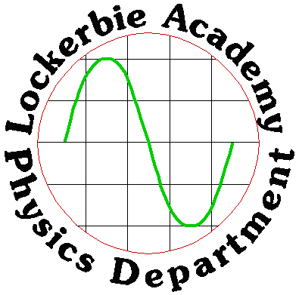

VECTORS/ TUTORIAL ANSWERS:

ANSWERS FOR TUTORIAL 1
1. X = RcosØ Y = RsinØ gives X = 20.616 cos 14.036o = 20
Y = 20.616 sin 14.036o = 5.09
The rectangular coordinates are (20, 5.09)
2. R2 = (X2 + Y2)
tanØ = Y/X gives R2 = 49.7372 + 40.2772 = 4096
R = 64
tanØ = 40.277 = 0.818 Ø = 39o
49.737
The distance from the origin is 64 units and it is at an angle of 39o to the X-axis.
3. The term polar coordinates refers to the position of a point given as the distance from the origin and the direction from the X-axis. It is customary to measure the angular component in the anti-clockwise direction. e.g.
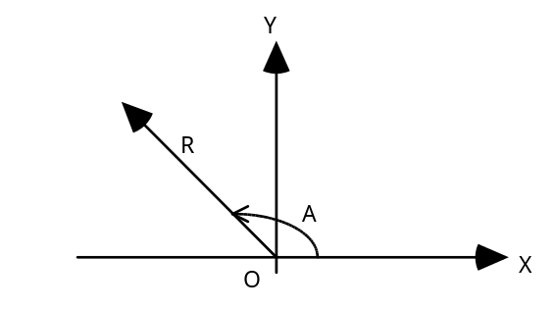
(a) (100,36.87o) gives X = 100 cos36.87o = 80 Y = 100 sin36.87o = 60
The rectangular coordinates are (80,60)
(b) (26.93, 68.2o) = (10,25)
(c) (45.34, 41.42o) = (34,30)
N.B. Some calculators perform this transformation using buttons labelled Rec-Pol and Pol-Rec.
4. R2 = X2 + Y2, which gives us: -

The pipe is 6m long at an angle of 20o to the longer wall.
5. Parallelogram.

ANSWERS FOR TUTORIAL 2

1. The only measurements on the list that are vector quantities are acceleration, force and momentum, (don’t worry about momentum you haven’t been taught about it yet!)

2.
60º
10N
10N
10N
60º
10N
60º
10N

R measures 17.3 N θ measures 30º
θº
10N
60º
R

Adding coordinates:
We usually take the horizontal line across the page as our x-axis and, if it is convenient, as it is in this case, we line up one of the vectors with it.
60º
10N
10N
i

60º
10N
10N
ii

i) We start with the vectors arranged in no particular way.
ii) Our new diagram rotates the vectors to a more useful position.
iii) We can now put the vectors into their rectangular coordinates.
X= 10 cos 60 = 5
60º
10N
10N
8.66N
5N
Y=10 sin 60 = 8.66
The sum of the coordinates is X= 10 + 5 = 15N
The sum of the Y coordinates is Y= 0 + 8.66 = 8.66N
The resultant is (15N, 8.66N)
x-axis

Converting this to polar coordinates gives us (17.32N, 30º) where the angular part is measured from the direction of whichever vector we chose as the X direction.
14N
70º
14N

2. Scale diagrams
Follow the steps for question one.

14N
R measures 22.9N θ measures 35º
14N

R
Adding coordinates
Taking the bottom force direction as our X-axis, and finding the rectangular components of the top force gives us:
θº
70º

X= 14 cos 70 = 4.8N
70º
14N
14N
13.2N
4.8N
x-axis
Y=14 sin 70 = 13.2N
The sum of the coordinates is X= 14 + 4.8 = 18.8N
The sum of the Y coordinates is Y= 0 + 13.2 = 13.2N
The resultant is (18.8N, 13.2N)
Converting this to polar coordinates gives us (22.9N, 35º) where the angular part is measured from the direction of whichever vector we chose as the X direction.
4.

R measures 9.4ms ^{– 1} θ measures 20⁰
5 ms ⁻¹
θ
40º
5 ms ⁻ ¹
R

Adding coordinates:
40º
5 ms ^{–1}

boat
5 ms ^{–1}

wind
x
Y
Resultant (0 + 5cos50, 5 + 5sin50) =(3.2, 8.8)
Polar coordinates = (9.4 ms⁻¹ , 70º )

5. (a) A scale drawing which looks like the one below, gives the resultant R as 4.6m at an angle of 27.2o

(b) A similar drawing to the above gives us R as 18.5m at 27.2o

(c) If one pair of vectors is a simple multiple of another pair, then their resultants will be the same multiple of each other.
6. (a) 4m from speed = distance ÷ time
distance = speed x time d = 2 x 2 = 4m
(b) 16m from speed = distance ÷ time
distance = speed x time d = 8 x 2 = 16m
(c) A scale diagram gives R as 16.5m at 14o to the side of the deck.

(d) Since velocity = displacement
time
We have it as 8.25ms-1 at 14o to the deck’s side, as shown here: -

7.(a) component Y of the tension is Y= 6.3 x 10 ^{–5} x sin 11.5
Y= 1.25 x 10 ^{–5} N
(b) The weight of the spider is supported by the tension in the strand of the web it is clinging to. Since the spider is in a balanced position, then its weight must equal the total verticla component of the tensions. The spider weighs 2.5x10-5N as there are two Y components to support the weight.
8. 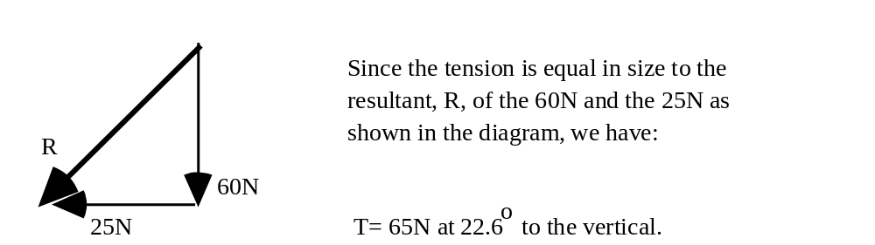

9. By scale drawings.
R measures 11.6m, θ measures 56º
6m48.7cm
9m61.7cm
θ
R
Coordinates
R = (6.487 + 0, 0 + 9.617) = (6.487, 9.617)
Polar coordinates = (11.6m, 56º)
As the vectors are at right angles Pythagoras can be used
R² = X² + Y²
R² = 6.487² + 9.617²
R² = 134.58 R = 11.6 m tanθ = Y/X , θ =56º

10.

R measures 7.2m, θ measures 30º

Coordinates
6m23.5cm
3m60cm
R
θ
R = (6.235 + 0, 0 + 3.60) = (6.235, 3.60)
Polar coordinates = (7.2m, 30º)
Pythagoras:
R² = X² + Y²
R² = 6.235² + 3.60²
R² = 51.9
R = 7.2 m tanθ = Y/X , θ = 30º

11. Scale drawing:

R measures 5.6 ms ^{– 1} θ measures 26º
5º
50 cms⁻¹
2 ms⁻¹
5 ms⁻¹
R

Coordinates
5º
50 cms⁻¹
2 ms⁻¹
5 ms⁻¹

Resultant = (5 + 0 + 0.5 cos85, 0 + 2 + 0.5 sin85) = (5.04, 2.5)
Polar coordinates = (5.6, 26º)
As there are three vectors and they are not all at right angles this problem cannot be tackled using Pythagoras.

12. Visualise the problem clearly:

16.9 ms ^{–1}
90 ms ^{–1}
78º
R
Start as if we know everything we need:

velocity = displacement ⇒ R = displacement
time 25min

but we don’t know R:
We can find R by scale diagram or by using coordinates.

R = (0 + (-16.9cos12), 90 + 16 sin12) = (-16.53, 93.51)
Polar coordinates = (94.96, 80º)
R = displacement
25min
95 = displacement
25 x 60
displacement = 95 x 25 x 60 = 142500m = 142.5km

13.
If the boat is to be held stationary, then the resultant of the three forces must be zero. The third force must therefore run from the head of the 6N force back to the tail of the 12N force. This is just the opposite vector to the one we get by adding the 12N and the 6N forces.
30º
12N
boat
6N
third force
30º
12N
boat
6N
Take note of the minus signs:
third force = - (12 + 6sin30, 0 + 6cos30)
= - (15, 5.12)
= (-15, -5.12)
Polar coordinates (15.87, -161º)

For this type of question you can also use the sine and cosine rules.

ANSWERS FOR TUTORIAL 3
1.

Pythagoras' theorem gives us
X2 + (9.2)2 = (10.5)2
Thus X = 5.1 The bricklayer lays a second line 5.1m long.

2. The resultant velocity of the fly is 3.5cms-1 downwards and it has 17.5cm to move for which it takes 5s. During this time the rope is raised a height of (14.5 x 5)cm = 72cm
Thus the fly runs out of rope and falls off the end.

3. Displacement is distance travelled in a stright line from the refernce point. Displacement is a vector quantity and must therefore have a direction. You ought to know that this makes up a 3,4, 5 triangle, (work this out by Pythagoras) so the displacement is 5km east. The distance is a scalar quantity and indicates how far the object has travelled. The plane has travelled 3km and then a further 4km = 7km.
Answer E is correct.
4. Using rectangular and polar coordinates
the horizontal is R cos 50, the vertical is R sin 50
or using the other angle given:
the horizontal is R sin 40, the vertical is R cos 40,
sin 40 = cos 50 or cos (90-40) etc.
Check this with your teacher if you are unsure of this.

Therefore E is the correct answer.

5. This is a typical higher question. There is far more information than is necessary to work out the answer. Use your gut feelings.
Remember from N5 that E_{p} = mgh = Wh, where h is the vertical height.
W = 800N, h = 5 sin20, therefore A is the correct answer.

6. The resultant force acting on the barge is supplied by whatever fraction of the cable force is acting down the North South line. The component of a cable’s force acting along the north south line is seen from the diagram to be 100000 cos26 = 2 x 10⁴ N
As there are two cables each providing this force the total force is twice this value = 1.8 x 10⁵ N

VECTORS/ TUTORIAL ANSWERS:

ANSWERS FOR TUTORIAL 1
1. X = RcosØ Y = RsinØ gives X = 20.616 cos 14.036o = 20
Y = 20.616 sin 14.036o = 5.09 The rectangular coordinates are (20, 5.09)

2. R2 = (X2 + Y2)
tanØ = Y/X gives R2 = 49.7372 + 40.2772 = 4096
R = 64
tanØ = 40.277
49.737 = 0.818
Thus Ø = 39o
The distance from the origin is 64 units and it is at an angle of 39o to the X-axis.

3. The term polar coordinates refers to the position of a point given as the distance from the origin and the direction from the X-axis. It is customary to measure the angular component in the anti-clockwise direction. e.g.

(a) (100,36.87o) gives X = 100 cos36.87o
= 80
Y = 100 sin36.87o
= 60
The rectangular coordinates are (80,60)
(b) (26.93, 68.2o) = (10,25)
(c) (45.34, 41.42o) = (34,30)

N.B. Some calculators perform this transformation using buttons labelled R-P and P-R. Ask your teacher to show you if you are unsure.

4. R2 = X2 + Y2, which gives us: -

The pipe is 6m long at an angle of 20o to the longer wall.
5. Parallelogram.

ANSWERS FOR TUTORIAL 2
1. The only measurements on the list that are vector quantities are acceleration, force and momentum, (don’t worry about momentum you haven’t been taught about it yet!)

2.
60º
60º
10N
10N

10N
10N
60º

10N
10N
R measures 17.3 N θ measures 30º
θº
60º

R

Adding coordinates:
We usually take the horizontal line across the page as our x-axis and, if it is convenient, as it is in this case, we line up one of the vectors with it.
60º
60º
10N
10N

10N
10N
i
ii

i) We start with the vectors arranged in no particular way.
ii) Our new diagram rotates the vectors to a more useful position.
iii) We can now put the vectors into their rectangular coordinates.

X= 10 cos 60 = 5
60º
10N

10N
8.66N
5N
x-axis
Y=10 sin 60 = 8.66
The sum of the coordinates is X= 10 + 5 = 15N
The sum of the Y coordinates is Y= 0 + 8.66 = 8.66N
The resultant is (15N, 8.66N)
Converting this to polar coordinates gives us (17.32N, 30º) where the angular part is measured from the direction of whichever vector we chose as the X direction.

2. Scale diagrams
Follow the steps for question one.
R measures 22.9N θ measures 35º
14N
14N

R
Adding coordinates
θº
70º

70º

14N
14N
Taking the bottom force direction as our X-axis, and finding the rectangular components of the top force gives us:
70º
14N

14N
13.2N
4.8N
x-axis

X= 14 cos 70 = 4.8N
Y=14 sin 70 = 13.2N
The sum of the coordinates is X= 14 + 4.8 = 18.8N
The sum of the Y coordinates is Y= 0 + 13.2 = 13.2N
The resultant is (18.8N, 13.2N)
Converting this to polar coordinates gives us (22.9N, 35º) where the angular part is measured from the direction of whichever vector we chose as the X direction.

4.
5 ms ⁻¹
θ
40º
5 ms ⁻ ¹
R

R measures 9.4ms ^{– 1} θ measures 20⁰

40º
5 ms ^{–1}

boat
5 ms ^{–1}

wind
x
Y
Adding coordinates:

Resultant (0 + 5cos50, 5 + 5sin50) =(3.2, 8.8)

Polar coordinates = (9.4 ms⁻¹ , 70º )

5. (a) A scale drawing which looks like the one below, gives the resultant R as 4.6m at an angle of 27.2o

(b) A similar drawing to the above gives us R as 18.5m at 27.2o

(c) If one pair of vectors is a simple multiple of another pair, then their resultants will be the same multiple of each other.

6. (a) 4m from speed = distance ÷ time
distance = speed x time
d = 2 x 2 = 4m
(b) 16m from speed = distance ÷ time
distance = speed x time
d = 8 x 2 = 16m
(c) A scale diagram gives R as 16.5m at 14o to the side of the deck.

(d) Since velocity = displacement
time
We have it as 8.25ms-1 at 14o to the deck’s side, as shown here: -

7.(a) component Y of the tension is Y= 6.3 x 10 ^{–5} x sin 11.5
Y= 1.25 x 10 ^{–5} N
(b) The weight of the spider is supported by the tension in the strand of the web it is clinging to. Since the spider is in a balanced position, then its weight must equal the total verticla component of the tensions. The
spider weighs 2.5x10-5N as there are two Y components to support the weight.
8.

9. By scale drawings.

θ
R

6m48.7cm

9m61.7cm

R measures 11.6m, θ measures 56º

Coordinates
R = (6.487 + 0, 0 + 9.617) = (6.487, 9.617)
Polar coordinates = (11.6m, 56º)

As the vectors are at right angles Pythagoras can be used

R² = X² + Y²
R² = 6.487² + 9.617²
R² = 134.58 R = 11.6 m tanθ = Y/X , θ =56º

10.
6m23.5cm
θ
R
3m60cm
R measures 7.2m, θ measures 30º

Coordinates
R = (6.235 + 0, 0 + 3.60) = (6.235, 3.60)
Polar coordinates = (7.2m, 30º)

Pythagoras:
R² = X² + Y²
R² = 6.235² + 3.60²
R² = 51.9
R = 7.2 m tanθ = Y/X , θ = 30º

11. Scale drawing:

R measures 5.6 ms ^{– 1} θ measures 26º
5º
50 cms⁻¹
2 ms⁻¹
5 ms⁻¹
R

Coordinates

5º
50 cms⁻¹
2 ms⁻¹
5 ms⁻¹

Resultant = (5 + 0 + 0.5 cos85, 0 + 2 + 0.5 sin85) = (5.04, 2.5)

Polar coordinates = (5.6, 26º)

As there are three vectors and they are not all at right angles this problem cannot be tackled using Pythagoras.

12. Visualise the problem clearly:

16.9 ms ^{–1}
90 ms ^{–1}
78º
R

Start as if we know everything we need:

velocity = displacement ⇒ R = displacement
time 25min

but we don’t know R:
We can find R by scale diagram or by using coordinates.

R = (0 + (-16.9cos12), 90 + 16 sin12) = (-16.53, 93.51)
Polar coordinates = (94.96, 80º)

R = displacement
25min
95 = displacement
25 x 60
displacement = 95 x 25 x 60 = 142500m = 142.5km

13.
30º
12N
boat
6N

If the boatis to be held stationary, then the resultant of the three forces must be zero. The third force must therefore run from the head of the 6N force back to the tail of the 12N force. This is just the opposite vector to the one we get by adding the 12N and the 6N forces.

third force
30º
12N
boat
6N

Take note of the minus signs:

third force = - (12 + 6sin30, 0 + 6cos30)
= - (15, 5.12)
= (-15, -5.12)
Polar coordinates (15.87, -161º)

For this type of question you can also use the sine and cosine rules.

ANSWERS FOR TUTORIAL 3
1.

Pythagoras' theorem gives us
X2 + (9.2)2 = (10.5)2
Thus X = 5.1
The bricklayer lays a second line 5.1m long.

2. The resultant velocity of the fly is 3.5cms-1 downwards and it has 17.5cm to move for which it takes 5s. During this time the rope is raised a height of (14.5 x 5)cm = 72cm

Thus the fly runs out of rope and falls off the end.

3. Displacement is distance travelled in a stright line from the refernce point. Displacement is a vector quantity and must therefore have a direction. You ought to know that this makes up a 3,4, 5 triangle, (work this out by Pythagoras) so the displacement is 5km east. The distance is a scalar quantity and indicates how far the object has travelled. The plane has travelled 3km and then a further 4km = 7km.

Answer E is correct.

4. Using rectangular and polar coordinates
the horizontal is R cos 50, the vertical is R sin 50

or using the other angle given:
the horizontal is R sin 40, the vertical is R cos 40,

sin 40 = cos 50 or cos (90-40) etc.
Check this with your teacher if you are unsure of this.

Therefore E is the correct answer.

5. This is a typical higher question. There is far more information than is necessary to work out the answer. Use your gut feelings.

Remember from SG or Int I & II that E_{p} = mgh = Wh, where h is the vertical height.

W = 800N, h = 5 sin20, therefore A is the correct answer.

6. The resultant force acting on the barge is supplied by whatever fraction of the cable force is acting down the North South line. The component of a cable’s force acting along the north south line is seen from the diagram to be 100000 cos26 = 2 x 10⁴ N

As there are two cables each providing this force the total force is twice this value = 1.8 x 10⁵ N

Worked Answers
By scale diagram:
60º
θ
10 N
10 N
R
R is 17.6 N and θ is 30º.

By calculating resultant vectors:
(assume x to be positive from left to right and y to be positive from bottom to top throughout these answers)
60º
10 N
10 N
X
Y
Resolve horizontally:
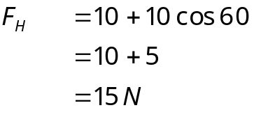
Resolve vertically:
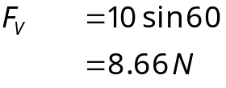

R
8.66 N
15 N
θ
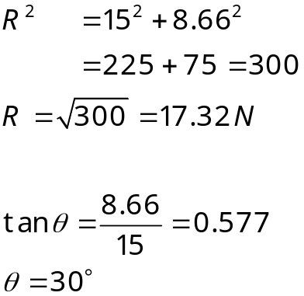

By scale diagram:
70º
θ
14 N
14 N
R
R is 22.9 N and θ is 35º.

By calculating resultant vectors:
Resolve horizontally:
70º
14 N
14 N
X
Y
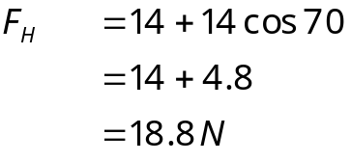
Resolve vertically:
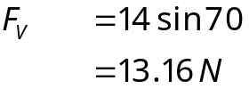

R
13.16 N
18.8 N
θ
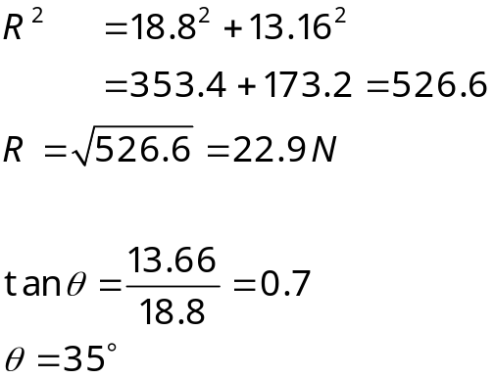
By scale diagram:
34º
4 N
6 N
R
R is 7.2 N

By calculating resultant vectors:
The vectors are already perpendicular so we don’t need to calculate the components.
R
6 N
4 N
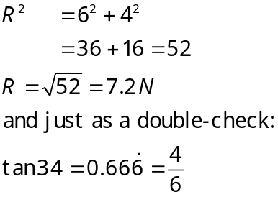

By scale diagram:

R is 9.4 m s⁻¹ and θ is 20º.
40º
θ
5 m s⁻¹
5 m s⁻¹
R
By calculating resultant vectors:
Resolve horizontally:
40º
5 m s⁻¹
X
Y
5 m s⁻¹
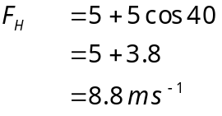
Resolve vertically:
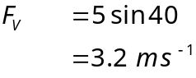
R
3.2 m s⁻¹¹
8.8 m s⁻¹
θ

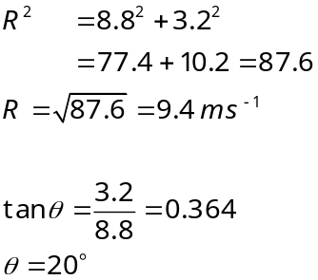

By scale diagram:
θ
4.5 N
9 N
R
3 N
R is 7.5 N, θ is 53º north of east.

By calculating resultant vectors:
4.5 N
X
Y
9 N
3 N
Resolve horizontally:
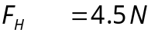
Resolve vertically:
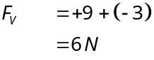
R
6 N
4.5 N
θ

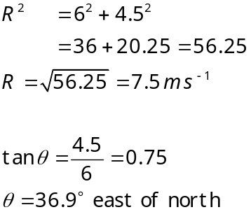
NB. Note the different ways we have expressed the angles here.

By scale diagram:
45º
θ
2 m
3 m
R

R is 4.6 m and θ is 27º.
By calculating resultant vectors:
Resolve horizontally:
45º
2 m
X
Y
3 m
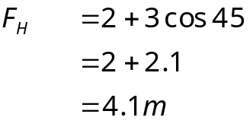
Resolve vertically:
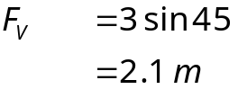
R
2.1 m
4.1 m
θ

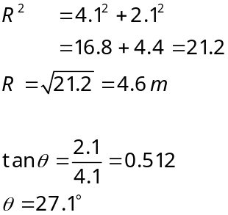

By scale diagram:
45º
θ
8 m
12 m
R

R is 18.4 m and θ is 27º.
By calculating resultant vectors:
Resolve horizontally:
45º
8 m
X
Y
12 m
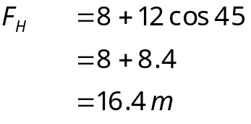
Resolve vertically:
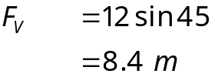

R
8.4 m
16.4 m
θ
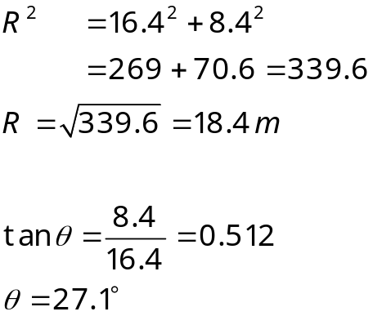

  - If one pair of vectors is a simple multiple of another pair, then their resultants will be the same multiple of each other.

- By scale diagram:
R
9.617 m
6.487 m
R (the least distance) is 11.6 m.
By calculating resultant vectors:
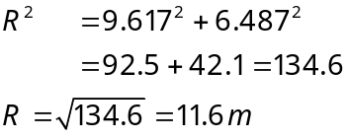

6.487 m
9.617 m
R
By scale diagram:
R is 7.2 m.
6.235 m
3.60 m
R
By calculating resultant vectors:

R
3.60 m
6.235 m
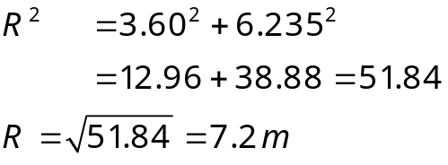
- By scale diagram:
R is 5.6 m s⁻¹ and θ is 23º.
5º
R
θ
5 m s⁻¹
2 m s⁻¹
0.5 m s⁻¹
By calculating resultant vectors:
5º
Y
Resolve horizontally:
5 m s⁻¹
X
2 m s⁻¹
0.5 m s⁻¹
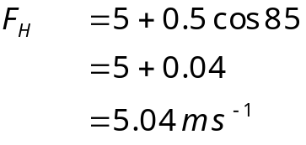
Resolve vertically:
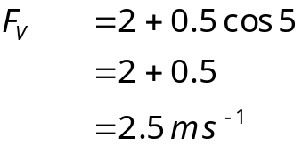

R
2.5 m s⁻¹
5.04 m s⁻¹
θ
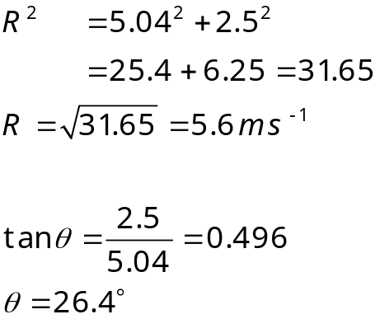

- By scale diagram:
78º
16.9 m s⁻¹
90 m s⁻¹
R

R is 95 m s⁻¹. Since it takes 25 minutes the total distance is given by .
By calculating resultant vectors:
Resolve horizontally:
78º
16.9 m s⁻¹
X
Y
90 m s⁻¹
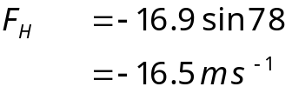
Resolve vertically:
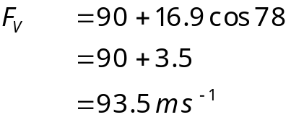
R
16.5 m s⁻¹
93.5 m s⁻¹

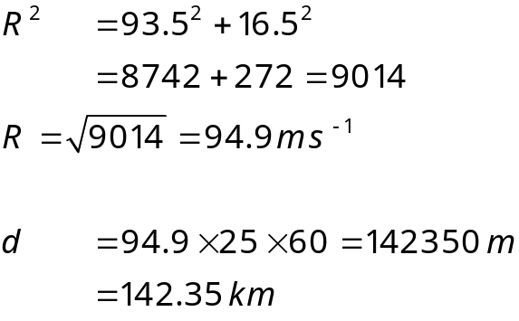
- By scale diagram:
60º
3 m s⁻¹
5 m s⁻¹
R
20º

R is 6.3 m s⁻¹. As the distance covered is 56.36 m the time taken is given by 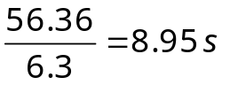
By calculating resultant vectors:
Resolve horizontally:
20º
3 m s⁻¹
X
Y
5 m s⁻¹
60º
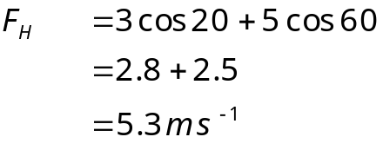
Resolve vertically:
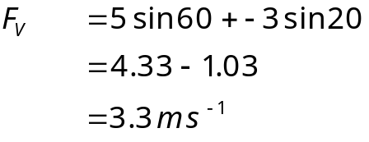

R
3.3 m s⁻¹
5.3 m s⁻¹

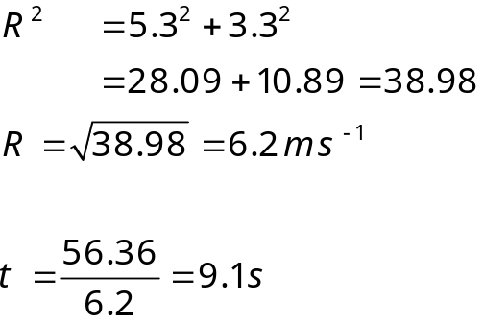
- By scale diagram:
8 m s⁻¹
2 m s⁻¹
R
θ

R is 8.2 m s⁻¹ and θ is 14º.
By calculating resultant vectors:

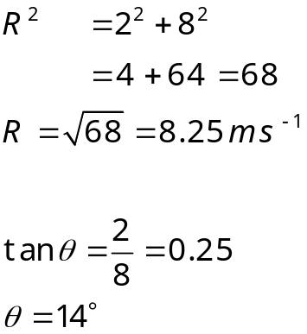
R
2 m s¹⁻
8 m s⁻¹
θ

  - Velocity across the deck = 2 m s⁻¹. 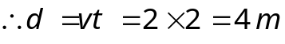

  - Velocity of the ferry = 8 m s⁻¹. 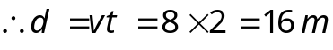

  - Resultant velocity = 8.25 m s⁻¹. .

  - 8.25 m s⁻¹ at 14º to the deckside.

EQUATIONS OF MOTION / ANSWERS

ANSWERS TO TUTORIAL 1

1. a = (v – u) / t
Acceleration = (27ms-1 - 15ms-1) / 8s
= 12ms-1 / 8s
= 1.5ms-2

2. Let its new velocity be v ms-1. Using this in the definition of acceleration gives us:
a = (v – u) / t
20 = v - 2
0.5
Thus 20 x 0.5 = v - 2
and so v = 10 + 2
= 12
Its new velocity is 12ms-1.

3. a = (v – u) / t
15 = 30 - 0
t
Thus t = 2

The sportscar takes 2s to reach 30ms-1.

ANSWERS TO TUTORIAL 2

1. (a) This is half-way between the initial and final velocities and is 15ms-1.
(b) At half time, which is 4s
(c) The area under the graph from zero to 4s is
10x4m + 0.5x4x(15-10) m
= 40m + 10m
= 50m
(d) Area under the graph = 10x8m + 0.5x8x(20-10)
= 80m + 40m
= 120m
(e)
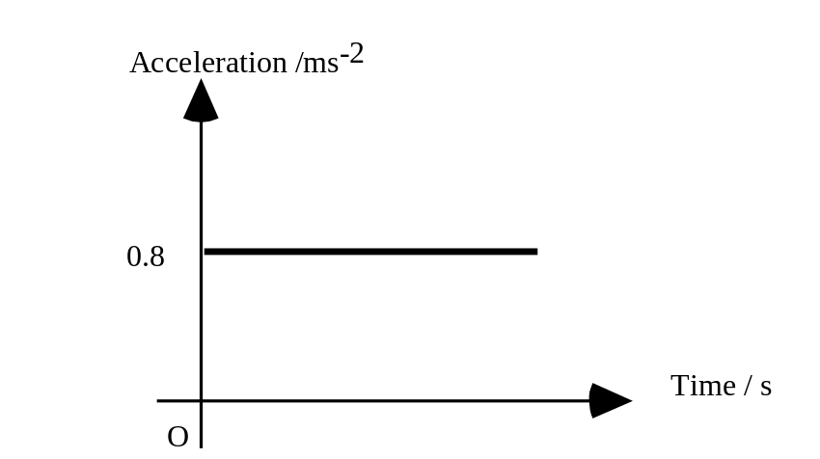

2. (a) The velocity increases steadily and then changes to a greater rate of increase, i.e. constant acceleration followed by a greater constant acceleration.
(b)

3. It is a steadily increasing acceleration since the velocity increases by 25ms-1, then 30ms-1, etc.

4. (a) At the origin.
(b) At 20s and again near 30s. You are looking for a gradient of zero, i.e. a horizontal line.
5.
time
velocity ms ^{–1}

6.
displacement (m) | 0 | 0.2 | 0.8 | 1.8 | 3.2 | 5.0
time (s) | 0 | 0.1 | 0.2 | 0.3 | 0.4 | 0.5

The displacement measurements are added together to get the displacement from the start.
e.g. t = 0.1, s = 0.2
t = 0.2, s = 0.2 + 0.6 = 0.8
t = 0.3, s = 0.2 + 0.6 + 1.0 = 1.8
t = 0.4, s = 0.2 + 0.6 + 1.0 +1.4 = 3.2
t = 0.5, s = 0.2 + 0.6 + 1.0 +1.4 + 1.8 = 5.0

6 b) These results show constant acceleration. You can tell this as the displacement results measured from the start are increasing by a different amount with each time period

ANSWERS TO TUTORIAL 3

1. a = v - u u = 5cm / 0.1s = 50cms-1
t v = 8cm / 0.02s = 400cms-1
t = 0.5s
Thus a = 400 - 50
0.5
= 700
The acceleration is 700 cms-2

2. (a) The object's average velocity is half way between 24ms-1 and zero. It is 12ms-1.
(b) It takes 8s to cover 96m at an average of 12ms-1.
(c) a = (0 - 24)/8 = -3
The deceleration is 3ms-2

3. (a) A 1Hz flash will show the object's position at one second intervals.
Displacement is the product of the object's average velocity during the interval and the duration of the interval.
Thus :-
 | Initial | Final | Average
Interval | vel. /cms-1 | vel. /cms-1 | vel. /cms-1 | Length / cm
1 | 0 | 3 | 1.5 | 1.5
2 | 3 | 6 | 4.5 | 4.5
3 | 6 | 9 | 7.5 | 7.5
4 | 9 | 12 | 10.5 | 10.5
5 | 12 | 15 | 13.5 | 13.5
6 | 15 | 18 | 16.5 | 16.5

(b) The figures quoted are displacements from the start.
After 1 second ------ 1.5cm
After 2 seconds------1.5cm + 4.5cm = 6cm
After 3 seconds ------1.5cm + 4.5cm + 7.5cm = 13.5cm

4. The Y-axis shows the velocity of the falling object which will increase steeply to begin with but level off as the air drag increases.

5. This is a very common examination type question. The important features to look out for are:

i) Starting velocity, in this question the ball is likely to have zero initial velocity.

ii) A constant gradient put your ruler up against the lines. This gradient represents falling under gravity. It should therefore be constant.

iii) The bounce should cause a rapid change of direction and hence change of velocity.

Iv) In this question the initial velocity and the gradient should have the same sign as they are in the same direction.

v) After the bounce if the collision is inelastic energy will be lost and the velocity after the bounce will be less than that before the bounce.

The answer is D.

6. You need to do the calculation error ÷ reading whichever is the biggest has the largest percentage error. In this question there is no point in working out C1, length of card, or the distance, as C1 is the same error as C2 but has a larger value. Remember the larger the reading the smaller the percentage error.

The answer is B.

7.

Vector | a | P | v | displacement | F
Scalar | E_{w} | E_{p} | E_{H} | distance | mass | E_{K} | t | speed

The answer is C.

8. Another common examination type question. It is best to familiarise yourself with these graphs.

The answer is D.

It cannot be A, B, or C as the velocity time graph is NOT the gradient of the displacement time graph given. E is incorrect as the displacement is gradually getting less, which indicates a negative gradient.

9. Carefully look at the question and graph and go through in your head what the graph represents. Between 0 and P, the trolley is accelerating, this corresponds to the initial push up the slope. Between P and Q the trolley is decelerating up the slope, i.e. in the same direction. At Q the trolley’s velocity goes from 0 to –1.5 ms⁻¹ this represents the trolley rolling back down the slope.

The maximum displacement of the trolley is at 2 seconds.

b) For 0 to P a = (v – u) / t = (3-0)/1 = 3
For P to Q a = (v – u) / t = (0-3)/2 = 1.5

For Q to R a = (v – u) / t =(-1.5-0)/5.25 = -0.67
-0.67
-1.5
Acceleration / ms ⁻ ²
R
Q
0
P
3

10a) We find the total distance by adding up the distances travelled during each period of the cat's motion. This is calculated by using its average speed during each period.
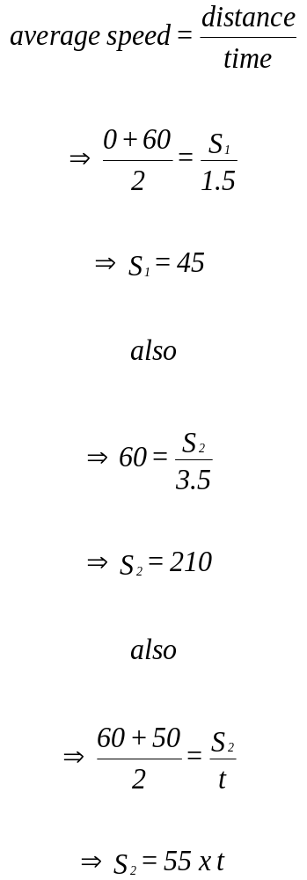

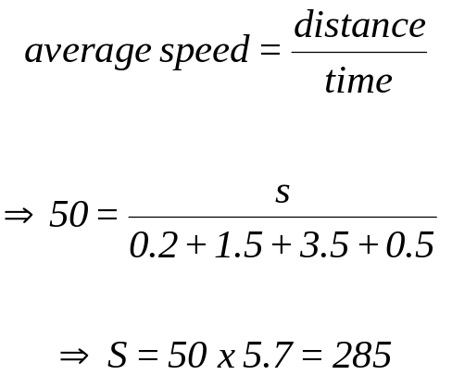b) The cockroach travels at constant speed and so:-
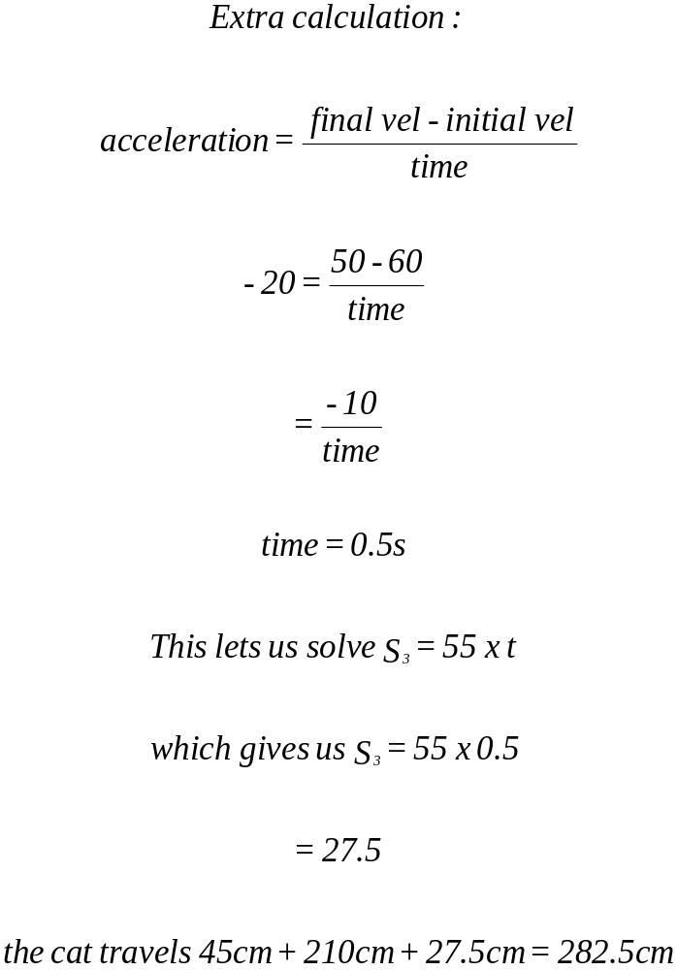

The cockroach travels 285cm while the cat travels 282.5cm, so the cockroach is 2.5cm in front when the cat hits the door.

0.2 1.7 5.2 5.7
acceleration
+40
-20

10c).

ANSWERS TO TUTORIAL 4
1. (a)
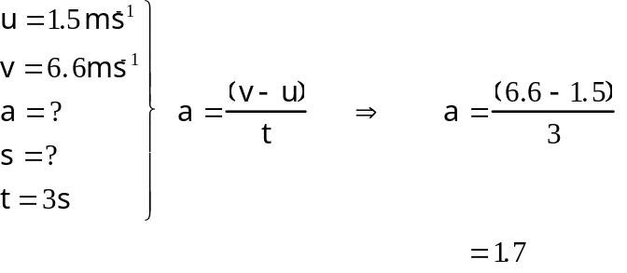
The acceleration is 1.7ms-2
(b)
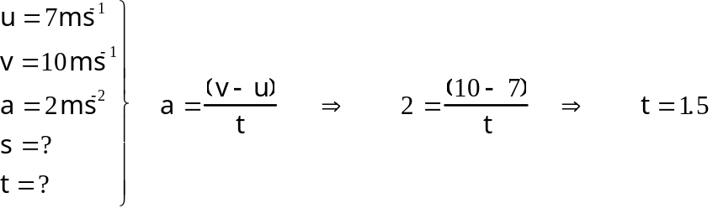
It takes 1.5 seconds

2.
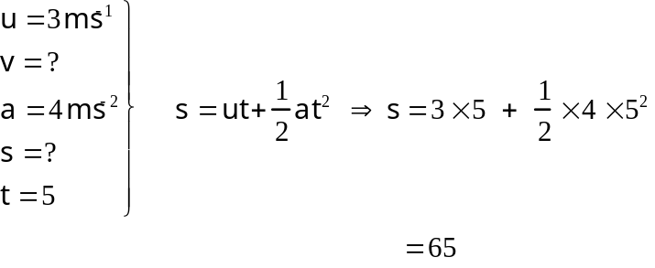
She slides 65m

3.
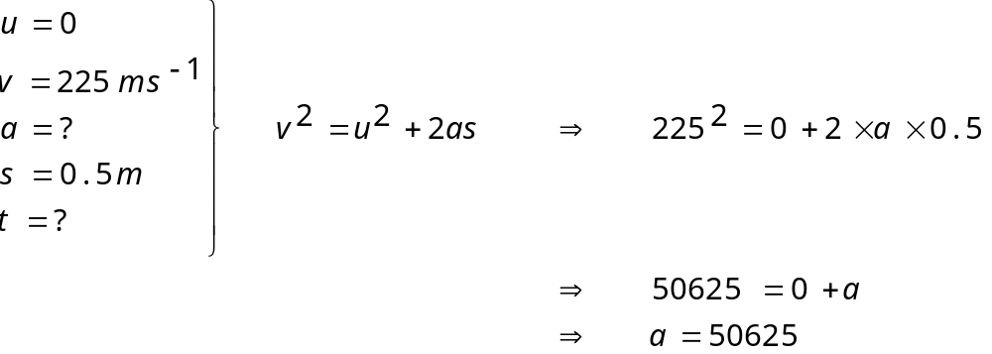
The pellet accelerates at 50625ms-2

4.
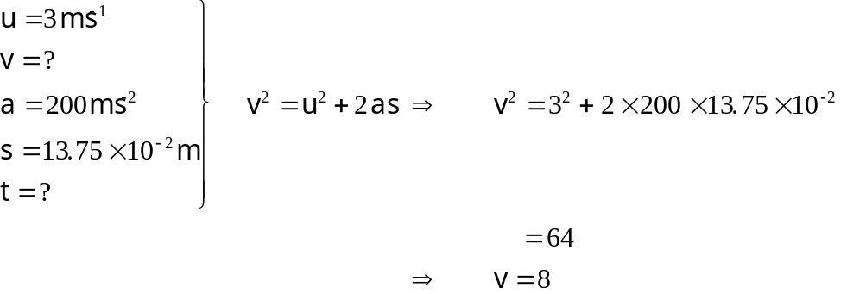

The ball is moving at 8ms-1 after the kick.

5.
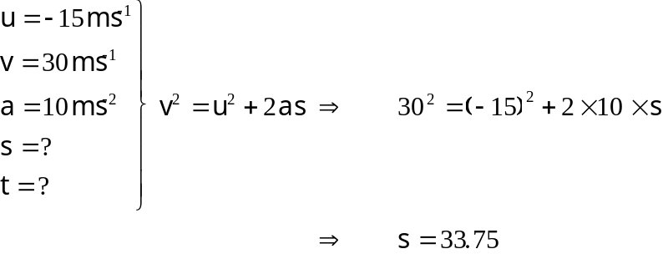
The window is 33.75m above the ground.

6. (a) The final velocity of the balloon is calculated from
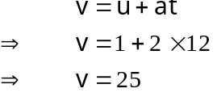
When acceleration is constant, average velocity is halfway between the initial and final velocity: -

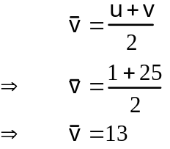

The average velocity is 13ms-1

(b) Displacement is the product of average velocity and time
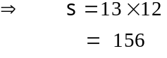
The balloon rises 156m
7. (a)
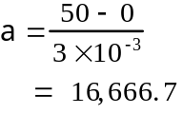
The ball's acceleration is 16,667ms-2
(b) Since there is no air resistance, we assume the ball maintains its 50ms-1 velocity and so has a displacement of 150 in the first 3s.

8. (a) Using the vertical component of the motion, we have
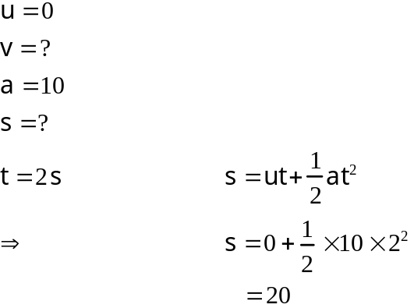
The cliff is 20m high

(b) Working with the horizontal components, we see that the stone has a constant horizontal velocity, which carries it 45m in 2s. Thus its initial velocity is 22.5ms-1 horizontally.
9.
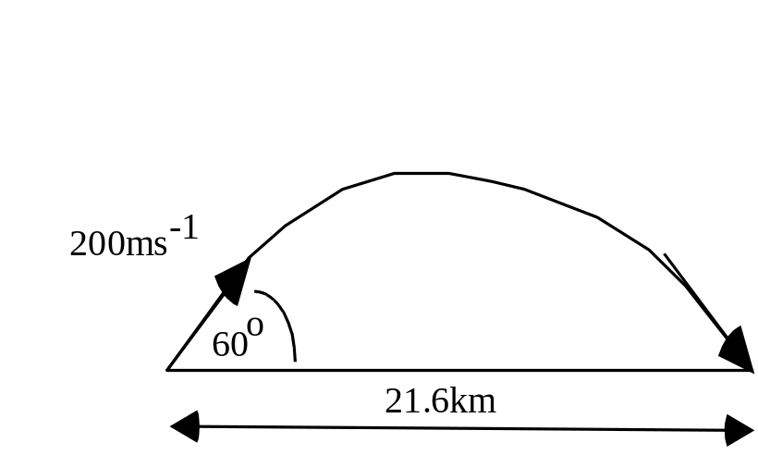

Using horizontal components, we find the time of flight since
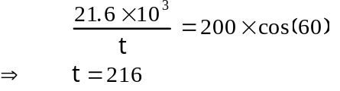

Working with vertical components, we have a choice:-
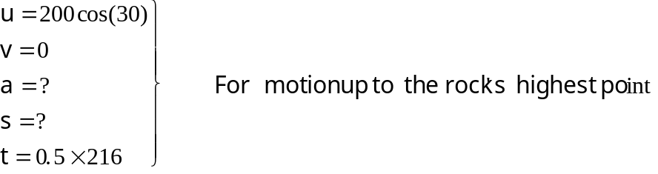

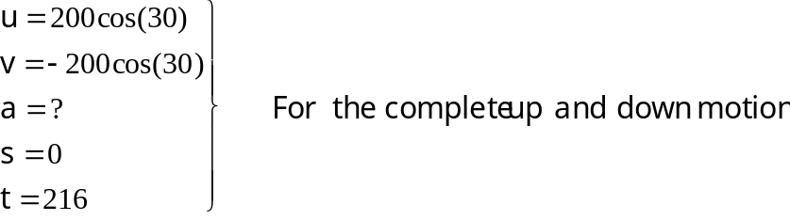

Using the first option: -
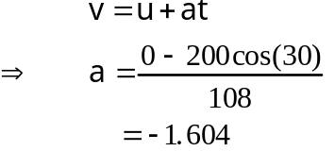
The Moon's gravitational acceleration is 1.6ms-2.

Using the second option: -
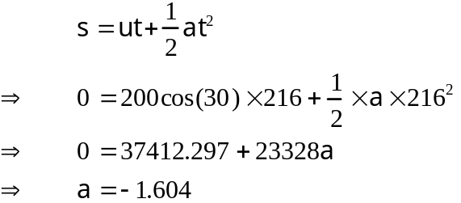
The Moon's gravitational acceleration is 1.6ms-2.

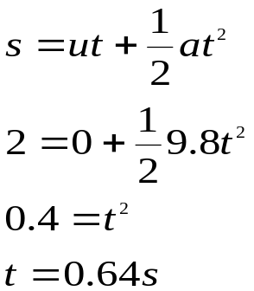10.

It takes 0.64s to reach the ground.

11. The time needed to cross the river is 3m ÷ 5.5 ms ^{–1} = 0.54s. The time to fall 1.5m is found by solving s=ut + 1/2at² for t.

1.5 = 0 + ½ x 9.8 x t² t = 0.55s

Since the rider takes longer to fall to the lower level than he does to cross, he misses the water, shame!
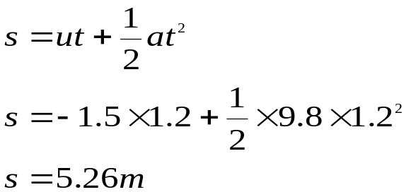
12.

The surface of the water is 5.26m below the fish.

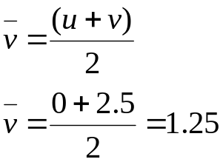13.a) The average velocity of the trolley is given by:
Since the average velocity for the 5s of travel is 1.25 ms ^{–1} , the trolley covers 6.25m.

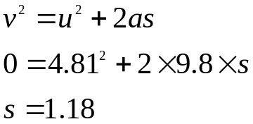b)

The maximum height reached is 1.18m

c) The ball moves forward at a constant velocity of 2.5 ms ^{–1} as the trolley accelerates so we need to calculate the distance covered by both.

The flight is calculated from v=u+at.

⇒ - 4.81 = 4.81 – 9.8t
⇒ t = 0.98s

The ball moves forward 2.5 x 0.98m = 2.45m

The distance moved forward by the trolley is given by:

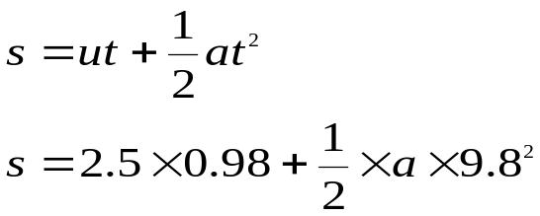
Finding the acceleration of the trolley using v=u+at gives
2.5 =0 + a  5
a = 0.5

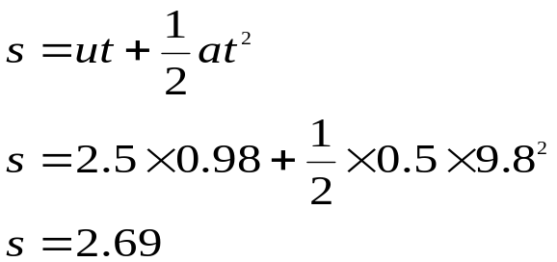Going back and finishing the first equation gives us

Thus the ball-bearing lands 24cm behind the trolley.

14. Time taken for the can and arrow to drop is found using
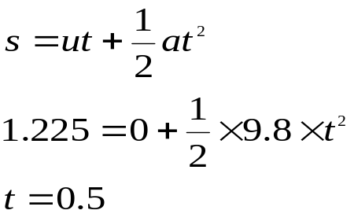The can’s horizontal velocity component is constant and it covers 0.3m in 0.5s. It’s horizontal velocity, according to v=s/t is
0.3m 0.5s = 0.6 ms ^{–1}

15.
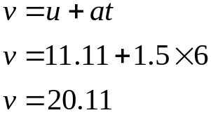 40kmh ^{–1} = 4000m per 3600s
from v = s / t = 11.11 ms ^{–1}

The train is moving at approximately 20.1 ms ^{–1} (74kmh ^{–1} ).

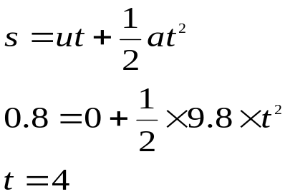16.
The 20p takes 4s to reach the bottom of the well.

17. a) Vertically downwards at 5ms ^{–1}
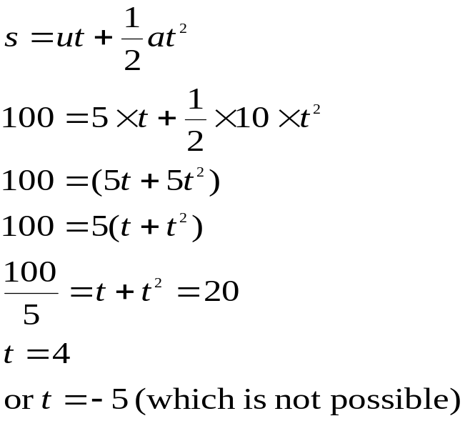

b) Vertically upwards at 5ms ^{–1}
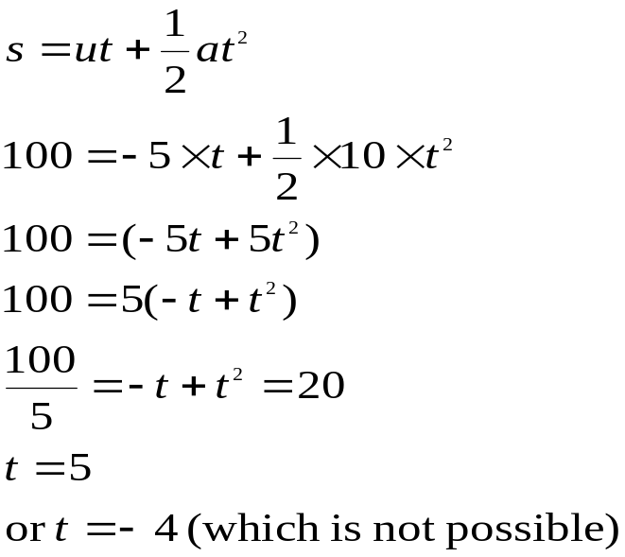

0r if you are not confident with the use of quadratic equations you can get by this by using 2 equations, eg.

a) Vertically downwards at 5ms ^{–1}
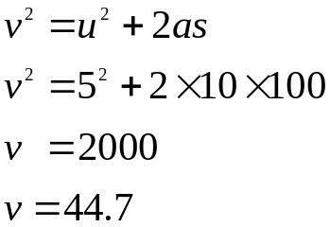
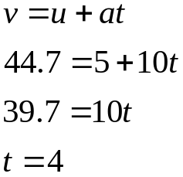Then find t from v = u + at

The stone takes four seconds to reach the ground.

b) Vertically upwards at 5ms ^{–1}

As this involves squaring and square rooting negative numbers the easiest way of doing this is to work out the details of the flight up to its highest point and then find its time to fall

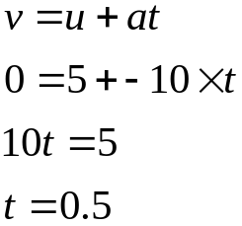
This is the time the stone takes to reach the top of the flight.
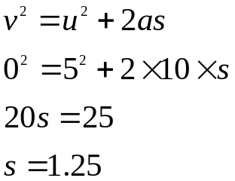
This is the extra displacement of the stone.

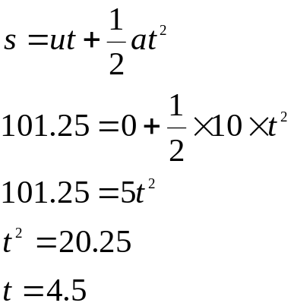Then find t from s = ut + 1/2at²

The time for the stone to fall the total distance from the top of the flight to the bottom is 4.5s, however, don’t forget to add in the time the stone takes to get to the top.

Total time = 0.5 + 4.5=5

The stone takes five seconds to reach the ground.

NEWTON’S SECOND LAW/ TUTORIAL ANSWERS:

ANSWERS FOR TUTORIAL 1

1. F=ma gives F = 105x5
The force needed is 5x 105N

2. F=ma gives 100=2x104m
m= 0.005
The pellet has a mass of 5g

3. 140 = 80a
a = 1.75
The acceleration is 1.75ms-2

ANSWERS FOR TUTORIAL 2
1.
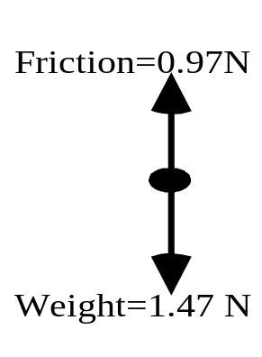

W = mg 150/1000  9.8 = 1.47 N
The resultant force is (1.47 – 0.97) = 0.5 N
F = m a  0.5 = 0.15  a  a = 3.3 ms ^{–2}

2.
100N
20N
F = 100 – 20 = 80N
a = 1000 ms ^{–2}
F = m a  80 = m  1000
 m = 0.08 kg = 80 g

3. F = ?
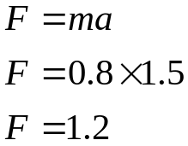 m = W  9.8 kg = 7.84  9.8 = 0.8 kg

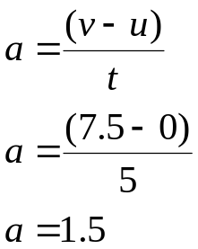
The accelerating force is 1.2 N

4.
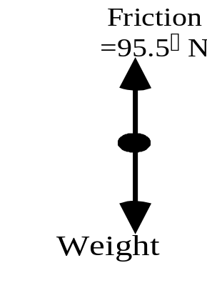 W=mg
W=(0.01 x 10⁻³ ) x 9.8
W= 9.8 x 10⁻⁵ N

Unbalanced (or accelerating) Force = W – F
= 98N – 95.5N
=2.5N

F=ma
2.5N = 0.01 x 10⁻³ x a
a = 0.25
The feather accelerates at 0.25 ms ^{–2}

5. One way to tackle this is to add the two forces using a vector diagram, than apply that force to the mass to find out what acceleration it causes. Alternatively, we can find the accelerations caused by the individual forces and then find the resultant acceleration using a vector diagram since acceleration is a vector quantity.

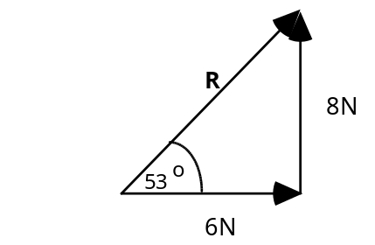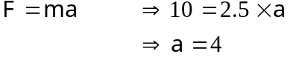
The acceleration caused is 4ms-2 at an angle of 53o to the 6N force as shown on the diagram.

6. (a)
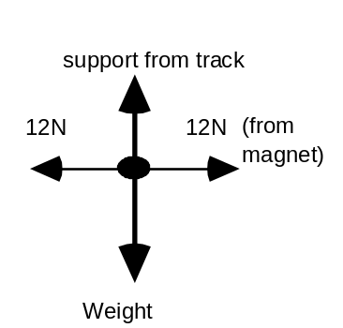 There is no unbalanced force so a=0

(b)
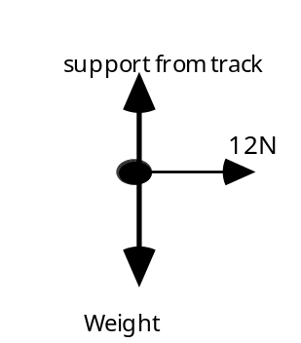 The 12N unbalanced force causes an acceleration of 4ms-2 to the right in the 3kg vehicle.

7. This problem can be answered using a scale diagram or using components.
Using a scale diagram
200N
200N
231N
30º

The resultant of these two forces is 115.5N at 90º to the 200N force

or using components
(Right positive, up positive)

Horizontal Force =200 + (-231 cos30)
=200 – 200
= 0
Vertical Force = 0 + 231 sin30
= 115.5N
F = ma
115.5 = 1.5 x a
a = 77 ms ^{–2}

8. This problem can be answered using a scale diagram or using components.

Using a scale diagram

The resultant of the three forces is 14.9N downwards.
26⁰
32N
35N
39N

or using components

(Right positive, down positive)

Horizontal Force =35 + 0 + (-39 cos26)
=35 + 0 + -35
= 0
Vertical Force = 0 + 32 + (-39 sin26)
= 32 + - 17.1
= 14.9N

F =ma
14.9 = 100 x a
a = 0.149 ms⁻² downwards

9. Have this question checked by your teacher.
10. Have this question checked by your teacher.

11. a) The mass of the block can be found using W=mg. The weight shown in the diagram as the force downwards.
W=mg
200 = m x 9.8
m = 20.4kg.

b) The block can move up or down the slope. The resultant is given by
R = Wsin - F
R = (200 sin 54) – 121
R = 40.8 N down the slope.

c) F = ma
40.8 = 20.4 x a
a = 2 ms⁻² down the slope.

12. This problem is quite easy but it needs tackling in stages. There are many ways to start this but all the piece must be found.

Find m
W=mg
686 = m x 9.8
m = 70kg.

Find the unbalanced force
F= ma
F = 70 x 2.5
F=175 N

Find the component of weight acting down the slope
Component = Wsin
= 686 sin 30
= 343N

The frictional force must be the difference between the component of weight trying to accelerate the block down the slope and the unbalanced accelerating force.

Friction = 343 – 175
= 168N

13. This problem is again quite easy but it needs tackling in stages. There are many ways to start this but all the piece must be found.

Find m
W=mg
735 = m x 9.8
m = 75kg.

Find the acceleration of the block down the slope.

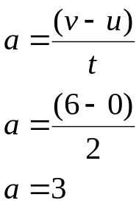
Find the unbalanced force
F= ma
F = 75 x 3
F=225 N

Find the component of weight acting down the slope
Component = Wsin
= 735 sin 30
= 367.5N

The frictional force must be the difference between the component of weight trying to accelerate the block down the slope and the unbalanced accelerating force.

Friction = 367.5 – 225
= 142.5N

ANSWERS FOR TUTORIAL 3

1. (a) E_{k} = ½ mv²
m =75000 + 25000 = 100000 kg.
v = 8 kms ^{–1} = 8000 ms ^{–1}
E_{k} = ½ mv²
⁼ ½  1000000 8000² = 320  10¹⁰ J
(b) work done =loss in E_{k} = 320  10¹⁰ J

(c) 53 minutes and 20 seconds = 3180 + 20 = 3200seconds
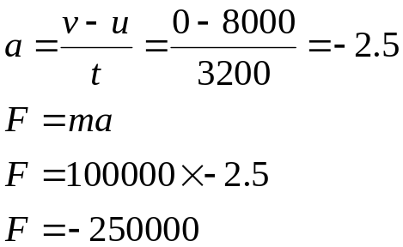
The average frictional force is 250000 N.

(d) E_{w} = F  s
320  10¹⁰ = 250000  s
=12800 km

2. E_{p} = mgh
= 0.1  10  40 = 40 J
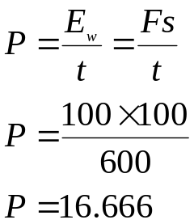
3. t = 10 minutes = 600 s

The average power of the man pushing the lawn mower is 17 W

4. The kinetic energy is converted into heat as the objects do work against the force of friction. Since their original energies are the same, they each do the same amount of work as they stop so their stopping distances must be equal.

5.(a) The minimum upward force exerted by the fork-lift truck would be equal to the weight of the case.
W = mg
W = 500 10
W = 5000N

(b) E_{p} = mgh
= 500  10  1.5 = 7500 J

(c) E_{k} = ½ mv²
⁼ ½  500  2.0² = 1000 J

(d) When the fork-lift truck stops this kinetic energy is transferred to the surroundings as heat.
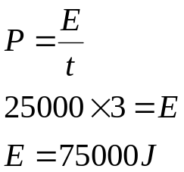
(e)

The energy into the system is 75000 J, the energy gained by the package is 7500J.
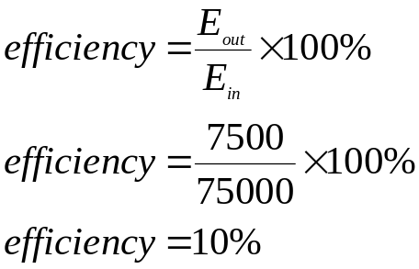
The system is 10% efficient.

6. (a) Work done = force x distance
= 10N x 3m
= 30J
(b) Kinetic energy since we can see from the second graph that the speed is increasing.

(c) The velocity is steady during this part of the motion and so the forces on the object are balanced. This means that the work done is against the force of friction which only produces heat.

ANSWERS TO TUTORIAL 1

1. a = (v – u) / t
Acceleration = (27ms-1 - 15ms-1) / 8s
= 12ms-1 / 8s
= 1.5ms-2

2. Let its new velocity be v ms-1. Using this in the definition of acceleration gives us:
a = (v – u) / t
20 = v - 2
0.5
Thus 20 x 0.5 = v - 2
and so v = 10 + 2
= 12
Its new velocity is 12ms-1.

3. a = (v – u) / t
15 = 30 - 0
t
Thus t = 2

The sportscar takes 2s to reach 30ms-1.

ANSWERS TO TUTORIAL 2

1. (a) This is half-way between the initial and final velocities and is 15ms-1.
(b) At half time, which is 4s
(c) The area under the graph from zero to 4s is
10x4m + 0.5x4x(15-10) m
= 40m + 10m
= 50m
(d) Area under the graph = 10x8m + 0.5x8x(20-10)
= 80m + 40m
= 120m
(e)

2. (a) The velocity increases steadily and then changes to a greater rate of increase, i.e. constant acceleration followed by a greater constant acceleration.
(b)

3. It is a steadily increasing acceleration since the velocity increases by 25ms-1, then 30ms-1, etc.

4. (a) At the origin.
(b) At 20s and again near 30s. You are looking for a gradient of zero, i.e. a horizontal line.
5.
time
velocity ms ^{–1}

6.
displacement (m) | 0 | 0.2 | 0.8 | 1.8 | 3.2 | 5.0
time (s) | 0 | 0.1 | 0.2 | 0.3 | 0.4 | 0.5

The displacement measurements are added together to get the displacement from the start.
e.g. t = 0.1, s = 0.2
t = 0.2, s = 0.2 + 0.6 = 0.8
t = 0.3, s = 0.2 + 0.6 + 1.0 = 1.8
t = 0.4, s = 0.2 + 0.6 + 1.0 +1.4 = 3.2
t = 0.5, s = 0.2 + 0.6 + 1.0 +1.4 + 1.8 = 5.0

6 b) These results show constant acceleration. You can tell this as the displacement results measured from the start are increasing by a different amount with each time period

ANSWERS TO TUTORIAL 3

1. a = v - u u = 5cm / 0.1s = 50cms-1
t v = 8cm / 0.02s = 400cms-1
t = 0.5s
Thus a = 400 - 50
0.5
= 700
The acceleration is 700 cms-2

2. (a) The object's average velocity is half way between 24ms-1 and zero. It is 12ms-1.
(b) It takes 8s to cover 96m at an average of 12ms-1.
(c) a = (0 - 24)/8 = -3
The deceleration is 3ms-2

3. (a) A 1Hz flash will show the object's position at one second intervals.
Displacement is the product of the object's average velocity during the interval and the duration of the interval.
Thus :-
 | Initial | Final | Average
Interval | vel. /cms-1 | vel. /cms-1 | vel. /cms-1 | Length / cm
1 | 0 | 3 | 1.5 | 1.5
2 | 3 | 6 | 4.5 | 4.5
3 | 6 | 9 | 7.5 | 7.5
4 | 9 | 12 | 10.5 | 10.5
5 | 12 | 15 | 13.5 | 13.5
6 | 15 | 18 | 16.5 | 16.5

(b) The figures quoted are displacements from the start.
After 1 second ------ 1.5cm
After 2 seconds------1.5cm + 4.5cm = 6cm
After 3 seconds ------1.5cm + 4.5cm + 7.5cm = 13.5cm

4. The Y-axis shows the velocity of the falling object which will increase steeply to begin with but level off as the air drag increases.

5. This is a very common examination type question. The important features to look out for are:

i) Starting velocity, in this question the ball is likely to have zero initial velocity.

ii) A constant gradient put your ruler up against the lines. This gradient represents falling under gravity. It should therefore be constant.

iii) The bounce should cause a rapid change of direction and hence change of velocity.

Iv) In this question the initial velocity and the gradient should have the same sign as they are in the same direction.

v) After the bounce if the collision is inelastic energy will be lost and the velocity after the bounce will be less than that before the bounce.

The answer is D.

6. You need to do the calculation error ÷ reading whichever is the biggest has the largest percentage error. In this question there is no point in working out C1, length of card, or the distance, as C1 is the same error as C2 but has a larger value. Remember the larger the reading the smaller the percentage error.

The answer is B.

7.

Vector | a | P | v | displacement | F
Scalar | E_{w} | E_{p} | E_{H} | distance | mass | E_{K} | t | speed

The answer is C.

8. Another common examination type question. It is best to familiarise yourself with these graphs.

The answer is D.

It cannot be A, B, or C as the velocity time graph is NOT the gradient of the displacement time graph given. E is incorrect as the displacement is gradually getting less, which indicates a negative gradient.

9. Carefully look at the question and graph and go through in your head what the graph represents. Between 0 and P, the trolley is accelerating, this corresponds to the initial push up the slope. Between P and Q the trolley is decelerating up the slope, i.e. in the same direction. At Q the trolley’s velocity goes from 0 to –1.5 ms⁻¹ this represents the trolley rolling back down the slope.

The maximum displacement of the trolley is at 2 seconds.

b) For 0 to P a = (v – u) / t = (3-0)/1 = 3
For P to Q a = (v – u) / t = (0-3)/2 = 1.5

For Q to R a = (v – u) / t =(-1.5-0)/5.25 = -0.67
-0.67
-1.5
Acceleration / ms ⁻ ²
R
Q
0
P
3

10a) We find the total distance by adding up the distances travelled during each period of the cat's motion. This is calculated by using its average speed during each period.
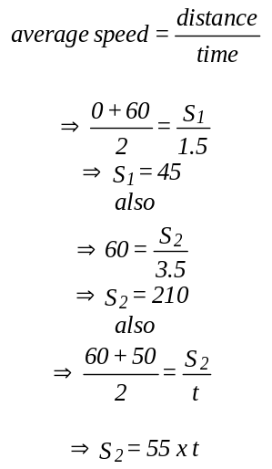

b) The cockroach travels at constant speed and so:-
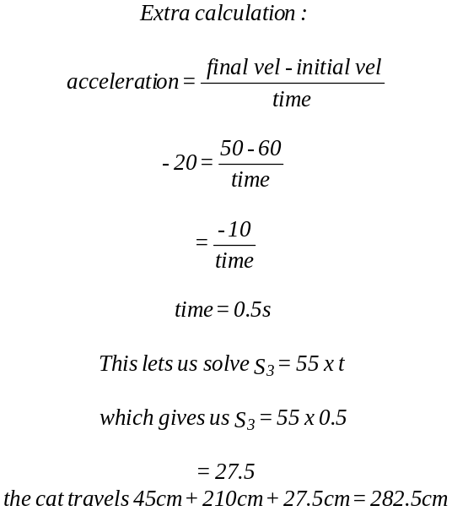

The cockroach travels 285cm while the cat travels 282.5cm, so the cockroach is 2.5cm in front when the cat hits the door.

0.2 1.7 5.2 5.7
acceleration
+40
-20

10c).

ANSWERS TO TUTORIAL 4
1. (a)
The acceleration is 1.7ms-2
(b)
It takes 1.5 seconds

2.
She slides 65m

3.
The pellet accelerates at 50625ms-2

4.

The ball is moving at 8ms-1 after the kick.

5.
The window is 33.75m above the ground.

6. (a) The final velocity of the balloon is calculated from
When acceleration is constant, average velocity is halfway between the initial and final velocity: -

The average velocity is 13ms-1

(b) Displacement is the product of average velocity and time
The balloon rises 156m
7. (a)
The ball's acceleration is 16,667ms-2
(b) Since there is no air resistance, we assume the ball maintains its 50ms-1 velocity and so has a displacement of 150 in the first 3s.

8. (a) Using the vertical component of the motion, we have
The cliff is 20m high

(b) Working with the horizontal components, we see that the stone has a constant horizontal velocity, which carries it 45m in 2s. Thus its initial velocity is 22.5ms-1 horizontally.
9.

Using horizontal components, we find the time of flight since

Working with vertical components, we have a choice:-

Using the first option: -
The Moon's gravitational acceleration is 1.6ms-2.

Using the second option: -
The Moon's gravitational acceleration is 1.6ms-2.

10.

It takes 0.64s to reach the ground.

11. The time needed to cross the river is 3m ÷ 5.5 ms ^{–1} = 0.54s. The time to fall 1.5m is found by solving s=ut + 1/2at² for t.

1.5 = 0 + ½ x 9.8 x t² t = 0.55s

Since the rider takes longer to fall to the lower level than he does to cross, he misses the water, shame!
12.

The surface of the water is 5.26m below the fish.

13.a) The average velocity of the trolley is given by:
Since the average velocity for the 5s of travel is 1.25 ms ^{–1} , the trolley covers 6.25m.

b)

The maximum height reached is 1.18m

c) The ball moves forward at a constant velocity of 2.5 ms ^{–1} as the trolley accelerates so we need to calculate the distance covered by both.

The flight is calculated from v=u+at.

⇒ - 4.81 = 4.81 – 9.8t
⇒ t = 0.98s

The ball moves forward 2.5 x 0.98m = 2.45m

The distance moved forward by the trolley is given by:

Finding the acceleration of the trolley using v=u+at gives
2.5 =0 + a  5
a = 0.5

Going back and finishing the first equation gives us

Thus the ball-bearing lands 24cm behind the trolley.

14. Time taken for the can and arrow to drop is found using
The can’s horizontal velocity component is constant and it covers 0.3m in 0.5s. It’s horizontal velocity, according to v=s/t is
0.3m 0.5s = 0.6 ms ^{–1}

15.
40kmh ^{–1} = 4000m per 3600s
from v = s / t = 11.11 ms ^{–1}

The train is moving at approximately 20.1 ms ^{–1} (74kmh ^{–1} ).

16.
The 20p takes 4s to reach the bottom of the well.

17. a) Vertically downwards at 5ms ^{–1}

b) Vertically upwards at 5ms ^{–1}

0r if you are not confident with the use of quadratic equations you can get by this by using 2 equations, eg.

a) Vertically downwards at 5ms ^{–1}
Then find t from v = u + at

The stone takes four seconds to reach the ground.

b) Vertically upwards at 5ms ^{–1}

As this involves squaring and square rooting negative numbers the easiest way of doing this is to work out the details of the flight up to its highest point and then find its time to fall

This is the time the stone takes to reach the top of the flight.
This is the extra displacement of the stone.

Then find t from s = ut + 1/2at²

The time for the stone to fall the total distance from the top of the flight to the bottom is 4.5s, however, don’t forget to add in the time the stone takes to get to the top.

Total time = 0.5 + 4.5=5

The stone takes five seconds to reach the ground.
MOMENTUM & IMPULSE / TUTORIAL ANSWERS

ANSWERS TO TUTORIAL 1

1. Impulse = change in momentum
= 0.2 × 15 - 0
= 3
The impulse = 3kgms-1

2. a) Change in momentum = impulse and so the momentum change in this situation is 520kgms-1
b) Since running into the player means that the runner slows down, his new momentum is 520kgms-1 less than his original. That is 80kgx8ms-1-520kgms-1 = 120kgms-1.
3. a)
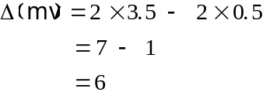
The momentum change is 6kgms-1

b)
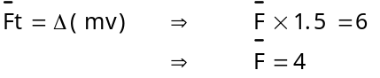
The average force acting is 4N.

4. Let the time taken to stop be t seconds.

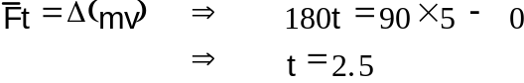
The football player takes 2.5s to stop.

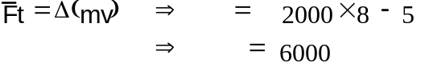5.

An impulse of 6000 Ns is needed to change the velocity of the car.

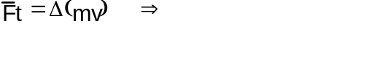6.
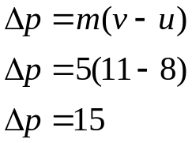
Impulse equals change in momentum. Therefore the space probes momentum change is 5 x 10⁹ kgms ^{–1}.

7. a)

The momentum change of the object is 15kgms⁻¹ .
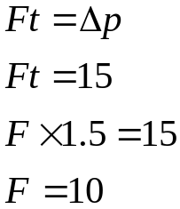
b)

The average force acting on the object is 10N.

c) Impulse equals change in momentum, so the impulse given to the object is 15Ns.

ANSWERS TO TUTORIAL 2.

1. Before:
Total momentum = (0.02 x 5 + 0.012 x 0) kgms-1
= 0.1kgms-1

After:
Total momentum = (0.02x2 + 0.012xv)kgms-1
= (0.04 + 0.012v)kgms-1

Since momentum is conserved, these two totals are the same.
0.04 + 0.012v = 0.1
v = 5
The 12g marble moves off at 5ms-1.

2. Total momentum before = (3 × 0.5 + 2v)kgms-1
Total momentum after = (3 × 2 + 2 × 0.75)kgms-1
Since momentum is conserved, 1.5 + 2v = 6 + 1.5
v = 3
The original velocity of the 2kg vehicle is 3ms-1.

3. Total momentum before explosion = zero
Total momentum after = 0.02 × 10 + 0.05v
Since momentum is conserved, 0.2 + 0.05v = zero
v = -4

The body of the pen moves off at 4ms-1 in the opposite direction to the lid.

ANSWERS TO TUTORIAL 3.

1.
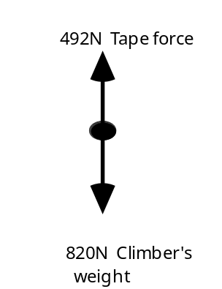
The resultant force = (820 - 492)N
= 328N
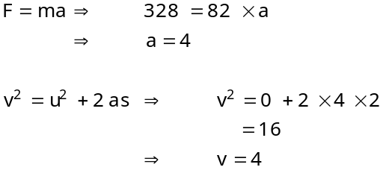

The climber is travelling at 4ms-1.

2. a)
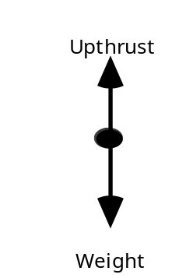

b) Because she is accelerating and a change in velocity only occurs if there is a resultant force greater than zero.
c) The F in F = ma is the resultant force.
F = 80 x 5
= 400
The resultant force is 400N

d)
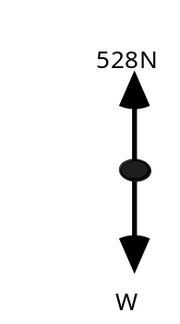
The 528N upward force balances the lady's weight and provides the accelerating force. Thus 528 = W + 400
W = 128
The gravitational field strength is therefore 128 Newton for 80kg, which is 1.6Nkg-1.

3. a) Using a scale diagram

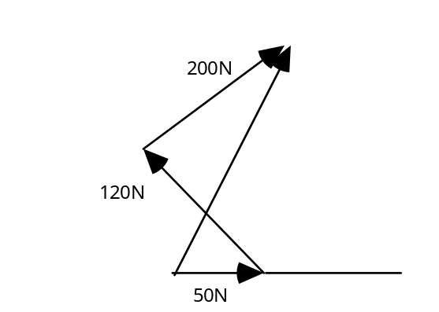
F=250N at an angle of 65º

Using components.
Left is positive, up is positive.
Horizontal Force = 50 + 200 cos45 – 120 cos 45
= 106.6N

Vertical Force = 0 + 200 sin45 + 120 sin45
= 226N

R² = H² + V²
R² = 106.6² +226²
R² = 11364 + 51200
R = 250N

tan  = opp/adj = 226/106.6 = 2.12
 = 65º

b) F=ma gives us 250 = 2000a so that the value of a is 0.125
The acceleration should be 0.125ms-2 but is measured at only 0.1ms-2. The standby thruster must in fact be giving some thrust which we can calculate in the usual way.

F=ma gives F = 2000 × 0.1 = 200
Thus the satellite is getting a resultant thrust of 200N when the calculated value is 250N so that the standby thruster is giving a small thrust of 50N.

4 Using 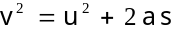 we get 102 = 0 + 2a x 0.25
a = 200

Applying F = ma to the 6kg dummy gives
F = 6 x 200
F = 1200
The force on the dummy is 1200N

5. gives (3x107)2 = 0 + 2a x 0.15
a = 3x1015

F = 9.1x10-31 x 3x1015
= 2.7x10-15
The electric force on the electron is 2.7x10-15N (Notice that the gravitational force on it is only 9.1x10-30N since gravity is the weakest of the natural forces.)

6. F = 50000 x 0.01
= 500
The resultant force on the barge is 500N

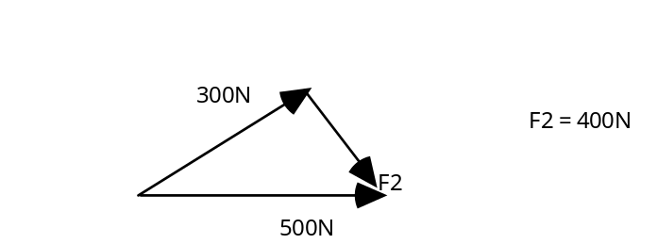
The second horse pulls the barge with a force of 400N

7. 152 = 0 + 2a x 22.5
a = 5
F = 1600 x 5
= 8000
Since 8000N of thrust are required, 8 bags of propellant are needed.

8. a) Momentum before = (0.1 × 20 + zero)
momentum after = (zero + 0.5v)
Since momentum is conserved, 0.5v = 2
Thus v = 4
The stick moves back at 4ms-1
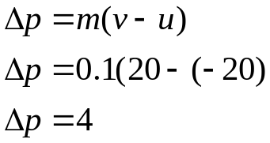
b) The puck loses 2kgms-1 of momentum as it stops then gains 2kgms-1 as it leaves. Its total momentum change is, therefore, 4kgms-1.

Remember that momentum and impulse are vector quantities.

9. a)
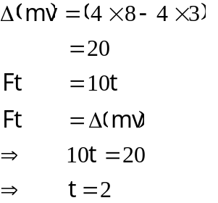

The force acted for 2s

b) Use impulse = Ft = 20Ns
or impulse = momentum change = (32 - 12)kgms-1
= 20kgms-1

10. a) Let the final speed of the wagon be vms-1
Then since momentum is conserved,
1000kg × 5ms-1 = (1000kg + 4000kg) × vms-1
5000 = 5000v
v=1
The velocity of the full wagon is 1ms-1.

b) As the coal slides over the bed of the wagon, the horizontal friction between them acts to slow the wagon and speed up the coal.

11. a) If the velocity of the astronaut is vms-1, then since momentum is conserved,
0.050kg × 100ms-1 = (100 - 0.05)kg × vms-1

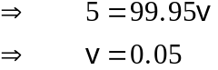

The astronaut moves at 0.05ms-1 towards his ship.

b)
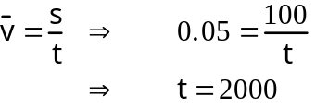

The astronaut takes 2000s to reach his ship.

c) Time remaining = 1550g/0.8 gs-1
= 1937.5s

d) If he releases double the mass of gas, his velocity doubles so that his journey is completed in safety.

12. a) Since energy is conserved, the kinetic energy of the pieces is equal to their previous kinetic energy plus the potential energy stored in the explosive.
b) Since momentum is conserved, the total momentum of the pieces is the same as the total momentum before the explosion.

13. Momentum is conserved.
a) If the balls are moving in the same direction
momentum before = momentum after
(2 × 5) + (8 × 2) = 10v
10 + 16 = 10v
v = 2.6 ms ^{–1}

E_{k} before = ½ mv² + ½ mv²
= ( ½ × 2 × 5²) + ( ½ × 8 × 2²)
= 41 J
E_{k} after = ½ mv²
= ( ½ × 10 × 2.6²)
= 33.8 J
7.2J of energy are lost.

Momentum is conserved.
b) If the balls are moving in opposite directions
momentum before = momentum after
(2 × 5) + (8 × -2) = 10v
10 - 16 = 10v
v = 0.6 ms ^{–1}

Energy is a scalar quantity so direction is not important when calculating size.
E_{k} before = ½ mv² + ½ mv²
= ( ½ × 2 × 5²) + ( ½ × 8 × 2²)
= 41 J
E_{k} after = ½ mv²
= ( ½ × 10 × 0.6²)
= 1.8 J
39.2J of energy are lost.

14. a) Find v as the putty lands in the bucket.

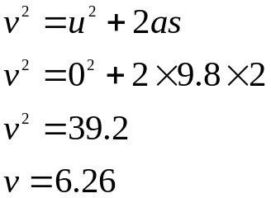The putty lands in the bucket with a velocity of 6.26 ms ^{–1}

Now we can find the velocity of the bucket as the putty lands in it.

momentum before = momentum after
(4 × 6.26) + (6 × 0) = (6+4)v
25 = 10v
v = 2.5 ms ^{–1} downwards

b) E_{k} before = ½ mv² + ½ mv²
= ( ½ × 4 × 6.26²) + ( ½ × 8 × 0²)
= 78.4 J
E_{k} after = ½ mv²
= ( ½ × 4 × 2.5²)
= 12.5 J
65.9J of kinetic energy are lost by the putty.

c) Impulse = change in momentum
p =Ft
Ft = m(v-u)
F(6 × 10⁻³ ) = 4(6.3 –2.5)
F=2520N

F=ma
2520 =10a
a = 252ms ^{–2}

15. Momentum is conserved
momentum before = momentum after
(0.02 × 50) + (0.380 × 0) = 0.4v
1 = 0.4v
v = 2.5 ms ^{–1}

Now find the acceleration of the block
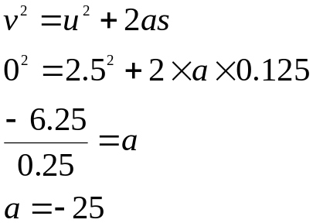

Now find the frictional force decelerating the pellet

F =ma
F = 0.4 × -25
F = -10N

The frictional force is 10N opposing the direction of motion.

16. E_{k} at the bottom = ½ mv²
= ( ½ × 200 × 20²)
= 40 000 J
E_{p} at the top = mgh
= (200 × 9.8 × 15²)
= 29 400 J
E loss due to friction is the difference between the two values
E_{k} – E_{p} = 40000 – 29400 = 10 600 J

The energy loss due to friction is 10 600J
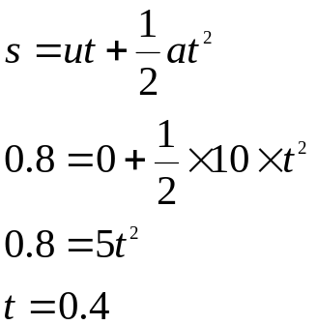
17.a)

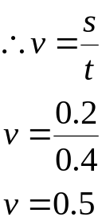The horizontal velocity is constant
Hence it has been shown that the velocity of the putty after the impact is 0.5ms ^{–1} .

b) The principle of the conservation of momentum is that During any collision the momentum of the system before is equal to the momentum of the system after the collision.

ii) Momentum before = momentum after
(0.1 × 0) + (5 × 10⁻⁴ × u) = (0.1+5 × 10⁻⁴ ) 0.5
5 × 10⁻⁴ u= 0.1005 × 0.5
5 × 10⁻⁴ u= 0.05025
u = 100.5 ms ^{–1}

c) The size of the putty could be reduced.

