NATIONAL QUALIFICATIONS CURRICULUM SUPPORT

Physics

Researching Physics Exemplar:
Earthquakes – Modelling and
Monitoring

[HIGHER]






The Scottish Qualifications Authority regularly reviews the arrangements for National Qualifications. Users of all NQ support materials, whether published by Learning and Teaching Scotland or others, are reminded that it is their responsibility to check that the support materials correspond to the requirements of the current arrangements.

Acknowledgement
Learning and Teaching Scotland gratefully acknowledges this contribution to the National Qualifications support programme for Physics.

© Learning and Teaching Scotland 2011

This resource may be reproduced in whole or in part for educational purposes by educational establishments in Scotland provided that no profit accrues at any stage.

Contents

Advice to students
Overview of the unit and activities 4
Organising your work and carrying out the activities 5
Assessment issues 6

Web-based research briefs
Initial research activity: Earthquake zones, frequency and magnitude 8
Research Activity 1: Seismic waves 9
Research Activity 2: Monitoring earthquakes 10

Practical investigation briefs
Practical Activity 1: Investigating tectonic plate slip 11
Practical Activity 2: Seismometers and the energy released in an earthquake 13
Practical Activity 3: Seismometers and the distance from an
earthquake 15
Practical Activity 4: Locating the epicentre of an earthquake 17

Advice to students

Overview of the unit and activities

What is involved in the Researching Physics unit?

Studying physics involves learning physics facts and concepts. It also involves developing particular skills. These include research skills, which may involve you in doing investigative experiments or researching information, perhaps from the internet. The aim of this unit is to help you develop these physics skills. You will learn some physics facts, probably in some depth, but it is the development of skills that is the focus of the unit.

What physics content will I be learning?

The context for your work is the modelling and monitoring of earthquakes. Earthquakes regularly cause damage to buildings in certain places in the world, sometimes causing injuries and death. It is the movement or slippage of tectonic plates that causes earthquakes. This pack includes details of investigations of tectonic slip, as well as methods of monitoring the strength and location of earthquakes.

An understanding of earthquakes includes knowing about the types of waves that transmit energy from the earthquake centre. Physics underpins this understanding and helps design the instruments used to detect earthquakes.

What activities will I be doing?

There are three types of activity in the unit.

Undertaking literature-based research is a hugely important skill. In this unit, this is best carried out as web-based research. It is easy to simply look up a single fact on the internet, but undertaking a more structured project is more complex. Sifting through what is often a large amount of data is demanding. Keeping track of what you are trying to find out is one of the most difficult parts of this type of research, and summarising what you have found, without merely cutting and pasting someone else’s work, is also challenging. In this material, there is an activity that describes how best to
carry out web-based research. There are also several research briefs that can be used in preparation for your investigation.

Investigative practical work can be fun and challenging. Planning and designing experiments is often the hardest part of this work. Actually carrying out the experiment may be straightforward. This material includes a number of activities that develop the skills required to do investigative practical work. There are also several investigation briefs that you can use to help you plan and carry out an investigation. The experiments you are likely to carry out in your investigation are not the kind where you can simply look up the results beforehand. There may be no right or wrong answers. What you find is what you find, and your way of doing the experiment may not be similar to others in your class.

Scientific communication is hugely important. It does not matter how interesting or groundbreaking your work is, if you cannot communicate your results then you have not completed your work. You should present the results and conclusions of your investigation. You may choose from a number of formats for your presentation.

Organising your work and carrying out the activities

How will I organise my work?

Some of the work you carry out in this unit will be in preparation for your research into one or more aspects of earthquakes. When you carry out the research activities themselves, it is likely that you will be responsible for organising your work.

You are required to produce several pieces of work, including the results of a piece of web-based research, and a scientific communication detailing the results and conclusions of your practical investigation. You are strongly advised not to produce these ‘as you go along’. Rather, it is very good practice to maintain a diary or record of work. This should record all your experimental results, ideas, problems you met, references and all the other day-to-day observations and data that you want recorded. The record of work is your record and as such it should be in a format that suits you. However, experience shows that students who organise their work for ease of reference are likely to be able to extract the information more easily and the resulting reports are likely to be easier to produce.

Will I do the same work as everyone else in my class?

This material includes a number of web-based research and practical investigation briefs. It is likely that students within the same class will be allocated different activities, depending on resources available and other classroom management issues.

What about teamwork?

It is probable that you will undertake some of the work as part of a group. Sometimes, within your team, you will be undertaking the same task and other times you will each focus on a different part of the task. In either case, it is important that discussion takes place. Agree the part that each member of the team will play and ensure that there is time to share the results of the work.

Assessment issues

What do I have to do to pass this unit?

As you work on this unit, you will carry out activities that develop your skills in undertaking research in physics.

Three of the activities contribute to the unit assessment. To be awarded the unit, you need to demonstrate that your work is of at least the required standard in each of the three types of activity.

The three types of activity are:

- undertaking web based research
- carrying out investigative practical work – you need to take an active part in planning and carrying out an investigation
- preparing a scientific communication.

Do I need evidence?

For the web-based research and scientific communication, you should ensure that you retain evidence that your work is of the required standard. Each year SQA will ask to see the evidence from a number of candidates. This process is easiest to manage if your evidence is stored in an e-portfolio. You can store text-based work, together with pictures, web pages, and any other material that you wish to present as evidence. If you do not use an e-portfolio, you should ensure that your evidence can be easily accessed.

What about assessment in the Higher Physics exam?

The Higher unit Researching Physics is available as a free-standing unit. It is also a required unit for a course award in Higher Physics. There will not be any questions in the Higher Physics course assessment that specifically relate to the topic of this unit. However, there will be questions in the course assessment that relate to the skills that you have developed in the unit. The following are the skills that may be assessed in the course assessment:

- selecting information from texts, tables, charts, graphs and diagrams
- presenting information in a variety of forms
- processing information
- planning and designing an experiment
- evaluating experimental procedures
- drawing conclusions and making predictions based on evidence provided.

Web-based research briefs

Initial research activity: Earthquake zones, frequency and magnitude

Research brief

Earthquakes are among the most deadly natural hazards. There are around 100 earthquakes each year of a size that could cause serious damage. They strike without warning and many of the Earth’s earthquake zones coincide with areas of high population density. When large earthquakes occur in such areas the results can be catastrophic, with terrible loss of human lives and untold economic cost.

In this initial research activity you will find out some background information about the frequency and location of earthquakes.

In carrying out your research you should answer the following questions:

- How are earthquakes caused?
- Where do earthquakes most often occur? (Do earthquakes occur in the UK?)
- How are earthquakes monitored and measured?

Answer the questions by carrying out research. This is probably best undertaken using web-based research. You are advised to have completed an activity in which you consider the issues of undertaking web-based research. This may have been done during your work on other units in Higher Physics.

You may work individually or as part of a team.

Produce a report of your findings. This may be hand-written, printed or electronic and saved in an e-portfolio.

You should spend approximately 2 hours on this activity.

If you work as part of a team that produces one report, you should include a short statement at the end of the report that indicates which part of the work you were responsible for.
Research Activity 1: Seismic waves

Research brief

Seismology is the study of earthquakes and seismic waves. A seismograph records the seismic waves generated by earthquakes, allowing the seismologist to determine where and how deep a particular earthquake is. Also, the seismic waves from earthquakes can be used to create an image of the deep interior of the Earth, providing vital clues to the internal structure of our planet.

In carrying out your research you should answer the following questions:

- P-waves and S-waves are two types of seismic waves. What are the properties of these waves?
- Where is the most damage caused to buildings in relation to the position and depth of the epicentre of an earthquake?
- What information about the interior of the Earth can be gained by a study of seismic waves?
- How can different seismic waves be recognised from a seismogram?
- How does the energy of an earthquake relate to the amplitude of seismic waves?
- How does the amplitude of a seismic wave relate to the distance from the epicentre of an earthquake?

Answer the questions by carrying out research. This is probably best undertaken using web-based research. You are advised to have completed an activity in which you consider the issues of undertaking web-based research. This may have been done during your work on other units in Higher Physics.

You may work individually or as part of a team.

Produce a report of your findings. This may be hand-written, printed or electronic and saved in an e-portfolio.

You should spend approximately 2 hours on this activity.

If you work as part of a team that produces one report, you should include a short statement at the end of the report that indicates which part of the work you were responsible for.
Research Activity 2: Monitoring earthquakes

Research brief

Seismology is the study of earthquakes and seismic waves. A seismometer is a device that is designed to detect earthquakes. A seismogram is a record of the seismic waves from an earthquake.

In carrying out your research you should answer the following questions:

- Almost all seismometers are based on the principle of inertia. What is the principle of inertia?
- How does a pendulum seismometer work?
- How is the relative motion of the mass in a seismometer detected and recorded?
- How is the Richter scale used to measure the size of an earthquake?
- What other scales, other than the Richter scale, can be used to measure the size of an earthquake?
- How can the size of an earthquake be determined from a seismogram?

Answer the questions by carrying out research. This is probably best undertaken using web-based research. You are advised to have completed an activity in which you consider the issues of undertaking web-based research. This may have been done during your work on other units in Higher Physics.

You may work individually or as part of a team.

Produce a report of your findings. This may be hand-written, printed or electronic and saved in an e-portfolio.

You should spend approximately 2 hours on this activity.

If you work as part of a team that produces one report, you should include a short statement at the end of the report that indicates which part of the work you were responsible for.

Practical investigation briefs

Practical Activity 1: Investigating tectonic plate slip

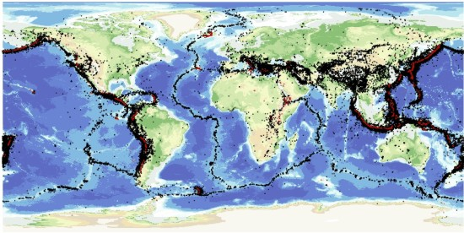
Investigation brief

Tectonic plates are the large solid pieces that make up the Earth’s crust. They move slowly relative to each other and at the boundaries considerable forces build up. When the forces are large enough, the plates may slip, relieving the stresses (or some of them). This is an earthquake.

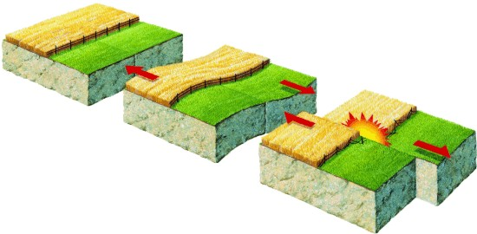
The slip of two plates can be simulated by applying a steadily increasing force to a rough brick resting on sandpaper. When the force is large enough, friction is overcome and the brick slips. The distance moved by the brick is the slip. In practice, the slip is sometimes small and sometimes large. This is similar to real tectonic plate slip.

The aim of this investigation is to compare the frequency of slips with the magnitude of the slip.

Discuss how you will carry out the investigation.

Write your plan in your record of work.

You should also include a hypothesis in your record of work. What do you think is the relationship between the frequency of slips and the magnitude of the slip?

Investigation notes

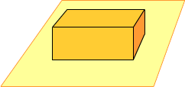
The equipment required to carry out this investigation is normally readily available in a physics laboratory although it will be necessary to obtain a suitable brick and sandpaper. It may be useful to carry out some preliminary work to find the best combination of brick and sandpaper.

You will also need to consider how best to apply an increasing force to the brick. When the brick moves, the force should be removed or at least reduced so that it no longer pulls the brick forward.

It will be necessary to give some thought to how many times the experiment should be repeated to enable the results to have statistical significance. Also, you should give careful consideration to how you will analyse and present your results.

It may be helpful to research how the frequency of real earthquakes is related to their magnitude.

Practical Activity 2: Seismometers and the energy released in an earthquake

Investigation brief

Earthquakes release an enormous amount of energy, which is transmitted away from the initial point of rupture by intense vibrations or seismic waves. The amount of energy that is released determines the maximum amplitude of the vibrations.

The aim of this investigation is to compare the energy of an earthquake with the maximum amplitude of the seismic waves.

In the laboratory, an earthquake can be simulated by dropping a weight onto a bench. The resulting vibrations can be detected with a model seismometer.

Discuss how you will carry out the investigation.

Write your plan in your record of work.

You should also include a hypothesis in your record of work. What do you think is the relationship between the energy of the earthquake (falling weight) and the maximum amplitude of vibration?

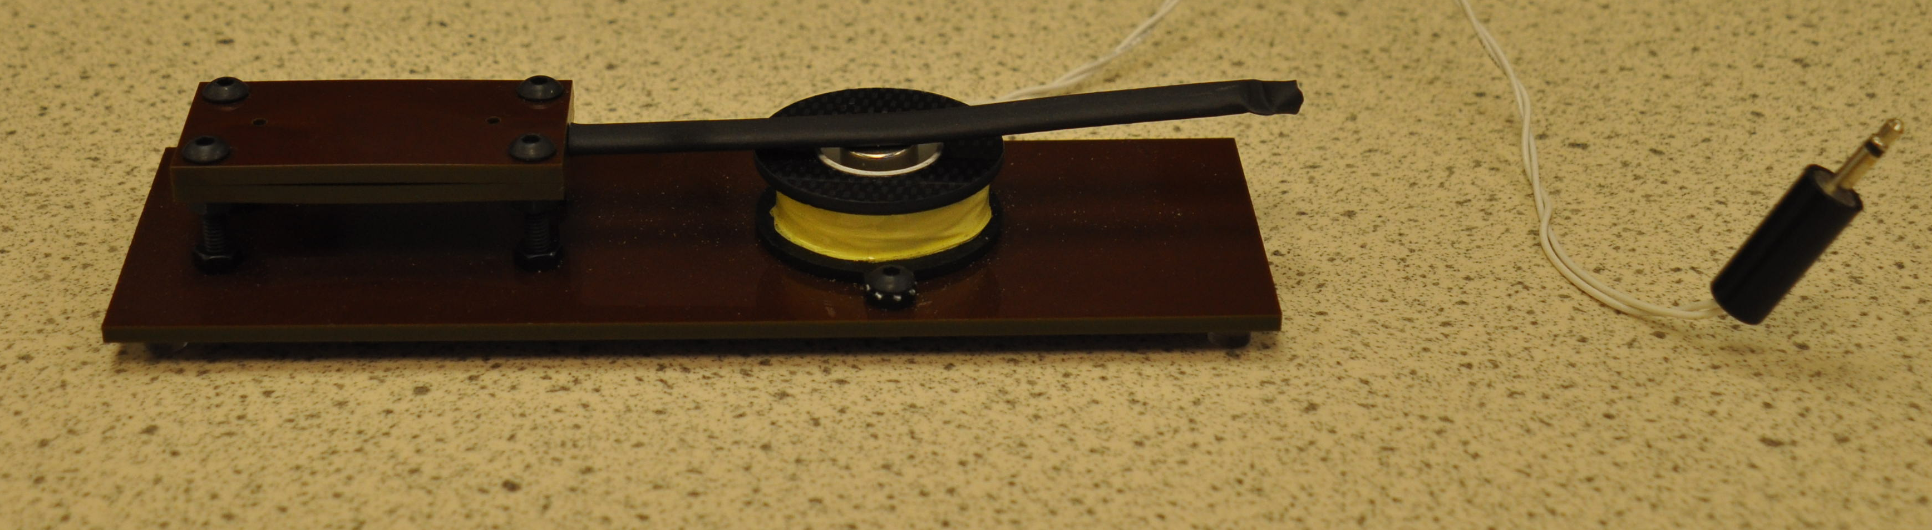

Investigation notes

A seismometer is a measuring device that detects earthquakes. Almost all seismometers are based on the principle of inertia. A suspended mass tends to remain still when the ground moves. One kind of model seismometer uses a magnet as the suspended mass. The magnet is attached to a metal arm and held inside a coil of wire, which is in contact with the ground or bench. As this surface vibrates, the coil vibrates. This movement, relative to the magnet, produces a small voltage, which can be measured. By connecting the output from the coil to the microphone input of a computer, software can be used to analyse the voltage and hence the amplitude of vibration of the coil.

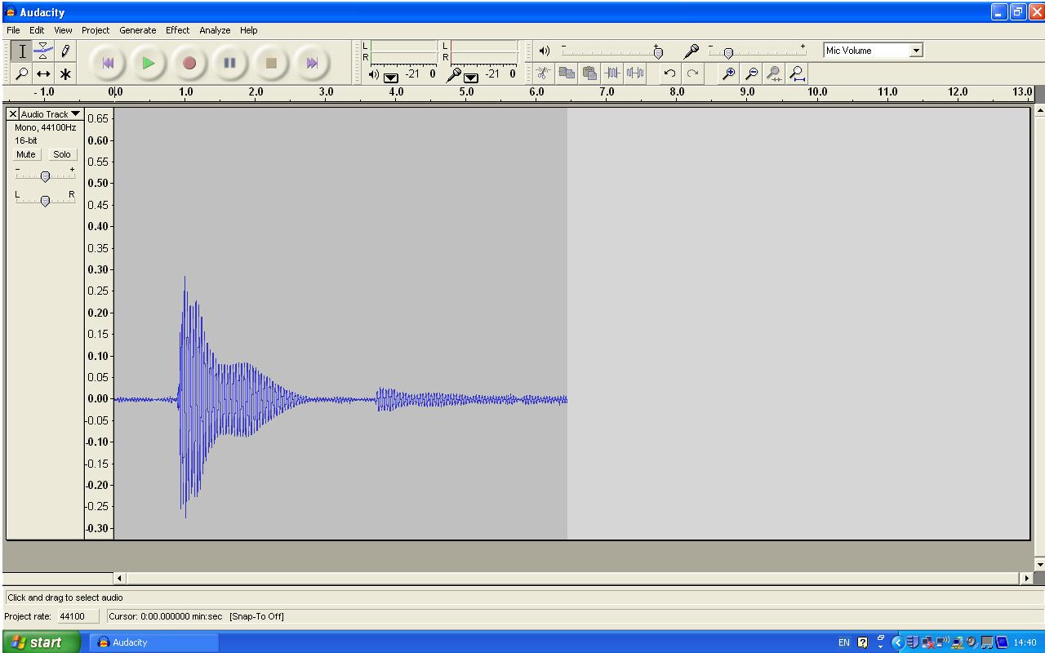
Audacity is one computer software package that can be used to analyse the voltage produced by the coil. You may need to spend some time familiarising yourself with it before carrying out the investigation.

It will be necessary to give some thought to how many times the experiment should be repeated. Also, you should give careful consideration to how you will present your results.

Practical Activity 3: Seismometers and the distance from an earthquake

Investigation brief

Earthquakes release an enormous amount of energy, which is transmitted away from the initial point of rupture by intense vibrations or seismic waves. These waves are what makes the ground shake and they can travel large distances in all directions.

The aim of this investigation is to compare the distance from an earthquake with the amplitude of the seismic waves.

In the laboratory, an earthquake can be simulated by dropping a weight onto a bench. The resulting vibrations can be detected with a model seismometer.

Discuss how you will carry out the investigation.

Write your plan in your record of work.

You should also include a hypothesis in your record of work. What do you think is the relationship between the distance from the earthquake (falling weight) and the amplitude of vibration?

Investigation notes

A seismometer is a measuring device that detects earthquakes. Almost all seismometers are based on the principle of inertia. A suspended mass tends to remain still when the ground moves. One kind of model seismometer uses a magnet as the suspended mass. The magnet is attached to a metal arm and held inside a coil of wire, which is in contact with the ground or bench. As this surface vibrates, the coil vibrates. This movement, relative to the magnet, produces a small voltage, which can be measured. By connecting the output from the coil to the microphone input of a computer, software can be used to analyse the voltage and hence the amplitude of vibration of the coil.

Audacity is one computer software package that can be used to analyse the voltage produced by the coil. You may need to spend some time familiarising yourself with it before carrying out the investigation.
It will be necessary to give some thought to how many times the experiment should be repeated. Also, you should give careful consideration to how you will present your results.

Practical Activity 4: Locating the epicentre of an earthquake

Investigation brief

By looking at the seismograms from different recording stations it is possible to find the epicentre of an earthquake. The seismic waves arrive first at the closest station and last at the furthest away. The time difference between the arrival of the waves is used to calculate the distance from the earthquake. In practice, measurements from at least three stations are required. In this investigation, two measuring devices (microphones) are used to find the location of a sound source placed between the microphones.

In the initial part of the investigation, you should measure the speed of sound in air. Knowing this, it is possible to use two microphones and computer software to locate the position of a sound source placed between the microphones.
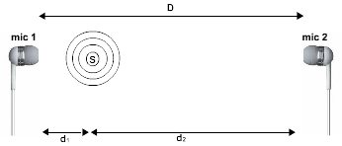
Discuss how you will carry out the investigation.

Write your plan in your record of work.

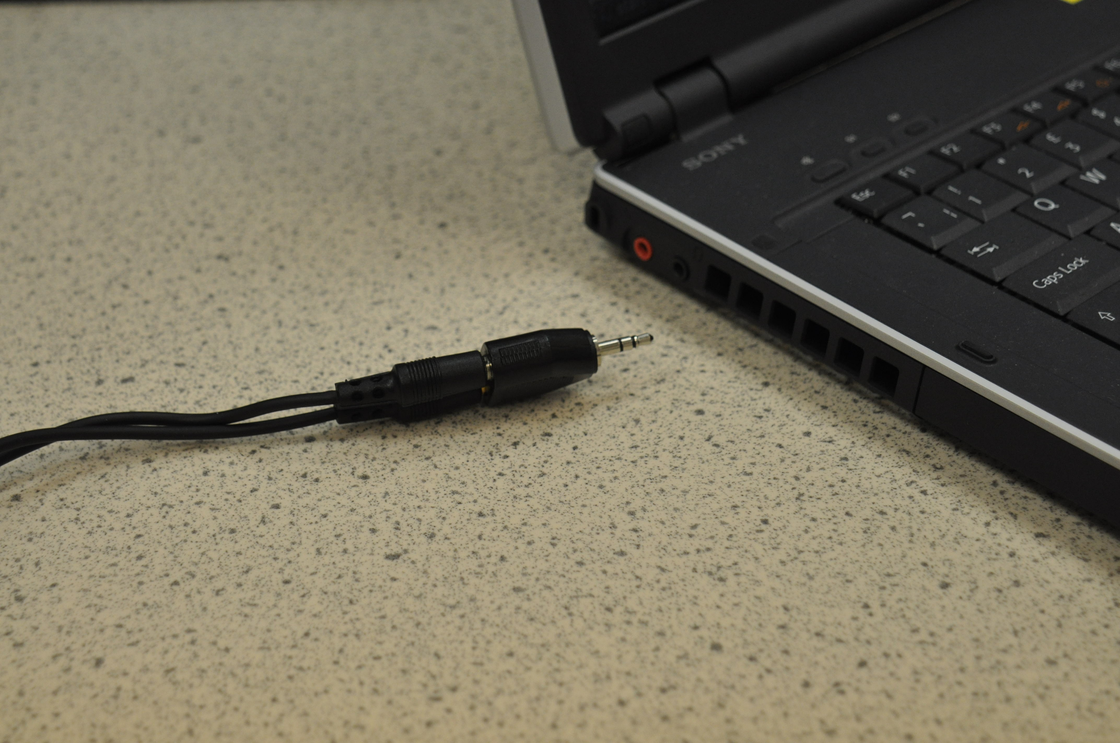
Investigation notes

Audacity is a software package that can be used to monitor the signal produced by two microphones. You may need to spend some time familiarising yourself with it before carrying out the investigation.

The two microphones can be connected via an adapter to the ‘Mic in’ point of some computers. Not all computers allow two channels to be monitored using Audacity. The time between two signal inputs can be measured when Audacity is set up to monitor a stereo input.

In measuring the speed of sound, you will need to consider where to position the microphones and what to use as a sound source.
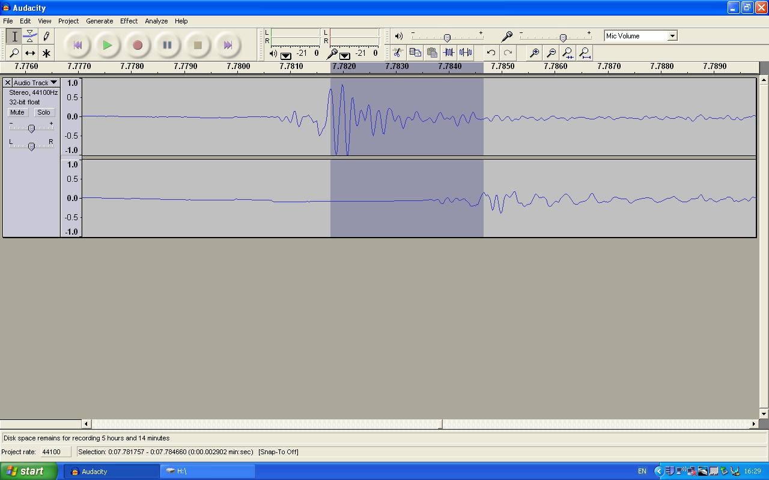
Knowing the speed of sound (v), it is possible to work out the location of the sound source when it is placed between the microphones if the time interval (Δt) between the two signals is known. By considering the diagram on the right you should derive a relationship so that d₁ (or d₂) can be found from D, v and Δt.

