**Planning the RP Unit Investigation**

For **ONE** of the experiments below you need to make a detailed plan of what you are completing.

RESOURCES- before you start read the Booklet X(21) RESEARCHING PHYSICS, also the Exoplanet pdf file background document.

**Wobbly Stars**

<http://en.wikipedia.org/wiki/Barycentric_coordinates_%28astronomy%29>

<http://astro.unl.edu/naap/esp/centerofmass.html>

**Background**

Kepler’s third law:



where p = orbital period (years) and a = average orbital distance (AU).

Thus mean orbital velocity = 

Newton’s version of this is:



but since Mstar >>> Mplanet



so given *p* measured from the Doppler effect we can find *a* (assuming the star’s mass is known).

Mplanet can be obtained by conservation of momentum i.e. there is no motion relative to the centre of mass of the rotating system:



*p* and *v* come directly from the Doppler plots, *a* is calculated as above so we can get *Mplanet*.

**The experiment**

Looking at the masses on a catenary experiment this last bit is relevant i..e conservation of momentum.

In general we can say that  where m is the mass of a body and the relevant *x* is the distance from that body to the centre of mass. That is what the data should show.

However, it looks like they only measured one of the x values. If the distance between the masses was kept constant something can be recovered since, if d is the total distance then



This is to do with Moments so you need to look up moments

You need the mass of each planet and the distance from the PIVOT point

**Planet Size and reduction of Irradiance detected from Sun**

**Background**

Area of “star”, 

Area of “planet”, 

When the planet blocks the light from the star the reduction in the intensity of radiation

is given by:



Reduction in intensity of radiation 

When I is the measured radiation with a planet blocking a part of the sun then:



If the unblocked radiation from the star, Is, is measured together with its radius, R, then we can plot the LHS vs. r2 and expect to get a gradient of 1/R2.

Things for your plan

1. Aim
2. What would you expect to happen (see front cover of the book)list, might be different to what you’d use.
3. kit list
4. THIS IS NOT THE INVERSE SQUARE LAW
5. Step by step set of instructions including what you’d measure and with what
6. Should this be a point source- NO!
7. What would you expect to happen?
8. How do you make your light bulb into a sun with a constant (making a light bulb diffuse)
9. Where should you put the planet to ensure that the light constantly is blocked?
10. How do you ensure each planet is blocked the same by the disc eg not reflecting light
11. Describe the background light level, if you can’t take this to zero how do you account for it?
12. How do you prevent shadows?
13. How do you ensure that other items don’t block the light?
14. Here you are needing to plot the light level without a planet (this is different to the ambient light level- so watch that)
15. You need to measure the radius (probably best to measure the diameter and divide by 2) of the sun and planet.
16. You need to measure find the reduction in light level.
17. The formula relates to the reduction in irradiance and radius of the planet over the sun.
18. Relative positions of Sun and planet- for good results make them close- why?
19. How are you going to note the position and make it even?
20. Do you need a ruler/ metre stick, if so where would you put it?

**Transit of Sun**

**Background**

<http://acrim.com/RESULTS/Venus%20Transit/aasposter12.pdf>

<http://www.sciencebrainwaves.com/blogs/physics/kepler-telescope-a-search-for-other-worlds/>

**Points to include**

1. Aim
2. What would you expect to happen (see front cover of the book)
3. Kit list, might be different to what you’d use.
4. Step by step set of instructions including what you’d measure and with what
5. How do you make your light bulb into a sun with a constant (making a light bulb diffuse)
6. Where should you put the planet to ensure that the light constantly is blocked?
7. How do you ensure each planet is blocked the same by the disc eg not reflecting light
8. Describe the background light level, if you can’t take this to zero how do you account for it?
9. How do you prevent shadows?
10. How do you ensure that other items don’t block the light?
11. Relative positions of Sun and planet- for good results make them close- why?
12. How are you going to note the position and make it even?
13. Do you need a ruler/ metre stick, if so where would you put it?

**National Unit specification: statement of standards**

**Unit title:** Researching Physics (SCQF level 6)

Acceptable performance in this Unit will be the satisfactory achievement of the standards set out in this part of the Unit specification. All sections of the statement of standards are mandatory and cannot be altered without reference to SQA.

**Outcome 1**

Research the physics underlying a topical issue to a given brief.

**Performance Criteria**

(a) Obtain and record information from suitable sources relating to focus questions from a given brief.

(b) The sources of information selected and recorded are identified.

**Outcome 2**

Plan and carry out investigative practical work related to a topical issue in physics.

**Performance Criteria**

(a) An appropriate experimental procedure is planned.

(b) The experimental procedure is carried out effectively.

**Outcome 3**

Prepare a scientific communication which presents the aim, results and conclusions from a practical investigation related to a topical issue in physics.

**Performance Criteria**

(a) The aim of the investigative work is clearly stated.

(b) Recorded information is analysed and presented in an appropriate format.

(c) Valid conclusions are drawn.

(d) A valid evaluation of procedures is made.

**Unit title:** Researching Physics (SCQF level 6)

**Evidence Requirements for this Unit**

Evidence is required to demonstrate that candidates have met the requirements of the Outcomes. Assessors should use their professional judgement to determine the most appropriate instruments of assessment for generating evidence and the conditions and contexts in which they are used. Exemplification of possible approaches may be found in the Unit support notes.

**Outcome 1**

Candidates will be provided with a briefing document which contains focus questions relating to key points of background information and/or physics theory likely to be unfamiliar to the candidate. Candidates must produce a brief report which contains:

* Clear and accurate answers to at least two focus questions selected from those contained in the brief.
* A record of at least two sources of information relating to each of the answers provided.

These should be identified in sufficient detail to allow a third party to retrieve the source article.

**Outcome 2**

Candidates should make an effective contribution to the planning and carrying out of investigative practical work. The teacher/lecturer must attest that this is the case.

**Outcome 3**

Candidates should produce a single scientific communication describing the investigative activity and its findings. The scientific communication must be the work of the individual candidate. Depending on the activity, the collection of information may involve group work. The scientific communication can take any format in which the results of scientific research are commonly reported including: conference poster format, scientific paper format, PowerPoint presentation, video presentation, web page or traditional lab report*.*

For this Unit, evidence may be written and/or oral and may be stored electronically. Assessor observation checklists may be used for recording purposes.

Exemplification of possible approaches may be found in topic exemplar material (available from LTS) and the Unit support notes.

Pupil Experimental Report

Aim

To find out the spectra of different light sources and compare them.

Method

The following equipment was used:

Digital Camera  
Spectrophotometer  
Light Sources:

Standard Torch  
 LED torch  
 Sodium lamp (gas discharge)  
 Natural light  
 Green LED  
 Red LED  
 Yellow LED  
 Power Supply  
 Wires  
 Resistor  
 Computer

To follow out this investigation I did the following. Firstly, I set up the light source to shine through a slit in the bottom of the spectrophotometer. This then passed through a diffraction grate which therefore allowed for a picture of the spectra of that particular light source. After the image was obtained, a digital camera was then used to take a photograph of this picture, and the resulting image was uploaded on to a computer. Tracker, the system used to process the results, was then used on the computer to obtain the graphs, valid for comparing the different spectras. This process was repeated for all light sources. The coloured LEDs were set up in a series circuit with a resistor and 5V power supply.

The light source was the only variable changed, with the distance from the spectrophotometer to the light source, the location of the room where the experiment took place (for consistent lighting). The light sources were different in either colour or form (i.e. gas discharge, filament bulb, natural light and LED).

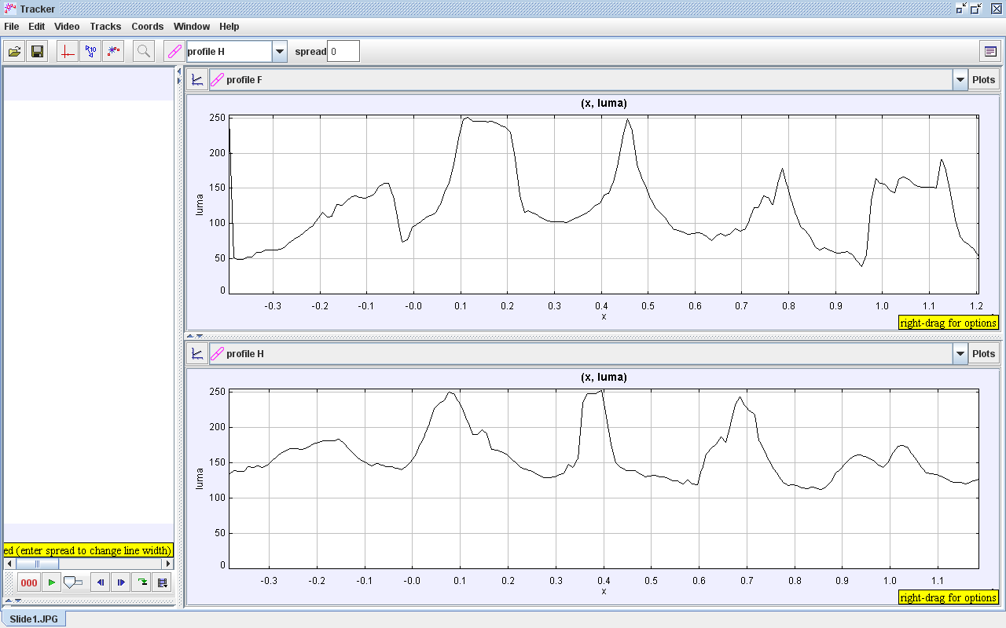Results Profile A – Sodium Lamp Profile B – Standard Torch

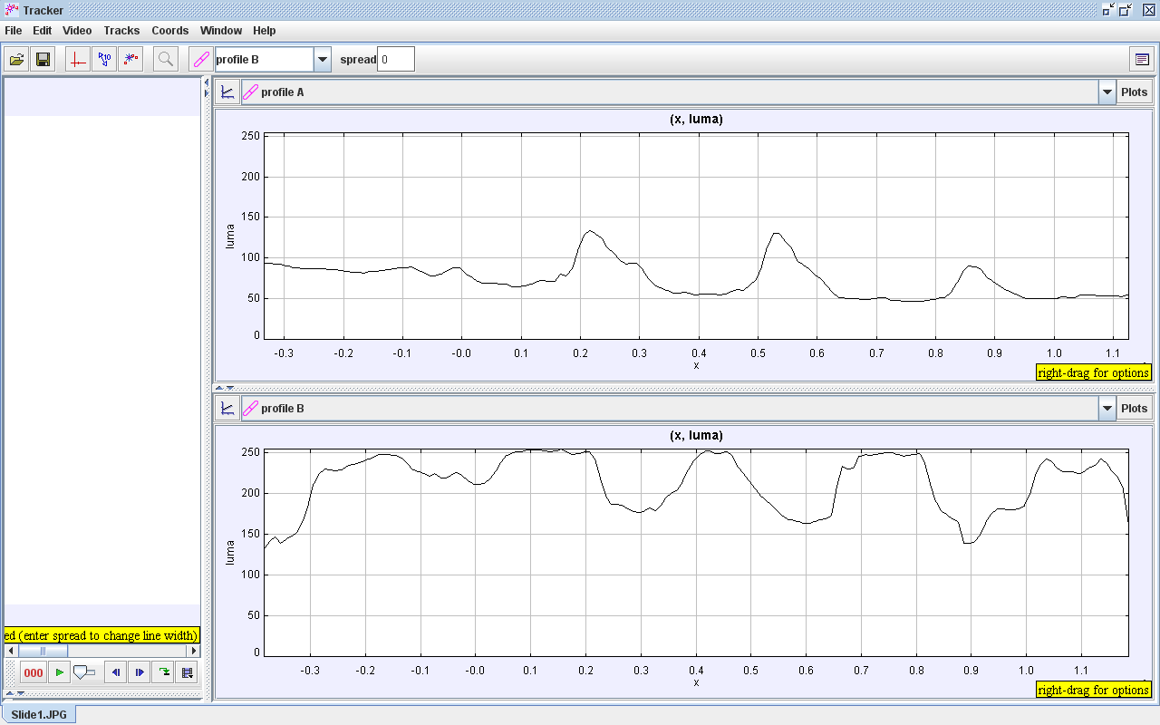 Profile F – LED Torch Profile H – Natural Light

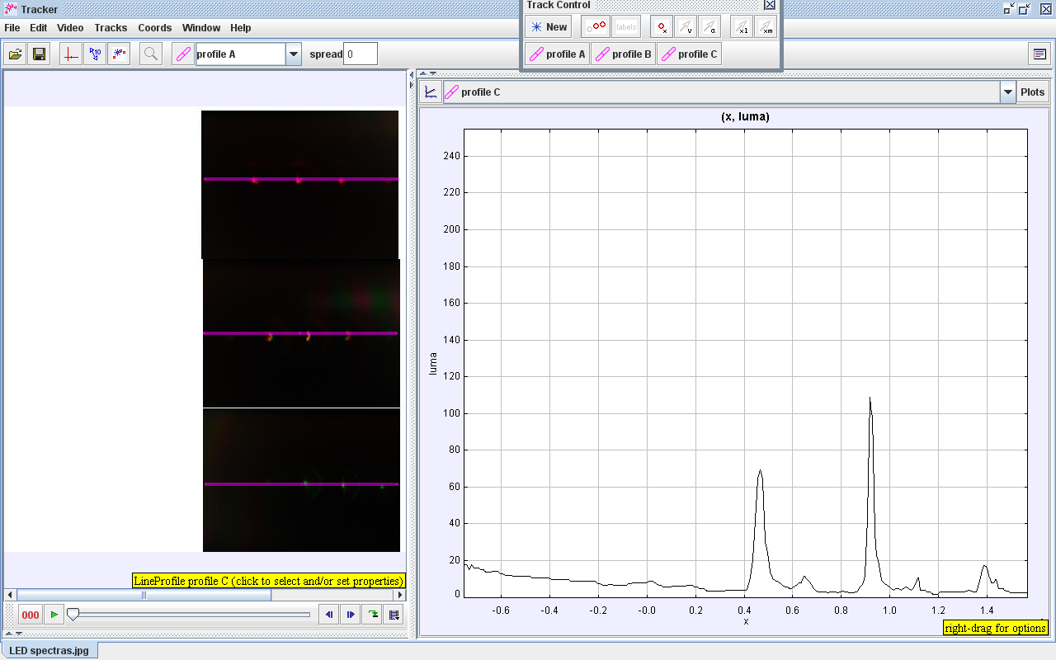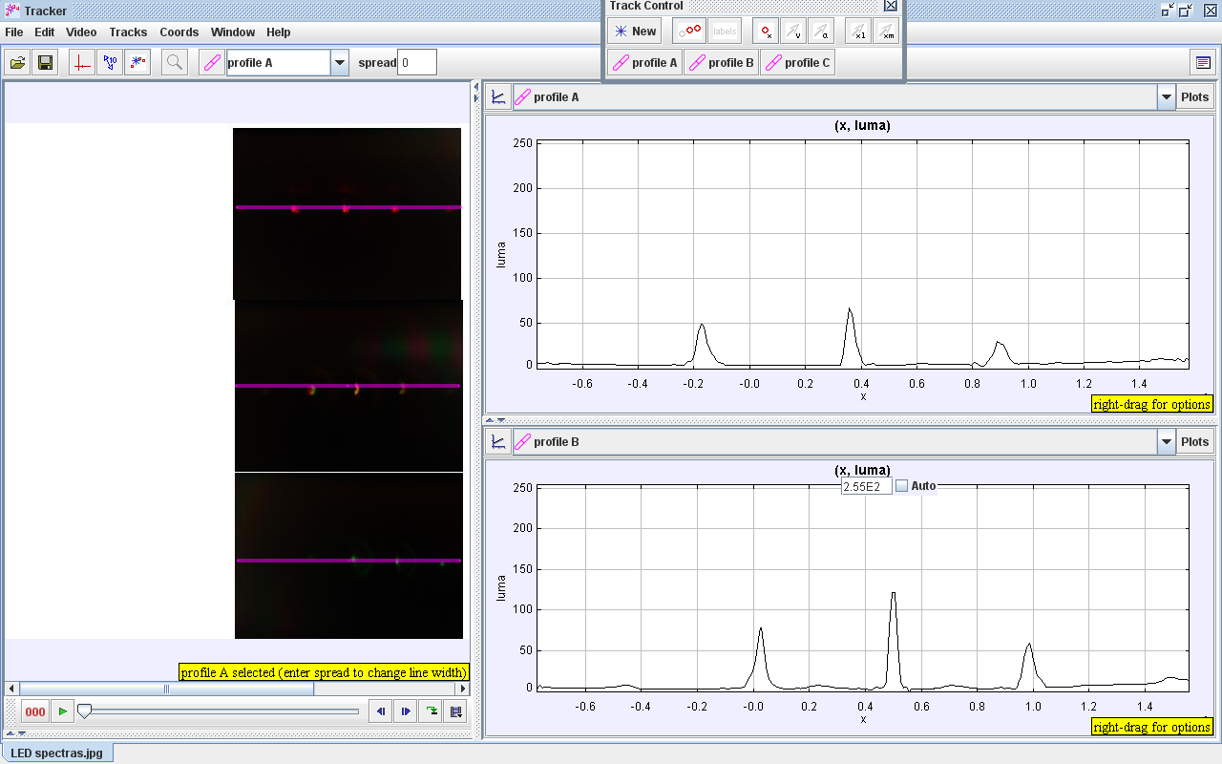Profile A – Red LED Profile B – Yellow LED Profile C – Green LED

Conclusion

Page 2 results

The results on page two compared different forms of light sources (i.e. gas discharge, filament, LED and natural light). On all sources the x axis shows frequency and the luma axis shows energy. The LED torch and natural light have a similar pattern in spectra; however, the natural light has a smaller range of energy output. The energy ratings in the LED torch range from 50 to 250 and natural light has a range from 150 to 250, showing natural light has half the energy range as LED. The sodium lamp has the lowest peak energy out of all the different forms. Its peak reached about 130 whereas the others had a peak energy of almost double.

Page 3 results

The results on page three compared how different colours of light affected the spectra. On all sources the x axis shows frequency and the luma axis shows energy. The yellow LED has the highest peak energy output and the red LED has the lowest peak energy about. The outputs show about 125 for yellow, whereas red has about 65 and green has about 110.

Evaluation

If the experiment was to be repeated, then there are several steps that could be taken to ensure the experiment is more valid. Firstly, the lighting in the room could have been kept at a more constant level. For example, a dark room would produce a constant light source compared to windows, which let in varying levels of light, and would not allow the light to interfere with the sources. Secondly, the room could have been darker which may have allowed for better contrast in photos of spectras. The graph results could also be calibrated to give more accurate results.