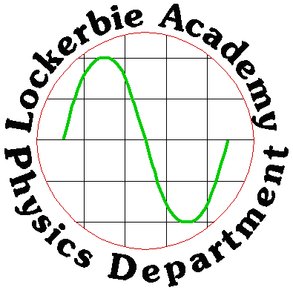
So what have you learned so far?
HIGHER REVISION TEST
HIGHER PHYSICS COURSE

J. A. Hargreaves
18th August 2013

BOOKLET 3a
SECTION Units Prefixes & Sci Notation TEST

1. Give the SI units for the following physical quantities

a) length, b) mass, c) acceleration, d) velocity, e) energy (5)

2. If a force of 1N is applied to a 3 kg mass what acceleration can this produce? (1)

3. A leaf of mass 0.1g feels a frictional force of 948μN as it falls from a tree. What is its acceleration as it falls? (take g as 9.8Nkg⁻¹ ).
Include a free body diagram of the leaf. (3)

4. Express the following in scientific notation.
a) 50mA
b) 0.3nF
c) 200s
d) 45μF (4)

SECTION Uncertainties TEST

1 a) Find the percentage error in the following display. (2)

0 10 20 30 40 50 60

2. Give an example of the following errors,
i) Random uncertainties,
ii) Systematic effects. (2)
3.
Time/s | 1.58 | 1.55 | 1.59 | 1.56 | 1.56 | 1.58

Calculate the percentage error in these results. (3)

4. What must you be aware of whenever you are making a measurement? (1)

5. How can you reduce the error that you make in your experiments? (1)

6. What is the best measurement that we can hope for? (1)

7. Draw a diagram illustrating the effects of a systematic error in a set of results. (1)

8. Estimate the scale-reading uncertainty in the following
a) a voltmeter reading of 0.12V
b) an ammeter reading of 1.0mA (4)

9. Find the absolute uncertainty in the following readings. (4)

Speed /ms ^{–1} | 0.97 | 0.92 | 1.07 | 1

b) What error has been made when recording the above results? (2)

10. The following results were obtained from an experiment.

distance = 1.00 ± 0.01m, time = 0.16 ± 0.02s

Calculate the speed from these results and express it in the form
final value ± uncertainty. (3)

Section- Introduction to Our Dynamic Universe Test (Part 1)

1. A fly crawls across a desk. Make a sketch of its path and mark on it the distance travelled, and the displacement of the fly. (3)

2. A dog runs from its kennel to the garden gate and back. Explain how to calculate its average speed and its average velocity. (2)

3. a) What is the definition of a vector quantity? (1)
b) Give one example each of vector and scalar quantities. (2)
c) A physicist measures the size of quantity A and the angle it makes with some reference line. He then measures the size of quantity B and the size of the angle through which a wheel C has been rotated. Classify each of these three measurements into either vector or scalar quantities. (3)

4. A farm trailer is moving north at 3.6ms-1 while the sheepdog in it walks east across the floor at 2.7ms-1. Use a scale diagram to find the dog's resultant velocity. (3)
5. What is meant by the resultant of a number of forces? (1)

6. What are the x and y components of a vector 25units long making an angle of 30o to the X-axis? (2)
7. A pond skating insect is blown east by a force of 5.1x10-3N and pushed by the water with a northerly force of 6.8x10-3N while its little feet paddle it west with a force of 10.2x10-3N. What is the resultant force on it? (3)

Section – More Introduction to Our Dynamic Universe. (Part 2)

1. What gives an acceleration of 1ms-2 to a 1kg mass? (1)
2. a) An object is accelerated at 1.8ms-2 by a force of 17 N. What is the mass of the object? (2)
b) 2x104 N acts on a mass of 1.25x103 kg. What acceleration does this cause? (2)
3. A bird's wings gives it a forward force of 10 N while its body gives it a drag of 8 N. Its mass is 2kg and its flight is horizontal.
a) Draw a free-body diagram for the bird. (2)
b) What is the bird's acceleration? (2)
4. a) A girl who weighs 500N runs up a flight of stairs in a time of 20s. If each step is 0.2m high and there are 60 steps in the flight, calculate the girl’s power. (2)
b) A pendulum bob of mass 1.0 kg is moved sideways until it has risen by a height of 0.45m. Calculate the speed of the bob at its lowest point. (Take g as 9.8Nkg⁻¹ ). (2)

