Particle Physics – The Standard Model

By early in the 20th century matter in the universe could be explained in terms of a nucleus, containing protons and neutrons, with orbiting electrons.
But
- New and unexplained particles were being found in cosmic rays.
- The missing energy in beta decay led scientists to postulate a new particle called the neutrino to carry the extra energy.
- The discovery of the positron lead to the idea that every particle has an antiparticle.
- Particle accelerators were being built and a host of new particles were being discovered. This lead to a zoo of particles.
- An important category of particle in this zoo is the mesons which have mass midway between protons and electrons.
It is important to realise these particles have very short lifetimes: they exist for less than a millionth of a second in cosmic rays and particle accelerators.

Quarks
To simplify the picture a new set of particles called quarks were predicted and the whole zoo of particles could be explained by combinations of these quarks. There are six quarks organised into three generations.

First Generation | Second Generation | Third Generation
Up | Charm | Top
Down | Strange | Bottom

- Everyday matter is made up of the first generation of quarks.
- Protons consist of two up quarks and a down quark.
- Neutrons consist of two down quarks and an up quark.
- Mesons consist of a quark – antiquark pair.

Leptons
Leptons consist of the electron and its heavier cousins the muon and the tau. Each has a neutrino associated with it. They are not thought to consist of simpler particles.
Forces
There are three forces and each one has an associated force carrying particle called a boson
- The electromagnetic force which holds electrons to the nucleus is the force that makes the world as we know it work. Interaction between electrons and the nucleus produces photons.
- The strong force binds the nucleus together and is associated with the gluon.
- The weak force causes radioactive beta decay and has two particles Z and W.
No one has been able to fit the gravitational force into the standard model. It would be nice if they could.

The whole picture is summarised in the table

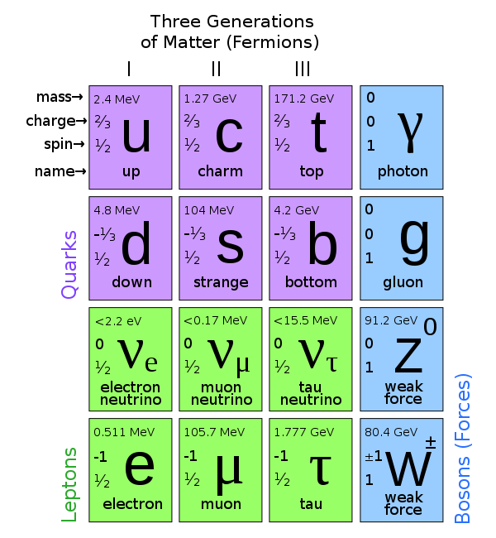http://www.stfc.ac.uk/1297.aspx
The theory predicts the existence of the Higgs Boson. Interaction with the Higgs field causes other particles to have mass. I think! The Higgs boson was finally identified in 2013 more than forty years after its existence was predicted.

