Higher

2017

J. A. Hargreaves

Lockerbie Academy

June 2015

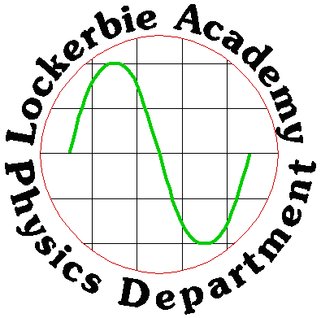

**Electricity- Part 2**



# Contents

Contents 2

CHAPTER 7 CONDUCTORS, SEMICONDUCTORS AND INSULATORS 4

Summary of Content 4

Summary of this chapter- notes from column three 4

Electrical properties of materials 4

Valence Electrons 5

Intrinsic Semiconductor 6

Holes 6

Band theory of solids 7

The Fermi Level (Going deeper) 9

CHAPTER 8 P-N JUNCTIONS 10

Summary of content 10

Group 4 Material -model 10

P- and N- Type Semiconductors 10

N-Type Semiconductor 11

P-Type Semiconductor 11

Notes on doping 12

P& N Junctions 15

Bands for Doped Semiconductors 14

Forward and Reverse Biasing 15

Biasing the diode 15

The forward-based diode 16

The reverse-biased diode 17

Voltage and Current graphs for junction diodes 17

Breakdown Voltage 18

Uses of Junction Diodes 18

Applications 19

Half wave rectification. 19

Full wave rectification. 20

Smoothing 21

Light Emitting Diodes (LED) 21

Practical 1: Finding the Switch on Voltage for A diode 23

Practical 2 Photodiode – photovoltaic mode 23

Practical 3 Forward and reverse-biased photodiode 24

Apparatus 24

Photodiodes 25

Photovoltaic mode 25

Energy Band diagram for the photodiode 25

The photodiode-reverse biasing 27

Photoconductive mode 27

Transistors 27

SUMMARY 27

Glossary for Revision 29

What charge carriers actually move across the p-n junction? 35

Tutorial 1: Semiconductors 35

Tutorial 2: Photodiodes 38

Tutorial Solutions 39

Tutorial Exam Questions 39

Tutorial Solutions- Exam Questions 45

***Acknowledgements:***

***Many of the diagrams and the information is taken from the HyperPhysics website The Physics website for Georgia State University.***

<http://hyperphysics.phy-astr.gsu.edu>

For a teacher’s update check out

<https://www.youtube.com/watch?v=uxUZvJ4F7_U>

Glossary:

<https://quizlet.com/90855867/122-conductors-semiconductors-and-insulators-flash-cards/>

# CHAPTER 7 CONDUCTORS, SEMICONDUCTORS AND INSULATORS

## Summary of Content

#### 5 CONDUCTORS, semiconductors and insulators

1. Knowledge that solids can be categorised into conductors, semiconductors or insulators by their ability to conduct electricity.
2. Awareness of the terms conduction band and valence band.
3. Qualitative explanation of the electrical properties of conductors, insulators and semiconductors using the electron population of the conduction and valence bands and the energy difference between the conduction and valence bands.

* Consideration of conducting and insulating materials in terms of the electron population of the conduction band.
* Consideration of the breakdown voltage of an insulator, for example in the context of lightning.
* Investigation of the operation of a Hall effect sensor.
* Investigation of the variation in resistance of a negative temperature coefficient thermistor as a function of its temperature.

## Summary of this chapter- notes from column three

**The electrons in atoms are contained in energy levels. When the atoms come together to form solids, the electrons then become contained in energy bands separated by gaps.**

**In metals, the highest occupied band is not completely full and this allows the electrons to move and therefore conduct. This band is known as the conduction band.**

**In an insulator, the highest occupied band (called the valence band) is full. The first unfilled band above the valence band is the conduction band. For an insulator, the gap between the valence band and the conduction band is large and at room temperature there is not enough energy available to move electrons from the valence band into the conduction band where they would be able to contribute to conduction. There is no electrical conduction in an insulator.**

**In a semiconductor, the gap between the valence band and conduction band is smaller and at room temperature there is sufficient energy available to move some electrons from the valence band into the conduction band allowing some conduction to take place. An increase in temperature increases the conductivity of a semiconductor.**

## Electrical properties of materials

Solids can be divided into ***three*** broad categories according to the availability of conduction electrons in their structures. They are ***conductors, insulators and semiconductors***.

|  |  |  |  |  |  |
| --- | --- | --- | --- | --- | --- |
| Solid classification | Definition | Example | | | Resistance  (1 m lengths and 0.1 mm2) |
| Conductors | **Materials with many free electrons. These electrons can easily be made to flow through the material.** | | **Silver copper Aluminium** | **R = 0.016 Ω R = 0.017 Ω R = 0.028 Ω** | |
| Insulators | **Materials that have very few free electrons.** | | **wood rubber plastic** | **R = 1×1018 Ω** | |
| Semiconductors | **These materials have resistances that lie between good conductors and good insulators. They are crystalline materials that are insulators when pure, but will conduct when an impurity is added and/or in response to light, heat, voltage, etc.** | | **Silicon Germanium** | **R = 6 × 107 Ω R = 2.3 × 1011 Ω** | |

**In CONDUCTORS an increase in temperature, leads to an increase in the resistance.**

**In SEMICONDUCTORS an increase in temperature results in a decrease in the resistance.**

## Valence Electrons

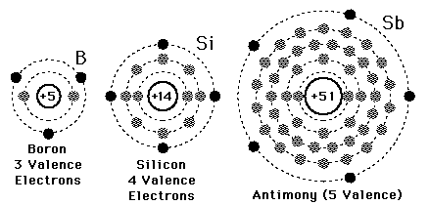The electrons in the outermost shell of an atom are called valence electrons; they determine the nature of the chemical reactions of the atom and greatly influence the electrical nature of solid matter.

Si

Si

Si

Si

Si

**Silicon (germanium) and its lattice**

Solid state electronics arises from the unique properties of silicon and germanium; both these materials have a valency of four, that is they have four outer electrons available for bonding. In a pure crystal, each atom is bonded covalently to another four atoms; all of its outer electrons are bonded and therefore there are few free electrons available to conduct. This makes the resistance very large. Such pure crystals are known as **intrinsic semiconductors.**

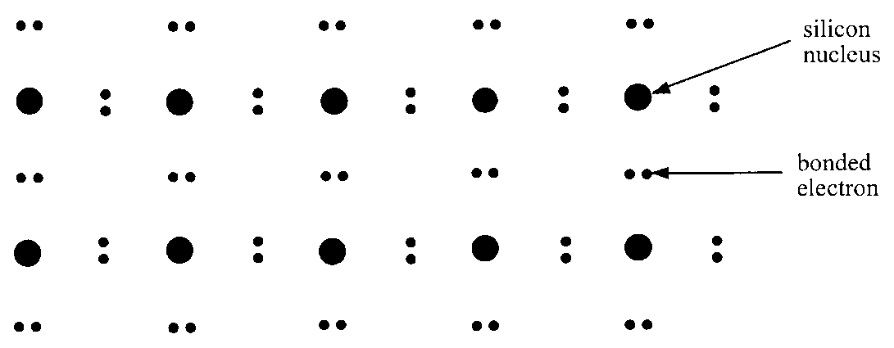

The few electrons that are available come from imperfections in the crystal lattice and thermal ionisation due to heating. **A higher temperature will result in more free electrons, increasing the conductivity and decreasing the resistance, as in a thermistor**.

## Intrinsic Semiconductor

This silicon or germanium crystal is called an intrinsic semiconductor, also called an undoped semiconductor, and a pure semiconductor which can conduct a small amount of current. The generally small currents consist of drifting electrons in one direction and drifting holes in the other.The number of charge carriers is therefore determined by the properties of the material itself instead of the amount of impurities.

A silicon crystal is different from an insulator because at any temperature above absolute zero, there is a finite probability that an electron in the lattice will be knocked loose from its position, leaving behind an electron deficiency called a "hole". In an intrinsic semiconductor the number of electrons in the conduction band is equal to the number of holes in the valence band.

## Holes

When an electron leaves its position in the crystal lattice, there is a space left behind that is positively charged. This lack of an electron is called a **positive hole**.

This hole may be filled by an electron from a neighbouring atom, which will in turn leave a hole there. Although it is technically the electron that moves, the effect is the same as if it was the hole that moved through the crystal lattice. The hole can then be thought of as a positive charge carrier. In complex semiconductors it is easier to calculate what is happening in terms of one moving positive hole, rather than many electrons.

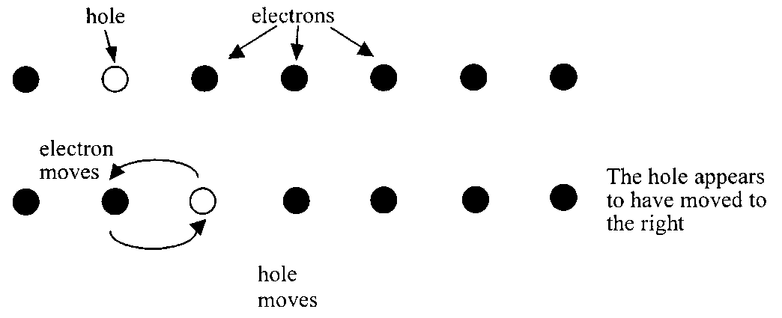

This is like a game of checkers where a marble is moved across the board and leaves a hole behind. The difference is that in checkers the marbles are only allowed to jump over another marble, in an extrinsic semiconductor the closest electron would fill the hole.

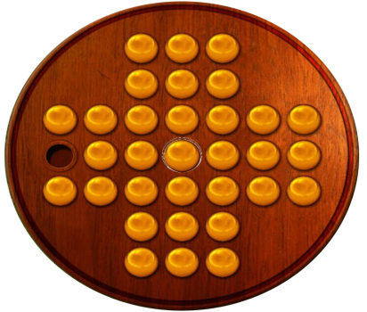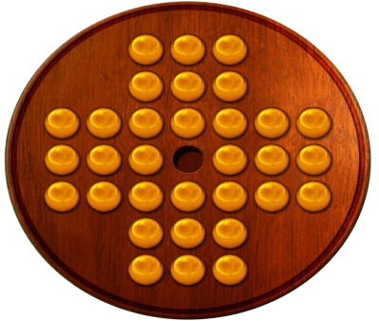

Although it is the marbles that are moving it appears that the hole moves to the left as the

marbles move to the right.

## Band theory of solids

Electrons in atoms are contained in energy levels. When the atoms come together to form solids, **a model** of the atom suggests the electrons then become contained in energy bands separated by gaps. We can represent the three types of solid as diagrams showing these two bands. The two highest energy bands are known as the **valence band** and the **conduction band, the conduction band being the highest of the energy bands**.

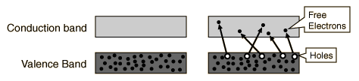

Conduction will occur if there are electrons in the conduction band. In insulators the electrons in the valence band are separated by a large gap from the conduction band, in conductors like metals the valence band overlaps the conduction band, and in semiconductors there is a small enough gap between the valence and conduction bands that thermal or other excitations can bridge the gap. With such a small gap, the presence of a small percentage of a doping material can increase conductivity dramatically. Doping is adding a small proportion of impurities to an intrinsic semiconductor material.

**Electrons are held tightly in the valence band, but are able to move freely in the conduction band.**

|  |  |
| --- | --- |
| **valence**  **band**  **conduction**  **band**  **semiconductor**  **valence**  **band**  **conduction**  **band**  **insulator**  band gap  **valence**  **band**  **conduction**  **band**  **conductor** | In a conductor,e.g metals, the bands overlap and the conduction band contains electrons free to move. These electrons can move to produce the current when an e.m.f. is applied to the solid.  In an insulator, the highest occupied band (called the valence band) is full. The first unfilled band above the valence band is the conduction band. There is a large energy gap between the bands [**band gap**]. It is so large that electrons almost never cross the gap and the solid never conducts, and at room temperature there is not enough energy available to move electrons from the valence band into the conduction band where they would be able to contribute to conduction. There is no electrical conduction in an insulator.  If we supply enough energy the solid will conduct but often the large amount of energy ends up destroying the solid.  Semiconductors are like insulators in that the valence band is full. However the gap between the two bands is small and at room temperature some electrons have enough energy to jump the gap and move from the valence to the conduction band. An increase in temperature increases the conductivity of a semiconductor. |

## The Fermi Level (Going deeper)

If an atom is cooled to absolute zero temperature (0 K) the thermal energy available to its electrons is zero. If all its electrons were removed and replaced one by one, each electron would occupy the lowest available energy level at the time. Since electrons cannot occupy the same level, the electrons would fill up the atom from the bottom up. The **Fermi Level** is the name given to the highest occupied energy level of the electron in the valence band. This would be occupied by the last electron to be replaced.

No overlap

Electron

energy

Fermi level

Insulator

Band gap

Semiconductor

Conductor

Valence

band

Valence

band

Valence

band

Conduction

band

Conduction

band

Conduction

band

Bands

overlap

In a conductor, there is no energy gap between the top Fermi level of the valence band and the lowest energy level of the conduction band. At normal room temperature, there is some thermal energy available to the electrons. Effectively this means that the valence band and the conduction bands overlap. In contrast, for a semi-conductor there is a small energy band gap, and for an insulator there is a large energy band gap.

***NB* The FERMI LEVEL cannot be in an energy gap, it is shown here as this would be the average energy of the Fermi level.**

# CHAPTER 8 P-N JUNCTIONS

## Summary of content

#### 6 p-n junctions (chapter 8)

1. Awareness that, during manufacture, the conductivity of semiconductors can be controlled, resulting in two types: p-type and n-type.
2. Knowledge that, when p-type and n-type materials are joined, a layer is formed at the junction. The electrical properties of this layer are used in a number of devices.
3. Awareness of the terms forward bias and reverse bias.
4. Knowledge that solar cells are p-n junctions designed so that a potential difference is produced when photons enter the layer. (This is known as the photovoltaic effect.)
5. Knowledge that LEDs are forward biased p-n junction diodes that emit photons when electrons ‘fall’ from the conduction band into the valence band of the p-type semiconductor.

* Investigation of the variation in the output voltage of a solar cell as a function of the irradiance and frequency of incident light.
* Investigation of the switch-on voltage of different coloured LEDs.

## Group 4 Material -model

## P- and N- Type Semiconductors

The electrical properties of semiconductors make them very important in electronic devices like transistors, diodes and light-dependent resistors (LDRs). In such devices the electrical properties are dramatically changed by the addition of very small amounts of impurities. The process of adding impurities to these semiconductors is known as doping and once doped they are known as **extrinsic semiconductors**. We can dope group 4 elements by adding a small portion of a Group 3(trivalent) or Group 5 (pentavalent) material.

|  |  |
| --- | --- |
|  |  |
| Adding Group 3 (eg. Gallium, Ga, and Indium, In) gives a POSITIVE material (p-type, hole or positive hole). | Adding Group 5 (eg. Arsenic, As, and Antimony, Sb) gives a NEGATIVE material (n-type, electron). |

## N-Type Semiconductor

|  |  |
| --- | --- |
|  | The addition of a group 5 material, such as antimony, arsenic or phosphorous contributes free electrons, which makes the semiconductor more conductive. The overall charge on the n-type semiconductor is still **zero** as each electron has a proton held in the nucleus to match its charge  **Valence**  **Band**  **Conduction**  **Band**  Extra electron energy level  Fermi level  Si  Si  Si  As  Si  Arsenic contributes free electrons |

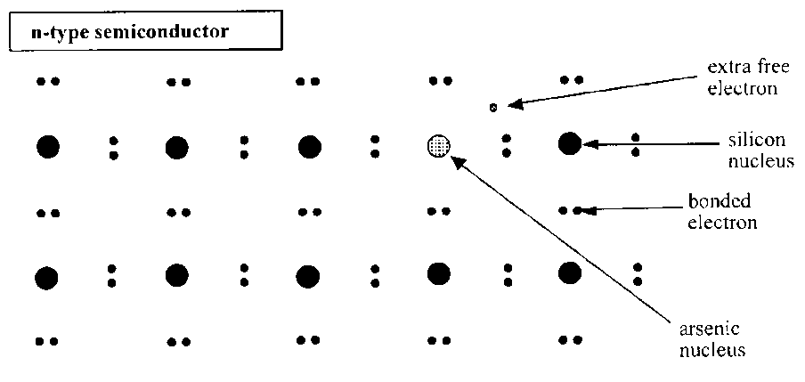Doping with a group 5 material means that the atoms have five outer electrons in the outer shell. Four of these electrons fill up the valence band, leaving one electron in the conduction band. Electrons in the conduction band are free to move, thus allowing conduction.

## P-Type Semiconductor

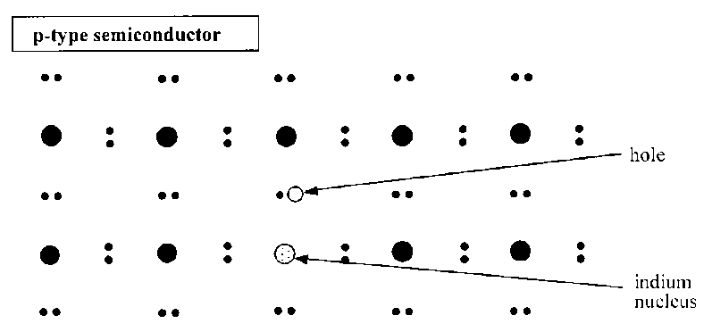

|  |  |
| --- | --- |
| The addition of materials in group 3 in the periodic table such as boron, aluminium or gallium to an intrinsic semiconductor creates a lack of valence electrons, called "holes". The overall charge on the p-type semiconductor is still **zero** as each electron has a proton held in the nucleus to match its charge.  **Valence**  **Band**  **Conduction**  **Band**  Extra electron energy level  Fermi level  Si  Si  Si  Ga  Si  Gallium acceptor impurity creates hole |  |

## Notes on doping

* **The doping material cannot simply be added to the semiconductor crystal. It has to be grown into the lattice when the crystal is grown so that it becomes part of the atomic lattice.**
* **The quantity of impurity is extremely small; it may be as low as one atom in a million. If it were too large it would disturb the regular crystal lattice.**
* **Although p-type and n-type semiconductors have different charge carriers, they are still both overall neutral (as any electron in its shell is ‘equalized’ by a proton in the nucleus).**
* **In terms of band structure we can represent the electrons as dots in the conduction band, and holes as circles in the valence band. The majority of charge carriers are electrons in n-type and holes in p-type, respectively.**

**However, there will always be small numbers of the other type of charge carrier, known as minority charge carriers, due to thermal ionisation.**

Diagrams showing doped crystals

Si

Si

Si

As

Si

Arsenic contributes free electrons

Si

Si

Si

Ga

Si

Gallium acceptor impurity creates hole

HOLE

Mrs Hargreaves’ representation of a p-type semiconductor, with additional holes

Group 5 material

ELECTRON

Mrs Hargreaves’ representation of a n-type semiconductor, with additional electrons.

In an intrinsic semiconductor the creation of an electron-hole pair means that every electron which is boosted to the conduction band leaves behind a hole in the valence band. This is shown in (a).

Electron

energy

Fermi level

Conduction

band

Conduction

band

Conduction

band

(c) p-type

semiconductor

(b) n-type

semiconductor

(a) Intrinsic semiconductor

Valence

band

Valence

band

Valence

band

**Fermi level decreased**

**Fermi level increased**

Figure (b) shows an **n-type semiconductor.** The addition of Group 5 “donor” atoms into the semiconductor introduces electrons in new energy levels which are just below the conduction band. Resulting in extra electron energy levels closer to the conduction band **This raises the Fermi level.** It takes much less energy to boost these electrons into the conduction band. As these are electrons from group 5 atoms, when they move into the conduction band, they do not leave a hole behind in the valence band. At higher temperatures, a few electrons are boosted directly from the valence band up to the conduction band, creating some holes in the valence band which are free to move. Holes are the minority charge carriers in an n-type material.

In a **p-type semiconductor** (c) the addition of Group 3 acceptor atoms **lowers the Fermi level**. However, because of the impurities, there are now stable energy levels for the valence electrons to fill which are much closer than the original conduction band. Valence electrons can move into this level, leaving behind **a hole in the valence band**. This hole is the majority charge carrier and is free to move. As before, at higher temperatures, some electrons are boosted directly up to the conduction band. These electrons are free to move and are the minority charge carriers in the p-type material.

## Bands for Doped Semiconductors

The application of band theory to n-type and p-type semiconductors shows that extra levels have been added by the impurities. In n-type material there are electron energy levels near the top of the band gap so that they can be easily excited into the conduction band. In p-type material, extra holes in the band gap allow excitation of valence band electrons, leaving mobile holes in the valence band.

## P& N Junctions

*When p-type and n-type material are joined, a layer is formed at the junction. The electrical properties of this layer are used in a number of devices.*

**n-type**

p-type

The different types of semiconductor have to be grown together so that one half is p-type and the other half is n-type, the product is called a **p–n junction** and it functions as a **diode**.

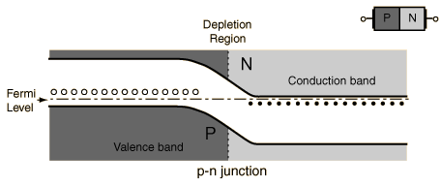

*Representation of a p-n junction at equilibrium*

When an electron meets a hole, they recombine, i.e. the electrons ‘fill in’ the holes, creating a charge imbalance: excess negative charge in the p-type region and excess positive in the n-type. This creates a slope in the conduction level which acts as a potential barrier (*Vi* ≈ 0.7 V for silicon) since it would require work of *eVi*to be done in order to get electrons to move against the barrier (*e* is the electron charge).

An excess of n-type electrons diffuse across the junction to fill holes on p-type side which becomes negatively charged while n side becomes positively charged. Any free electrons in junction drift back towards the n-type material, resulting in the holes drifting back to the p-type.

The build-up of charge on either side of the junction causes any free electrons/holes in the junction to **drift** back across the junction. Once this drift balances the diffusion in the opposite direction, equilibrium is reached and the Fermi level (where you are likely to find electrons) is flat across the junction.

When no external voltage is applied to a p–n junction we refer to it as unbiased.

## Forward and Reverse Biasing

### Biasing the diode

When we apply an external voltage we say that the diode is biased. There are two possibilities: forward and reverse bias.

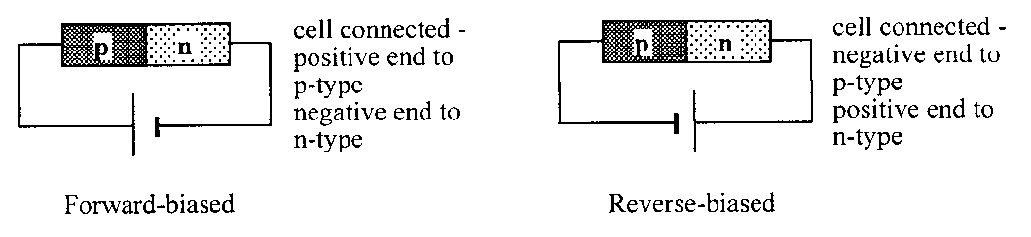

### The forward-based diode

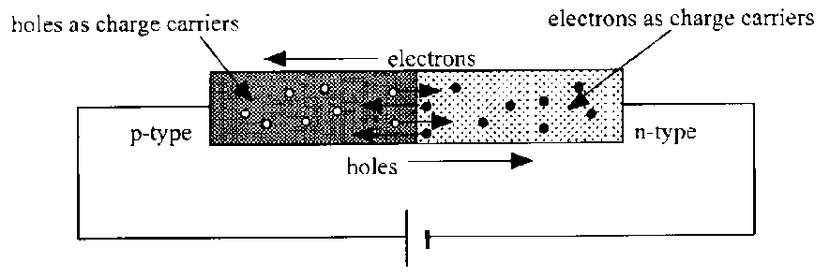FORWARD BIASING 🡺 CURRENT

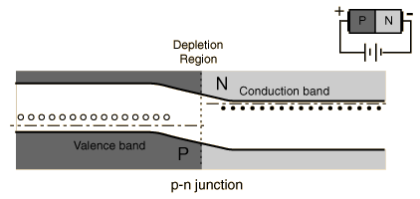When the p-side is attached to the positive side of a battery (*V*a = applied voltage) then the electrons at that side have less potential energy than under no bias. This lowers the Fermi level and the conduction bands on the p-side from where they were originally. We say it is **forward biased**.

Acknowledgement: Hyperphysics

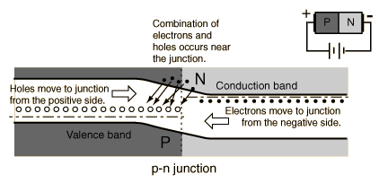

As the applied voltage (Va) approaches the built in voltage (Vi), more electrons will have sufficient energy to flow up the now smaller barrier and an appreciable current will be detected. Once the applied voltage reaches the in-built voltage there is no potential barrier and the p–n junction presents almost no resistance, like a conductor. The holes are similarly able to flow in the opposite direction across the junction towards the negative side of the power supply.

### The reverse-biased diode

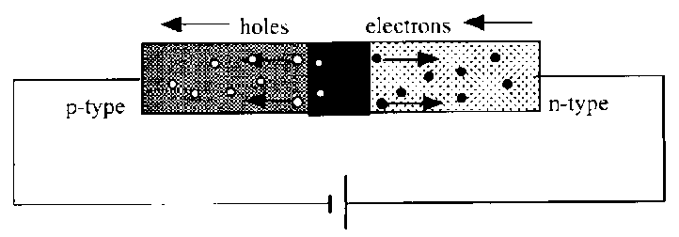REVERSE BIASING 🡺 NO CURRENT

The applied voltage can either act against or with the in-built potential barrier. When the p-side is attached to the negative side of a power supply (*V*a, the applied voltage is now negative) then the electrons at that side have more potential energy than previously. This has the effect of raising the bands on the p-side from where they were originally. We say it is **reverse biased**.

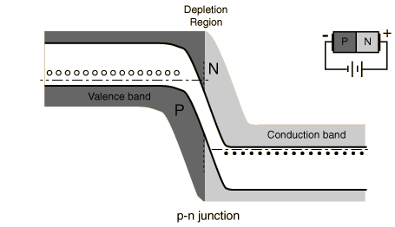

Almost no conduction can take place since the battery is trying to make electrons flow ‘up the slope’ of the difference in the conduction bands. The holes face a similar problem in flowing in the opposite direction. The tiny current that does flow is termed reverse leakage current and comes from the few electrons which have enough energy from thermal ionisation to make it up the barrier.

### Voltage and Current graphs for junction diodes

**I–V characteristics**

A graph of the variation of current with pd across a p–n junction is shown below:

In reality the graph is slightly different!

V

I

Forward bias

Reverse bias

0

## Breakdown Voltage

The breakdown voltage of an insulator is the minimum voltage that causes a portion of an insulator to become electrically conductive.

The breakdown voltage of a diode is the minimum reverse voltage to make the diode conduct in reverse. Some devices (such as TRIACs) also have a forward breakdown voltage.

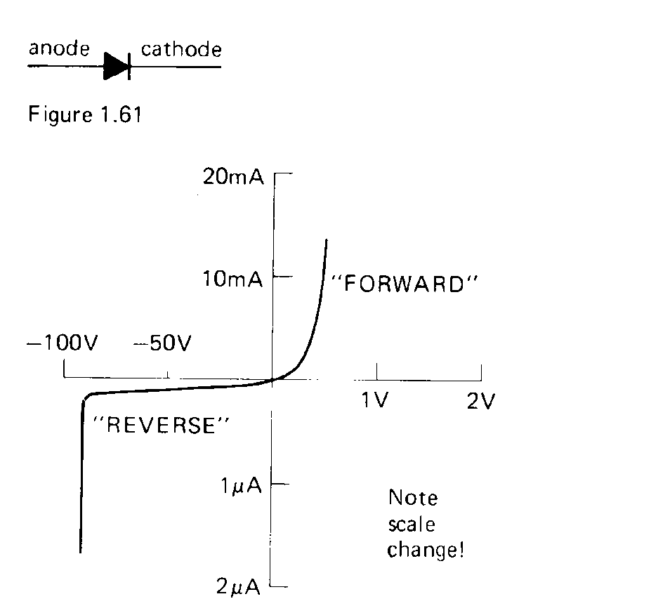The rapid change in current at about –90V is the reverse breakdown voltage

(Note the different scale on each side of the x-axis)

## Uses of Junction Diodes

+ -

Valuable

Component

**diode**

A diode can be placed as a safety device in a circuit to protect the circuit or a valuable component against incorrect polarity. Usually when the batteries are inserted correctly the diode is in reverse bias and there is no conduction through it. The valuable component works as it is designed. If the power supply is connected with the wrong polarity this could potentially destroy the component, however, the diode is now in forward bias and provides a route for the current. Charge flows through the diode in preference to the valuable component, which is not working, but is not damaged.

Valuable

Component

Diode

FORWARD BIAS

- +

Valuable

Component

Diode

REVERSE BIAS

+ -

## Applications

c.r.o. screen

### Half wave rectification.

Adding a single diode in a circuit is a very basic way of providing a d.c. from a.c., but for half the cycle there is zero voltage and current in the circuit. Many circuits would not work with this design, and a more appropriate circuit is required.

### Full wave rectification.

This is a better way of getting d.c. from a.c. and is known as a BRIDGE RECTIFIER.

c.r.o. screen

LOAD

c.r.o. screen

LOAD

+

-

c.r.o. screen

LOAD

+

-

## Smoothing

As previously mentioned in the capacitance section adding a capacitor to the bridge rectifier circuit smooths the voltage across the component and results in a more consistent voltage or ripple voltage.

## Light Emitting Diodes (LED)

*LEDs are p-n junctions which emit photons when a current is passed through the junction.*

A photon is emitted when a hole and electron recombine. This happens in all diodes but energy is usually given off in the form of heat.

clear plastic case

with convex lens to focus light

junction near the surface

connections

**+ve**

**-ve**

**flow of electrons**

LED

**Gallium arsenide phosphide** can give **out red, green or yellow** depending on the proportions used. The light is only of use if it can escape from the diode so the junction is designed to be close to the surface

We have seen that in a forward-biased p-n junction diode, holes and electrons pass through the junction in opposite directions. Sometimes holes and electrons will meet and recombine. When this happens, energy is emitted in the form of a photon. For each recombination of electron and hole, one photon of radiation is emitted. In most semiconductors this takes the form of heat, resulting in a temperature rise. In some semiconductors such as gallium arsenic phosphide, however, the energy is emitted as light. If the junction is close to the surface of the material, this light may be able to escape. This makes a **Light Emitting Diode (LED)**. The colour of the emitted light (red, yellow, green, blue) depends on the relative quantities of the three constituent materials. The recombination energy can be calculated using E = hf if the frequency of the light emitted is measured.

The LED does not work in reverse bias since the charge carriers do not travel across the junction towards each other so cannot recombine.

**Worked example**

(a) Explain how a semiconductor is ‘doped’ to form a p-type semiconductor and how this doping affects the electrical properties of the semiconducting material.

p

n

0·7 V

A

B

(b) A potential difference of 0.7 V is maintained across the ends of a p–n diode as shown in the diagram:

1. In what direction do the majority of the charge carriers in the p-type material flow?
2. The recombination of charge carriers in the junction region can be represented by a transition between two energy levels separated by 2·78 × 10–19 J. What is the wavelength of the radiation emitted from the junction region?

(a) The semiconducting material has added to it very small quantities of an element; this has fewer outer electrons. When a material is doped in this way there exists in its atomic arrangement places where electrons should be, but are not. These places are called positive holes, hence p-type semiconductor. The existence of these positive holes gives rise to conduction through the migration of electrons into holes. Thus the resistance of the semiconductor is reduced.

(b) (i) A to B

(ii) *E* = *hf*

2·78 × 10–19 = 6·63 × 10–34 × *f*

*f* =  = 4·19 × 1014 Hz

*λ* =  = 7·16 × 10–7 m (716 nm)

## Practical 1: Finding the Switch on Voltage for A diode

#### Aim

Measurement of the variation of current with applied p.d. for a forward and reverse-biased p-n junction.

#### Apparatus

1.5 V cell, p-n junction diode, potentiometer, milliammeter, voltmeter.

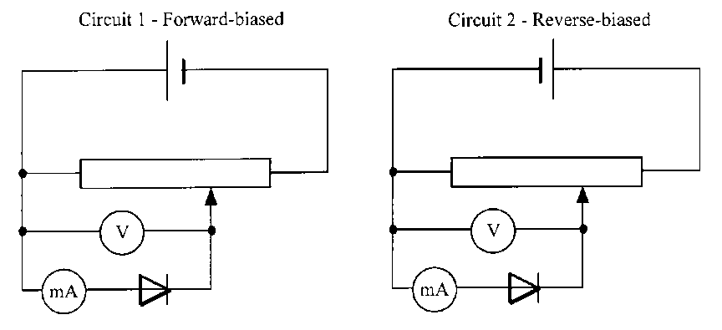

#### Instructions

1. Set up circuit 1, the forward-biased diode.
2. The diode is connected in the circuit so that the current through it can be measured as the p.d. across it is increased.
3. For a range of values of potential difference across the diode, measure the corresponding value of current through it.
4. 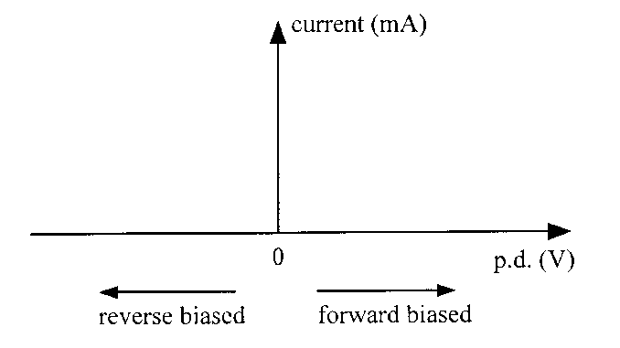Reverse the 1.5 V cell so that the diode is reverse-biased. Again increase the p.d. across the diode and note the current through it.
5. Graph your results with current on the y axis and p.d. across the diode on the x axis. Reverse bias p.d. can be represented by negative values on the y axis.

## Practical 2 Photodiode – photovoltaic mode

#### Aim

To measure the frequency of an a.c. supply using a photodiode in photovoltaic mode.

#### Apparatus

12 V a.c. power supply, 12 V lamp, photodiode, oscilloscope.

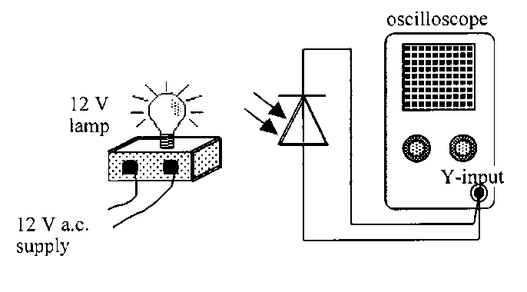

#### Instructions

1. Set up the circuit above, preferably with the room darkened.
2. Adjust the oscilloscope to obtain a clear trace.
3. Calculate the frequency of the wave trace produced.
4. Write a conclusion based on the results of the experiment.

## Practical 3 Forward and reverse-biased photodiode

### Apparatus

1.5 V cell, photodiode, potentiometer, milliammeter, voltmeter, 12 V lamp and power supply.

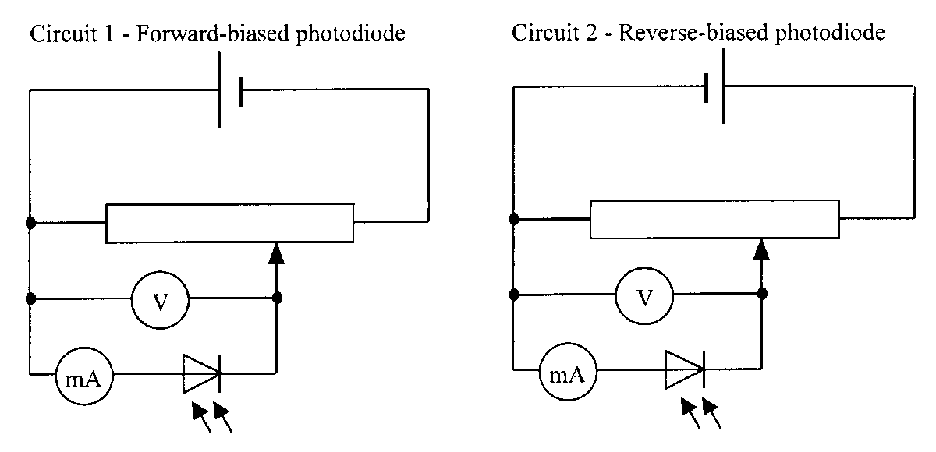

#### Instructions

1. Set up Circuit 1, the forward-biased photodiode.
2. In a darkened room, position the 12 V lamp to give a constant fixed level of illumination of the diode.
3. Using the potentiometer, adjust the value of the potential difference across the photodiode.
4. For a range of values of potential difference across the photodiode, measure the corresponding value of current through it.
5. Repeat for the reverse-biased photodiode in Circuit 2.
6. Use an appropriate format to show the relationship between current and applied p.d. for both circuits.

## Photodiodes

Photodiodes can be used in two modes:



* Photovoltaic – no biasing
* Photoconductive- reversed biased.

## Photovoltaic mode

*Solar cells are p-n junctions are designed so that a potential difference is produced when photons enter the layer. This is the photovoltaic effect.*

Photovoltaic mode is the basis of SOLAR CELLS and can be used to supply power to a load. In this mode there is no power supply and therefore the diode is not biased. Each individual photon that is incident on the junction has its energy absorbed producing **electron-hole pairs**. This results in an excess number of electrons in the n-type and an excess of holes in the p-type producing a **potential difference** across the photodiode.

A p–n junction in a transparent coating will react to light in what is called the photovoltaic effect. Each individual photon that is incident on the junction has its energy absorbed, assuming the energy is larger than the band gap. In the p-type material this will create excess electrons in the conduction band and in the n-type it will create excess holes in the valence band. Some of these charge carriers will then diffuse to the junction and be swept across the built-in electric field of the junction. The light has supplied energy to the circuit, producing a current, ie it provides the emf in the circuit. **More intense light** (more photons) will lead to **more electron-hole pairs** being produced and therefore a **higher voltage**. In fact the current is proportional to the light intensity.

## Energy Band diagram for the photodiode

The band diagram below shows that

**Fermi**

**level**

**n-type**

**p-type**

Conduction band

Valence band

Hole

drift

Electron

drift

Incident photons

Incident photons

Electron

energy

* Incoming photons boost electrons from the valence band of the p-type material to the conduction-band (top-left of the diagram).
* holes are created by the removal of electrons from the valence band of the n-type material (bottom right).

These particles can then drift back across the junction due to the static charge that is present on either side of the p-n junction (+ on the n-side and – on the p-side!)

As a result a current flows in the circuit. The p–n junction can supply power to a load, eg a motor.

Many photodiodes connected together form a **solar cell**.

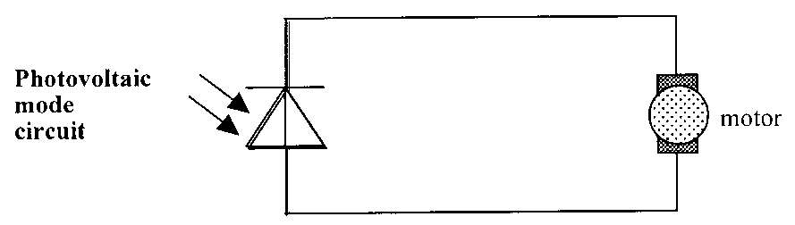

It is interesting to note that there is no bias applied to a solar cell and the photodiode therefore acts like an LED in reverse.

Photodiodes working in the photovoltaic mode are:

• usually referred to as photocells

• form the basis of the solar cells used to supply electrical power in satellites and calculators.

• limited to very low power applications (as listed above)

• A photodiode in this mode acts like an LED in reverse.

## The photodiode-reverse biasing

### Photoconductive mode

In this mode the photodiode is connected in **reverse bias**. If it is kept dark, it acts just like an ordinary reverse-biased p-n junction and will not conduct. When light is incident on the junction **extra electrons** are created in the **conduction** band of the p-type material and in the n-type **extra holes** are created in the **valence** band. These extra minority charge carriers produce a greater drift current across the junction producing a current in the circuit. Higher irradiance (more photons) will lead to more electron-hole pairs being produced and therefore a higher current. The current is proportional to the light irradiance and fairly independent of the bias voltage. The current can be measured by putting a large resistor in series with the reverse biased photodiode and monitoring the potential difference across the resistor, as shown in the diagram.

It is found that the switching action (the response to a change in light level) of a reverse biased photodiode is extremely fast. A photodiode in this mode is the basis of an **LDR** or can be used as a very fast timing switch.

Tranny

## Transistors

If three layers (two junctions) are grown together then the forming device can be made into a transistor.

## SUMMARY

|  |  |  |  |
| --- | --- | --- | --- |
| **BIASING** | **ENERGY** | **TERMINOLOGY** | **EXAMPLES** |
| **No biasing** | **energy from light (photons)** | **PHOTOVOLTAIC MODE** | **eg. solar cell** |
| **Reverse bias** | **energy from light** | **PHOTOCONDUCTIVE MODE** | **eg. photodiode or fast timing switch** |
| **Forward bias** | **energy RELEASED** | **-** | **eg. LED** |
| **3 layers** |  |  | **eg. transistor** |

**Revised Higher Physics 2013**

* + - * 1. Use band theory to explain how electrical conduction takes place in a pure semiconductor such as silicon. Your explanation should include the terms: electrons, valence band and conduction band.

**most/**majority of electrons in valence band **or “fewer electrons in conduction band”**

band gap is small electrons are excited to conduction band charge can flow when electrons are in conduction band

* + - * 1. A light emitting diode (LED) is a p-n junction which emits light. The table gives the colour of some LEDs and the voltage across the junction required to switch on the LED.

|  |  |
| --- | --- |
| Colour of LED | Switch on Voltage /V |
| Green | 2.0 |
| Red | 1.4 |
| Yellow | 1.7 |

Using this data, suggest a possible value for the switch on voltage of an LED that emits blue light.

(c ) The remote control for a television contains an LED.



The graph shows the range of wavelengths emitted by the LED and the relative light output. Calculate the maximum energy of a photon emitted from this LED.

|  |  |  |  |
| --- | --- | --- | --- |
| **(b)** | value greater than 2·1V but less than 2·8V  (inclusive) | must have unit  **must be a value, not a range.** | **1**  **(1A)** |
| **(c)** | v = f λ ½  3 × 108 = f × 850×10-9  f = 3·53 × 1014 (Hz)  E = hf  = 6·63 × 10-34 × 3·53×1014 ½  = 2·34 × 10-19 J 1 | v = fλ  E = hf  (½) each for both formulas anywhere | **3**  **(3A)** |

Higher Physics 2012

* + - * 1. An n-type semiconductor is formed by adding impurity atoms to a sample of pure semiconductor material. State the effect that the addition of the impurity atoms has on the resistance of the material.

**Decreases**

* + - * 1. A p-n junction is used as a photodiode as shown.



(i) In which mode is the photodiode operating?

(ii) The irradiance of the light on the junction of the photodiode is now increased.

Explain what happens to the current in the circuit

*Answer*

*Photoconductive mode*

|  |  |  |  |
| --- | --- | --- | --- |
| *Current increases* | *(½)* | | *2* |
| *more photons of light arrive at the* | | *Any wrong physics in the explanation* | |
| *junction* | *(½)* | | *max (½) (for 'current increases')* |
| *more free charge carriers produced* | | *(½)* | |
| per second (could be linked to | | (½) | |
| either photons or charge carriers) | | | |

## Glossary for Revision

<https://quizlet.com/90855867/122-conductors-semiconductors-and-insulators-flash-cards/>

#### Conductors

Conductivity is the ability of a materials to conduct charge carriers (electrons or positive holes)  
(all metals, semi metals like carbon-graphite, antimony and arsenic)

#### Insulators

Materials that have very few charge carriers (free electrons or positive holes). (plastic, glass and wood)

#### Semiconductors

These materials lie between the extremes of good conductors and good insulators. They are crystalline materials that are insulators when pure but will conduct when an impurity is added and/or in response to light, heat, voltage, etc (silicon (Si), germanium (Ge), gallium arsenide (GaAs)

#### Band structure

Electrons in an isolated atom occupy discrete energy levels. When atoms are close to each other these electrons can use the energy levels of their neighbours. When the atoms are all regularly arranged in a crystal lattice of a solid, the energy levels become grouped together in a band. This is a continuous range of allowed energies rather than a single level. There will also be groups of energies that are not allowed, what is known as a band gap. Similar to the energy levels of an individual atom, the electrons will fill the lower bands first. The fermi level gives a rough idea of which levels electrons will generally fill up to, but there will always be some electrons with individual energies above this

#### In a conductor:

the highest occupied band, known as the conduction band, is not completely full. This allows the electrons to move in and out from neighbouring atoms and therefore conduct easily

#### In an insulator:

the highest occupied band is full. This is called the valnce band, by analogy with the valence electrons of an individual atom. The first unfilled band above the valence band above the valence band is the conduction band. For an insulator the gap between the valence and conduction bands is large and at room temperature there is not enough energy available to move electrons from the valence band into the conduction band, where they would be able to contribute to conduction. Normally, there is almost no electrical conduction in an insulator. If the applied voltage is high enough (beyond the breakdown voltage) sufficient electrons can be lifted to the conduction band to allow current to flow. Often this flow of current causes permanent damage. Within a gas this voltage is often referred to as the striking voltage, particularly within the context of a fluorescent lamp since this is the voltage at which the gas will start to conduct and the lamp will light.

#### In a semiconductor:

the gap between the valence band and the conduction band is smaller, and at room temperature there is sufficient energy available to move some electrons from the valence band into the conduction band, allowing some conduction to take place. An increase in temperature increases the conductivity of the semiconductor as more electrons have enough energy to make the jump to the conduction band. This is the basis of an NTC thermistor. NTC stands for "negative temperature coefficient" (increased temperature means reduced resistance). This makes current increase so conductivity increases.

#### Optical properties of materials

Electron bands also control the optical properties of materials. They explain why a hot solid can emit a continuous spectrum rather than a discrete spectrum as emitted by a hot gas. In the solid the atoms are close enough together to form continuous bands. The exact energies available in these bands also control at which frequencies a material will absorb or transmit and therefore what colour will appear

#### Bonding in semiconductors

The most commonly used semiconductors are silicon and germanium. Both these materials have a valency of 4 (they have 4 outer electrons available for bonding. In a pure crystal, each atom is bonded covalently to another 4 atoms: all of its outer electrons are bonded and therefore there are few free electrons available to conduct. This makes resistance very large. Such pure crystals are known as intrinsic semiconductors. The few electrons that are available come from imperfections in the crystal lattice and thermal ionisation due to heating. A higher temperature will thus result in more free electrons, increasing the conductivity and decreasing the resistance, as in a thermistor

#### Holes

When an electron leaves its position in the crystal lattice, there is a space left behind that is positively charged. This lack of an electron is called a positive hole. Even though electrons are moving, the effect is the same as if it was the hole that moved through the crystal lattice. The hole can be thought of as a positive charge carrier. In complex semiconductors it is easier to calculate what is happening in terms of 1 moving positive hole, rather than many electrons

#### In an intrinsic semiconductor the number of holes is equal to

the number of electrons. The generally small currents consist of drifting electrons in 1 direction and drifting holes in the other.

#### Doping

Semiconductor's electrical properties are dramatically changed by the addition of very small amounts of impurities. Once doped they are known as extrinsic semiconductors. Solid state semiconductors are much smaller and use much less power than valve transistors.  
OR  
Doping a semiconductor involves growing impurities such as boron or arsenic into an   
intrinsic semiconductor such as silicon

#### An in intrinsic semiconductor is

an undoped semiconductor

#### Fermi level

Energy of latest occupied level which the states below this energy are completely occupied and above it are completely unoccupied

#### N-type semiconductors

If an impurity such as arsenic with 5 outer electrons is present in the crystal lattice then 4 of its electrons will be used in bonding with the silicon. The 5th will be free to move about and conduct. Since the ability of the crystal to conduct is increased, the resistance of the semiconductor is therefore reduced. Because of the extra electrons present, the Fermi level is closer to the conduction band than in an intrinsic semiconductor. This type of conductor is called n - type, since most conduction is by the movement of free electrons (-ve)

#### P-type semiconductors

The semiconductor may also be doped with an element like Indium, which has 3 outer electrons. This produces a hole in the crystal lattice, where an electron is "missing". Because of this lack of electrons, the Fermi level is closer to the valence band than in an intrinsic semiconductor. An electron from the next atom can move into the hole created, as described previously. Conduction can thus take place by the movement of positive holes. Most conduction takes place by the movement of positively charged holes

#### Notes on doping

The doping material cannot be added to the semiconductor crystal. It has to be grown into the lattice when the crystal is grown so that it becomes part of the atomic lattice.   
The quantity of the impurity is extremely small (could be 1 atom in 1 million). If it were too large it would disturb the regular crystal lattice.  
Overall charge on semiconductors are still neutral  
In n - type and p - type there will always be small numbers of the other type of charge carrier, known as minority charge carriers, due to thermal ionisation.

#### p-n junctions

When a semiconductor is grown so that 1 half is p-type and 1 half is n-type, the product is called a p-n junction and it functions as a diode. A diode is a discrete component that allows current to flow in one direction only.

#### At temperatures other than absolute Zero kelvin, the electrons in the n-type and the holes in the p-type material will constantly

diffuse(particles will spread from high concentration regions to low concentration regions). Those near the junction will be able to diffuse across it.

#### Reverse-biased

Cell connected negative end to p-type and positive end to n-type

#### Forward-biased

Cell connected positive end to p-type and negative end to n-type.

#### Reverse biased - charge carriers

When the p-side is attached to the negative side of a battery (V↓a) then the electrons at that side have more potential energy than previously. This has the effect of raising the bands on the p-side from where they were originally. We say it is reverse-biased. Almost no conduction can take place since the battery is trying to make electrons flow "up the slope" of the difference in conduction bands. The holes face a similar problem in flowing in the opposite direction. The tiny current that does flow is termed reverse leakage current and comes from the few electrons which have enough energy from the thermal ionisation to make it up the barrier.

#### Forward biased - charge carriers

When the p-side is attached to the positive side of the battery (V↓a) then the electrons at that side have less potential energy than under no bias. This has the effect of lowering the bands on the p-side from where they were originally. We sat it is forward biased. As the applied voltage approaches the built in voltage, more electrons will have sufficient energy to flow up the now smaller barrier and an appreciable current will be detected. Once the applied voltage reaches the in-built voltage there is no potential barrier and the p-n junction has almost no resistance, like a conductor. The holes are similarly able to flow in the opposite direction across the junction towards the negative side of the battery.

#### In the junction region of a forward-biased LED

electrons move from the conduction band to the valence band to emit photons.

#### In a forward-biased p-n junction diode, holes and electrons pass through the junction in opposite directions.

**Sometimes holes and electrons will meet and recombine. When this happens**

energy is emitted in the form of a photon. For each recombination of electron to hole, 1 photon of radiation is emitted. Most of the time heat energy is released but in some semiconductors like gallium arsenic phosphide, the energy is emitted as light. If the junction is close to the surface of the material, this light may be able to escape. This makes an LED.

#### The colour of light emitted from an LED depends on

On the elements and relative quantities of the three constituent materials. The higher the recombination energy the higher the frequency of light.

#### The LED does not work in reverse bias since the charge carriers

do not/can not travel across the junction towards each other so cannot recombine

#### Photodiode

A p-n junction in a transparent coating will react to light in what is called the photovoltaic effect. Each individual photon that is incident on the junction has its energy absorbed, assuming the energy is larger than the band gap. In the p-type material this will create excess electrons in the conduction band and in the n-type material it will create excess holes in the valence band. Some of these charge carriers will then diffuse to the junction and be swept across the built-in electric field of the junction. The light has supplied energy to the circuit, enabling current to flow (it is the emf in the circuit). More intense light (more photons) will lead to more electron-hole pairs being produced and therefore a higher current. Current is proportional to light intensity.  
OR  
The incoming light provides energy for an electron within the valence band of the p-type to be removed from a positive hole and moved up to the conduction band in the n-type material. As this electron is moved up into the conduction band it has an increase in energy. Since EMF is the energy per coulomb of charge an EMF is generated.

#### Photovoltaic mode

The p-n junction can supply power to a load (motor). Many photo-diodes connected together form a solar cell. This is described as photovoltaic mode.There is no bias applied to a solar cell and it acts like an LED in reverse. The increased movement of charge across a p-n junction can reduce resistance of component containing the junction

#### Photoconductive mode

When connected to a power supply a photodiode will act as a LDR. This is described as photoconductive mode. The LDR is connected in reverse bias, which leads to a large depletion region. When light hits the junction, electrons and holes are split apart. This leads to free charge carriers in the depletion region. The free charge carriers reduce overall resistance of the diode, allowing current to flow. Conductivity of diode is being changed.

#### Addition of impurity atoms to a pure semiconductor(doping) decreases its

Resistance

#### Applications of p-n junctions

Photovoltaic cell /LED /Photoconductive mode(LDR)

#### What is photovoltaic effect?

A process in which a photovoltaic cell converts photons of light into electricity.

#### Depletion layer

Near the junction, electrons diffuse across to combine with holes, creating a "depletion region".

#### Majority charge carriers in n-type

The electrons in the conduction band are free move towards the positive terminal of an applied p.d.

#### Majority charge carriers in p-type

The "positive holes" in the valence band move towards the negative terminal   
of an applied p.d.

#### Majority charge carriers across the p-n junction (forward biased)

With the applied p.d. in the direction shown electrons in the n-type material move to the left and holes in the p-type material move to the right. The depletion layer in the centre becomes thinner and thinner and if the p.d. of the supply is greater than the barrier potential(0.7V for silicon-based semiconductors) the barrier is broken down and a current flows through the device.

#### How light is produced at the p-n junction of an LED

When the diode is forward biased the free electrons in the conduction band of the n-type material are given energy by the supply to overcome the energy barrier generated by the depletion layer at the junction. Once these electrons overcome the energy barrier they drop down from the conduction band to the valence band of the p-type material and combine with a positive hole in the valence band of the p-type material. As the electron drops between the bands it loses and energy and emits this as light.

#### Use band theory to explain how electrical conduction takes place in a pure semiconductor such as silicon.

**Your explanation should include the terms: electrons, valence band and conduction band.**

most/majority of electrons in valence band 1⁄2 or "fewer electrons in conduction band"  
band gap is small 1⁄2 electrons are excited to conduction band 1⁄2  
charge can flow when electrons are in conduction band 1⁄2

### What charge carriers actually move across the p-n junction?

Electrons

## Tutorial 1: Semiconductors

1. In the following descriptions of energy levels in metals, insulators and semiconductors some words and phrases have been replaced by the letters A to N.

In a metal the ____**A**____band is completely filled and the ____**B**____band is partially filled. The electrons in the ____**C**____ band are free to move under the action of ____**D**____so the metal has a ____**E**____conductivity.

In an insulator there are no free electrons in the ____**F**____band. The energy gap between the two bands is large and there is not enough energy at room temperature to move electrons from the ____**G**____band into the ____**H**____band.

Insulators have a very ____**I**____conductivity.

In a pure semiconductor the energy gap between the valence and conduction bands is ____**J**____than in a metal. At room temperature there is enough energy to move some electrons fromthe____**K**____ band into the ____**L**____band. As the temperature is increased the number of electrons in the conduction band ____**M**____so the conductivity of the semiconductor ____**N**____*.*

From the table below choose the correct words or phrases to replace the letters.

|  |  |
| --- | --- |
| *Letter* | *List of replacement word or phrase* |
| A, B, C, F, G, H, K, L | conduction, valence |
| D | an electric field, a magnetic field |
| E, I | low, high |
| J | bigger, smaller |
| M, N | decreases, increases |

2. The conductivity of a semiconductor material can be increased by ‘doping’.

(a) Explain what is meant by the ‘conductivity’ of a material.

(b) Explain, giving an example, what is meant by ‘doping’ a semiconductor.

(c) Why does ‘doping’ decrease the resistance of a semiconductor material?

3. (a) A sample of pure germanium (four electrons in the outer shell) is doped with phosphorus (five electrons in the outer shell). What kind of semiconductor is formed?

(b) Why does a sample of n-type semiconductor still have a neutral overall charge?

4. Describe the movement of the majority charge carriers when a current flows in:

1. an n-type semiconductor material
2. a p-type semiconductor material.

5. A p-n junction diode is connected across a d.c. supply as shown. 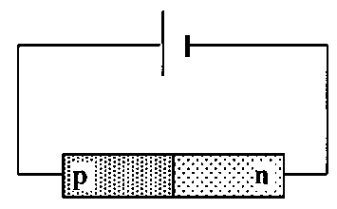

1. Is the diode connected in forward or reverse bias mode?
2. Describe the movement of the majority charge carriers across the p-n junction.
3. What kind of charge is the only one that actually moves across the junction?

6. When positive and negative charge carriers recombine at the junction of ordinary diodes and LEDs, quanta of radiation are emitted from the junction.

1. Does the junction have to be forward biased or reverse biased for radiation to be emitted?
2. What form does this emitted energy take when emitted by:
3. an LED
4. an ordinary junction diode?

7. A particular LED is measured as having a recombination energy of 3·12 × 10–19 J.

(a) Calculate the wavelength of the light emitted by the LED.

(b) What colour of light is emitted by the LED?

(c) What factor about the construction of the LED determines the colour of the emitted light?

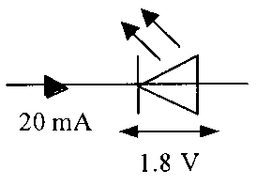8. (a) State two advantages of an LED over an ordinary filament lamp.

(b) An LED is rated as follows:

operating p.d. 1·8 V, forward current 20 mA

The LED is to be operated from a 6 V d.c. power supply.

1. Draw a diagram of the circuit, including a protective resistor, which allows the LED to operate at its rated voltage.
2. 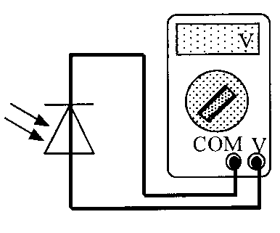Calculate the resistance of the protective resistor that allows the LED to operate at its rated voltage.

9. The diagram shows a photodiode connected to a voltmeter.

1. In which mode is the photodiode operating?
2. Light is now incident on the photodiode.

(i) Explain how an e.m.f. is created across the photodiode.

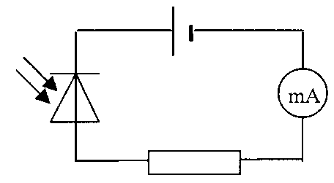(ii) The irradiance of the light incident on the photodiode is now increased. Explain why this increases the e.m.f. of the photodiode.

10. A photodiode is connected in reverse bias in a series circuit as shown.

(a) In which mode is the photodiode is operating?

(b) Why is the photodiode connected in reverse bias?

(c) What is the current in the circuit when the photodiode is in darkness? Explain your answer.

(d) The irradiance of the light on the photodiode is now increased.

(i) What is the effect on the current in the circuit?

(ii) What happens to the effective ‘resistance’ of the photodiode? Explain why this happens.

## Tutorial 2: Photodiodes

1. 

If the ammeter shown here has its ampere scale replaced to allow us to read the light intensity directly from it, is the zero of this light intensity at the left or right of the dial?

1. The basic components necessary for sending a signal that tells when a rotating mechanism has reached a certain position are shown below.  
     
   Explain the functions of the L.E.D. and the L.D.R.
2. A school power supply pack contains a step-down transformer which can give a variety of output voltages, and a full-wave rectifying bridge of junction diodes.  
   Which is their correct order in the power pack, and why?
   1. Mains input, transformer, rectifier, output
   2. Mains input, rectifier, transformer, output.

## Tutorial Solutions

**Electrons at work**

1. A = valence; B = conduction; C = conduction; D = an electric field; E = high; F = conduction; G = valence; H = conduction; I = low; J = smaller; K = valence; L = conduction; M = increases; N = increases.

7. (a) 638 nm

(b) Red

8. (b) (ii) 210 Ω

## Tutorial Exam Questions

1. An LED consists of a p-n junction as shown.

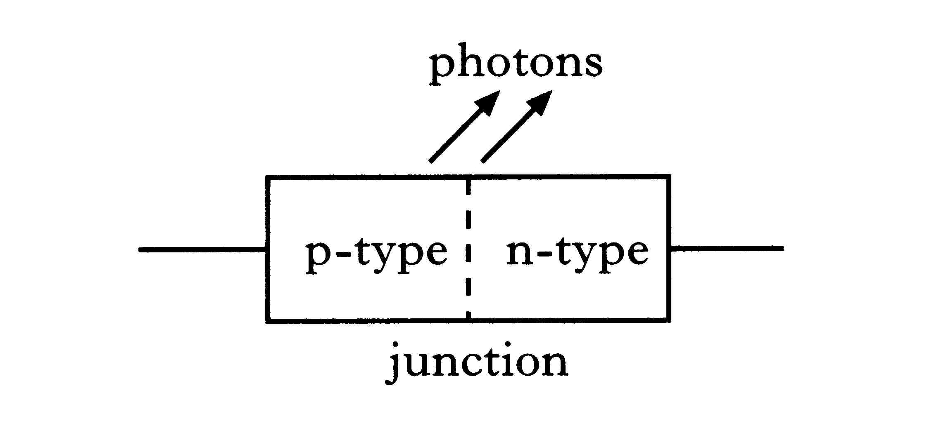

(a) Copy the diagram and add a battery so that the p-n junction is   
forward-biased. 1

(b) Using the terms *electrons*, *holes* and *photons*, explain how light is produced at the p-n junction of the LED. 1

(c) The LED emits photons, of energy 3·68 × 10−19 J.

(i) Calculate the wavelength of a photon of light from this LED. 2

(ii) Calculate the minimum potential difference across the p-n junction when it emits photons. 2

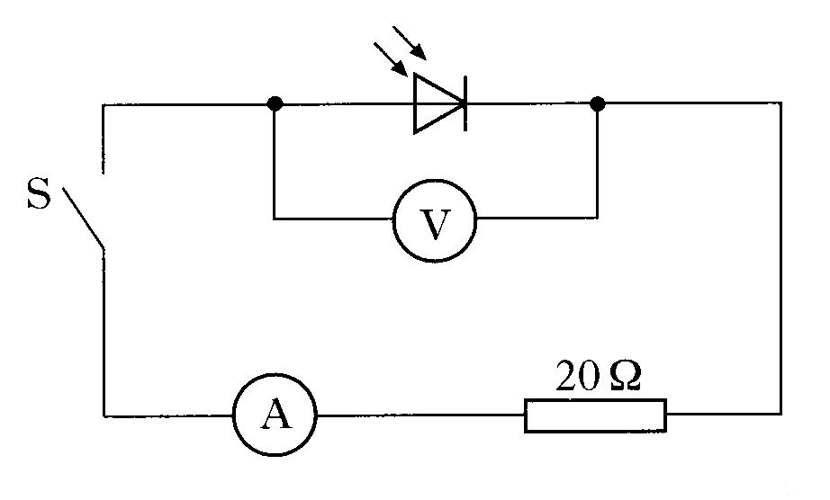 (6)

2. A photodiode is connected in a circuit as shown below.

Switch S is open.

Light is shone on to the photodiode.

A reading is obtained on the voltmeter.

(a) (i) State the mode in which the photodiode is operating. 1

(ii) Describe the effect of light on the material of which the photodiode is made. 1

(iii) The irradiance of the light on the photodiode is increased.

What happens to the reading on the voltmeter? 1

(b) Light of a constant irradiance is shone on the photodiode in the circuit shown above.

The following measurements are obtained with switch S open and then with switch S closed.

|  |  |  |
| --- | --- | --- |
|  | S open | S closed |
| *reading on voltmeter*/V | 0·508 | 0·040 |
| *reading on ammeter*/mA | 0·00 | 2·00 |

(i) What is the value of the e.m.f. produced by the photodiode for this light irradiance? 1

(ii) Calculate the internal resistance of the photodiode for this light irradiance. 2

(c) In the circuit above, the 20  resistor is now replaced with a 10  resistor.

The irradiance of the light is unchanged.

The following measurements are obtained.

|  |  |  |
| --- | --- | --- |
|  | S open | S closed |
| *reading on voltmeter*/V | 0·508 | 0·021 |

Explain why the reading on the voltmeter, when S is closed, is smaller than the corresponding reading in part (b). 2

(8)

3. A circuit is set up as shown below. The amplitude of the output voltage of the d.c. supply is kept constant.

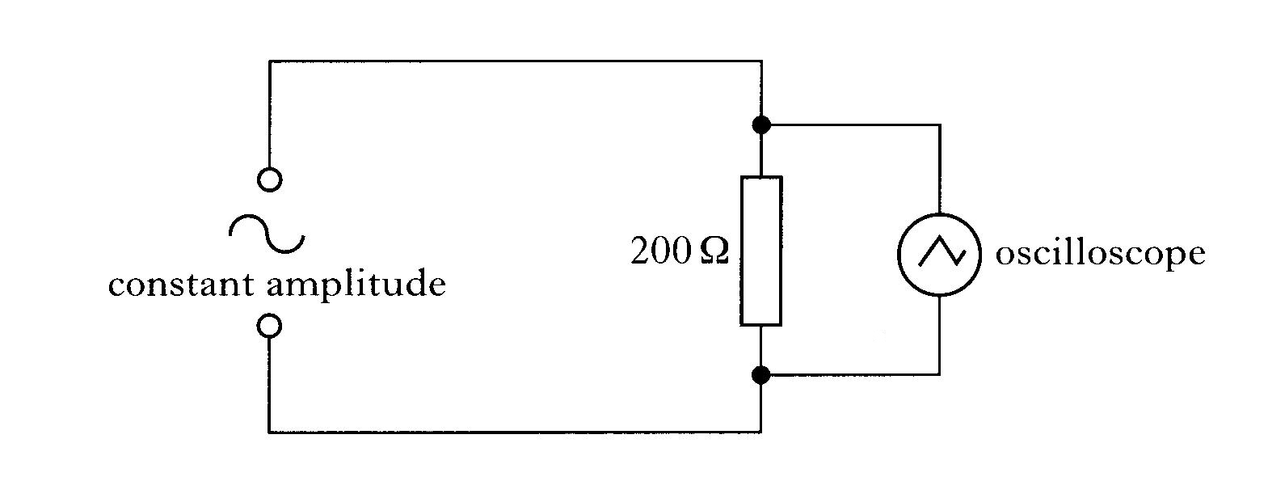

The settings of the controls on the oscilloscope are as follows:

y-gain setting = 5V/division

time-base setting = 2·5 ms/division

The following trace is displayed on the oscilloscope screen.

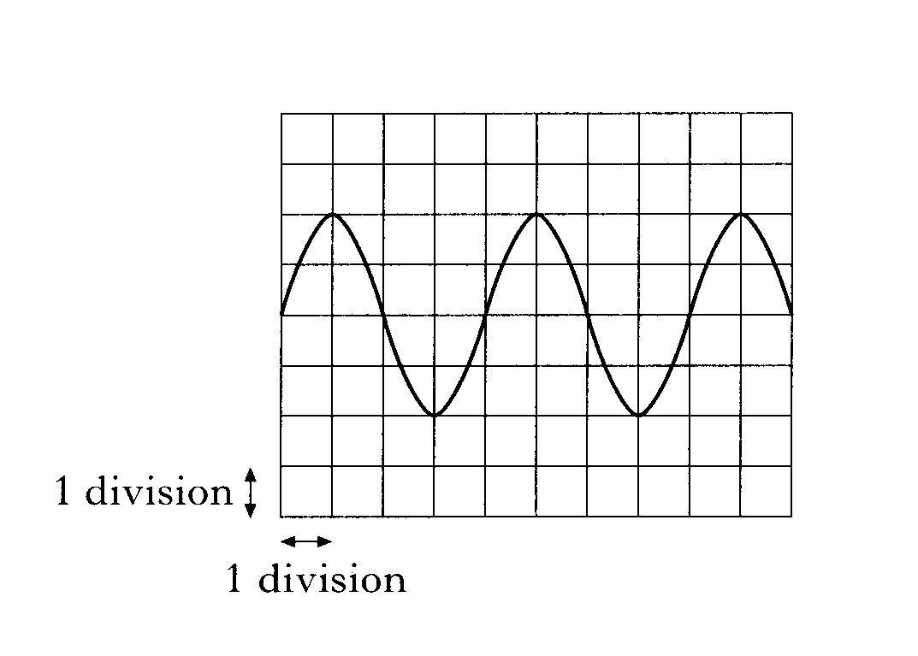

(a) (i) Calculate the frequency of the output from the a.c. supply. 2

(ii) Calculate the **r.m.s. current** in the 200  resistor. 3

(b) A diode is now connected in the circuit as shown below.

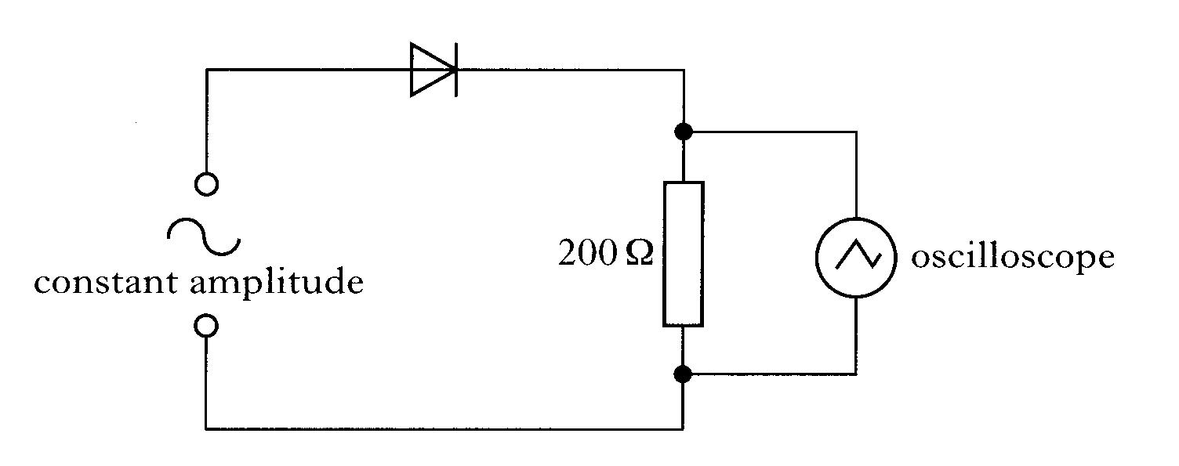

The setting on the controls of the oscilloscope remains unchanged.

Connecting the diode to the circuit causes **changes** to the original trace displayed on the oscilloscope screen. The new trace is shown below.

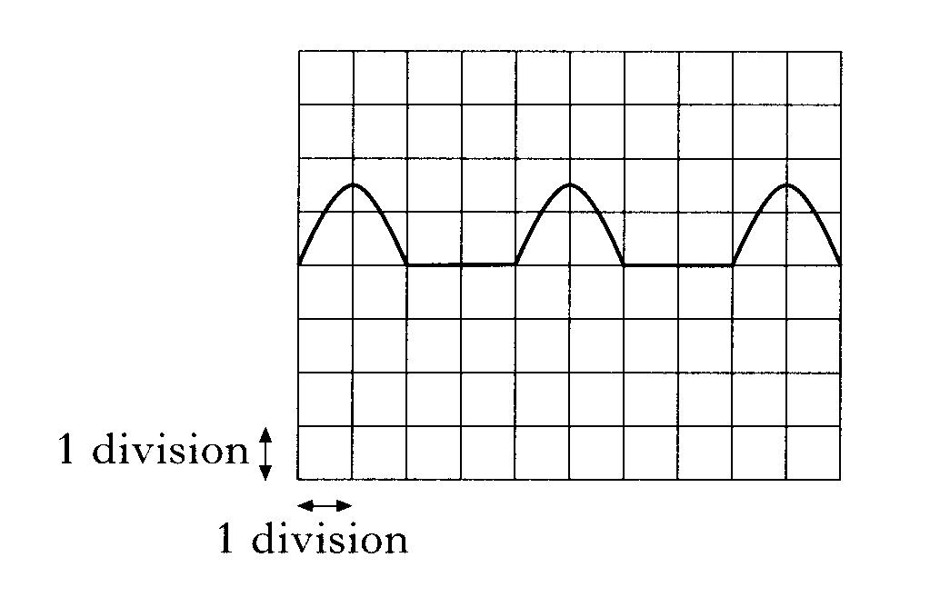

Describe and explain the changes to the original trace. 2

(7)

4. The diagram shows a photodiode connected to a voltmeter. A lamp is used to shine light onto the photodiode.

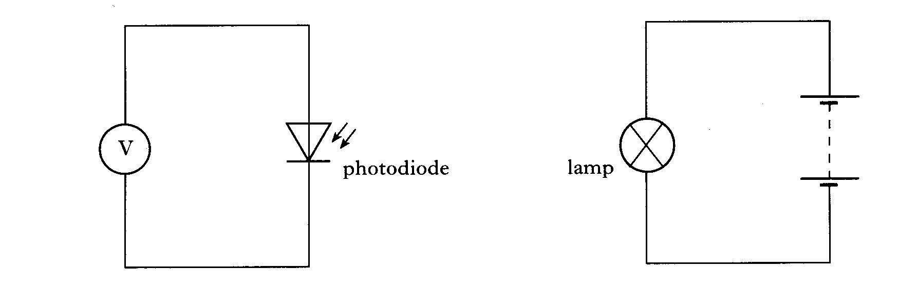

The reading on the voltmeter is 0·5 V.

The lamp is now moved closer to the photodiode.

Using the terms **photons**, **electrons** and **holes**, explain why the voltmeter reading changes. 2

(2)

5. (a) The diagram below represents the p-n junction of a light emitting diode (LED).

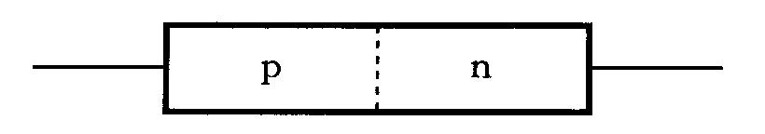

(i) Draw a diagram showing the above p-n junction connected to a battery so that the junction is forward biased. 1

(ii) When the junction is forwarded biased, there is a current in the diode. Describe the movement of charge carriers which produces this current. 2

(iii) Describe how the charge carriers in the light emitting diode enable light to be produced. 2

(b) The following graph shows the variation of current with voltage for a diode when it is forward biased.

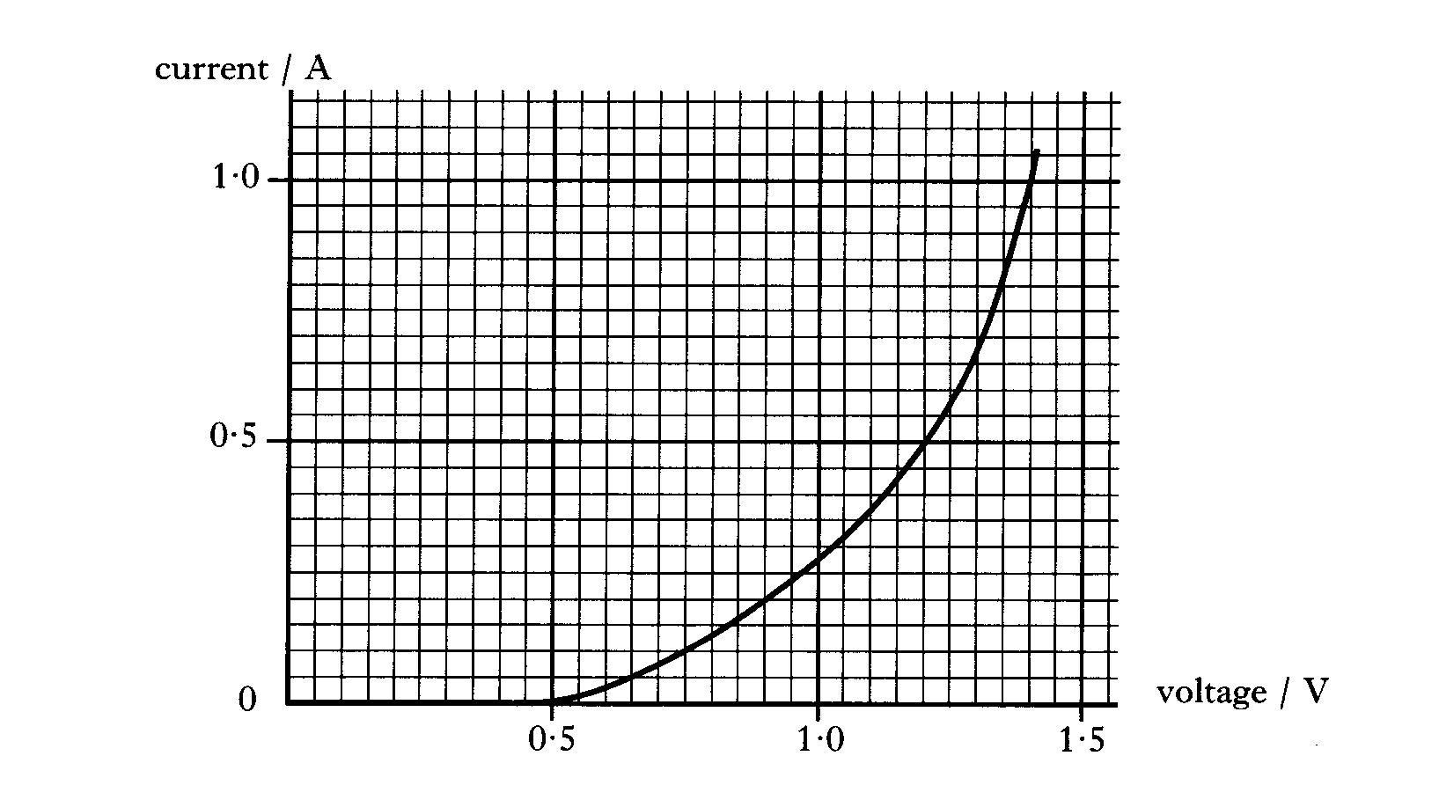

(i) What is the minimum voltage required for the diode to conduct. 1

(ii) What happens to the resistance of the diode as the voltage is increased above this minimum value?

Use information from the graph to justify your answer. 2

6. The circuit below shows a photodiode connected in series with a resistor and an ammeter. The power supply has an output voltage 5 V and negligible internal resistance.

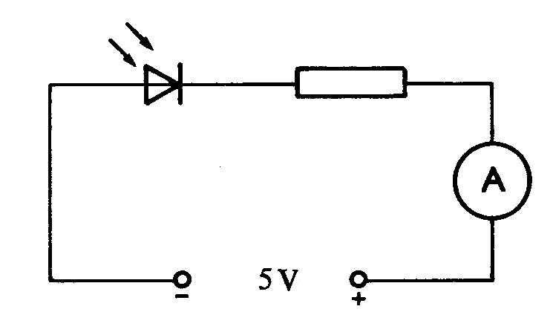

In a darkened room, there is no current in the circuit.

When light strikes the photodiode, there is a current in the circuit.

(a) Describe the effect of light on the material of which the photodiode is made. 1

(b) In which mode is the photodiode operating? 1

(c) When the photodiode is placed 1·0 m from a small lamp, the current in the circuit is 3·0 A.

Calculate the current in the circuit when the photodiode is placed 0·75 m from the same lamp. 3

(5)

7. The power for a space probe is produced by an array of photodiodes. Each photodiode in the array acts as a photovoltaic cell. Under certain conditions the power output of the array is 150 W at 34 V.

(a) Calculate the current produced by the array. 2

(b) Explain how a photovoltaic cell can produce a small voltage. 2

(c) What happens to the irradiance of the solar radiation falling on the array if the probe moves to a position twice as far from the Sun? Justify your answer. 2

(6)

**Uncertainties in Electricity**

1. Measurements of the p.d. across a resistor and the current in the resistor give the following results.

p.d. = (30·00 ± 0·03) V

current = (2·00 ± 0·01) A

Use these results to calculate the resistance of the resistor and express your answer in the form

resistance ± uncertainty 3

**Open-ended Questions**

1. A battery is charged using a 12 V d.c. supply as shown in Diagram I.

5 

12 V

**+**+

-+

5 

12 V

MP3

player

Diagram I Diagram II

When charged it is connected to an MP3 player, as shown in Diagram II.

A teacher states that ‘*The energy used to charge the electrical battery is always greater than the energy that can be taken from it.’*

Use your knowledge of physics to comment on this statement.

You may use calculations to aid your comment.

## Tutorial Solutions- Exam Questions

1. (a)

(b) Electrons and holes (re)combine (½) (at junction) energy released as photons (½) OR photons given out OR light photons combine/join together/falls into hole

(c) (i) E = hf 3·68 x 10−19 = 6·63 x 10−34 f f = 5·55 x 1014 (Hz)

v = fλ (½) for both E and v equations

3 x 108 = 5·55 x 1014 λ

λ = 5·40 x 10−7 m

(ii) E = QV 3·68 x 10−19 = 1·6 x 10−19 V V = 2·3 V

2. (a) (i) Photovoltaic mode

(ii) The light causes electron-hole pairs (to be created) in the junction (or intrinsic layer)

(iii) It will increase

(b) (i) emf =0.508 V

(ii) r = (E – V)/I = (0.58 – 0.040)/2.00 x 10 -3 =234 Ω

OR RT = 0.508/2.00 x 10-3 = 254 Ω r = 254 – 20 = 234 Ω

OR correct use of V1/V2 = R1/R2

(c) With 10 Ω resistor in circuit there is more current (drawn from photodiode). Pd across internal resistance increases OR lost volts increases.

3. (a) (i) f = 1/t = 1/0.01 = 100 Hz

(ii) Vrms = Vpeak/√2 = 10/√2 = 7.1 V

Irms = Vrms/R = 7.1/200 = 0.036 A

(b) Half cycle missing as diodes only conduct in one direction.

Vpeak across resistor less since p.d. developed across diode.

4.

* The lamp produces photons of light that have an energy that can be calculated using the equation E=hf.
* Some of this energy is absorbed by the semiconductor material of the photodiode.
* The absorbed energy creates electron hole pairs in the photodiode that increases the conductivity of the photodiode.
* There is a reduction in the potential barrier at the pn junction and therefore a reduction in the voltmeter reading.

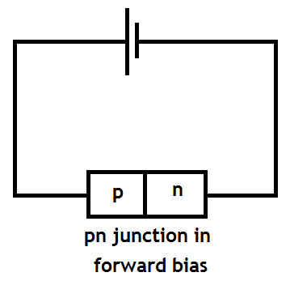5. (a) (i)

1. When forward biased the majority charge carriers in the n-type material, electrons, flow to the p-type material. This movement of electrons also makes it appear that holes in the p-type material move towards the n-type material.

(iii) When conduction band electrons in the n-type material pass into the p-type material they fall into lower energy holes and emit energy as a visible photon, if the energy loss is equal to the energy of a visible photon.

(b) (i) Conduction starts when the applied voltage is 0.5V.

(ii) The resistance of the diode decreases as the applied voltage increases. This can be justified by using ohms law to calculate the resistance at different applied voltages.

R1 = V1/I1 = 1.0/0.275 = 3.6Ω

R2 = V2/I2 = 1.2/0.5 = 2.4Ω

6. (a) Light incident on the pn-junction photodiode will increase the number of electron hole pairs and consequently increase the conductivity of the diode.

(b)The diode is operating in **photoconductive mode**.

(c) I1d12 = I2d22 I2 = I1d12/d22 = 3.0x12/0.752  = 5.33mA

7. (a) P = VI so I = P/V =150/34 = 4.1 A

(b) The light causes electron-hole pairs (to be created) in the junction (or intrinsic layer). Electrons can move through the semiconducting to fill the holes thus creating a potential difference.

(c) I1d12 = I2d22 so doubling the distance reduces the irradiance by a factor of 4

**Uncertainties in Electricity**

1. Uncertainty in p.d. = (0.03/30.00) x 100% = 0.1%

Uncertainty in current = (0.01/2.00) x 100% = 0.5%

Greatest % uncertainty is 0.5%

R = V/I = 30/2 = 15 Ω ± 0.5%

0.5% of 15 = 0.075 Ω

So R = (15.00 ± 0.08) Ω

**YOU MADE IT TO THE END OF THE COURSE**

**WELL DONE!**

**NOW YOU’VE JUST TO LEARN IT ALL!**

**T’was nice knowing you- ALL THE BEST**

**KEEP IN TOUCH**

***Mrs H***

