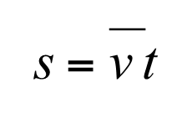
The displacement – velocity - time equation.
s = displacement travelled, in metres (m)
v = average velocity, in metres per second (m/s)
t = time taken for trip, in seconds (s)
Displacement is distance from beginning to end of journey in a straight line. Since it is a vector, it also has direction eg right, north, or 53°.

This equation is only used when the velocity is constant, or for an average velocity.

If the velocity is changing, use the area under a velocity – time graph to calculate displacement.

This equation governs the horizontal component of projectile motion, since a is constant (0 m/s).
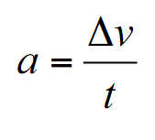

To calculate constant or average acceleration.

a = acceleration of object, in metres per second per second (m/s²)
Δv = change in velocity of object, in metres per second (m/s)
t = time for change in velocity to occur, in seconds (s)

Use this equation when the question gives you a change in velocity, rather than initial and final velocities.

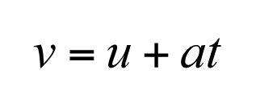
The equation from standard grade, rearranged.
Equation of motion without displacement s.

v = final velocity, in metres per second (m/s)
u = initial velocity, in metres per second (m/s)
a = average acceleration, in metres per second per second (m/s²)
t = time taken for trip, in seconds (s)

v, u, and a are vector quantities. t is a scalar quantity.

For projectiles, the link between horizontal and vertical motion is time, t.
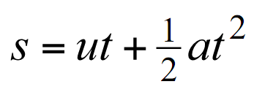

Equation of motion without final velocity v.

s = displacement, in metres (m)
u = initial velocity, in metres per second (m/s)
t = time taken for trip, in seconds (s)
a = average acceleration, in metres per second per second (m/s²)

Remember: only the t is squared, not the a.
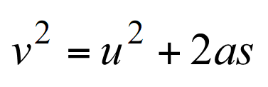

Equation of motion without time t.

v = final velocity, in metres per second (m/s)
u = initial velocity, in metres per second (m/s)
a = average acceleration, in metres per second per second (m/s²)
s = displacement, in metres (m)

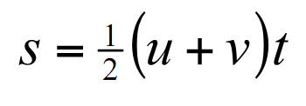

Equation of motion without acceleration a.

s = displacement, in metres (m)
u = initial velocity, in metres per second (m/s)
v = final velocity, in metres per second (m/s)
t = time taken for trip, in seconds (s)

There is a fifth equation of motion, not in the data book, without initial velocity u:

s = vt - ½ at²
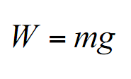

To calculate the weight of an object.

W = weight of object, in Newton (N)
m = mass of object, in kilograms (kg)
g = gravitational field strength, in newton per kilogram (N/kg)

Weight is a force. The weight of an object is the force on it due to gravitational pull. If an object weighs 100 N on Earth, it weighs 0 N in space (no gravity) and 16 N on the moon.

Gravitational field strength is the weight per unit mass of an object in the field. The value of g on Earth is 9.8 N/kg.

The mass of an object is the amount of matter in the object. The mass remains constant anywhere in the universe. An object with mass 10 kg on earth will have a mass of 10 kg in space and a mass of 10 kg on the moon.
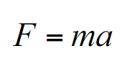

The equation for Newton’s Second Law.

F = unbalanced force acting on body, in newton (N)
m = mass of body, in kilograms (kg)
a = acceleration of body, in metres per second per second (m/s²)

The unbalanced force is the resultant of all forces acting on a body.

Forces can change the shape, speed and direction of motion of an object.

When the force stays constant and the mass increases, the acceleration decreases.

When the mass stays constant and the force increases, the acceleration increases.

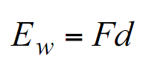

To calculate work done by a force.

E_{w} = work done, in joules (J) or newton metres (Nm)
F = force applied, in newton (N)
d = distance moved by force, in metres (m)

Work done is a measure of energy transferred.

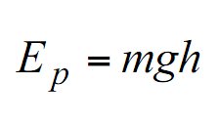

To calculate change in gravitational potential energy.

E_{p} = change in gravitational potential energy, in joules (J)
m = mass, in kilograms (kg)
g = gravitational field strength, in newton per kilogram (N/kg)
h = vertical height moved, in metres (m)

Gravitational potential energy is the energy required to move a mass upwards through a height.

It is also the energy transferred when an object drops though a height. In this case, the energy is usually converted to kinetic energy.

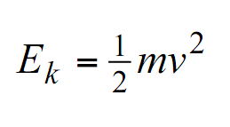

To calculate kinetic energy.

E_{k} = kinetic energy of the body, in joules (J)
m = mass of the body, in kilograms (kg)
v = velocity of the body, in metres per second (m/s)

Kinetic energy is the energy possessed by moving objects.

Note: only the velocity is squared – not the mass!

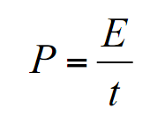

To calculate the power of both mechanical and electrical systems.

P = power, in watts (W)
E = energy transferred, in joules (J)
t = time taken, in seconds (s)

Power is the energy transferred in one second.

Power can also be expressed in joules per second (J/s).

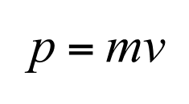
To calculate momentum.

p = momentum of object, in kilogram metre per second (kgm/s)
m = mass of object, in kilograms (kg)
v = velocity of object, in metres per second (m/s)

The Law of Conservation of momentum
When two bodies interact, in the absence of net external forces, the total momentum remains constant before and after the interaction.

Total momentum before = total momentum after
m₁u₁ + m₂u₂ = m₁v₁ + m₂v₂

There are 2 types of collision: elastic & inelastic:
elastic: both momentum and kinetic energy are conserved
inelastic: momentum only is conserved. This usually occurs when the objects stick together after impact.

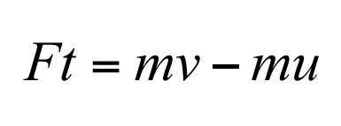
To calculate impulse.

F = unbalanced force acting on body, in newton (N)
t = time which unbalanced force acts for, in seconds (s)
m = mass of body, in kilograms (kg)
u = initial velocity of body, in metres per second (m/s)
v = final velocity of body, in metres per second (m/s)

The term Ft is the impulse. The term mv-mu is the effect of the impulse and is the change in momentum.

If re-arranged to F=(mv-mu)/t, the term (mv-mu)/t is the rate of change of momentum, and is another definition of force.

When the force is not constant, the size of the impulse can be found from the area under a Force – Time graph.
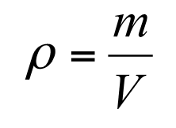

To calculate density.

ρ = density of substance, in kilogram per metre cubed (kg/m³)
m = mass of substance, in kilogram (kg)
V = volume of substance, in metres cubed (m³)

The symbol for density is the Greek letter ρ (rho).

The density of a substance is its mass per unit volume.

The density of a solid or liquid is 1000X that of its gas.

The molecular spacing of a gas is 10X that of its solid or liquid.
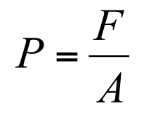

To calculate pressure.

P = pressure, in pascals (Pa) or (N/m²)
F = force normal to surface, in newton (N)
A = area over which force is exerted, in metres squared (m²)

One pascal is a force of one newton per square metre, when the force acts normal to the surface.

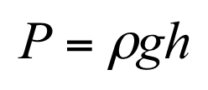

To calculate the pressure at a point in a fluid at rest.

P = pressure, in pascals (Pa) or (N/m²)
ρ = density of fluid, in kilogram per metre cubed (kg/m³)
g = gravitational field strength, in newton per kilogram (N/kg)
h = depth, in metres (m)

Pressure exerts a force equally in all directions.

The upthrust, or buoyancy force, of an object in a fluid is equal to the weight of fluid displaced. It is also related to the difference in pressure between the top and bottom of an object.
F_{u} = ρgV
F_{u} = upthrust, or buoyancy force, in newton (N)
ρ = density of fluid, in kilogram per metre cubed (kg/m³)
g = gravitational field strength, in newton per kilogram (N/kg)
V = volume of object, in metres cubed (m³)

Explain why a buoyancy force acts on an object when it is submerged in a fluid.

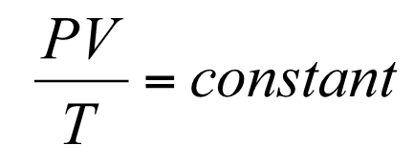

The General Gas Law.

P = gas pressure, in pascals (Pa) or (N/m²)
V = volume of gas, in metres cubed (m³)
T = temperature of gas, in Kelvin (K)

The mass is kept constant.

K = °C + 273.15

At 0 K, or absolute zero, all particle motion stops. Particles have no energy, and this is the lowest possible temperature.

The kinetic theory of gas states that pressure is caused by very small particles bouncing elastically off surfaces. Their change in momentum mv – mu is transferred to the surface.

Use the kinetic model to explain the change in pressure as the temperature of a gas increases.

As temperature increases, the kinetic energy of the gas particles increases. {½}

The particles hit the wall of the container more often {½}

And with greater force. {½}

So the pressure increases. {½}

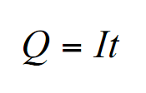
To calculate the amount of charge transferred in an electrical circuit.

Q = charge transferred, in coulombs (C)
I = current, in amperes (A)
t = time taken for charge to transfer, in seconds (s)

To calculate work done by a potential difference on a charge.

W = work done, in joules (J).
Q = charge, in coulombs (C)
V = potential difference, or voltage, in volts (V)

Field lines start at the positive point or plate, and finish on the negative point or plate. The direction of the lines indicates the force on a positive “test” charge placed in the field.

The pd between 2 points is a measure of the work done in moving one coulomb of charge between 2 points.

If 1 joule of work is done in moving 1 coulomb of charge between 2 points, then the pd between the points is 1 volt.

The equation for a non-ideal battery ie one with an internal resistance.

E = electromotive force of supply, or emf, in volts (V).
V = potential difference across supply, in volts (V).
I = current in circuit, in amperes (A).
r = internal resistance of supply, in ohms (Ω).

The term Ir is known as the lost volts, because it is the voltage lost inside the battery due to its internal resistance.
The emf of a source is the electrical potential energy supplied to each coulomb of charge which passes through the source. It is equal to the open circuit pd across its terminals.

V = IR stated as a conservation of energy equation.

Σ E = sum of electromotive forces (emf), in volts (V)
Σ IR =sum of current, in amperes (A) x resistance, in ohms (Ω)

IR = is the pd across a component.

The sum off all the energies put into a closed circuit = the sum of all the energies taken out of the circuit.
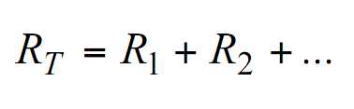

To calculate the total resistance of resistances in series.

R_{T} = total resistance of circuit, in ohms (Ω)
R₁ = resistance of first resistor, in ohms (Ω)
R₂ = resistance of second resistor, in ohms (Ω)

In a series circuit, the total resistance is the sum of the individual resistances.
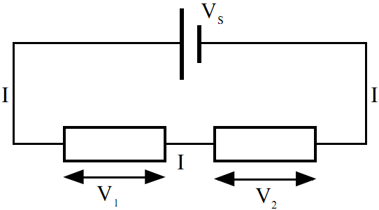
R1
R2

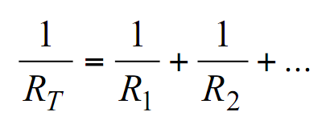

To calculate the total resistance of resistors in parallel.

R_{T} = total resistance of circuit, in ohms (Ω)
R₁ = resistance of first resistor, in ohms (Ω)
R₂ = resistance of second resistor, in ohms (Ω)
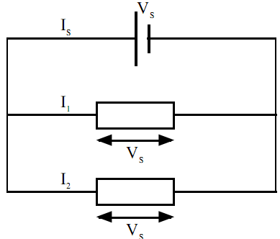
R1
R2

The equation for a balanced Wheatstone bridge.

R1 = resistance of R1, in ohms (Ω)
R2 = resistance of R2, in ohms (Ω)
R3 = resistance of R3, in ohms (Ω)
R4 = resistance of R4, in ohms (Ω)

The absolute values of the resistances are not important. Only their ratios count. A balanced bridge is when the pd across the terminals is 0 V. For small quantities, the out-of-balance pd is proportional to the change in resistance.
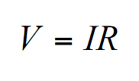

Also known as “Ohm’s Law” equation.

V = voltage across resistance, in volts (V)
I = current through resistance, in amperes (A)
R = resistance, in ohms (Ω)

To calculate electrical power.

P = power, in watts (W)
V = pd across resistance, in volts (V)
I = current through resistance, in amperes (A)
R = resistance, in ohms (Ω)

For alternating (sinusoidally varying) voltage:

V_{peak} = amplitude of supply voltage, in volts (V)
V_{rms} = root mean square of peak voltage, in volts (V)

V_{rms} is also known as the effective voltage.

V_{rms}, or
effective voltage

For alternating (sinusoidally varying) current:

I_{peak} = amplitude of supply current, in amperes (A)
I_{rms} = root mean square of peak current, in amperes (A)

I_{rms} is also known as the effective current. This would be the value of the direct current which would give the same effect.

The equation for capacitance.

C = capacitance of capacitor, in farads (F)
Q = charge “stored” in capacitor, in coulombs (C)
V = potential difference across capacitor, in volts (V)

One farad is a very large unit. Capacitance is usually measured in micro farads (μF) or even pico farads (pF).

Charge is not really stored in a capacitor: energy is. Charge is re-distributed from one plate to another. This creates a pd across the capacitor which opposed the supply pd.

The equation for energy stored in a capacitor:

E = energy stored in capacitor, in joules (J)
Q = charge “stored” in capacitor, in coulombs (C)
V = potential difference across capacitor, in volts (V)
C = capacitance of capacitor, in farads (F)

Work must be done to “charge” a capacitor because electrons are moved through a field against a pd. This energy stored is given by the area under the Q (charge) v V (pd) graph.
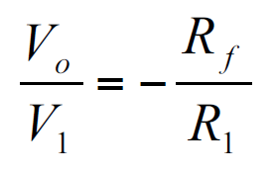

The op amp in inverting mode gain expression:

V₀ = output voltage, in volts (V)
V₁ = voltage applied to inverting input, in volts (V)
R_{f} = resistance of feedback resistor, in ohms (Ω)
R₁ = resistance of input resistor, in ohms (Ω)

The term R_{f}/R₁ is the voltage gain of the amplifier. The input signal is inverted.

An amp cannot produce an output voltage greater than the supply voltage.

The op amp differential mode gain expression:

V₀ = output voltage, in volts (V)
V₂ = voltage applied to non-inverting input, in volts (V)
V₁ = voltage applied to inverting input, in volts (V)
R_{f} = resistance of feedback resistor, in ohms (Ω)
R₁ = resistance of input resistor, in ohms (Ω)

A differential amplifier amplifies the pd between its 2 inputs.

The Period equation.

T = period of wave, in seconds (s)
f = frequency of wave, in hertz (Hz)

T is the time taken for 1 complete wave to pass a point, in seconds (s).

Frequency = no of waves
time taken

For constructive interference.

path difference = difference in length between 2 wave paths, in metres (m)
n = order of the maximum. This number has no units, and is an integer.
λ = wavelength, in metres (m).

The 2 waves will have the same wavelength, because they are coherent.
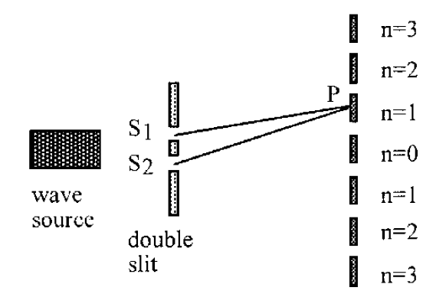
At the central, (zero order) maximum, n = 0, so the path difference = 0 m. (ie the 2 paths are the same length)

At the first order maximum, n = 1, so the path difference = λ

For destructive interference.

path difference = difference in length between 2 wave paths, in metres (m)
n = order of the minimum. This number has no units, and is an integer.
λ = wavelength, in metres (m).

The order of the 2 central minima is n= 0.

So, at the first minimum (n = 0), the path difference = λ/2.

The Grating Equation.

d = separation of slits, in metres (m)
Θ = angle from zero order to nth order maximum
n = order of the maximum. This number has no units, and is an integer.
λ = wavelength, in metres (m).

Angle Θ is dependent on wavelength λ. So, the bigger the wavelength, the bigger the angle. Since red has a longer wavelength than blue, it deflects further.

Approximate wavelengths:
Red: 700 nm
Green: 540 nm
Blue: 490 nm

To calculate the refractive index of a material.

n = refractive index of material (no units)
θ₁ = angle of incidence of ray in vacuum, in degrees (°)
θ₂ = angle of refraction of ray in material, in degrees (°)

The refractive index of a material will vary with the wavelength of the light passing through it. It is assumed that air is the same as a vacuum.

n is always larger than 1. So Θ₁ is always the larger angle ie the angle in air.

The wave relationship between angle, wavelength, and velocity of a wave passing from one medium to another.

θ₁ = angle of incidence of ray in material 1, in degrees (°)
θ₂ = angle of refraction of ray in material 2, in degrees (°)
θ₁ = wavelength of ray in material 1, in metres (m)
θ₂ = wavelength of ray in material 2, in metres (m)
v₁ = velocity of ray in material 1, in metres per second (m/s)
v₂ = velocity of ray in material 2, in metres per second (m/s)

To calculate the critical angle for a material.

θ_{c} = critical angle of material, in degrees (°)
n = refractive index of material (no units)
The critical angle occurs when the angle of refraction = 90°.

When the angle of refraction θ₁ = 90°, then sinθ₁ = 1, and sinθ₂ becomes the critical angle, θ_{c.}
Θ₁
For Perspex, θ_{c} ~ 42°.
Θ_{c}

To calculate the irradiance of a point source on a surface.
I = irradiance of point source, in watts per square metre (W/m²)
k = constant
d = distance from point source, in metres (m)

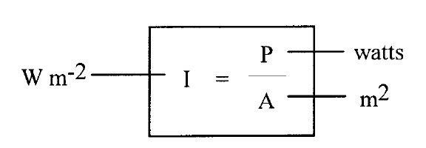
Irradiance is the term used for the amount of light energy that falls on a surface.

When radiation is incident on a surface, irradiance is power per unit area.

The irradiance equation is more useful in the form on the left, when irradiance is compared at 2 distances.

The energy of a photon.

E = energy of photon, in joules (J)
h = Planck’s constant: 6.63 × 10-34 Js (found in data sheet at start of paper)
f = frequency of photon, in hertz (Hz)

Light with a higher frequency has a higher energy. So, blue light has more energy per photon than red light.

To calculate the irradiance of photons.

I = total irradiance of photons, in watts per square metre (W/m²)
N = number of photons, no units.
h = Planck’s constant: 6.63 × 10-34 Js (found in data sheet at start of paper)
f = frequency of photon, in hertz (Hz)

To calculate the kinetic energy of a photo-emitted electron.

E_{k} = kinetic energy of emitted electron, in joules (J)
h = Planck’s constant: 6.63 × 10-34 Js (found in data sheet at start of paper)
f = frequency of photon, in hertz (Hz)
f₀ = threshold frequency, in hertz (Hz)

hf₀ is the work function, in joules (J), and is the energy required by a photon to dislodge one electron from the surface of the material.

f₀ is the minimum frequency of EM radiation required in order to eject electrons from a particular material. It is dependent on the surface being irradiated.

Any amount of irradiation of a frequency less than f₀ will not dislodge any electrons. For frequencies > f₀, the photoelectric current produced is directly proportional to irradiance at the surface

To calculate the frequency of photons absorbed or emitted by specific energy levels.

W₂ = energy of electron at higher energy level, in joules (J)
W₁ = energy of electron at lower energy level, in joules (J)
h = Planck’s constant: 6.63 × 10-34 Js (found in data sheet at start of paper)
f = frequency of photon, in hertz (Hz)
ground state

The equation for Einstein’s theory of special relativity.

E = energy released by reaction, in joules (J)
m = decrease in mass of substances, in kilograms (kg)
c = speed of light in vacuum (3x10⁸ m/s)

This equation is used to calculate the energy created during a nuclear reaction.

The energy released is carried away as kinetic energy of the products.

To calculate radioactive activity.

A = radioactive activity, in becquerels (Bq)
N = number of decays (counts) (no units)
t = time taken, in seconds (s)

One becquerel is an activity of 1 decay per second.

To calculate absorbed dose.

D = absorbed dose, in grays (Gy)
E = absorbed energy, in joules (J)
m = mass of matter absorbing the dose, in kilograms (kg)

One gray = 1 J/kg.

The absorbed dose is the energy absorbed per unit mass.

The absorption of energy by a substance depends on:
· the nature and thickness of the substance
· the type of radiation
· the energy of the particles or photons of the radiation.

Equivalent, or effective, dose.

H = equivalent dose, in sieverts (Sv)
D = absorbed dose, in grays (Gy).
w_{R} = radiation weighting factor (no units). This is a measure of radiation’s biological effect.

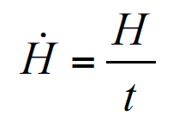
Equivalent dose rate.

= equivalent dose rate, in sieverts per unit time
H = equivalent dose, in sieverts (Sv)
t = time over which dose is absorbed (units vary: usually days or years).

We have to take into account the time of exposure when considering the damage done by radiation. If the dose is concentrated in a short period of time it can lead to radiation sickness or even death.

For the public, exposure should not exceed 5 mSv in any year and should not exceed 1 mSv per year on a long term basis.

The average annual effective dose that a person in the UK receives due to natural sources is approximately 2.0 mSv, although this can vary from place to place.

Uncertainties.

The best estimate of a true value is calculated from the average of multiple readings. The random uncertainty is calculated using the equation on this card.

The scale reading uncertainty is calculated as follows:

analogue scale:
± half the least division of the scale.

digital scale:
± 1 in the least significant digit displayed.

