Semiconductors

CONTENT STATEMENTS

23 State that materials can be divided into three broad categories according to their electrical properties - conductors, insulators and semiconductors.
24 Give examples of conductors, insulators and semiconductors.
25 State that the addition of impurity atoms to a pure semiconductor (a process called doping) decreases its resistance.
26 Explain how doping can form an n-type semiconductor in which the majority of the charge carriers are negative, or a p-type semiconductor in which the majority of the charge carriers are positive.
27 Describe the movement of the charge carriers in a forward/reverse-biased p-n junction diode.
28 State that in the junction region of a forward-biased p-n junction diode, positive and negative charge carriers may recombine to give quanta of radiation.
29 State that a photodiode is a solid-state device in which positive and negative charges are produced by the action of light on a p-n ]unction.
30 State that in the photovoltaic mode, a photodiode may be used to supply power to a load.
31 State that in the photoconductive mode, a photodiode may be used as a light sensor.
32 State that the leakage current of a reverse-biased photodiode is directly proportional to the light intensity and fairly independent of the reverse-biasing voltage, below the breakdown voltage.
33 State that the switching action of a reverse-biased photodiode is extremely fast.

ELECTRICAL PROPERTIES OF MATERIALS

Materials can be divided into three broad categories according to their electrical properties. They are conductors, insulators and semiconductors.

Conductors | Insulators | Semiconductors
silver | wood ( R = 1×10¹⁸ Ω) | Silicon (R = 6 × 10⁷ Ω)
copper (R = 1.72 Ω) | rubber | Germanium (R = 2.3 × 10¹¹ Ω)
aluminium | plastic

(Resistances are given for 1 m lengths and 0.1 mm²).

In CONDUCTORS an increase in temperature increases the resistance.

In SEMICONDUCTORS an increase in temperature decreases the resistance.

Semiconductors are found in Group 4 of the periodic table. We can DOPE them by adding a small portion (about 1 part per million) of a Group 3 or Group 5 material.

Adding Group 3 (eg. Gallium, Ga, and Indium, In) gives a POSITIVE material (p-type, hole or positive hole).

Adding Group 5 (eg. Arsenic, As, and Antimony, Sb) gives a NEGATIVE material (n-type, electron).

Energy is produced when hole meets electron!!
FORWARD AND REVERSE BIASING

n-type
p-type
n-type
p-type
electrons pushed
holes
pushed
combining of holes and electrons

FORWARD BIASING – CURRENT FLOWS

because of the strong forces pulling the electrons to the positive terminal.

This causes the release of energy usually in the form of heat but sometimes in the visible spectrum (see LED).

REVERSE BIASING – NO CURRENT FLOWS
n-type
p-type
electrons pulled
holes
pulled

because holes are attracted to the negative terminal the electrons are pulled to the positive terminal. The gap at the junction requires too much energy for the charges to cross.

n- and p-type semiconductors joined form a JUNCTION DIODE.

Voltage and Current graphs for junction diodes

In reality the graph is slightly different!
V
I
Forward bias
Reverse bias
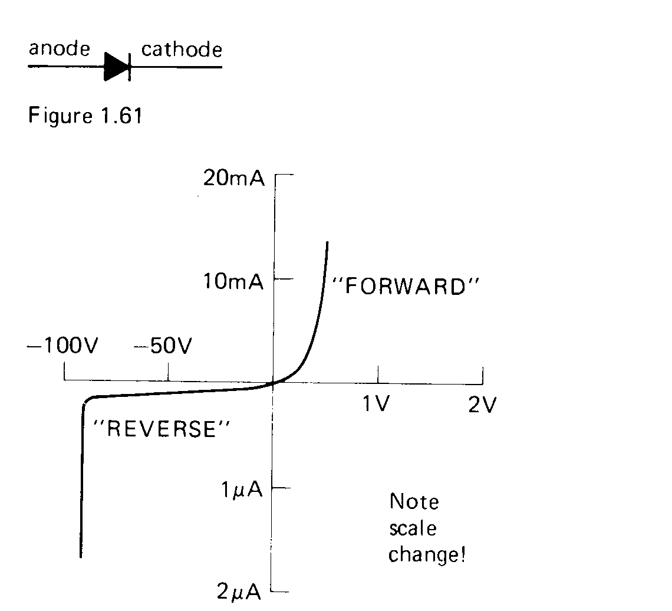
The rapid change in current at about –90V is the reverse breakdown voltage (your diode just got cooked!).
Uses of Junction Diodes

Valuable
Component
Diode
+ -

Light Emitting Diodes (LED)

Light is emitted when the holes and electrons recombine. This happens in all diodes but energy is usually given off in the form of heat.

Different materials can give off light of different colours.

GALLIUM ARSENIDE PHOSPHIDE can give out RED, GREEN or YELLOW depending on the proportions used.
The light is only of use if it can escape from the diode so the junction is designed to be close to the surface
clear plastic case
junction near the surface
connections

Photodiode

This acts as an LED in reverse. A photon may be absorbed in the depletion layer. This provides the energy to release an electron and leave its corresponding hole.

As the light intensity increases the current it produces increases proportionately.

We say that the photodiode is being used in PHOTOVOLTAIC MODE. This is the basis of SOLAR CELLS and can be used to supply power to a load.

In this mode there is no power supply and therefore the diode is not biased.

Photodiodes – Reverse biasing

If a p-n junction is connected in the REVERSE BIAS in the circuit there is negligible current flowing through it.

Charges are unable to pass the relatively high voltage gap of the depletion layer.

As light falls on the junction electrons are released from this layer. This changes the number of positive holes and electrons in the p=type and n-type layers thus creating more charge carriers. We say the photodiode is being used in PHOTOCONDUCTIVE MODE. The current this causes is proportional to light intensity.

The photodiode set up in this way can be used as a very fast timing switch.

Transistors

If three layers (two junctions) are grown together then the forming device can be made into a transistor.

Applications

Half wave rectification.

c.r.o. screen
This gives a very basic d.c. from a.c., but for half the cycle there is zero voltage and current.

Full wave rectification.
c.r.o. screen
LOAD

This is a better way of getting d.c. from a.c. and is known as a BRIDGE RECTIFIER.

SUMMARY

BIASING | ENERGY | TERMINOLOGY | EXAMPLES
No biasing | energy from light (photons) | PHOTOVOLTAIC MODE | eg. solar cell
Reverse bias | energy from light | PHOTOCONDUCTIVE MODE | eg. photodiode or fast timing switch
Forward bias | energy RELEASED | - | eg. LED
3 layers |  |  | eg. transistor
Today the word ‘semiconductor’ is normally used to describe an electronic component, such as a transistor, diode, or integrated circuit. However the word semiconductor originally meant a material which was neither a good conductor, nor a good insulator, and the word is still used this way in physics. A 1 cm³ sample of a conductor will have a very low resistance, perhaps 10⁻³ Ω. A 1 cm³ sample of an insulator will have a very high resistance, perhaps 10¹³Ω. A 1 cm³ sample of a semiconductor however will have a moderate resistance, perhaps about 100 Ω.

A good conductor has charges in it which are easy to get to move. For example, most metals are good conductors because the outer electrons are only loosely attached to the atoms, and can be easily moved from one atom to the next. Indeed, in many metals the outer orbitals of the atoms overlap, and the outer electrons are free to wander from atom

to atom without having to do any work removing them from the rest of the atom. This means that in most metals there are as many mobile charges as atoms - this is a very large number.
A good insulator by comparison has its charges tightly held in place, so that it is very difficult to get them to move. Often electrons can only be removed from an atom in an insulator by breaking a covalent bond, and so breaking down the material. Polyethylene is an example of a good insulator, as are most other covalently bonded materials.

Semiconductors are materials where there are a few of the charges which are able to move, but not the vast numbers of charges in a metal. Silicon and Germanium are examples of semiconducting materials, as is Tin Oxide and Gallium Arsenide.

Silicon is a typical semiconducting material. Silicon is in group 4 of the periodic table, and so has 4 outer electrons. In its pure state, silicon is called intrinsic, and forms crystals, like diamond, where each silicon atom is covalently bonded to its four nearest neighbours. This structure suggests that silicon should be an insulator!
At very low temperatures silicon is indeed an insulator. However as the temperature increases its conductivity also increases. This happens because the thermal energy of some of the atoms is sufficient to remove an electron from one of the covalent bonds. This electron can then move from atom to atom, like the electrons in a metal, causing the silicon to conduct. The greater the temperature, the greater the thermal energy of the atoms, and the more electrons can be removed from their bonds.
The vacancy where the electron came from also plays a part in conduction. This vacancy is called a ‘hole’, and it acts like a mobile positive charge. (It can be filled in by an electron from a neighbouring atom, which then leaves a new hole at a different place.)

The conductivity of silicon can be increased substantially by adding controlled amounts of other elements to it. This process is called ‘doping’. Doping silicon decreases its resistance.

For example, a small amount of Phosphorous, a group 5 element, may be added to the silicon. The Phosphorous is forced into the crystal structure, and forms four covalent bonds with the surrounding silicon atoms. When this happens, the fifth outer electron of the Phosphorous becomes only loosely held, and can readily be removed from the atom by thermal energy. It then is able to move from atom to atom, and the silicon conducts. Because silicon doped this way has free electrons (negative charges), it is called N-Type silicon.
Similarly, if a small amount of a group 3 element, such as Boron is added to the silicon before letting it crystallize, the Boron will again be incorporated in the crystal structure, and form covalent bonds with the neighbouring silicon atoms. As boron only has 3 outer electrons however, it will leave a ‘hole’ in the electronic structure. There will be a vacancy in one of the covalent bonds which can be filled in by an electron from a neighbouring atom. This will produce a new hole, and the hole can move throughout the crystal as if it is a mobile positive charge Silicon doped in this way is called P-Type.

The Diode

A diode is a component which will only allow current to flow in one direction. A semiconductor diode is made by joining a piece of P-type silicon with a piece of N-type silicon, and so can also be called a PN junction diode.
The N-type silicon contains free electrons, and the P-type silicon contains holes, which are able to move.
When the two types of silicon are joined together, some of the free electrons from the N-type silicon fill in the holes in the P-type semiconductor. The electrons and holes cancel each other out, leaving a region in the crystal where there are no mobile charges. This region is called the depletion zone.
The movement of electrons stops because the N-type silicon has lost electrons, and so is now positively charged. This overcomes the attraction between the electrons and the positive holes. Similarly the P-type silicon has gained electrons, and so the holes are no longer attracted towards the N-type silicon. There is a potential difference of about 0.6 volts set up between the two ends of the diode.
When the diode is connected into a circuit, the battery can either oppose or reinforce the potential difference between the two ends of the diode.

When the diode is reverse biased, no current flows, because the battery reinforces the existing potential difference, and the insulating depletion zone grows.
When the diode is forward biased, the battery opposes the potential difference between the ends of the diode. The depletion zone shrinks. Provided the battery voltage is above 0.6 volts, the depletion zone shrinks to zero, and the electrons and holes are free to combine at the junction.
The electrons in the N-type silicon are pushed towards the junction by the battery voltage. At the junction the free electrons fall into the holes, and become trapped in the covalent bonds holding the material together. The free electrons are however continuously replaced by others pushed in by the battery.

The holes in the P-type are also pushed towards the junction by the battery, where they are destroyed. New holes are produced at the connection to the circuit, as electrons are pulled out of the P-type material by the battery. There is a continuous flow of charges round the circuit, and the diode conducts.

When the electrons and holes combine at the PN junction, they give out energy. This energy is emitted as a quanta of radiation (a photon). The energy of the photon depends on the energy levels within the materials. A standard diode, which is intended to be used as a rectifier, produces infra-red photons at the PN junction. If materials are used with a greater difference in energy levels, then visible photons can be produced. This is a light emitting diode.

