Higher Physics
Key Areas of Revision

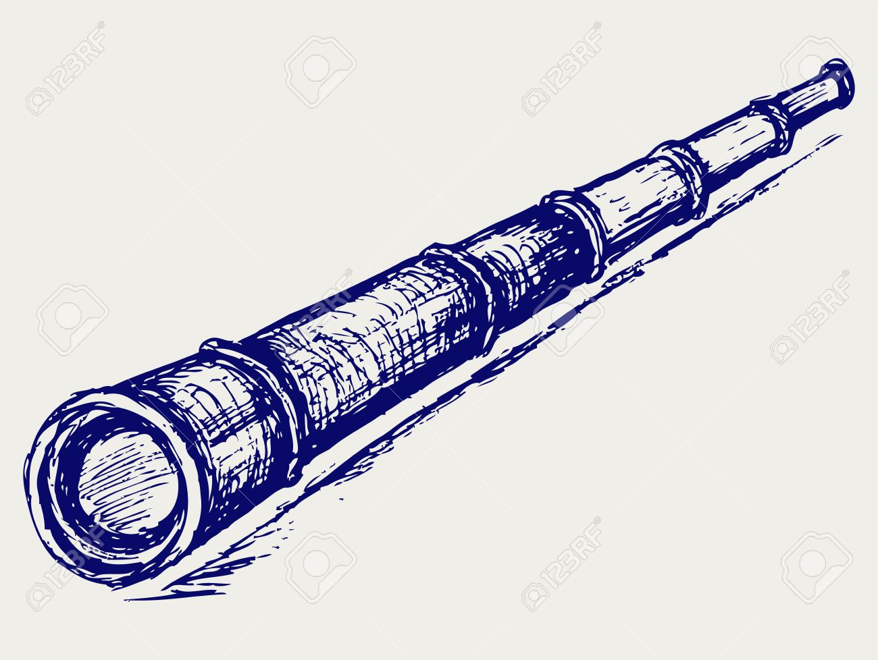

Contents
Help Sheet page 3-7
Direction, Acceleration and Sign page 8-10
Newton's Universal Law of Gravitation page 10-11
Total number of electrons or photons page 11-12
Redshift page 12
Particle Accelerators: Conservation of Energy page 13-14
Photoelectric Effect: Conservation of Energy page 14-15
Refractive Index page 15-16
Irradiance page 17
Internal Resistance and Electromotive Force page 18-19
Energy in Capacitors page 19-21
Nuclear Energy: E = mc² page 21-22
Weight on a Slope page 22-23
Answers page 24-29

Key Revision Areas Help Sheet
Direction and Sign
In Our Dynamic Universe the direction is very important.
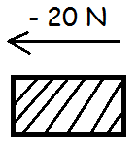
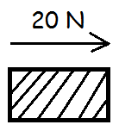

General rule,
Right “+” Left “–”
Up “+” Down “–”

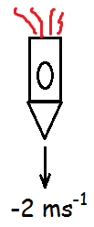
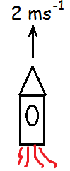

Acceleration and Sign
Whether something is accelerating or decelerating also is very important for “+” or “– “
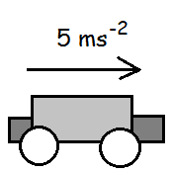
Accelerating forwards
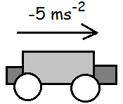
Decelerating forwards (braking)
Accelerating “+”
Decelerating “–”

Direction, Acceleration and Sign
If you are considering the acceleration/deceleration of a projectile in terms of vertical motion then a = -9.8 ms⁻² always.

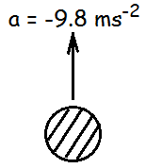
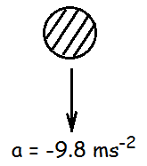
Moving upwards, but decelerating.
Accelerating, but moving downwards

Newton's 3 Laws of Motion

- 1st Law – Balanced forces = no change in speed
- 2nd Law – Unbalanced forces = changing speed
– “F_{un} = ma”
- 3rd Law – “For every action there is an equal and opposite reaction” – If a car crashes into a wall, whatever force the car applies to the wall, the walls applies an equal amount of force back but in the opposite direction.

Newton's Universal Law of Gravitation
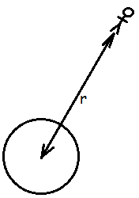

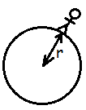

In the equation F = Gm₁m₂/r², “r” is always the distance between a person/object and the centre of a planet/moon. It is not just the radius of the planet/moon. "m₁" is the person/object's mass.
"F" is just the weight ("W") so F = W Gm₁m₂/r² = m₁g.
Total Number of Electrons
- Do Q = It to work out the total charge
- Divide the total charge by the charge of one electron (data sheet)
- This will give you the total number of electrons

Total Number of Photons
- Do P = E/t to work out the total energy of the light
- Divide the total energy by the energy of one photon (you might need to work out E_{photon} using E = hf first)
- This will give you the total number of photons

Red-Shift (λ_{observed} vs. λ_{rest})
- λ_{observed} is always the wavelength of light from the galaxy seen from Earth
- λ_{rest} is always the wavelength of light from a source on Earth seen from Earth

Particle Accelerators: Conservation of Energy
- "Energy can only turn into other forms, it cannot be created or destroyed." - conservation of energy law
- For particle accelerators, E_{electrical}= E_{kinetic} (the electrical energy gained by the electron/proton from the particle accelerator turns into kinetic energy meaning the electron/proton will accelerate)
- E_{electrical} = E_{kinetic} QV = ½mv²
- You will always have 3 variables for the above equation, you will be asked to calculate the 4th variable
- N.B. The charge "Q" of an electron/proton is always 1.6 x 10⁻¹⁹ C which is found on your data sheet. The mass "m" is different for an electron/proton so you will need to use your data sheet.
Refractive Index
- "The ratio of the velocity of light in a vacuum to the velocity of light in a medium" - refractive index
- The refractive index "n" must always be larger than 1
- In n = sinθ₁/sinθ₂ , theta₁ must always be larger than theta₂

The Photoelectric Effect: Conservation of Energy
- When photons of light land on a metal surface it may cause electrons to be ejected from the surface (photoelectric effect)
- The energy of a light photon is equal to the minimum energy required to eject an electron (work function) + the kinetic energy of the electron.
- E_{photon} = E_{work function} + E_{kinetic} (conservation of energy)
- hf = hf_{o} + ½mv²
- The minimum frequency of light required to eject an electron is called the threshold frequency (f_{o})
- You may be given the energy of a photon and the work function of a specific metal. You may then be asked to work out the speed of an ejected electron using the above equation, where "m" is the mass of the ejected electron.

Using All the Data: Irradiance
- I = k/d², where k is a constant (just a number with no units)
- Do calculations for all of the information in the table to determine the "constant"
- This may be four or five separate calculations depending on how much data you have been given
- If the number (constant) is the same or extremely similar in all cases then there is a relationship

Electromotive Force and Internal Resistance
- E = IR + Ir
- "E" is the maximum energy given per coulomb of charge
- "R" is the total external resistance
- "r" is the total internal resistance
- If given a graph "E" is the y-intercept (where voltage is most)
- If asked to find the short-circuit current then it means there is no external resistance so E = (I x 0) +Ir E = Ir

Energy in Capacitors
- To determine the maximum energy stored in a capacitor you must use the maximum voltage (supply voltage) to calculate this.

Nuclear Energy: E = mc²
- "m" is always the lost mass in the reaction (the difference in mass before and after the reaction)

Weight on a Slope
- W_{parallel} = mgsinθ
- W_{perpendicular}= mgcosθ
- These will not be on the equation sheet, you must memorise both of these equations

Projectile Motion
- v_{horizontal}= vcosθ
- v_{vertical}= vsinθ
- These will not be on the equation sheet, memorise them.
Higher Physics: Key Areas Revision Questions
Direction, Acceleration and Sign
1. A footballer kicks a ball up the pitch as shown in the diagram below.
a) Calculate:
i) the vertical component of the initial velocity of the ball. 1
ii) the horizontal component of the initial velocity of the ball. 1
b) Calculate the total time of flight. 3
c) Calculate the range of the ball. 3
d) Calculate the maximum height reached by the ball. 3
The footballer kicks the ball again, but this time towards a steep embankment as shown in the diagram below.
e) Calculate the total time of flight for her second kick. 4

2. Two curling stones are slid towards one another on an ice rink. The diagrams below show what happens as the stones come together, collide and then move apart. The collision lasts 20 ms.
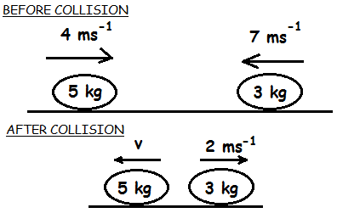
a) State the law of the conservation of linear momentum. 1
b) Calculate the velocity of the 5 kg stone after the collision. 3
c) Calculate the force the 5 kg stone exerts on to the 3 kg stone. 3
d) State the force the 3 kg stone exerts on to the 5 kg stone. 1
e) Is the collision elastic or inelastic? You must justify your answer by calculation. 4

3. Two shuttles dock with one another in deep space to form a "super shuttle". The diagram below crudely shows what happens during this process.
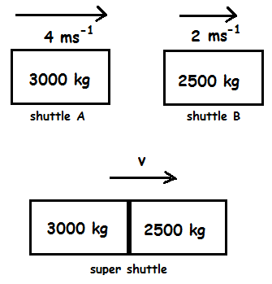
a) State the law of the conservation of linear momentum. 1
b) Calculate the final velocity of the super shuttle after the collision. 3
c) Sketch a force-time graph of how the collision would appear. Numerical values are not required. 1
d) State what can be determined from the area under and F-t graph. 1
e) Show by calculation whether the collision is elastic or inelastic. 4

Newton's Universal Law of Gravitation
4. A satellite of mass 4 x 10³ kg orbits the moon at a height of 180 km above the surface. It is collecting data on the moon's many craters. The moon has a mass of 7.4 x 10²² kg and a radius of 1740 km.
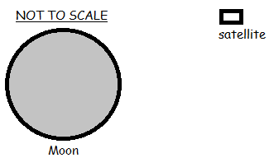
a) Calculate the size of the gravitational force of attraction between the satellite and the moon. 3
b) Calculate the gravitational field strength of the moon at this height. 3
c) The moon has many craters on its surface but comparatively the Earth has very few. Explain what causes the craters and why the Earth, which is much larger than the moon, does not have as many craters. 1

5. An astronaut of mass 70 kg steps outside of the International Space Station (ISS) which orbits the Earth at a height of 400 km. The Earth has a radius of 6370 km and a mass of 5.97 x 10²⁴ kg.
a) Calculate the gravitational force of attraction between the astronaut and Earth.3
b) Calculate the gravitational field strength at this height. 3
c) Calculate its orbital height when the gravitational field strength is 0.5 Nkg⁻¹. 4
[Tough/Extension - wouldn't be asked this in the exam]
Total Number of Electrons/Photons
6.The following circuit is set up using bulbs of different resistance to see which one will appear brighter.
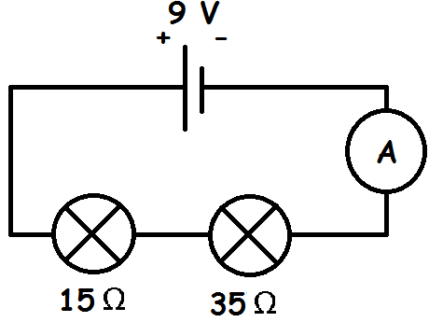
a) Calculate the current in this circuit. 4
b) Calculate the number of electrons that pass through the ammeter in 5 seconds.4
c) Show by calculation which of the two bulbs is brighter. 4

7. The following circuit is set up to find the turn on voltage of a red LED which has a wavelength of 630 nm. A resistor of 200 Ω is also placed in the circuit.
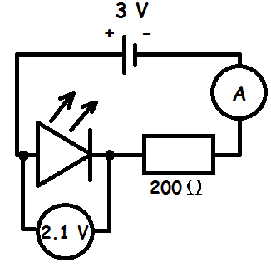
a) Calculate the current passing through the resistor. 4
b) Calculate the number of negatively charged electrons that pass through the resistor in 10 seconds. 4
c) Calculate the power of the LED in this circuit. 3
d) Calculate the energy of a single photon emitted by the LED. 4
e) Calculate the total number of photons that the LED will emit in 10 seconds. 4

Redshift
8. When helium is burned on Earth it gives off particular colours of light. One of these colours has a wavelength of 455 nm. When a distant galaxy is observed the same colours of light are emitted but to us on Earth they appear red-shifted. The same colour mentioned before now has a wavelength of 478 nm.
a) Calculate the red-shift of the galaxy. 3
b) Calculate the recessional velocity of the galaxy. 3

9. An astronomer burns helium on Earth and, using a spectroscope, she notices particular colours of light being emitted. One of the lines has a wavelength of 590 nm. She then observes a galaxy through her spectroscope and notices that the same lines appear as before, meaning there must be burning helium in that galaxy (from the stars). However, the lines have moved towards the red-end of the spectrum and the individual line she noticed on Earth before now has a wavelength of 607 nm.
a) Calculate the red-shift of the galaxy. 3
b) Calculate the recessional velocity of the galaxy. 3
c) Calculate how far away the galaxy is from Earth. 3
d) Explain, in terms of wave fronts, why light from the galaxy appears red-shifted to us on Earth. 2

Particle Accelerators: Conservation of Energy
10. An electron is being accelerated by a particle accelerator. The electron is stationary in the beginning.
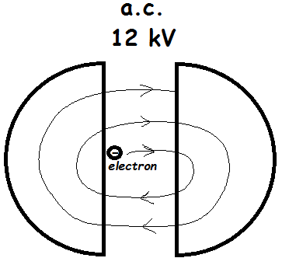
a) Name this type of particle accelerator. 1
b) State the direction of the magnetic field in the right-hand "D". 1
c) Calculate the energy gained by the electron as it crosses between the "D"s. 3
d) Calculate the speed of the electron after crossing between the "D"s once. 3

11. A proton is accelerated by a particle accelerator. The proton is stationary in the beginning.
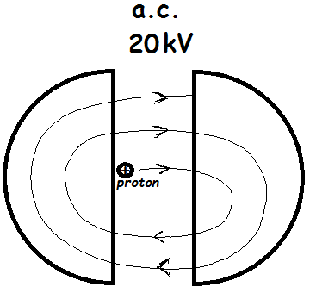
a) State the direction of the magnetic field in the right-hand "D". 1
b) Calculate the speed of the proton after crossing between the "D"s twice. 4

12.An electron is accelerated in a linear accelerator. The electron enters the first section of the accelerator at a speed of 5 x 10⁶ ms⁻¹.
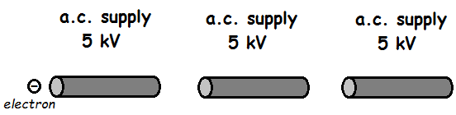
a) Calculate the gain in energy of the electron as it passes through one section of the linear accelerator. 3
b) Calculate the speed of the electron after is has passed through all three sections of the linear accelerator. 4
c) If a proton, starting at the same speed as the electron, was used in the above accelerator, how would its final speed compare with your previous answer after having passed through all three sections. Justify your answer. 2

Photoelectric Effect: Conservation of Energy
13. A scientist shines a green light on to 4 different metal surfaces. Each metal surface has been induced to give it a negative charge. The green light has a wavelength of 550 nm. The work function of the metals is shown in the following table.
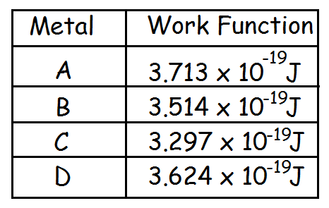
Show by calculation whether or not the green light will cause electrons to be ejected from any of the 4 metals. 4

14. Two different colours of light are shone on top of a clean metal surface to eject electrons by photoemission. One of the lights is blue and has a wavelength of 430 nm. The other is red and has a wavelength of 650 nm. The metal surface has a work function of 4.30 x 10⁻¹⁹ J.
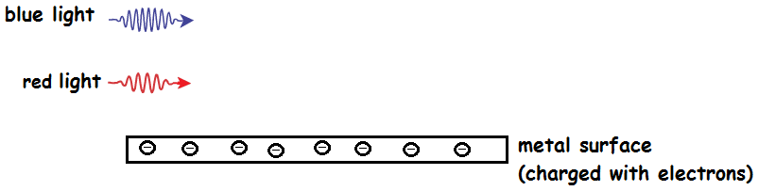

a) Show by calculation if both of the colours of light would cause electrons to be ejected. 4
b) Calculate the speed of the electrons ejected by the blue light. 3
c) Explain how it could be possible for electrons to be ejected at larger speeds. 2

Refractive Index
15. A man observes a fish that is underneath the water in a river. Light reflects off the back of the fish then refracts out of the water, allowing the man to see it.
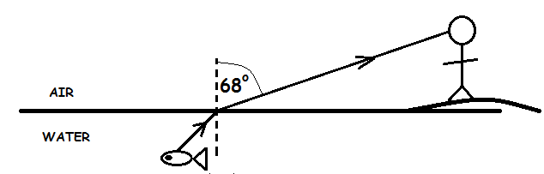
a) Calculate the angle of incidence. 3
b) State what happens to the speed, frequency and wavelength of the light as it passes from the water to the air. 2

16. A green light of 550 nm is shone through a glass block causing refraction to occur. The glass has a refractive index of 1.6.
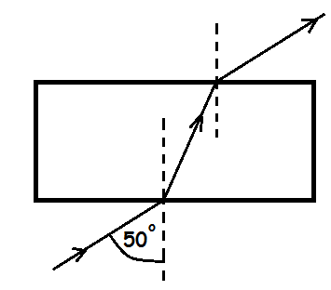
a) Calculate the critical angle of the glass block. 3
b) Calculate the angle of refraction after the light has entered the glass block. 3
c) Calculate the wavelength of the light in the glass block. 3
d) Explain what would need to happen to the angle of incidence outside of the glass block before total internal reflection could occur inside the glass block. Justify your answer. 3
17. A beam of light is shone into a prism as shown below. The prism has a refractive index of 1.5.
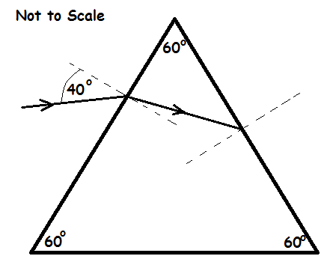
a) Calculate the critical angle of the prism. 3
b) Show by calculation, and by determining the relevant angles, whether the light will totally internally reflect at the right-hand side of the prism or whether the light will refract out at the right-hand side of the prism. 4

Irradiance
18.A light bulb is placed at 4 different distances from a light level meter. Data was collected and has been recorded in the table below.
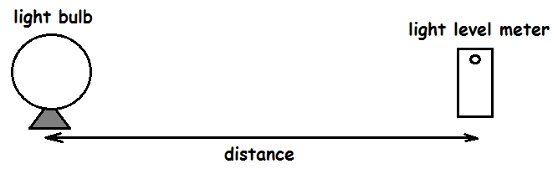
Irradiance (Wm⁻²) | 60 | 6.67 | 2.4 | 1.22
distance (m) | 0.5 | 1.5 | 2.5 | 3.5

a) Using all of the data, show that there is a relationship between the irradiance and the distance. 2
b) Calculate the irradiance if the distance between the apparatus was extended to 10 m. 3
19. A satellite orbits around the Sun. The closeness of the satellite to the Sun is varied so that better images can be taken. On the satellite there are two solar panels. Each solar panel has a surface area of 12 m².
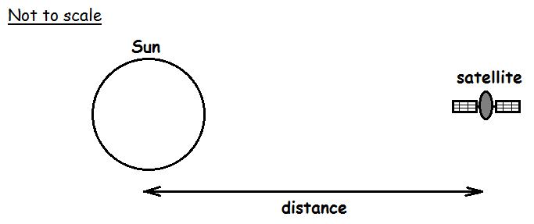
Irradiance (Wm⁻²) | 4200 | 6274 | 10370 | 20330
distance (Gm) | 110 | 90 | 70 | 50

a) Using all the data, show that there is a relationship between irradiance and distance. 2
b) Calculate the power of the solar panels when the satellite is a distance of 90 Gm from the Sun. 3
Internal Resistance and Electromotive Force
20. The following circuit is set up to help scientist better understand internal resistance.
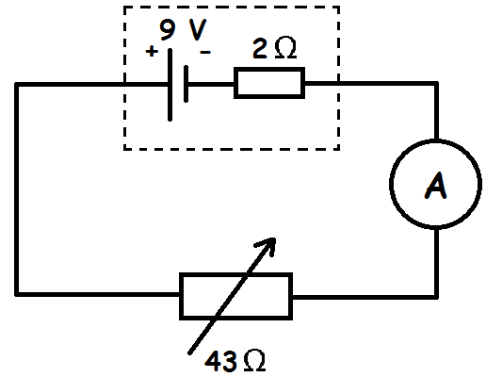
a) Calculate the current in this circuit. 3
b) Calculate the lost volts. 3
c) Explain what would happen to the lost volts if the resistance of the variable resistor decreased. 2
21.The following circuit is set up to see if the resistance of an unknown resistor can be determined.
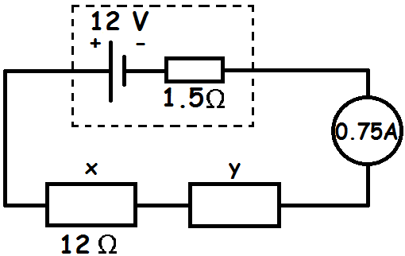
a) Calculate the resistance of resistor "y" in this circuit. [Tough question but try to work out as much info as you may need in the lead up to your answer, problem solve as best you can]. 4
b) Explain what would happen to the terminal potential difference if resistor "y" was removed from the circuit. 2

22. The following circuit is set up to help students better understand the effects of a power supplies' internal resistance.
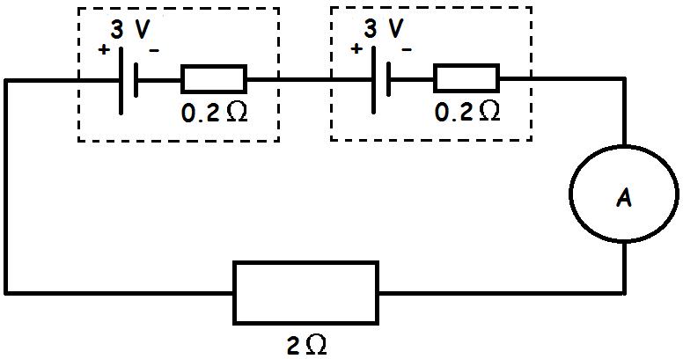
a) Calculate the current flowing in this circuit. 3
b) Calculate the terminal potential difference in this circuit. 3
c) Determine the lost volts. 1
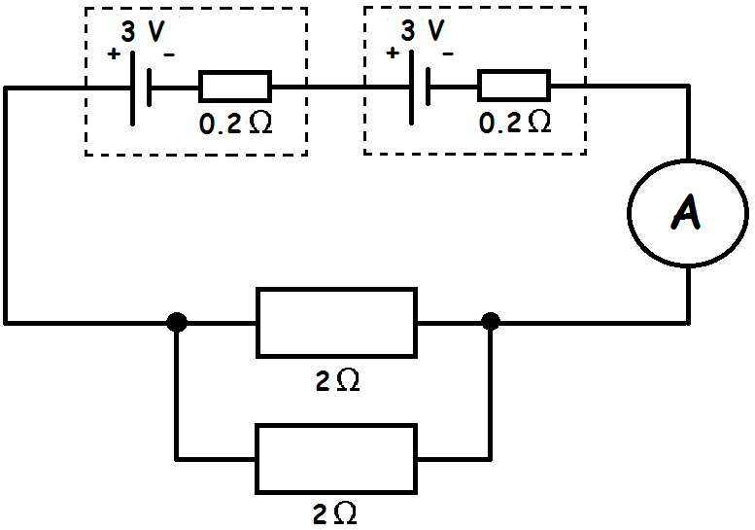
Another 2 Ω resistor is placed into the circuit in parallel with the first one.
d) Will the lost volts now increase, decrease or stay the same? Justify your answer.2
Energy in Capacitors
23. The following circuit is set up to determine how much energy can be stored in a capacitor and to see how long it takes to charge up. The diagram shows what is happening at a particular stage in the charging process.
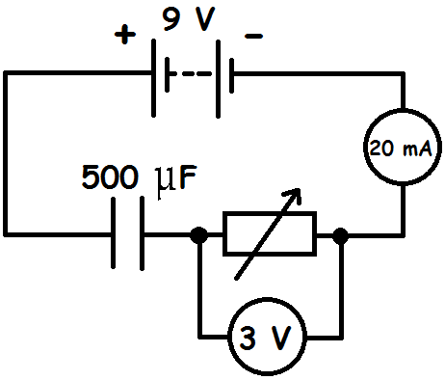
a) Calculate the amount of charge stored in the capacitor at the stage of the charging process shown in the diagram. 4
b) Calculate the maximum energy that the capacitor can store. 3
c) If the resistance of the variable resistor was increased, how would this affect the time it takes for the capacitor to charge? Explain you answer. 2

24.A circuit is set up to see how long a circuit takes a capacitor to charge.
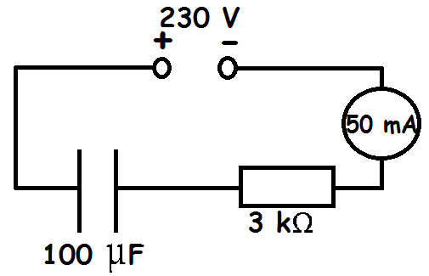
a) Calculate the potential difference across the resistor. 3
b) Calculate the energy stored in the capacitor at the point of the charging process shown in the above diagram. 4
c) Why must a d.c. supply be used to charge up a capacitor and not an a.c. supply? 1

25. The following circuit is set up to see how long a discharging capacitor can keep an LED lit.
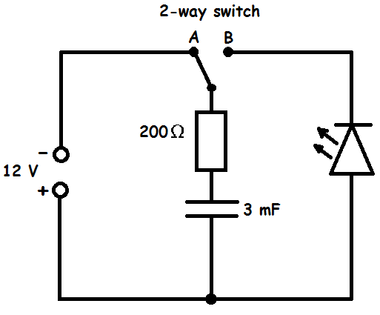
a) Explain how this circuit works so that the capacitor could light the LED. 2
b) Calculate the maximum current in this circuit as the capacitor starts to charge. 3
c) Calculate the maximum energy stored by the capacitor. 3
d) Sketch a graph to show what happens to the current across the resistor as the capacitor charges. Numerical values are needed on the y-axis only. 2
e) On the same graph, sketch what happens to the current across the resistor as the capacitor discharges. Numerical values are needed on the y-axis only. 2
Nuclear Energy: E = mc²
26. A nuclear reaction occurs causing energy to be released. The word equation for the reaction is shown below.
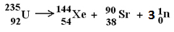
Element/Particle | mass (kg)
Uranium | 390.246 x 10⁻²⁷
Xenon | 238.319 x 10⁻²⁷
Strontium | 146.864 x 10⁻²⁷
neutron | 1.675 x 10⁻²⁷

a) State the type of nuclear reaction taking place. 1
b) Explain how energy is produced in this type of reaction. 1
c) Calculate the energy released in this reaction. 4

27.At a nuclear power station, one of the reactors has a power rating of 1 MW. A nuclear reaction occurs inside causing energy to be released. The word equation for the reaction is shown below.

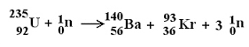

Element/Particle | mass (kg)
Uranium | 390.218 x 10⁻²⁷
Barium | 232.619 x 10⁻²⁷
Krypton | 154.242 x 10⁻²⁷
neutron | 1.675 x 10⁻²⁷

a) State the type of nuclear reaction. 1
b) Calculate the energy released by one reaction. 4
c) Calculate how many reactions occur in the chamber in 10 seconds. 4
Weight on a Slope
28.A box is placed on a slope and the angle is increased to see when the weight acting down the slope is greater than the friction acting between the box and the slope.
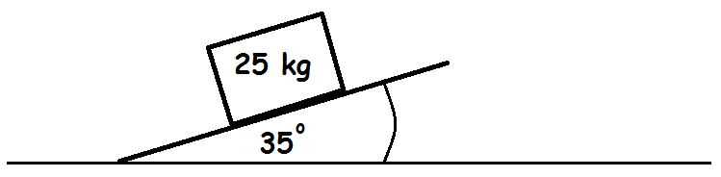
In the above example the box is stationary.
a) Calculate:
i) The weight component acting parallel to the slope. 1
ii) The weight component acting perpendicular to the slope. 1
b) State the force of friction acting up the slope. 1
The angle of the slope is now increased as shown in the diagram below. This causes the box to move down the slope now with an acceleration of 0.5 ms⁻².
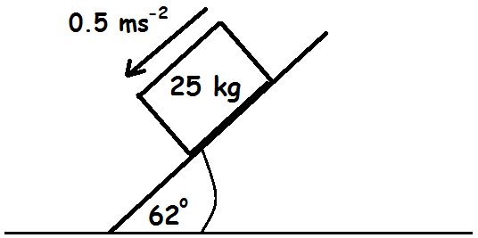
c) Calculate:
i) The weight component acting parallel to the slope. 1
ii) The weight component acting perpendicular to the slope. 1
d) Calculate the force of friction acting up the slope. 4

29.A skier travels down a slope as shown in the diagram below. She has dropped both of her skiing poles so accelerates down the slope freely. Her mass is 55 kg.
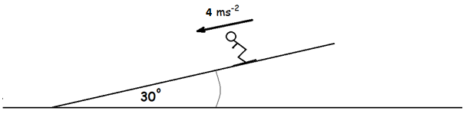

a) Calculate her weight component parallel to the slope. 1
b) Calculate the force of friction acting against her. 4
c) Give one example of how she could increase her acceleration. 1

Answers
Direction, Acceleration and Sign
1ai) 16.1 ms⁻¹
1aii) 19.2 ms⁻¹
1b) time to top = 1.643 s, so total time = 3.286 s or 3.29s (to 3 significant figures)
1c) 63.2 m
1d) 13.2 m
1e) [2 different suvat equations to get the extra time] Extra time = 0.54 s, so total time = 3.29 + 0.54 = 3.83 s
2a) Thetotal momentum before a collision is equal to the total momentum after a collision in the absence of external forces
2b) -1.4 ms⁻¹ if you made things moving to the left negative
2c) 1350 N if you made things moving to the left negative (have to use information for the 3 kg stone in the equation as this is affected by the force of the 5kg stone).
2d) -1350 N
2e) [Calculate total E_{K} before the collision and compare with total E_{K} after it] 113.5 J ≠ 10.9 J Inelastic as not the same before and after
3a) The total momentum before a collision is equal to the total momentum after a collision in the absence of external forces
3b) 3.09 ms⁻¹ (to 3 significant figures)
3c)
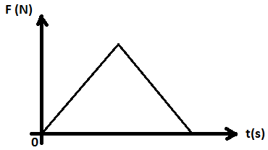
3d) Change in momentum (otherwise known as impulse)
3e) 29000 J ≠ 26300 J Inelastic

Newton's Universal Law of Gravitation
4a) 5360 N (to 3 significant figures)
4b) 1.34 Nkg⁻¹
4c) The moon does not have an atmosphere but Earth does. When asteroids enter Earth's atmosphere they burn up as their kinetic energy turns to heat energy due to air resistance. This means they do not hit the surface of Earth, but they do the moon's surface as it does not have an atmosphere to protect it. [Or something similar]
5a) 608 N
5b) 8.69 Nkg⁻¹
5c) 2.19 x 10⁷ m or 21,900,000 m or 21,900 km
Total Number of Electrons/Photons
6a) 0.18 A [V = IR Total Voltage = Total Current x Total Resistance]
6b) 5.63 x 10¹⁸ electrons (to 3 significant figures)
6c) The 35 Ω bulb is brighter as it is more powerful [need to use P = I²R]
7a) 4.5 x 10⁻³ A [Use 0.9 V in the equation V = IR]
7b) 2.81 x 10¹⁷ electrons (to 3 significant figures)
7c) 9.45 x 10⁻³ W
7d) 3.16 x 10⁻¹⁹ J [Use v = fλ then E =hf]
7e) 2.99 x 10¹⁷ photons
Redshift
8a) 0.0505 or 5.05 x 10⁻² (to 3 significant figures. There are no units)
8b) 1.52 x 10⁷ ms⁻¹ (to 3 significant figures)
9a) 0.0288
9b) 8.64 x 10⁶ ms⁻¹
9c) 3.76 x 10²⁴ m
9d) As the galaxy moves away there is a larger gap between emitted waves of light. The further apart two wave fronts are the larger the wavelength, meaning they appear more red-shifted to us on Earth.
Particle Accelerators: Conservation of Energy
10a) Cyclotron
10b) Into the page [Right-hand Rule as an electron]
10c) 1.92 x 10⁻¹⁵ J
10d) 6.49 x 10⁷ ms⁻¹
11a) Out of the page [Left-hand Rule as a proton]
11b) 2.77 x 10⁶ ms⁻¹
12a) 8 x 10⁻¹⁶ J
12b) 7.28 x 10⁷ ms⁻¹ (remember to add on the initial kinetic energy to your total energy as the electron was already travelling at a speed before entering the particle accelerator).
12c) It would be less speed as protons have more mass. As E_{k} = ½mv², if the gained kinetic energy (from the particle accelerators) is constant but the mass is greater then the final speed must be less.
Photoelectric Effect: Conservation of Energy
13. frequency of green light = 5.45 x 10¹⁴ Hz, energy of green light = 3.61 x 10⁻¹⁹ J.
So B and C as their work functions are below the green light's energy.
14a) Energy of blue light = 4.63 x 10⁻¹⁹ J, Energy of red light = 3.06 x 10⁻¹⁹ J.
The blue light will eject electrons as its energy is more than the work function, but the red light won't as its energy is less than the work function.
14b) 2.69 x 10⁵ ms⁻¹
14c) If the frequency of the light used was greater (as the energy of the light would be greater).
Refractive Index
15a) 44º (always write angles to a whole number, no decimal points)
15c) The speed and wavelength both increase. The frequency remains constant.
16a) 39º
16b) 29º
16c) 343 nm or 3.43 x 10⁻⁷ m or 343 x 10⁻⁹ m
16d) The angle of incidence outside the glass block would need to increase to cause the angle of refraction to increase. This would mean the angle of incidence inside the glass block would also increase. If this angle is larger than the critical angle then the light will totally internally reflect.
17a) 42º
17b) The angle of refraction inside the prism = 25º; the angle of incidence inside the glass prism = 35º. As this is less than the critical angle the light will refract out the other side.
Irradiance
18a) Id² = k (constant) if there is a relationship.
60 x 0.5² = 15; 6.67 x 1.5² = 15; 2.4 x 2.5² = 15; 1.22 x 3.5² = 15
18b) I = k/d² I = 15/10² I = 0.15 Wm⁻²
19a) Id² = k (constant) if there is a relationship.
4200 x (110 x 10⁹)² = 5.08 x 10²⁵; 5980 x (90 x 10⁹)² = 5.08 x 10²⁵; 9880 x (70 x 10⁹)² = 5.08 x 10²⁵; 19400 x (50 x 10⁹)² = 5.08 x 10²⁵
19b) 151,000 W
Internal Resistance and Electromotive Force
20a) 0.2 A
20b) 0.4 V
20c) If the external resistance decreases then the current will decrease. The internal resistance will not change, this is constant. As Lost Volts = Ir then the lost volts must increase.
21a) 2.5 Ω
21b) E = V + Ir The current will have increased as there is now less total resistance. As r is constant then this means the lost volts will increase. E is also constant so to balance V must decrease. The terminal potential difference decreases.
22a) 2.5 A
22b) 5 V
22c) 1 V
22d) The current will now be greater as the total resistance is less. As r is constant and Lost Volts = Ir then the lost volts will increase.
Energy in Capacitors
23a) 3 x 10⁻³ C
23b) 2.03 x 10⁻² J (to 3 significant figures)
23c) The larger the resistance the smaller the current. This means it would take a longer period of time to get the capacitor charged up.
24a) 150 V
24b) 0.32 J
24c) If an a.c. supply was used then the charge would be moving back and forth round the circuit. This means it would not build up on one of the plates of the capacitor so it wouldn't charge.
25a) The switch is in position A allowing the capacitor to charge. The switch is then moved to position B which would allow the capacitor to discharge through the LED.
25b) 0.06 A
25c) 0.216 J
25d) 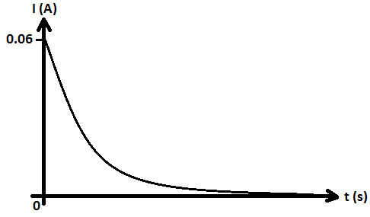
25e)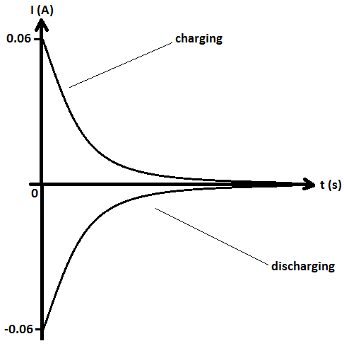
(upside down as travelling in the opposite direction now - the negative direction)
Nuclear Energy: E = mc²
26a) Spontaneous nuclear fission
26b) Some mass is lost after the reaction which is converted to energy by E=mc²
26c) lost mass = 0.038 x 10⁻²⁷ kg E = 3.42 x 10⁻¹² J
27a) Induced Nuclear Fission
27b) Lost mass = 0.007 kg E = 6.3 x 10⁻¹³ J
27c) 1.59 x 10¹⁹ reactions
Weight on a Slope
28ai) 141 N
28aii) 201 N
28b) 141 N
28ci) 216 N
28cii) 115 N
28d) 203.5 N or 204 N
29a) 270 N
29b) 50 N 29c) Crouch down lower to reduce air resistance; wax her skis so there is less friction; wear skin tight clothing so there is less air resistance; wear an aerodynamic helmet to reduce air resistance. [any one of these answers]

