Measuring Planck’s Constant
Planck’s constant is one of the fundamental parameters for our universe. It defines the quantum scale and plays a vital role in all quantum phenomena. The Measuring Planck’s Constant resource from Perimeter Institute gives students the opportunity to measure this incredibly small number. The experiment uses very simple equipment that can be accessed through any number of sources. A quick internet search will lead to some possible sources:
LEDs: - look for 5 mm bright LEDs that are clear and colourless when not illuminated.
- https://www.superbrightleds.com/cat/through-hole/ has a wide variety of colours
- https://solarbotics.com has fewer colours but also sell resistors
Resistors: - the size you will need depends on the LEDs that you purchase
- https://solarbotics.com have a good selection of resistors
- https://www.circuitspecialists.com/carbon-film-resistors
Potentiometers are not absolutely necessary. The activity can be done by just connecting the LED to at least 4 V and measuring the drop across the LED. The potentiometer allows the student to see that the LED does not light up until a certain voltage is reached. If you decide to order potentiometers you can find them at: https://www.circuitspecialists.com/linear-taper-potentiometers.
NB: We have no connection to any of the suppliers above. We are neither endorsing their products nor providing any sort of guarantee.

Planck’s Constant Demonstrator
(based on design by Barry Panas)
The Measuring Planck’s Constant activity gives students the opportunity to build a circuit and determine the relationship between the applied voltage and the colour of light produced by an LED. The Planck’s Constant Demonstrator has the LEDs mounted in such a way that the students can just make the relevant measurements without having to build the circuit.
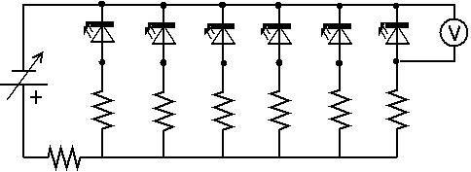
Schematic Diagram:

Helpful Hints:

- the longer lead on the LED is connected to the POSITIVE end of the battery (usually RED connector)
- the resistors are all 100 Ω, one with each LED and one in series with the entire circuit
- the LEDs are spaced out using a scale based on the wavelengths and the space available
(ie. 200 nm = 15 cm)
- the contact points are bolts that are fastened through the lid
- the LED is attached across these bolts
- resistors go from bolts to conducting wire
- project boxes are available from electronic hobby shops
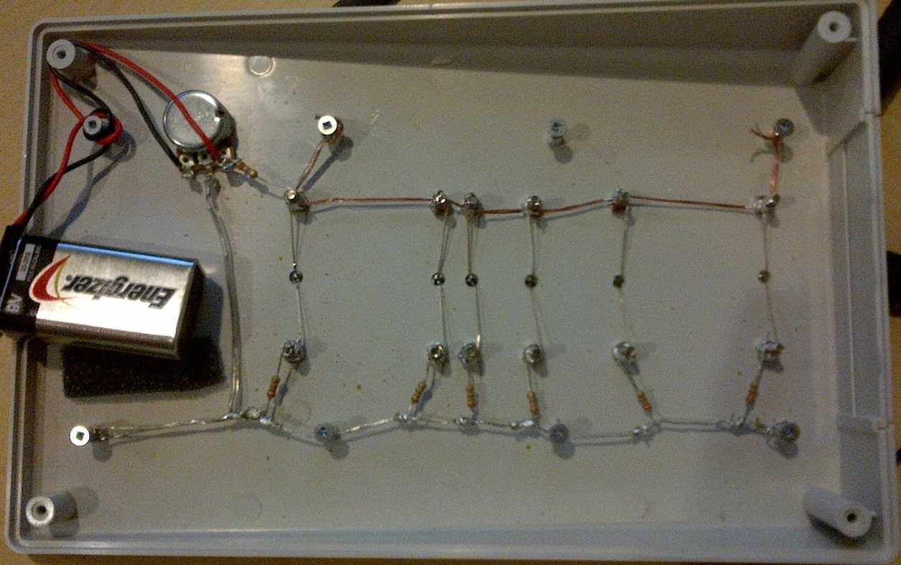
(I used Hammond #1599KSTLGYBAT)

