Higher Waves
Past Paper Questions
Book 1

Contents
Interference and Diffraction Gratings pg 2-21
Irradiance pg 22-32

Interference and Diffraction Gratings
1. |  | When white light passes through a grating, maxima of intensity are produced on a screen, as shown below. The central maximum is white. Continuous spectra are obtained at positions P and Q.
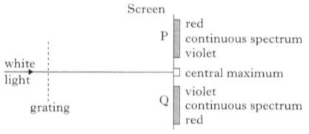
grating
light
white
Q
P
red
red
continuous spectrum
violet
central maximum
violet
continuous spectrum
In the continuous spectra, violet is observed closest to the central maximum.
Which of the following statements is/are true?
 |  | I Violet light has the shortest wavelength of all the visible radiations.
 |  | II Violet light has the longest wavelength of all the visible radiations.
 |  | III Violet light travels faster through air than the other visible radiations.
 | A  B  C  D  E | I only  II only  III only  I and III only  II and III only

2. |  | Waves from coherent sources, S₁ and S₂, produce an interference pattern. Maxima of intensity are detected at the positions shown below.  maxima of intensity
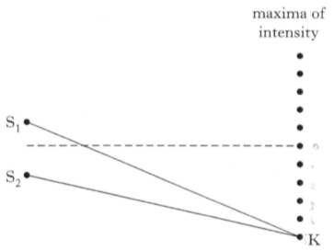
S₂
S₁
K
 |  | The path difference S₁K - S₂K is 154 mm. The wavelength of the waves is
 | A  B  C  D  E | 15·4 mm  25·7 mm  28·0 mm  30·8 mm  34·2 mm.
3. |  | S₁ and S₂ are sources of coherent waves which produce an interference pattern along the line XY.  X
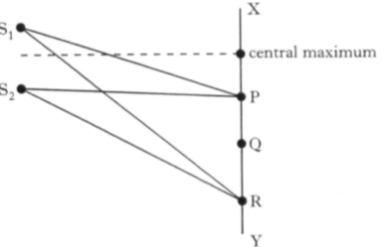
Y
central maximum
S₂
S₁
R
Q
P
 |  | The first maximum occurs at P, where S₁P = 20 cm and S₂P = 18cm.
 |  | For the third maximum, at R, the path difference (S₁R - S₂R) is
 | A  B  C  D  E | 3 cm  4 cm  5 cm  6 cm  8 cm.

4. |  | Microwave radiation is incident on a metal plate which has 2 slits, P and Q. A microwave receiver is moved from R to S, and detects a series of maxima and minima of intensity at the positions shown.  S
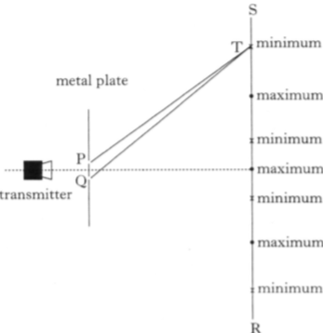
T
Q
P
transmitter
metal plate
R
minimum
maximum
minimum
maximum
minimum
maximum
minimum
The microwave radiation has a wavelength of 4 cm.
The path difference between PT and QT is
 | A  B  C  D  E | 2 cm  3 cm  4 cm  5 cm  6 cm

5. |  | Two identical loudspeakers, L₁ and L₂, are operated at the same frequency and in phase with each other. An interference pattern is produced.  L₁
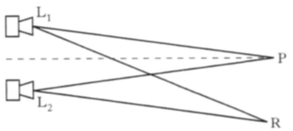
R
P
L₂
At position P, which is the same distance from both loudspeakers, there is a maximum intensity.
The next maximum intensity is at position R, where L₁R = 5·6 m and
L₂R = 5·3 m.
The speed of the sound produced is 340 m s⁻¹.
The frequency of the sound emitted by the loudspeakers is given by
 | A | $$\frac{\text{5}\text{·}\text{6} \text{- 5}\text{·}\text{3 }}{\text{340}} Hz$$
 | B | $$\frac{\text{340} }{\text{5}\text{·}\text{6}\text{ +} \text{5}\text{·}\text{3}} Hz$$
 | C | $$\frac{\text{340 }}{\text{5}\text{·}\text{6 - 5}\text{·}\text{3}} Hz$$
 | D | 340 x (5·6 - 5·3) Hz
 | E | 340 x (5·6 + 5·3) Hz
6. |  | A microwave source at point O produces waves of wavelength 28 mm.  A metal reflector is placed as shown.  Metal reflector
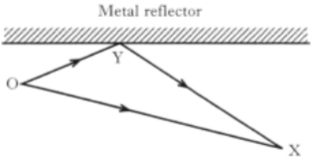
O
Y
X
An interference pattern is produced.
Constructive interference occurs at point X.
The distance OX is 400 mm.
The total path length OYX is
 | A  B  C  D  E | 414 mm  421 mm  442 mm  456 mm  463 mm.

7. |  | A source of microwaves of wavelength λ is placed behind two slits, R and S.
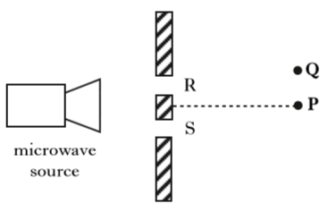
microwave source
S
R
P
Q
The detector is moved and the next maximum is recorded at Q.
The path difference (SQ - RQ) is
 | A | 0
 | B | $$\frac{λ }{\text{2}}$$
 | C | λ
 | D | $$\frac{\text{3}λ }{\text{2}}$$
 | E | 2λ
8. |  | Which of the following proves that light is transmitted as waves?
 | A  B  C  D  E | Light has a high velocity.  Light can be reflected.  Light irradiance reduces with distance.  Light can be refracted.  Light can produce interference patterns.

9. |  | Two identical loudspeakers, L₁ and L₂, are connected to a signal generator as shown.
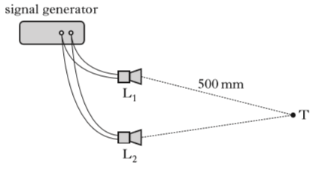
signal generator
L₂
L₁
T
500 mm
 |  | An interference pattern is produced.
 |  | A minimum is detected at point T.
 |  | The wavelength of the sound is 40 mm.
 |  | The distance from L₁ to T is 500 mm.
 |  | The distance from L₂ to T is
 | A  B  C  D  E | 450 mm  460 mm  470 mm  480 mm  490 mm
10. |  | S₁ and S₂ are sources of coherent waves.  An interference pattern is obtained between X an Y.
 | S₂  S₁ | 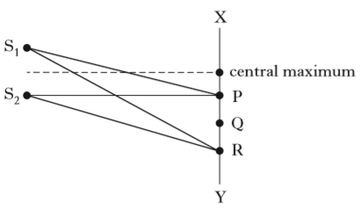  X  Y  R  Q  P  central maximum
The first order maximum occurs at P, where S₁P = 200 mm and
S₂P = 180 mm.
For the third order maximum, at R, the path difference (S₁R - S₂R) is
 | A  B  C  D  E | 20 mm  30 mm  40 mm  50 mm  60 mm.
11. |  | Two identical loudspeakers, L₁ and L₂, operate at the same frequency and in phase with each other. An interference pattern is produced.
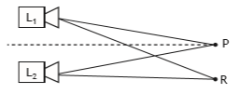
L₂
L₁
R
P
At position P, which is the same distance from both loudspeakers, there is a maximum.
The next maximum is at position R, where L₁R = 5·6 m and L₂R = 5·3 m.
The speed of sound in air is 340 m s⁻¹.
The frequency of the sound emitted by the loudspeakers is
 | A  B  C  D  E | 8·8 x 10⁻⁴ Hz  3·1 x 10¹ Hz  1·0 x 10² Hz  1·1 x 10³ Hz  3·7 x 10³ Hz
12. |  | A ray of monochromatic light is incident on a grating as shown.
grating |  | 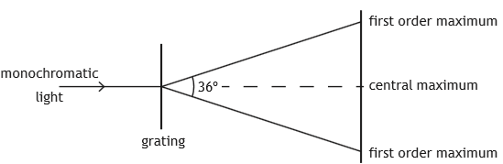  central maximum  first order maximum  first order maximum  36º  monochromatic  light
The wavelength of the light is 633 nm.
The separation of the slits on the grating is
 | A  B  C  D  E | 1·96 x 10⁻⁷ m  1·08 x 10⁻⁶ m  2·05 x 10⁻⁶ m  2·15 x 10⁻⁶ m  4·10 x 10⁻⁶ m.

13. |  | A student makes the following statements about waves from coherent sources.
 |  | I Waves from coherent sources have the same velocity.
 |  | II Waves from coherent sources have the same wavelength.
 |  | III Waves from coherent sources have a constant phase relationship.
 |  | Which of these statements is/are correct?
 | A  B  C  D  E | I only  II only  I and II only  I and III only  I, II and III
14. |  | Waves from two coherent sources, S₁ and S₂, produce an interference pattern. Maxima are detected at the positions shown below.  maxima
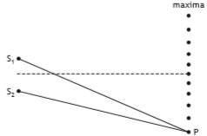
S₂
S₁
P
The path difference S₁P - S₂P is 102 mm.
The wavelength of the waves is
 | A  B  C  D  E | 10·2 mm  20·4 mm  22·7 mm  459 mm  510 mm.

15. |  | Waves from two coherent sources, S₁ and S₂, produce an interference pattern.  Maxima are detected at the positions shown.
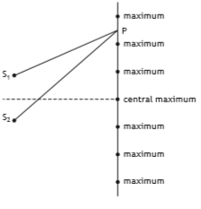
S₂
S₁
central maximum
maximum
maximum
maximum
maximum
P
maximum
maximum
The wavelength of the waves is 28 mm.
For the third minimum, at P, the path difference (S₂P - S₁P) is
 | A  B  C  D  E | 42 mm  56 mm  70 mm  84 mm  98 mm.

Interference and Diffraction Gratings
16. | (a) | In an experiment, laser light of wavelength 633 nm is incident on a grating.  A series of bright spots are seen on a screen placed some distance from the grating. The distance between the spots and the central spot is shown.
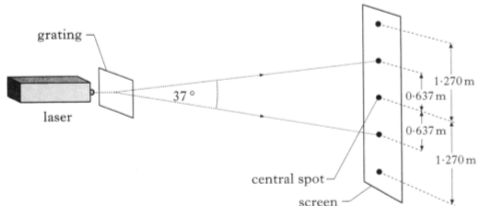
central spot
0·637 m
1·270 m
1·270 m
0·637 m
screen
37º
laser
grating
 |  | Calculate the number of lines per metre on the grating. | 4
 | (b) | The laser is replaced with another laser and the experiment repeated. With this laser the bright spots are closer together.
 |  | State how the wavelength of the light from this laser compares with that from the original laser.  You must justify your answer. | 2

Interference and Diffraction Gratings
17. |  | A laser produces a narrow beam of monochromatic light.
 | (a) | Red light from a laser passes through a grating as shown.
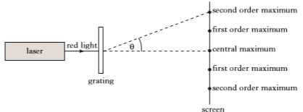
θ
red
light
laser
screen
grating
first order maximum
second order maximum
central order maximum
first order maximum
second order maximum
 |  | A series of maxima and minima is observed on the screen.
 |  | Explain, in terms of waves, how a minimum is produced. | 1
 | (b) | The laser is now replaced by a second laser, which emits blue light.
 |  | Explain why the observed maxima are now closer together. | 2
 | (c) | The wavelength of the blue light from the second laser is 4·73 x 10⁻⁷ m. The spacing between the lines on the grating is 2·00 x 10⁻⁶ m.
 |  | Calculate the angle between the central maximum and the second order maximum. | 3

Interference and Diffraction Gratings
18. |  | A student is carrying out an experiment to investigate the interference of sound waves. She sets up the following apparatus.  oscilloscope
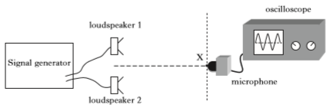
microphone
X
loudspeaker 2
loudspeaker 1
Signal
generator
 |  | The microphone is initially placed at point X which is the same distance from each loudspeaker. A maximum is detected at X.
 | (a) | The microphone is now moved to the first minimum at Y as shown.  oscilloscope
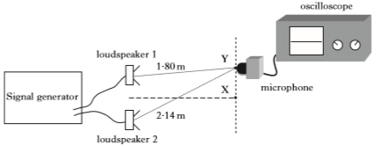
Signal
generator
1·80 m
loudspeaker 1
2·14 m
Y
X
microphone
loudspeaker 2
 |  | Calculate the wavelength of the sound waves. | 3
 | (b) | Loudspeaker 1 is now disconnected.
 |  | State what happens to the amplitude of the sound detected by the microphone at Y.  Explain your answer. | 2

Interference and Diffraction Gratings; Refraction
19. | (a) | The first demonstration of the interference of light was performed by Thomas Young in 1801.
 |  | State what the demonstration of interference proves about the nature of light. | 1
 | (b) | A grating is placed in a colourless liquid in a container. Laser light is incident on the grating along the normal. The spacing between the lines on the grating is 5·0 x 10⁻⁶ m. Interference occurs and the maxima produced are shown in the diagram.
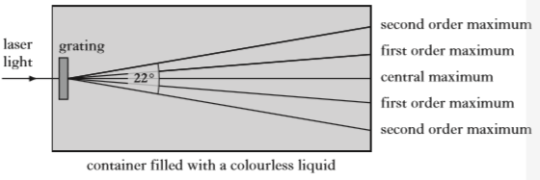
container filled with a colourless liquid
grating
22º
laser
light
second order maximum
first order maximum
central maximum
first order maximum
second order maximum
 |  | (i) Calculate the wavelength of the laser light in the liquid. | 3
 |  | (ii) The refractive index of the colourless liquid decreases as the temperature of the liquid increases.  The liquid is now heated.  State the effect this has on the spacing between the maxima.  You must justify your answer. | 2

Interference and Diffraction Gratings
20. |  | A student is using different types of electromagnetic radiation to investigate interference.
 | (a) | In the first experiment, two identical sources of microwaves, S₁ and S₂, are positioned a short distance apart as shown.
to meter
S₂
S₁
detector
X
central maximum
P
Y
 |  | (i) The student moves a microwave detector from X towards Y. The reading on the meter increases and decreases regularly.  Explain, in terms of waves, what causes the minimum readings to occur. | 1
 |  | (ii) The third maximum from the central maximum is located at P.  The distance from S₁ to P is 620 mm.  The wavelength of the waves is 28 mm.  Calculate the distance from S₂ to P. | 3
 | (b) | In the second experiment, a beam of parallel, monochromatic light is incident on a grating. An interference pattern is produced on a screen. The edges of the screen are at an angle of 40º to the centre of the grating as shown.
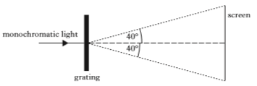
40º
grating
monochromatic light
40º
screen
 |  | The wavelength of the light is 420 nm and the separation of the slits on the grating is 3·27 x 10⁻⁶ m.  Determine the total number of maxima visible on the screen. | 4
Interference and Diffraction Gratings
21. |  | Two experiments are carried out to study the interference of waves.
 | (a) | In the first experiment, monochromatic light of wavelength 589 nm passes through a grating. The distance between the slits on the grating is 5·0 x 10⁻⁶ m.  screen
 | monochromatic light | 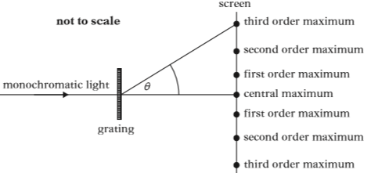  second order maximum  first order maximum  θ  third order maximum  grating  not to scale  second order maximum  first order maximum  central maximum  third order maximum
 |  | Calculate the angle θ between the central maximum and the third order maximum. | 3
 | (b) | In the second experiment, microwaves of wavelength 30 mm pass through two gaps between metal plates as shown.  J
 | microwave  source | 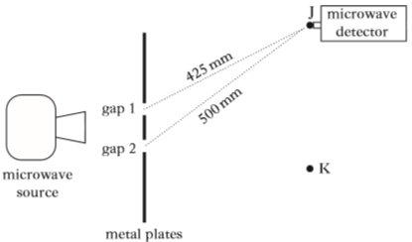  gap 2  metal plates  425 mm  500 mm  gap 1  K  detector  microwave
 |  | (i) The distances from each of the gaps to point J are shown in the diagram.  Use this information to determine whether J is a point of constructive or destructive interference.  You must justify your answer by calculation. | 2
 |  | (ii) The microwave detector is now moved to K, which is a point of destructive interference.  Gap 1 is then covered with a sheet of metal.  State whether the strength of the signal detected at K increases, decreases or stays the same.  You must explain your answer. | 2
Interference and Diffraction Gratings
22. |  | A student carries out an experiment to measure the wavelength of microwave radiation. Microwaves pass through two gaps between metal plates as shown.  B
 | microwave  source | 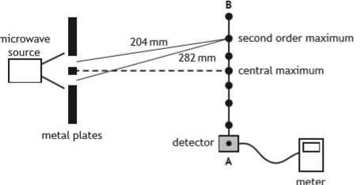  282 mm  204 mm  second order maximum  central maximum  metal plates  meter  detector  A
 |  | As the detector is moved from A to B, a series of maxima and minima are detected.
 | (a) | The microwaves passing through the gaps are coherent.
 |  | State what is meant by the term coherent waves. | 1
 | (b) | Explain, in terms of waves, how a maximum is produced. | 1
 | (c) | The measurements of the distance from each gap to the second order maximum are shown in the diagram above.
 |  | Calculate the wavelength of the microwaves. | 3
 | (d) | The distance separating the two gaps is now increased.
 |  | State what happens to the path difference to the second order maximum.  Justify your answer. | 2

Interference and Diffraction Gratings
23. |  | An experiment is carried out to determine the wavelength of light from a laser.  screen
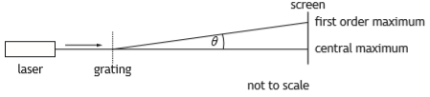
first order maximum
laser
not to scale
θ
grating
central maximum
 | (a) | Explain, in terms of waves, how a maximum is formed. | 1
 | (b) | The experiment is carried out with four gratings.  The separation of the slits d is different for each grating.  The angle between the central maximum and the first order  maximum θ, produced by each grating, is measured.  The results are used to produce a graph of sinθ against $\frac{\text{1}}{\text{d}}$ .  0·60  sinθ
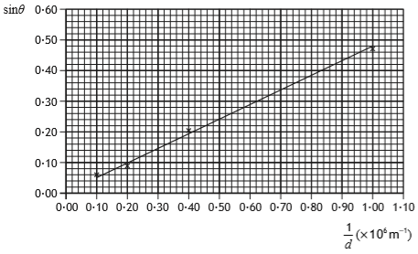
0·10
0·30
1·10
0·90
0·70
0·50
0·00
0·10
0·20
0·30
0·40
0·50
1·00
0·80
0·60
0·40
0·20
0·00
(x 10⁶ m⁻¹)
$$\frac{\text{1}}{\text{d}}$$
 |  | (i) Determine the wavelength of the light from the laser used in this experiment. | 3
 |  | (ii) Determine the angle θ produced when a grating with a spacing d of 2·0 x 10⁻⁶ m is used with this laser. | 3
 | (c) | Suggest two improvements that could be made to the experiment to improve reliability. | 2

Interference and Diffraction Gratings
24. |  | A student investigates interference of light by directing laser light of wavelength 630 nm onto a grating as shown.  not to scale
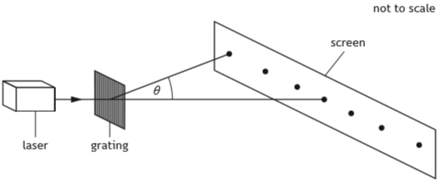
θ
laser
grating
screen
 | (a) | A pattern of bright spots is observed on a screen.
 |  | (i) Explain, in terms of waves, how bright spots are produced on the screen. | 1
 |  | (ii) The grating has 250 lines per millimetre.  Calculate the angle θ between the central maximum and the third order maximum. | 3
 |  | (iii) The grating is now replaced by one which has 600 lines per millimetre.  State the effect of this change on the pattern observed.  Justify your answer. | 2
 |  | (iv) The interference pattern is produced by coherent light.  State what is meant by the term coherent. | 1

24. |  | (continued)
 | (b) | The student now shines light from the laser onto a £5 note.
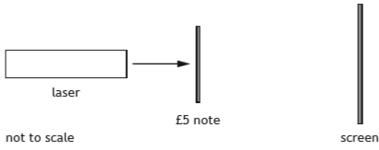
not to scale
laser
£5 note
screen
When it is shone through the transparent section of the note the student observes a pattern of bright spots on the screen.
The diagram below shows the pattern that the student observes on the screen.
 |  | Suggest a reason for the difference in the pattern produced using the £5 note and the pattern produced using the grating. | 1

Interference and Diffraction Gratings
25. |  | A student carries out an experiment to investigate the effect of a grating on beams of light from three different lasers.  screen
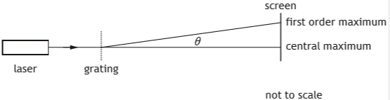
θ
central maximum
first order maximum
laser
grating
not to scale
The three different lasers produce red, green and blue light respectively.
Each laser beam is directed in turn towards the grating.
The grating has a slit separation of 3·3 x 10⁻⁶ m.
 | (a) | State which of these three colours of laser light would produce the smallest angle θ between the central maximum and the first order maximum.  Justify your answer. | 3
 | (b) | The angle θ between the central maximum and the first order maximum for light from one of the lasers is 8·9º.
 |  | (i) Calculate the wavelength of this light. | 3
 |  | (ii) Determine the colour of light from this laser. | 1
 |  | (iii) Another student suggests that a more accurate value for the wavelength of this laser light can be found if a grating with a slit separation of 5·0 x 10⁻⁶ m is used.  Explain why this suggestion is incorrect. | 2

Irradiance
1. |  | The intensity of light from a point source is 20 W m⁻² at a distance of  5·0 m from the source.
 |  | The intensity of the light at a distance of 25 m from the source is
 | A  B  C  D  E | 0·032 W m⁻²  0·80 W m⁻²  1·2 W m⁻²  4·0 W m⁻²  100 W m⁻².
2. |  | The apparatus used to investigate the relationship between light intensity I and distance d from a point source is shown.
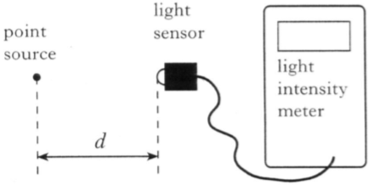
point source
light sensor
light intensity meter
d
 |  | The experiment is carried out in a darkened room.
 |  | Which of the following expressions gives a constant value?
 | A  B  C  D  E | I x d  I x d ²  $$\frac{ I}{\text{d} }$$  $$\frac{ I}{\text{d} \text{2}}$$  I x $√$d

3. |  | The intensity of light can be measured in
 | A  B  C  D  E | W  W m⁻¹  W m  W m⁻²  W m².
4. |  | The irradiance of light from a point source is 160 units at a distance of  0·50 m from the source.  At a distance 2·0 m from this source, the irradiance is
 | A  B  C  D  E | 160 units  80 units  40 units  10 units  5 units.
5. |  | A small lamp is placed 0·50 m above the surface of a desk.
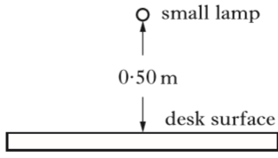
0·50 m
desk surface
small lamp
There is no other source of light.
The lamp is now moved until the irradiance at the desk surface is halved.
The new distance of the lamp above the desk surface is approximately
 | A  B  C  D  E | 0·7 m  1·0 m  1·4 m  1·5 m  2·0 m.

6. |  | The irradiance of light from a point source is 32 W m⁻² at a distance of 4·0 m from the source.  The irradiance of the light at a distance of 16 m from the source is
 | A  B  C  D  E | 0·125 W m⁻²  0·50 W m⁻²  2·0 W m⁻²  8·0 W m⁻²  128 W m⁻².
7. |  | A point source of light is 8·00 m away from a surface. The irradiance, due to the point source, at the surface is 50·0 mW m⁻². The point source is now moved to a distance of 12·0 m from the surface.  The irradiance, due to the point source, at the surface is now
 | A  B  C  D  E | 22·2 mW m⁻²  26·0 mW m⁻²  33·3 mW m⁻²  75·0 mW m⁻²  267 mW m⁻².
8. |  | The irradiance on a surface 0·50 m from a point source of light is I .  The irradiance on a surface 1·5 m from this source is
 | A  B  C  D  E | 0·11I  0·33I  1·5I  3·0I  9·0I

9. |  | A student carries out an experiment to investigate how irradiance varies with distance.  A small lamp is placed at a distance d away from a light meter. The irradiance I at this distance is displayed on the meter. This measurement is repeated for a range of different distances.  The student uses these results to produce the graph shown.
 |  | 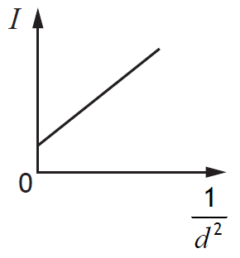
The graph indicates that there is a systematic uncertainty in this experiment.
Which of the following would be most likely to reduce the systematic uncertainty in this experiment?
 | A  B  C  D  E | Repeating the readings and calculating mean values.  Replacing the small lamp with a larger lamp.  Decreasing the brightness of the lamp.  Repeating the experiment in a darkened room.  Increasing the range of distances.

Irradiance
10. |  | A laser beam is shone on to a screen which is marked with a grid.  The beam produces a uniformly lit spot of radius 5·00 x 10⁻⁴ m as shown.
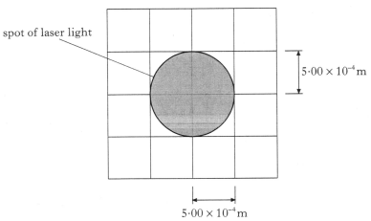
5·00 x 10⁻⁴ m
5·00 x 10⁻⁴ m
spot of laser light
 | (a) | The intensity of the spot of light on the screen is 1020 W m⁻².  Calculate the power of the laser beam. | 4
 | (b) | The distance between the screen and the laser is now doubled.  State how the radius of the spot now compares with the one shown in the diagram.  You must justify your answer. | 2

Irradiance
11. |  | A student carries out an experiment to investigate how irradiance on a surface varies with distance from a small lamp.  Irradiance is measured with a light meter.  The distance between the small lamp and the light meter is measured with a metre stick.  The apparatus is set up as shown in a darkened laboratory.  light meter
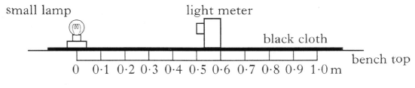
1·0 m
0·9
0·8
0·7
0·6
0·5
0·4
0·3
0·2
0·1
0
small lamp
black cloth
bench top
 |  | The following results are obtained.
Distance from source / m | 0·20 | 0·30 | 0·40 | 0·50
Irradiance / units | 675 | 302 | 170 | 108

 | (a) | State what is meant by the term irradiance. | 1
 | (b) | Use all the data to find the relationship between irradiance I and distance d from the source. | 3
 | (c) | Explain the purpose of the black cloth on top of the bench. | 1
 | (d) | The small lamp is replaced by a laser.  Light from the laser is shone on to the light meter.  A reading is taken from the light meter when the distance between the laser is 0·50 m.  The distance is now increased to 1·00 m.  State how the new reading on the light meter compares with the one at 0·50 m.  Justify your answer. | 2

Irradiance
12. |  | The diagram shows a light sensor connected to a voltmeter.  A small lamp is placed in front of the sensor.
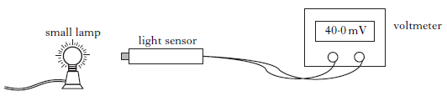
light sensor
40·0 mV
voltmeter
small lamp
 |  | The reading on the voltmeter is 20 mV for each 1·0 mW of power incident on the sensor.
 | (a) | The reading on the voltmeter is 40·0 mV.  The area of the light sensor is 8·0 x 10⁻⁵ m².  Calculate the irradiance of light on the sensor. | 4
 | (b) | The small lamp is replaced by a different source of light.  Using this new source, a student investigates how irradiance varies with distance.  The results are shown.
Distance / m | 0·20 | 0·30 | 0·40
Irradiance / W m⁻² | 675 | 302 | 170

 |  | Using all the data, prove whether or not this new source can be considered a point source of light. | 3

Irradiance; Interference and Diffraction Gratings
13. |  | A laser produces a beam of light with a frequency of 4·74 x 10¹⁴ Hz.
 |  | 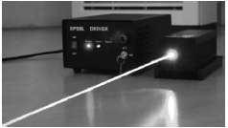
 | (a) | The laser has a power of 0·10 mW.  Explain why light from this laser can cause eye damage. | 1
 | (b) | Calculate the energy of each photon in the laser beam. | 3
 | (c) | This laser beam is now incident on a grating as shown below.
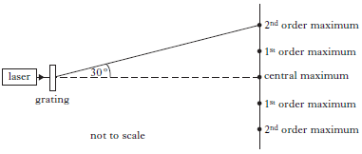
30º
central maximum
2nd order maximum
1st order maximum
2nd order maximum
1st order maximum
grating
laser
not to scale
 |  | The second order maximum is detected at an angle of 30º from the central maximum.
 |  | Calculate the separation of the slits on the grating. | 4

Irradiance
14. |  | A student investigates how irradiance I varies with distance d from a small lamp.  The following apparatus is set up in a darkened laboratory.  light meter  small lamp
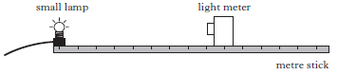
metre stick
 |  | The results are used to produce the following graph.
 | irradiance / W m⁻² | 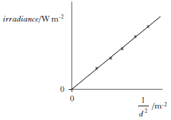  $\frac{\text{1}}{\text{d} \text{2}}$ / m⁻²  0  0
 | (a) | Explain why this graph confirms the relationship I = $\frac{\text{k}}{\text{d} \text{2}}$ | 1
 | (b) | The irradiance of light from the lamp at a distance of 1·6 m is 4·0 W m⁻².  Calculate the irradiance of the light at a distance of 0·40 m from the lamp. | 3
 | (c) | The experiment is repeated with the laboratory lights switched on.
 |  | Copy the graph shown and, on the same axes, draw another line to show the results of the second, repeated experiment. | 2

Irradiance
15. | (a) | A technician uses the following apparatus to investigate the relationship between the irradiance of the light from a lamp and the distance from it.  lamp  light sensor  meter
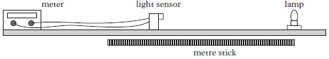
metre stick
 |  | The results of the experiment are shown.
Distance between light sensor and lamp / m | Irradiance / units
0·10 | 242
0·15 | 106
0·20 | 60
0·25 | 39

 |  | Use all the results to determine whether or not the lamp behaves like a point source of light in this experiment. | 3
 | (b) | The experiment is now repeated using a 1·00 x 10⁻⁴ W laser which produces light of wavelength 633 nm.  laser  light sensor  meter
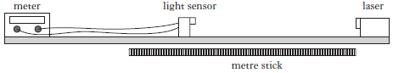
metre stick
 |  | (i) Explain why the results obtained with the laser differ from those obtained using the lamp. | 1
 |  | (ii) Calculate the energy of each photon being emitted. | 4
 |  | (iii) Calculate the number of photons being emitted in a time of 5 seconds. | 4
 |  | (iv) Light from the laser is described as coherent.  State what is meant by the term coherent. | 1

Irradiance
16. |  | A student investigates how irradiance I varies with distance d from a point source of light.  small lamp
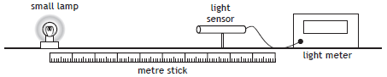
light meter
light sensor
metre stick
 |  | The distance between a small lamp and a light sensor is measured with a metre stick. The irradiance is measured with a light meter.
 |  | The apparatus is set up as shown in a darkened laboratory.
 |  | The following results are obtained.
d (m) | 0·20 | 0·30 | 0·40 | 0·50
I (W m⁻²) | 134·0 | 60·5 | 33·6 | 21·8

 | (a) | State what is meant by the term irradiance. | 1
 | (b) | Use all the data to establish the relationship between irradiance I and distance d . | 3
 | (c) | The lamp is now moved to a distance of 0·60 m from the light sensor.  Calculate the irradiance of light from the lamp at this distance. | 3
 | (d) | Suggest one way in which the experiment could be improved.  You must justify your answer. | 2

