H

Higher Assignment
Protocol Sheet: Half Value Thickness

This experiment can only be completed by students over the age of 16.
Half Value Thickness

Apparatus
Geiger-Muller tube, counter or ratemeter, radioactive source,
lead absorbers.
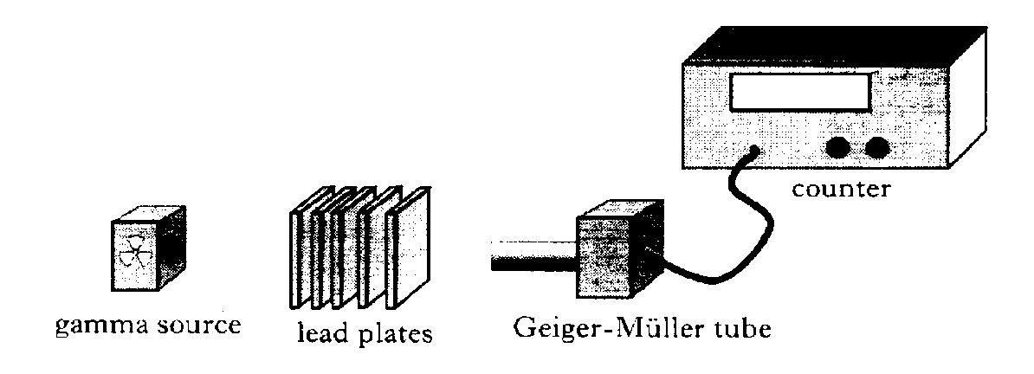

Instructions:

• Determine the background count rate.
• With the radioactive source in position, record the count rate with no absorber, paying due attention to safety requirements.
• Place a piece of lead of known thickness between the source and detector.
• Record thef count rate and thickness of lead absorber.
• Repeat using lead absorbers of different known thickness.
• Use an appropriate format to determine the half-thickness of lead.

Risk Assessment
- Before completing this experiment schools must ensure that they have a full Radiation Policy in place and it complies with all laws. If in doubt contact Gregor Steele at SSERC if you are in a Scottish State School.
- The student must actively participate in the experiment.
- Due attention must be paid to safety requirements and age restrictions.
- The source must be out for the minimum time and all other students should be kept away from the experiment.
- Perspex sheets should be available to absorb the Bremsstrahlung radiation as electrons are scattered as gamma radiation is passed through lead.
- Do a visual check on all wiring to ensure it is safe. Discuss with a teacher if you have any concerns.

