H

Higher Assignment
Protocol Sheet: acceleration and slopes

Determine gravitational field strength from a slope/
Acceleration down a slope

Apparatus
Trolley with single or double mask, 1 or 2 light gates, ramp, books, power supply, interface, computer
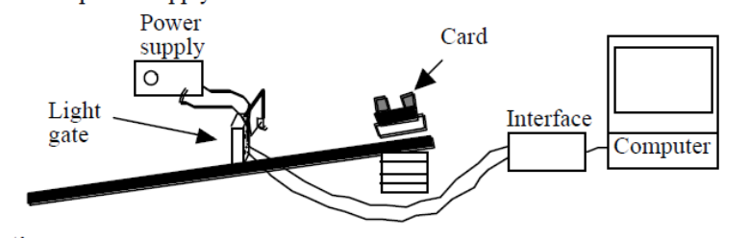
Instructions:

- Choose the set up (double mask and 1 light gate or single mask and two light gates) and select the appropriate .
- Measure the length of the slope using a metre stick or tape measure.
- Compensate the slope for friction.
- Allow the trolley to roll down the slope
- Record the acceleration of the trolley
- Adjust the height of the trolley.
- Use the appropriate format to find the relationship between the angle of slope and the acceleration of the trolley
- OR use the appropriate format to find the value of g.

Risk Assessment
- Do a visual check on all wiring to ensure it is safe. Discuss with a teacher if you have any concerns.
- Do an electrical safety check by observing all the wires.
- Ensure the trolley cannot be a trip hazard to yourself or others.
- Be observant to those around you.
- Do not block fire exits or routes out of the classroom with the apparatus.

