Higher Particles
Past Paper Questions
Book 1

Contents
Nuclear Reactions pg 2-20
Particle Accelerators pg 21-34
Nuclear Reactions
1. |  | The statement below represents a nuclear reaction.
 |  | ${}_{\text{92}}^{\text{235}}{\text{ U}}$ + ${}_{\text{0}}^{\text{1}}{\text{ n}}$ ${}_{\text{36}}^{\text{92}}{\text{ Kr}}$ + ${}_{\text{56}}^{\text{141}}{\text{ Ba}}$ + ${}_{\text{0}}^{\text{1}}{\text{ n}}$ + ${}_{\text{0}}^{\text{1}}{\text{ n}}$ + ${}_{\text{0}}^{\text{1}}{\text{ n}}$
 |  | This is an example of
 | A  B  C  D  E | nuclear fusion  alpha particle emission  beta particle emission  spontaneous nuclear fission  induced nuclear fission.
2. |  | Under certain conditions, a nucleus of nitrogen absorbs an alpha particle to form the nucleus of another element and releases a single particle.
 |  | Which one of the following statements correctly describes this process?
 | A  B  C  D  E | ${}_{\text{7}}^{\text{14}}{\text{ N}}$ + ${}_{\text{2}}^{\text{3}}{\text{ He}}$ ${}_{\text{9}}^{\text{16}}{\text{ F}}$ + ${}_{\text{0}}^{\text{1}}{\text{ n}}$  ${}_{\text{7}}^{\text{14}}{\text{ N}}$ + ${}_{\text{2}}^{\text{4}}{\text{ He}}$ ${}_{\text{10}}^{\text{17}}{\text{ N}}$ + ${}_{\text{-1}}^{\text{0}}{ \text{e}}$  ${}_{\text{7}}^{\text{14}}{\text{ N}}$ + ${}_{\text{2}}^{\text{3}}{\text{ He}}$ ${}_{\text{8}}^{\text{16}}{\text{ O}}$ + ${}_{\text{1}}^{\text{1}}{\text{ p}}$  ${}_{\text{7}}^{\text{14}}{\text{ N}}$ + ${}_{\text{2}}^{\text{4}}{\text{ He}}$ ${}_{\text{9}}^{\text{18}}{\text{ F}}$ + 2 ${}_{\text{-1}}^{\text{0}}{ \text{e}}$  ${}_{\text{7}}^{\text{14}}{\text{ N}}$ + ${}_{\text{2}}^{\text{4}}{\text{ He}}$ ${}_{\text{8}}^{\text{17}}{\text{ O}}$ + ${}_{\text{1}}^{\text{1}}{\text{ p}}$
3. |  | Which row of the table shows the correct values of x, y and z for the nuclear reaction described below?
 |  | ${}_{\text{x}\text{.}}^{\text{236}}{\text{ U}}$ ${}_{\text{90}}^{\text{..}\text{y}\text{.}}{\text{ Th}}$ + ${}_{\text{z}\text{.}}^{\text{4}}{\text{ He}}$
 | A  B  C  D  E | x y z  88 240 2  90 232 0  90 240 0  92 232 2  92 240 2

4. |  | A student writes the following statements about the decay of radionuclides.
 |  | I During alpha emission a particle consisting of 2 protons and 4 neutrons is emitted from a nucleus.
 |  | II During beta emission a fast moving electron is emitted from a nucleus.
 |  | III During gamma emission a high energy photon is emitted from a nucleus.
 |  | Which of these statements is/are true?
 | A  B  C  D  E | II only  I and II only  I and III only  II and III only  I, II and III
5. |  | The equation below represents a nuclear reaction.
 |  | ${}_{\text{92}}^{\text{236}}{\text{ U}}$ ${}_{\text{56}}^{\text{141}}{\text{ Ba}}$ + ${}_{\text{36}}^{\text{93}}{\text{ Kr}}$ + 2 ${}_{\text{0}}^{\text{1}}{\text{ n}}$
 |  | It is an example of
 | A  B  C  D  E | nuclear fusion  spontaneous nuclear fission  induced nuclear fission  alpha particle emission  beta particle emission.

6. |  | Part of a radioactive decay series is shown.  ^{α}  ^{β}
${}_{\text{Q}}^{\text{P}}{ \text{Po}}$ ${}_{\text{S}}^{\text{R}}{ \text{Pb}}$ ${}_{\text{83}}^{\text{206}}{ \text{Bi}}$
^{decay}
^{decay}
 |  | A polonium nucleus emits an alpha particle, and its product, a lead nucleus, emits a beta particle.
 |  | Which numbers are represented by P, Q, R and S?
 | A  B  C  D  E | P Q R S  206 82 206 82  206 82 206 83  210 84 206 82  210 84 210 85  210 85 206 83
7. |  | A series of radioactive decays starts from the isotope Uranium-238.  Two alpha particles and two beta particles are emitted during the decays.  Which row in the table gives the mass number and the atomic number of the resulting nucleus?
 | A  B  C  D  E | Mass number Atomic number  232 88  230 86  230 90  246 94  246 98

8. |  | For the nuclear decay shown, which row of the table gives the correct values of x, y and z ?
 |  | ${}_{\text{x}\text{.}}^{\text{214}}{\text{ Pb}}$ ${}_{\text{83}}^{\text{y}\text{.}}{\text{ Bi}}$ + ${}_{\text{z}\text{.}}^{\text{0}}{ \text{e}}$
 | A  B  C  D  E | x y z  85 214 2  84 214 1  83 210 4  82 214 -1  82 210 -1
9. |  | The following statement describes a fusion reaction.
 |  | ${}_{\text{1}}^{\text{3}}{ \text{H}}$ + ${}_{\text{1}}^{\text{2}}{ \text{H}}$ ${}_{\text{2}}^{\text{4}}{ \text{He}}$ + ${}_{\text{0}}^{\text{1}}{ \text{n}}$ + energy
 |  | The total mass of the particles before the reaction is 6·684 x 10⁻²⁷ kg.
 |  | The total mass of the particles after the reaction is 6·680 x 10⁻²⁷ kg.
 |  | The energy released in this reaction is
 | A  B  C  D  E | 6·012 x 10⁻¹⁰ J  6·016 x 10⁻¹⁰ J  1·800 x 10⁻¹³ J  3·600 x 10⁻¹³ J  1·200 x 10⁻²¹ J.

10. |  | The following statement represents a nuclear decay.
 |  | ${}_{\text{x}\text{.}}^{\text{241}}{ \text{Am}}$ ${}_{\text{93}}^{\text{y}\text{.}}{ \text{Np}}$ + ${}_{\text{z}\text{.}}^{\text{4}}{ \text{α}}$
 | A  B  C  D  E | x y z  95 237 2  95 245 -1  92 237 -1  91 237 2  91 245 -1
11. |  | The statement below represents a nuclear reaction.
 |  | ${}_{\text{1}}^{\text{3}}{ \text{H}}$ + ${}_{\text{1}}^{\text{2}}{ \text{H}}$ ${}_{\text{2}}^{\text{4}}{ \text{He}}$ + ${}_{\text{0}}^{\text{1}}{ \text{n}}$
The total energy released during one nuclear reaction of this type is 2·79 x 10⁻¹² J.
The lost mass that is converted in to energy is
 | A  B  C  D  E | 2·51 x 10⁵ kg  8·37 x 10⁻⁴ kg  1·61 x 10⁻¹⁶ kg  9·30 x 10⁻²¹ kg  3·10 x 10⁻²⁹ kg.
12. |  | Which of the following statements describes a spontaneous nuclear fission reaction?
 | A  B  C  D  E | ${}_{\text{92}}^{\text{235}}{ \text{U}}$ + ${}_{\text{0}}^{\text{1}}{ \text{n}}$ ${}_{\text{56}}^{\text{144}}{ \text{Ba}}$ + ${}_{\text{36}}^{\text{90}}{ \text{Kr}}$ + 2 ${}_{\text{0}}^{\text{1}}{ \text{n}}$  ${}_{\text{3}}^{\text{7}}{ \text{Li}}$ + ${}_{\text{1}}^{\text{1}}{ \text{H}}$ ${}_{\text{2}}^{\text{4}}{ \text{He}}$ + ${}_{\text{2}}^{\text{4}}{ \text{He}}$  ${}_{\text{1}}^{\text{3}}{ \text{H}}$ + ${}_{\text{1}}^{\text{2}}{ \text{H}}$ ${}_{\text{2}}^{\text{4}}{ \text{He}}$ + ${}_{\text{0}}^{\text{1}}{ \text{n}}$  ${}_{\text{88}}^{\text{226}}{ \text{Ra}}$ ${}_{\text{86}}^{\text{222}}{ \text{Rn}}$ + ${}_{\text{2}}^{\text{4}}{ \text{He}}$  ${}_{\text{84}}^{\text{216}}{ \text{Po}}$ ${}_{\text{84}}^{\text{216}}{ \text{Po}}$ + γ

13. |  | Part of a radioactive decay series is shown in the diagram below.  The symbols X₁ and X₅ represents nuclides in this series.
 | mass  number | 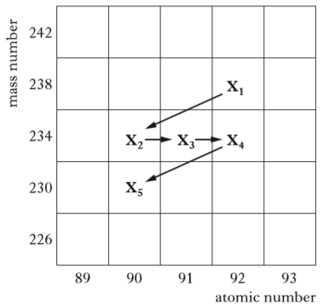  atomic number  93  92  91  89  90  226  230  238  234  242
 |  | A student makes the following statements about the decay series.
 |  | I Nuclides X₂ and X₃ contain the same number of protons.
 |  | II Nuclide X₁ decays into nuclide X₂ by emitting an alpha particle.
 |  | III Nuclide X₃ decays into nuclide X₄ by emitting a beta particle.
 |  | Which of these statements is/are correct?
 | A  B  C  D  E | I only  II only  III only  II and III only  I, II and III

14. |  | The following statement represents a fission reaction.
 |  | ${}_{\text{92}}^{\text{235}}{ \text{U}}$ + ${}_{\text{0}}^{\text{1}}{ \text{n}}$ ${}_{\text{57}}^{\text{139}}{ \text{La}}$ + ${}_{\text{42}}^{\text{95}}{ \text{Mo}}$ + 2 ${}_{\text{0}}^{\text{1}}{ \text{n}}$ + 7${}_{\text{-1}}^{\text{0}}{ \text{e}}$
 |  | The total mass of the particles before the reaction is 391·848 x 10⁻²⁷ kg.
 |  | The total mass of the particles after the reaction is 391·478 x 10⁻²⁷ kg.
 |  | The energy released in this reaction is
 | A  B  C  D  E | 3·53 x 10⁻⁸ J  3·52 x 10⁻⁸ J  3·33 x 10⁻¹¹ J  1·67 x 10⁻¹¹ J  1·11 x 10⁻¹⁹ J.
15. |  | An isotope of uranium decays into an isotope of protactinium in two stages as shown.
${}_{\text{92}}^{\text{238}}{ \text{U}}$ ${}_{\text{90}}^{\text{234}}{ \text{Th}}$ ${}_{\text{91}}^{\text{234}}{ \text{Pa}}$
^{stage 1}
^{stage 2}
 |  | Which row in the table identifies the radiations which must be emitted at each stage?
 | A  B  C  D  E | stage 1 stage 2  alpha gamma  beta gamma  gamma beta  beta alpha  alpha beta

16. |  | The last two changes in a radioactive decay series are shown below.
A bismuth nucleus emits a beta particle, and its product, a polonium nucleus, emits an alpha particle.
^{α}
^{β}
${}_{\text{Q}}^{\text{P}}{ \text{Bi}}$ ${}_{\text{S}}^{\text{R}}{ \text{Po}}$ ${}_{\text{82}}^{\text{208}}{ \text{Pb}}$
^{decay}
^{decay}
 |  | Which numbers are represented by P, Q, R and S ?
 | A  B  C  D  E | P Q R S  210 83 208 81  210 83 210 84  211 85 207 86  212 83 212 84  212 85 212 84
17. |  | The following statement represents a nuclear reaction.
 |  | ${}_{\text{103}}^{\text{256}}{ \text{Lr}}$ Z + ${}_{\text{2}}^{\text{4}}{ \text{He}}$
 |  | Nucleus Z is
 | A  B  C  D  E | ${}_{\text{101}}^{\text{252}}{ \text{Md}}$  ${}_{\text{101}}^{\text{252}}{ \text{No}}$  ${}_{\text{101}}^{\text{256}}{ \text{Md}}$  ${}_{\text{105}}^{\text{260}}{ \text{Db}}$  ${}_{\text{103}}^{\text{252}}{ \text{Lr}}$.
18. |  | A nuclear fission reaction is represented by the following statement.
 |  | ${}_{\text{0}}^{\text{1}}{ \text{n}}$ + ${}_{\text{92}}^{\text{235}}{ \text{U}}$ ${}_{\text{56}}^{\text{141}}{ \text{Ba}}$ + X + 3 ${}_{\text{0}}^{\text{1}}{ \text{n}}$
 |  | The nucleus represented by X is
 | A  B  C  D  E | ${}_{\text{40}}^{\text{96}}{ \text{Zr}}$  ${}_{\text{36}}^{\text{92}}{ \text{Kr}}$  ${}_{\text{40}}^{\text{97}}{ \text{Zr}}$  ${}_{\text{36}}^{\text{93}}{ \text{Kr}}$  ${}_{\text{40}}^{\text{94}}{ \text{Zr}}$.

19. |  | A nucleus represented by ${}_{\text{87}}^{\text{223}}{ \text{Fr}}$ decays by beta emission.
 |  | The symbol representing the nucleus formed as a result of this decays is
 | A  B  C  D  E | ${}_{\text{87}}^{\text{224}}{ \text{Fr}}$  ${}_{\text{87}}^{\text{222}}{ \text{Fr}}$  ${}_{\text{88}}^{\text{223}}{ \text{Ra}}$  ${}_{\text{86}}^{\text{223}}{ \text{Rn}}$  ${}_{\text{88}}^{\text{224}}{ \text{Ra}}$.

Nuclear Reactions; Particle Accelerators
20. |  | Radium (Ra) decays to radon (Rn) by the emission of an alpha particle.  Some energy is also released by this decay.  The decay is represented by the statement shown below.
 |  | ${}_{\text{88}}^{\text{226}}{ \text{Ra}}$ ${}_{\text{y}}^{\text{x}}{ \text{Rn}}$ + ${}_{\text{2}}^{\text{4}}{ \text{He}}$
 |  | The masses of the nuclides involved are as follows.
Mass of ${}_{\text{88}}^{\text{226}}{ \text{Ra}}$ = 375·428 x 10⁻²⁷ kg
Mass of ${}_{\text{y}}^{\text{x}}{ \text{Rn}}$ = 368·771 x 10⁻²⁷ kg
Mass of ${}_{\text{2}}^{\text{4}}{ \text{He}}$ = 6·64832 x 10⁻²⁷ kg
 | (a) | (i) Determine the values of x and y for the nuclide ${}_{\text{y}}^{\text{x}}{ \text{Rn}}$. | 2
 |  | (ii) Explain why energy is released in this reaction. | 1
 |  | (iii) Calculate the energy released by one decay of this type. | 4
 | (b) | The alpha particle leaves the radium nucleus with a speed of  1·5 x 10⁷ m s⁻¹.  The alpha particle is then accelerated through a potential difference of  25 kV.  Calculate the final kinetic energy, in joules, of the alpha particle. | 4

Nuclear Reactions
21. |  | The following statement represents a nuclear reaction.
 |  | ${}_{\text{94}}^{\text{239}}{ \text{Pu}}$ + ${}_{\text{0}}^{\text{1}}{ \text{n}}$ ${}_{\text{52}}^{\text{137}}{ \text{Te}}$ + ${}_{\text{42}}^{\text{100}}{ \text{Mo}}$ + 3 ${}_{\text{0}}^{\text{1}}{ \text{n}}$ + energy
The total mass of the particles before the reaction is 3·9842 x 10⁻²⁵ kg.
The total mass of the particles after the reaction is 3·9825 x 10⁻²⁵ kg.
 | (a) | State and explain whether this reaction is spontaneous or induced. | 2
 | (b) | Calculate the energy, in joules, released by this reaction. | 4
 | (c) | These nuclear reactions occur as a rocket takes off. The average power of the rocket during take-off is 900 MW.
 |  | Calculate the average number of reactions that occur during the rocket's take-off in the first 20 seconds. | 4

Nuclear Reactions
22. |  | The following statement represents a nuclear reaction.
 |  | ${}_{\text{94}}^{\text{240}}{ \text{Pu}}$ ${}_{\text{92}}^{\text{236}}{ \text{U}}$ + ${}_{\text{2}}^{\text{4}}{ \text{He}}$
 |  | The table shows the masses of the particles involved in this reaction.
Particles | Mass (kg)
$${}_{\text{94}}^{\text{240}}{ \text{Pu}}$$ | 398·626 x 10⁻²⁷
$${}_{\text{92}}^{\text{236}}{ \text{U}}$$ | 391·970 x 10⁻²⁷
$${}_{\text{2}}^{\text{4}}{ \text{He}}$$ | 6·645 x 10⁻²⁷

 | (a) | State whether this is a nuclear reaction for alpha, beta or gamma decay. | 1
 | (b) | Calculate the energy released in this reaction. | 4

Nuclear Reactions
23. |  | A ship is powered by a nuclear reactor.
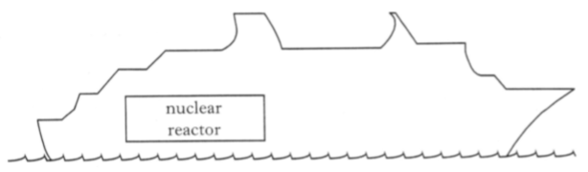
nuclear
reactor
 |  | One reaction that takes place in the core of the nuclear reactor is represented by the statement below.
 |  | ${}_{\text{92}}^{\text{235}}{ \text{U}}$ + ${}_{\text{0}}^{\text{1}}{ \text{n}}$ ${}_{\text{58}}^{\text{140}}{ \text{Ce}}$ + ${}_{\text{40}}^{\text{94}}{ \text{Zr}}$ + 2 ${}_{\text{0}}^{\text{1}}{ \text{n}}$ + 6${}_{\text{-1}}^{\text{0}}{ \text{e}}$
 | (a) | The symbol for the Uranium nucleus is ${}_{\text{92}}^{\text{235}}{ \text{U}}$
 |  | State what information about the nucleus is provided by the following numbers.
 |  | (i) 92 | 1
 |  | (ii) 235 | 1
 | (b) | The masses of particles involved in the reaction are shown in the table.
Particle | Mass (kg)
$${}_{\text{92}}^{\text{235}}{ \text{U}}$$ | 390·173 x 10⁻²⁷
$${}_{\text{58}}^{\text{140}}{ \text{Ce}}$$ | 232·242 x 10⁻²⁷
$${}_{\text{40}}^{\text{94}}{ \text{Zr}}$$ | 155·884 x 10⁻²⁷
$${}_{\text{0}}^{\text{1}}{ \text{n}}$$ | 1·675 x 10⁻²⁷
$${}_{\text{-1}}^{\text{0}}{ \text{e}}$$ | negligible

 |  | Calculate the energy released in the reaction. | 4

Nuclear Reactions
24. |  | Some power stations use nuclear fission reactions to provide energy for generating electricity. The following statement represents a fission reaction.
 |  | ${}_{\text{92}}^{\text{235}}{ \text{U}}$ + ${}_{\text{0}}^{\text{1}}{ \text{n}}$ ${}_{\text{57}}^{\text{139}}{ \text{La}}$ + ${}_{\text{42}}^{\text{r}}{ \text{Mo}}$ + 2 ${}_{\text{0}}^{\text{1}}{ \text{n}}$ + s${}_{\text{-1}}^{\text{0}}{ \text{e}}$
 | (a) | Determine the numbers represented by the letters r and s in the above statement. | 2
 | (b) | Explain why a nuclear fission reaction releases energy. | 1
 | (c) | The masses of the particles involved in the reaction are shown in the table.
Particle | Mass (kg)
$${}_{\text{92}}^{\text{235}}{ \text{U}}$$ | 390·173 x 10⁻²⁷
$${}_{\text{57}}^{\text{139}}{ \text{La}}$$ | 230·584 x 10⁻²⁷
$${}_{\text{42}}^{\text{r}}{ \text{Mo}}$$ | 157·544 x 10⁻²⁷
$${}_{\text{0}}^{\text{1}}{ \text{n}}$$ | 1·675 x 10⁻²⁷
$${}_{\text{-1}}^{\text{0}}{ \text{e}}$$ | negligible

 |  | Calculate the energy released in this reaction. | 4

Nuclear Reactions; Internal Resistance; Practical Circuits
25. |  | A smoke alarm contains a very small sample of the radioactive isotope Americium-241, represented by the symbol ${}_{\text{95}}^{\text{241}}{ \text{Am}}$.
 |  | smoke alarm
 | (a) | State how many neutrons are in a nucleus of the isotope Amercium-241. | 1
 | (b) | This isotope decays by emitting alpha particles as shown in the following statement.
 |  | ${}_{\text{95}}^{\text{241}}{ \text{Am}}$ ${}_{\text{r}}^{\text{s}}{ \text{T}}$ + α
 |  | (i) Determine the numbers represented by the letters s and r. | 1
 |  | (ii) Use the data booklet to identify the element T . | 1
 | (c) | The alarm circuit in the smoke detector contains a battery of e.m.f.  9·0 V and internal resistance 2·0 Ω.
 |  | The circuit is shown.
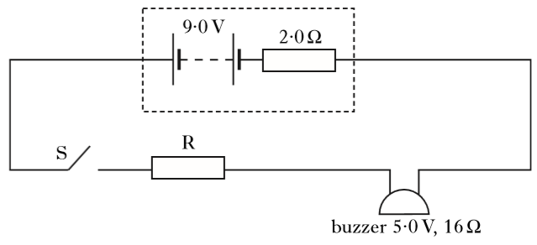
buzzer 5·0 V, 16 Ω
S
R
2·0 Ω
9·0 V
 |  | When smoke is detected, switch S closes and the buzzer operates. The buzzer has a resistance of 16 Ω and an operating voltage of 5·0 V.
 |  | Calculate the resistance value of resistor R required in this circuit. | 4

Nuclear Reactions; Line Spectra
26. | (a) | The Sun is the source of most of the energy on Earth. This energy is produced by nuclear reactions which take place in the interior of the Sun.  One such reaction can be described by the following statement.
 |  | ${}_{\text{1}}^{\text{3}}{ \text{H}}$ + ${}_{\text{1}}^{\text{2}}{ \text{H}}$ ${}_{\text{2}}^{\text{4}}{ \text{He}}$ + ${}_{\text{0}}^{\text{1}}{ \text{n}}$
 |  | The masses of the particles involved in this reaction are shown in the table.
Particle | Mass (kg)
$${}_{\text{1}}^{\text{3}}{ \text{H}}$$ | 5·005 x 10⁻²⁷
$${}_{\text{1}}^{\text{2}}{ \text{H}}$$ | 3·342 x 10⁻²⁷
$${}_{\text{2}}^{\text{4}}{\text{ He}}$$ | 6·642 x 10⁻²⁷
$${}_{\text{0}}^{\text{1}}{ \text{n}}$$ | 1·675 x 10⁻²⁷

 |  | (i) State the name of this type of nuclear reaction. | 1
 |  | (ii) Calculate the energy released in this reaction. | 4
 | (b)  E₃ | The Sun emits a continuous spectrum of visible light. When this light passes through hydrogen atoms in the Sun's outer atmosphere, certain wavelengths are absorbed.  The diagram shows some of the energy levels for the hydrogen atom.  -1·360 x 10⁻¹⁹ J
 | E₀  E₁  E₂ | -21·760 x 10⁻¹⁹ J  -5·424 x 10⁻¹⁹ J  -2·416 x 10⁻¹⁹ J
 |  | (i) One of the wavelengths absorbed by the hydrogen atoms results in an electron transition from energy level E₁ to E₃.  Calculate this wavelength. | 4
 |  | (ii) The absorption of this wavelength produces a faint dark line in the continuous spectrum from the Sun.  In which colour of the spectrum is this dark line observed? | 1
Nuclear Reactions
27. |  | The following statement represents a nuclear reaction.
 |  | ${}_{\text{Z}}^{\text{A}}{ \text{X}}$ + ${}_{\text{1}}^{\text{2}}{ \text{H}}$ 2${}_{\text{2}}^{\text{4}}{ \text{He}}$ + ${}_{\text{0}}^{\text{1}}{ \text{n}}$ + energy
 |  | The masses of some of the particles involved in this reaction are shown in the table.
Particle | Mass (kg)
$${}_{\text{1}}^{\text{2}}{ \text{H}}$$ | 3·342 x 10⁻²⁷
$${}_{\text{2}}^{\text{4}}{\text{ He}}$$ | 6·642 x 10⁻²⁷
$${}_{\text{0}}^{\text{1}}{ \text{n}}$$ | 1·675 x 10⁻²⁷

 | (a) | Use your data booklet to indentify element X. | 1
 | (b) | The energy released in this reaction is 2·97 x 10⁻¹² J.  Calculate the mass of the nucleus ${}_{\text{Z}}^{\text{A}}{ \text{X}}$. | 4

Nuclear Reactions; The Standard Model
28. | (a) | The following statement represents a nuclear decay in which an alpha particle is emitted.
 |  | ${}_{\text{92}}^{\text{238}}{ \text{U}}$ ${}_{\text{90}}^{\text{234}}{ \text{Th}}$ + ${}_{\text{2}}^{\text{4}}{ \text{α}}$
 |  | The energy released in this decay is 6·9 x 10⁻¹³ J.
 |  | Explain why energy is released in this decay. | 1
 | (b) | Calcium-47 decays by releasing a beta particle ${}_{\text{-1}}^{\text{0}}{ \text{e}}$ .  The following statement represents this decay.
 |  | ${}_{\text{20}}^{\text{47}}{ \text{Ca}}$ X + ${}_{\text{-1}}^{\text{0}}{ \text{e}}$
 |  | (i) Identify the element represented by X. | 1
 |  | (ii) The total momentum before and after each calcium-47 decay is not equal based on the products shown in the statement.  Beta decay gives rise to the existence of another sub- atomic particle, allowing total momentum to be conserved.  State the name of this sub-atomic particle. | 1
Nuclear Reactions; Particle Accelerators
29. |  | The diagram shows part of an experimental fusion reactor.
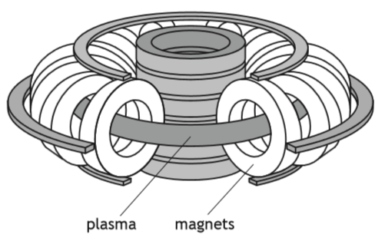
plasma
magnets
 |  | The following statement represents a reaction that takes place inside the reactor.
 |  | ${}_{\text{1}}^{\text{2}}{ \text{H}}$ + ${}_{\text{1}}^{\text{3}}{ \text{H}}$ ${}_{\text{2}}^{\text{4}}{ \text{He}}$ + ${}_{\text{0}}^{\text{1}}{ \text{n}}$
 |  | The masses of the particles involved in the reaction are shown in the table.
Particle | Mass (kg)
$${}_{\text{1}}^{\text{2}}{ \text{H}}$$ | 3·3436 x 10⁻²⁷
$${}_{\text{1}}^{\text{3}}{ \text{H}}$$ | 5·0083 x 10⁻²⁷
$${}_{\text{2}}^{\text{4}}{\text{ He}}$$ | 6·6465 x 10⁻²⁷
$${}_{\text{0}}^{\text{1}}{ \text{n}}$$ | 1·6749 x 10⁻²⁷

 | (a) | Explain why energy is released in this reaction. | 1
 | (b) | Calculate the energy released in this reaction. | 4
 | (c) | Magnetic fields are used to contain the plasma inside the fusion reactor. Explain why it is necessary to use a magnetic field to contain the plasma. | 1
 | (d) | The plasma consists of charged particles. A positively charged particle enters a region of the magnetic field as shown.  region of magnetic field into page
 |  | positively charged particle
 |  | Determine the direction of the force exerted by the magnetic field on the positively charged particle as it enters the field. | 1
Nuclear Reactions
30. |  | A diagram from a 'How Things Work' website contains information about a nuclear fusion reaction.
 |  | Reaction of helium-3 with deuterium
 |  | 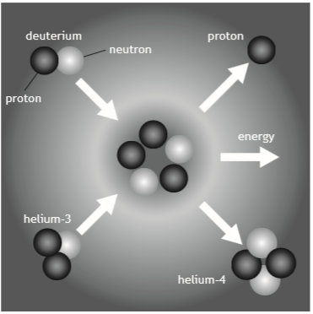
 | (a) | State what is meant by the term nuclear fusion. | 1
 | (b) | The following statement represents this fusion reaction.
 |  | ${}_{\text{2}}^{\text{3}}{ \text{He}}$ + ${}_{\text{1}}^{\text{2}}{ \text{H}}$ ${}_{\text{2}}^{\text{4}}{ \text{He}}$ + ${}_{\text{1}}^{\text{1}}{ \text{p}}$
 |  | The mass of the particles involved in the reaction are shown in the table.
Particle | Mass (kg)
$${}_{\text{2}}^{\text{3}}{ \text{He}}$$ | 5·008 x 10⁻²⁷
$${}_{\text{1}}^{\text{2}}{ \text{H}}$$ | 3·344 x 10⁻²⁷
$${}_{\text{2}}^{\text{4}}{\text{ He}}$$ | 6·646 x 10⁻²⁷
$${}_{\text{1}}^{\text{1}}{ \text{p}}$$ | 1·673 x 10⁻²⁷

 |  | (i) Explain why energy is released in this reaction. | 1
 |  | (ii) Determine the energy released in this reaction. | 4

31. |  | The Sun emits energy at an average rate of 4·1 x 10²⁶ J s⁻¹. This energy is produced by nuclear reactions taking place inside the Sun.
 |  | The following statement shows one reaction that takes place inside the Sun.
 |  | ${}_{\text{1}}^{\text{2}}{ \text{H}}$ + ${}_{\text{1}}^{\text{2}}{ \text{H}}$ ${}_{\text{2}}^{\text{3}}{ \text{He}}$ + ${}_{\text{0}}^{\text{1}}{ \text{n}}$
 | (a) | State the name given to this type of nuclear reaction. | 1
 | (b) | The mass of the particles involved in this reaction are shown in the table.
Particle | Mass (kg)
$${}_{\text{1}}^{\text{2}}{ \text{H}}$$ | 3·3436 x 10⁻²⁷
$${}_{\text{2}}^{\text{3}}{\text{ He}}$$ | 5·0082 x 10⁻²⁷
$${}_{\text{0}}^{\text{1}}{ \text{n}}$$ | 1·6749 x 10⁻²⁷

 |  | Determine the energy released in this reaction. | 4
 | (c) | Determine the number of these reactions that would be required per second to produce the Sun's average energy output. | 2
Nuclear Reactions
Particle Accelerators
1. |  | A student writes the following statements about electric fields.
 |  | I There is a force on a charge in an electric field.
 |  | II When an electric field is applied to a conductor, the free electric charges in the conductor move.
 |  | III Work is done when a charge is moved in an electric field.
 |  | Which of the above statements is/are correct?
 | A  B  C  D  E | I only  II only  I and II only  I and III only  I, II and III
2. |  | A potential difference of 5000 V is applied between two metal plates. The plates are 0·10 m apart. A charge of +2·0 mC is released from rest at the positively charged plate as shown.
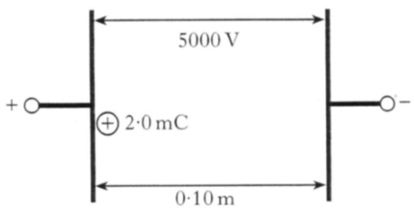
+
2·0 mC

0·10 m

5000 V

_
+
 |  | The kinetic energy of the charge just before it hits the negative plate is
 | A  B  C  D  E | 4·0 x 10⁻⁷ J  2·0 x 10⁻⁴ J  5·0 J  10 J  500 J.

3. |  | An electron is accelerated from rest through a potential difference of  2·0 kV.  The kinetic energy gained by the electron is
 | A  B  C  D  E | 8·0 x 10⁻²³ J  8·0 x 10⁻²⁰ J  3·2 x 10⁻¹⁹ J  1·6 x 10⁻¹⁶ J  3·2 x 10⁻¹⁶ J.
4. |  | A potential difference, V , is applied between two metal plates. The plates are 0·15 m apart. A charge of +4·0 mC is released from rest at the positively charged plate as shown.  0·15 m
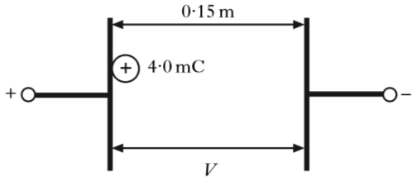
+

_

+

4·0 mC

V

 |  | The kinetic energy of the charge just before it hits the negative plate is 8·0 J.
 |  | The potential difference between the plates is
 | A  B  C  D  E | 3·2 x 10⁻² V  1·2 V  2·0 V  2·0 x 10³ V  4·0 x 10³ V.

5. |  | The product, X, of a nuclear reaction passes through an electric field as shown.
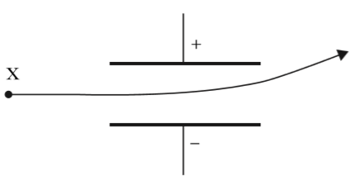
X

_

+

 |  | Product X is
 | A  B  C  D  E | an alpha particle  a beta particle  gamma radiation  a fast neutron  a slow neutron.
6. |  | The potential difference between two points is
 | A | the work done in moving one electron between the two points
 | B | the voltage between the two points when there is a current of one ampere
 | C | the work done in moving one coulomb of charge between the two points
 | D | the kinetic energy gained by an electron as it moves between the two points
 | E | the work done in moving any charge between the two points.

7. |  | An electron enters a region of magnetic field as shown.
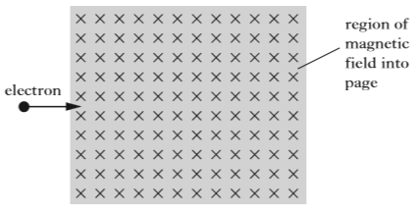
region of magnetic field into page

electron

 |  | The direction of the force exerted by the magnetic field on the electron as it enters the field is
 | A  B  C  D  E | towards the left of the page  into the page  out of the page  towards the top of the page  towards the bottom of the page.
8. |  | One joule of work is done in moving one coulomb of charge between two plates as shown.
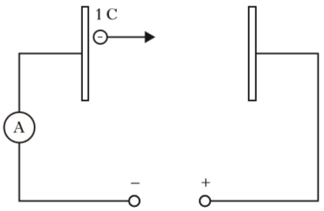
1 C

+

_

A

-

 |  | From the information given, which of the following statements must be true?
 | A  B  C  D  E | The distance between the plates is one metre.  The capacitance of the circuit is one farad.  The current in the circuit is one ampere.  The potential difference between the plates is one volt.  The resistance of the circuit is one ohm.
9. |  | A potential difference of 2 kV is applied across two metal plates.  An electron passes between the metal plates and follows the path shown.  +2 kV
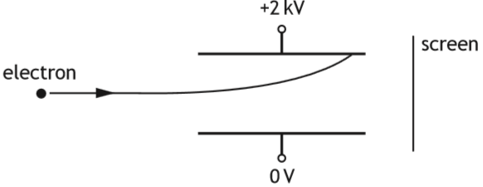
electron

0 V

screen

 |  | A student makes the following statements about changes that could be made to allow the electron to pass between the plates and reach the screen.
 |  | I Increasing the initial speed of the electron could allow the electron to reach the screen.
 |  | II Increasing the potential difference across the plates could allow the electron to reach the screen.
 |  | III Reversing the polarity of the plates could allow the electron to reach the screen.
 |  | Which of these statements is/are correct?
 | A  B  C  D  E | I only  II only  III only  I and II only  I and III only
10. |  | A proton enters a region of magnetic field as shown.
region of magnetic field into page

proton

 |  | On entering the magnetic field the proton
 | A  B  C  D  E | deflects into the page  deflects out of the page  deflects towards the top of the page  deflects towards the bottom of the page  is not deflected.
11. |  | An electron enters a region of uniform magnetic field as shown.
electron

region of magnetic field out of page

 |  | The direction of the force on the electron immediately after entering the field is
 | A  B  C  D  E | towards the top of the page  towards the bottom of the page  towards the right of the page  into the page  out of the page.
12. |  | An alpha particle is accelerated in an electric field between metal plates P and Q.  Q  P
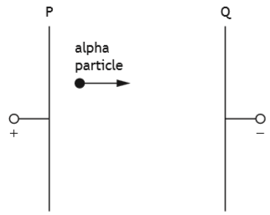
alpha particle

_

+

 |  | The charge on the alpha particle is 3·2 x 10⁻¹⁹ C.
 |  | The kinetic energy gained by the alpha particle while travelling from plate P to plate Q is 8·0 x 10⁻¹⁶ J.
 |  | The potential difference across plates P and Q is
 | A  B  C  D  E | 2·6 x 10⁻³⁴ V  2·0 x 10⁻⁴ V  4·0 x 10⁻⁴ V  2·5 x 10³ V  5·0 x 10³ V.
Particle Accelerators
13. |  | The diagram below shows the basic features of a proton accelerator. It is enclosed in an evacuated container.
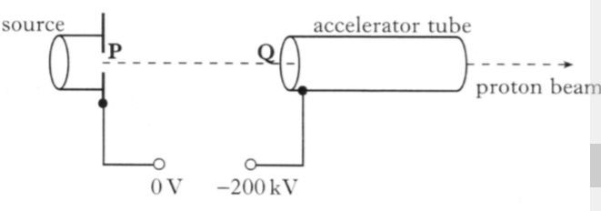
accelerator tube

0 V

-200 kV

proton beam

Q

P

Protons released from the proton source start from rest at P.
A potential difference of 200 kV is maintained between P and Q.
 | (a) | State what is meant by the term potential difference of 200 kV. | 1
 | (b) | Explain why protons released at P are accelerated towards Q. | 1
 | (c) | Calculate:
 |  | (i) the work done on a proton as it accelerates from P to Q; | 3
 |  | (ii) the speed of a proton as it reaches Q. | 3
 | (d) | The distance between P and Q is now halved.
 |  | State what effect, if any, this change has on the speed of a proton as it reaches Q.  Justify your answer. | 2

Particle Accelerators
14. |  | The apparatus shown in the diagram is designed to accelerate alpha particles.  _  +
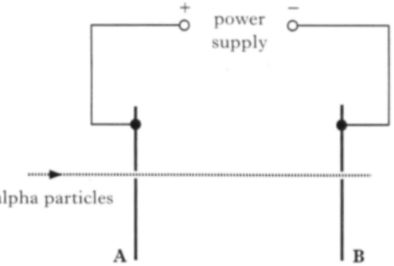
B

A

alpha particles

power
supply

 |  | An alpha particle travelling at a speed of 2·60 x 10⁶ m s⁻¹ passes through a hole in plate A. The mass of an alpha particle is 6·64 x 10⁻²⁷ kg and its charge is 3·2 x 10⁻¹⁹ C.
 | (a) | When the alpha particle reaches plate B, its kinetic energy has increased to 3·05 x 10⁻¹⁴ J.
 |  | Show that the work done on the alpha particle as it moves from plate A to plate B is 8·1 x 10⁻¹⁵ J. | 3
 | (b) | Calculate the potential difference between plates A and B. | 3
 | (c) | The apparatus is now adapted to accelerate electrons from A to B through the same potential difference.
 |  | State whether the increase in kinetic energy for an electron is more than, less than or the same as the increase in kinetic energy of the alpha particle in part (a).  Justify your answer. | 2

Particle Accelerators; Momentum and Impulse
15. |  | An ion propulsion engine can be used to propel spacecraft to areas of deep space.  A simplified diagram of a Xenon ion engine is shown.
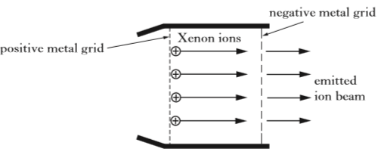
Xenon ions

emitted ion beam

positive metal grid

negative metal grid

 |  | The positively charged Xenon ions are accelerated as they pass through an electric field between the charged metal grids. The emitted ion beam causes a force on the spacecraft in the opposite direction (Newton's third law of motion! ).
 |  | The spacecraft has a total mass of 750 kg.
The mass of a Xenon ion is 2·18 x 10⁻²⁵ kg and its charge is
1·60 x 10⁻¹⁹ C. The potential difference between the charged metal grids is 1·22 kV.
 | (a) | (i) Show that the work done on a Xenon ion as it moves through the electric field is 1·95 x 10⁻¹⁶ J. | 2
 |  | (ii) Assuming the ions are accelerated from rest, calculate the speed of a Xenon ion as it leaves the engine. | 3
 | (b) | The ion beam exerts a constant force of 0·070 N on the spacecraft.  Calculate the change in speed of the spacecraft during a 60 second period of time. | 3
 | (c) | A different ion propulsion engine uses Krypton ions which have a smaller mass than Xenon ions. The Krypton engine emits the same number of ions per second at the same speed as the Xenon engine.
 |  | State which of the two engines produces a greater forces.  Justify your answer. | 2

Particle Accelerators
16. |  | A cyclotron is used in a hospital to accelerate protons that are then targeted to kill cancer cells.
 |  | The cyclotron consists of two D-shaped, hollow metal structures, called "dees", placed in a vacuum. The diagram shows the cyclotron viewed from above.
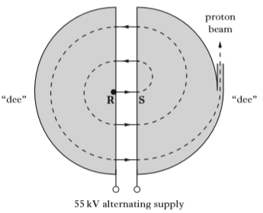
R

S

55 kV alternating supply

"dee"

"dee"

proton
beam

 |  | Protons are released from rest at R and are accelerated across the gap between the "dees" by a voltage of 55 kV.
 | (a) | (i) Show that the work done on a proton as it accelerates from R to S is 8·8 x 10⁻¹⁵ J. | 2
 |  | (ii) Calculate the speed of a proton as it reaches S. | 3
 | (b) | Inside the "dees" a uniform magnetic field acts on the protons.
 |  | Determine the direction of this magnetic field. | 1
 | (c) | Explain why an alternating voltage is used in the cyclotron. | 2

Particle Accelerators
17. |  | An experiment is set up to investigate the behaviour of electrons in electric fields.  electron beam
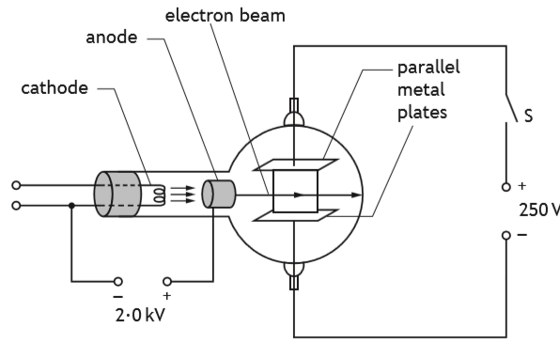
anode
cathode
2·0 kV
+

_

parallel metal plates

_

+

S

 | (a) | Electrons are accelerated from rest between the cathode and the anode by a potential difference of 2·0 kV.
 |  | Calculate the kinetic energy gained by each electron as it reaches the anode. | 3
 | (b) | The electrons then pass between the two parallel metal plates.
 |  | The electron beam current is 8·0 mA.
 |  | Determine the number of electrons passing between the metal plates in one minute. | 4
 | (c) | The switch S is now closed.  The potential difference between the metal plates is 250 V.  The path of the electron beam between the metal plates is shown.  + 250 V
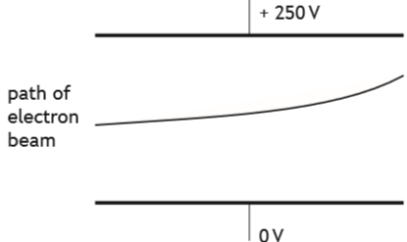
path of electron beam
0 V
 |  | Copy and complete the diagram to show the electric field pattern between the metal plates. | 2
Particle Accelerators
18. |  | X-ray machines are used in hospitals.
 |  | An X-ray machine contains a linear accelerator that is used to accelerate electrons towards a metal target.
 |  | The linear accelerator consists of hollow metal tubes placed in a vacuum.
 | 2·50 kV  alternating supply | 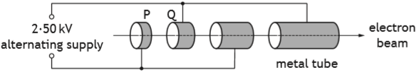  P  Q  metal tube  electron beam
 |  | Electrons are accelerated across the gaps between the tubes by an alternating supply.
 | (a) | (i) Calculate the work done on an electron as it accelerates from P to Q.
 |  | (ii) Explain why an alternating supply is used in the linear accelerator.
 | (b) | The electron beam is then passed into a "slalom magnet" beam-guide. The function of the beam-guide is to direct the electrons towards a metal target.  Inside the beam-guides R and S, two different magnetic fields act on the electrons.  Electrons strike the metal target to produce high energy photons of radiation.
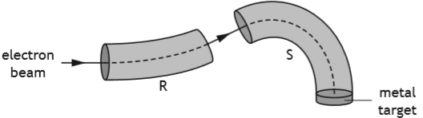
S
R
metal target
electron beam
 |  | (i) Determine the direction of the magnetic field inside beam guide R. | 1
 |  | (ii) State two differences between the magnetic fields inside beam-guides R and S. | 2
 | (c) | Calculate the minimum speed of an electron that will produce a photon of energy 4·16 x 10⁻¹⁷ J. | 3
Particle Accelerators
19. |  | An experiment is set up to demonstrate a simple particle accelerator.  anode
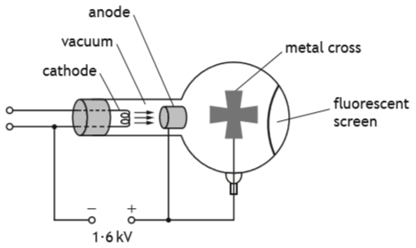
+
_
1·6 kV
cathode
vacuum
metal cross
fluorescent screen
 | (a) | Electrons are accelerated from rest between the cathode and the anode by a potential difference of 1·6 kV.
 |  | (i) Show that the work done in accelerating an electron from rest is 2·6 x 10⁻¹⁶ J. | 2
 |  | (ii) Calculate the speed of the electron as it reaches the anode. | 3
 | (b) | As the electrons travel through the vacuum towards the fluorescent screen they spread out.  In the path of the electrons there is a metal cross, which is connected to the positive terminal of the supply. The electrons that hit the cross are stopped by the metal.  Electrons that get past the metal cross hit the fluorescent screen at the far side of the tube.  When electrons hit the fluorescent screen, the screen glows.
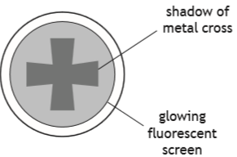
shadow of metal cross
glowing fluorescent screen
 |  | The potential difference between the anode and the cathode is now increased to 2·2 kV. This changes what is observed on the screen.
 |  | Suggest one change that is observed.  You must justify your answer. | 2
Particle Accelerators; Open Ended
20. |  | A student builds a model of a particle accelerator. The model accelerates a small ball on a circular track. A battery-operated motor accelerates the ball each time it passes the motor. To cause a collision a plastic block is pushed onto the track. The ball then hits the block.  plastic block  track  ball  motor
 |  | 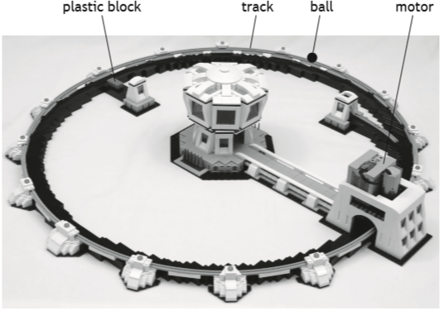
 |  | Using your knowledge of physics, comment on the model compared to a real particle accelerator, such as the large hadron collider at CERN. | 3

