Higher Particles
Past Paper Questions
Book 2

Contents
The Photoelectric Effect pg 2-19
The Standard Model pg 20-32
The Photoelectric Effect
1. |  | Ultraviolet radiation causes the emission of photoelectrons from a zinc plate.  The intensity of the ultraviolet radiation is increased.  Which row in the following table shows the effect of this change?
 | A  B  C  D  E | Maximum kinetic energy of a photoelectron Number of photoelectrons per second  increases no change  no change increases  no change no change  increases increases  decreases increases
2. |  | Ultraviolet radiation is incident on a clean zinc plate. Photoelectrons are ejected.  The clean zinc plate is replaced by a different metal which has a lower work function. The same intensity of ultraviolet radiation is incident on this metal.  Compared to the zinc plate, which of the following statements is/are true for the new metal?
 |  | I The maximum speed of the photoelectrons is greater.
 |  | II The maximum kinetic energy of the photoelectrons is greater.
 |  | III There are more photoelectrons ejected per second.
 | A  B  C  D  E | I only  II only  III only  I and II only  I, II and III

3. |  | When light of frequency f is shone on to a certain metal, photoelectrons are ejected with a maximum velocity v and kinetic energy E_{k} .  Light of the same frequency but twice the irradiance is shone on to the same surface.  Which of the following statements is/are correct?
I Twice as many electrons are ejected per second.
II The speed of the fastest electron is 2v.
III The kinetic energy of the fastest electron is now 2E_{k} .
 | A  B  C  D  E | I only  II only  III only  I and II only  I, II and III
4. |  | Photons of energy 7·0 x 10⁻¹⁹ J are incident on a clean metal surface. The work function of the metal is 9·0 x 10⁻¹⁹ J.  Which of the following is correct?
 | A  B  C  D  E | No electrons are emitted from the metal.  Electrons with a maximum kinetic energy of 2·0 x 10⁻¹⁹ J are emitted from the metal.  Electrons with a maximum kinetic energy of 7·0 x 10⁻¹⁹ J are emitted from the metal.  Electrons with a maximum kinetic energy of 9·0 x 10⁻¹⁹ J are emitted from the metal.  Electrons with a maximum kinetic energy of 16 x 10⁻¹⁹ J are emitted from the metal.

5. |  | Electromagnetic radiation of frequency 9·0 x 10¹⁴ Hz is incident on a clean metal surface.  The work function of the metal is 5·0 x 10⁻¹⁹ J.  The maximum kinetic energy of a photoelectron released from the metal surface is
 | A  B  C  D  E | 1·0 x 10⁻¹⁹ J  4·0 x 10⁻¹⁹ J  5·0 x 10⁻¹⁹ J  6·0 x 10⁻¹⁹ J  9·0 x 10⁻¹⁹ J.
6. |  | Ultraviolet radiation causes the emission of photoelectrons from a zinc plate.  Another source of ultraviolet radiation with a higher frequency is now incident on the zinc plate. The intensity of the ultraviolet radiation that is incident on the zinc plate is unchanged.  Which row in the table shows the effect of the frequency of the ultraviolet radiation changing?
 | A  B  C  D  E | Maximum kinetic energy of a photoelectron Number of photoelectrons per second  decreases increases  increases increases  no change no change  no change increases  increases no change

7. |  | Clean zinc plates are mounted on insulating handles and then charged.  Different types of electromagnetic radiation are now incident on the plates as shown.  Which of the zinc plates is most likely to discharge due to photoelectric emission?  INFRARED
 | A  insulating handle | 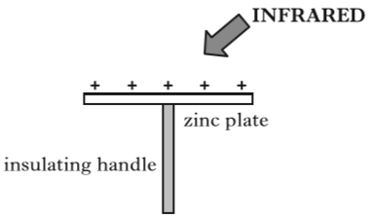  zinc plate  INFRARED
 | B  insulating handle | 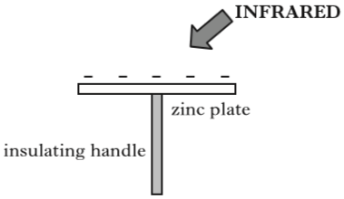  zinc plate  ULTRAVIOLET
 | C  insulating handle | 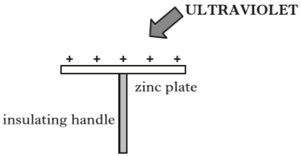  zinc plate  ULTRAVIOLET
 | D  insulating handle | 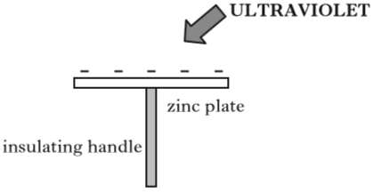  zinc plate  VISIBLE LIGHT
 | E  insulating handle | 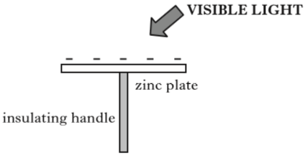  zinc plate

8. |  | Radiation of frequency 9·40 x 10¹⁴ Hz is incident on a clean metal surface.  The work function of the metal is 3·78 x 10⁻¹⁹ J.  The maximum kinetic energy of an emitted photoelectron is
 | A  B  C  D  E | 2·45 x 10⁻¹⁹ J  3·78 x 10⁻¹⁹ J  6·23 x 10⁻¹⁹ J  1·00 x 10⁻¹⁸ J  2·49 x 10³³ J.
9. |  | Radiation of frequency 9·00 x 10¹⁵ Hz is incident on a clean metal surface.  The maximum kinetic energy of a photoelectron ejected from this surface is 5·70 x 10⁻¹⁸ J.  The work function of the metal is
 | A  B  C  D  E | 2·67 x 10⁻¹⁹ J  5·97 x 10⁻¹⁸ J  1·17 x 10⁻¹⁷ J  2·07 x 10⁻² J  9·60 x 10⁻¹ J.
10. |  | The table below shows the threshold frequency of radiation for some metals.
Metal | Threshold Frequency (Hz)
sodium | 4·4 x 10¹⁴
potassium | 5·4 x 10¹⁴
zinc | 6·9 x 10¹⁴

Radiation of frequency 6·3 x 10¹⁴ Hz is incident on the surface of each of the metals.
Photoelectric emission occurs from
 | A  B  C  D  E | sodium only  zinc only  potassium only  sodium and potassium only  zinc and potassium only.

11. |  | Ultraviolet radiation of frequency 7·70 x 10¹⁴ Hz is incident on the surface of a metal.  Photoelectrons are emitted from the surface of the metal.  The maximum kinetic energy of an emitted photoelectron is  2·67 x 10⁻¹⁹ J.  The work function of the metal is
 | A  B  C  D  E | 1·07 x 10⁻¹⁹ J  2·44 x 10⁻¹⁹ J  2·67 x 10⁻¹⁹ J  5·11 x 10⁻¹⁹ J  7·78 x 10⁻¹⁹ J.
12. |  | Radiation is incident on a clean zinc plate causing photoelectrons to be emitted.  The source of radiation is replaced with one emitting radiation of a higher frequency.  The irradiance of the radiation incident on the plate remains unchanged.  Which row in the table shows the effect of this change on the maximum kinetic energy of a photoelectron and the maximum speed of a photoelectron?
Maximum kinetic energy of a photoelectron | Maximum speed of a photoelectron
decreases | decreases
no change | no change
increases | increases
no change | increases
increases | no change

13. |  | A photon of energy 6·40 x 10⁻¹⁹ J is incident on a metal plate.
 |  | This causes photoemission to take place.
 |  | The work function of the metal is 4·20 x 10⁻¹⁹ J.
 |  | The maximum speed of the photoelectron is
 | A  B  C  D  E | 1·19 x 10⁶ m s⁻¹  9·60 x 10⁵ m s⁻¹  6·95 x 10⁵ m s⁻¹  6·79 x 10⁵ m s⁻¹  4·91 x 10⁵ m s⁻¹.

14. |  | The diagram shows an experiment set up to investigate the photoelectric effect.  The frequency of the incident radiation is varied and the current in the circuit is measured.  incident radiation
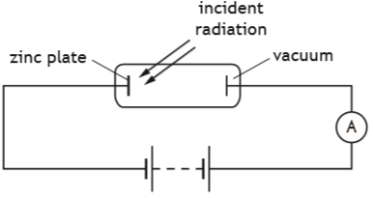
vacuum
zinc plate
A
 |  | Which graph shows the relationship between the current I in the circuit and the frequency f of the incident radiation?
 | A | 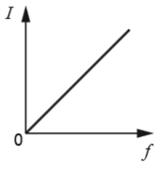  0  f  I | D | 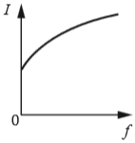  f  0  I
 | B | 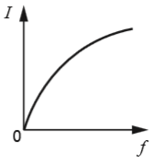  0  f  I  I | E  I | 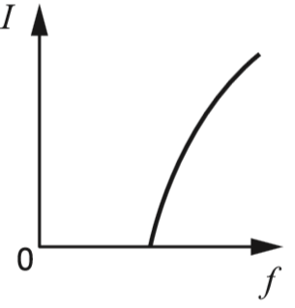  0  f
 | C | 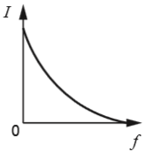  0  f

The Photoelectric Effect
15. | (a) | The apparatus shown below is used to investigate photoelectric emission from a metal surface when electromagnetic radiation is shone on the surface.  The intensity and frequency of the incident radiation can be varied as required.  metal surface
constant voltage
supply
A
incident radiation
 |  | (i) Explain what is meant by photoelectric emission from a metal. | 1
 |  | (ii) State the name given to the minimum frequency of the radiation that produces a current in the circuit. | 1
 |  | (iii) A particular source of radiation produces a current in the circuit.  Explain why the current in the circuit increases as the intensity of the incident radiation increases. | 2
 | (b) | A semiconductor chip is used to store information. The information can only be erased by exposing the chip to ultraviolet radiation for a period of time.  The following data is provided.  Frequency of ultraviolet radiation used = 9·0 x 10¹⁴ Hz  Minimum intensity of ultraviolet radiation  required at the chip = 25 W m⁻²  Area of the chip exposed to radiation = 1·8 x 10⁻⁹ m²  Time taken to erase the information = 15 minutes  Energy of radiation needed to erase the information = 40·5 µJ
 |  | (i) Calculate the energy of a photon of the ultraviolet radiation used. | 3
 |  | (ii) Determine the number of photons of the ultraviolet radiation required to erase the information. | 2
The Photoelectric Effect; Particle Accelerators
16. |  | An image intensifier is used to improve night vision. It does this be amplifying the light from an object.  Light incident on a photocathode causes the emission of photoelectrons. These electrons are accelerated by an electric field and strike a phosphorescent screen causing it to emit light. This emitted light is of a greater intensity than the light that was incident on the photocathode.  photocathode  phosphorescent screen
 | light from object | 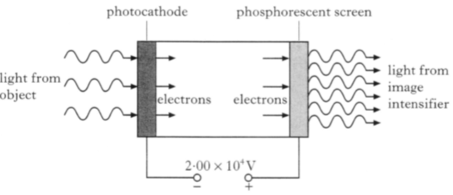  2·00 x 10⁴ V  _  +  light from image intensifier  electrons  electrons
 |  | The voltage between the photocathode and the phosphorescent screen is 2·00 x 10⁴ V.
 |  | The minimum frequency of the incident light that allows photoemission to take place is 3·33 x 10¹⁴ Hz.
 | (a) | State the name given to the minimum frequency of the light required for photoemission to take place. | 1
 | (b) | (i) Show that the work function of the photocathode material is 2·21 x 10⁻¹⁹ J. | 2
 |  | (ii) Light of frequency 5·66 x 10¹⁴ Hz is incident on the photocathode.  Calculate the maximum kinetic energy of an electron emitted from the photocathode. | 3
 |  | (iii) Calculate the kinetic energy gained by an electron as it is accelerated from the photocathode to the phosphorescent screen. | 3

Particle Accelerators
17. |  | In 1902, P. Lenard set up an experiment similar to the one shown below.  monochromatic radiation
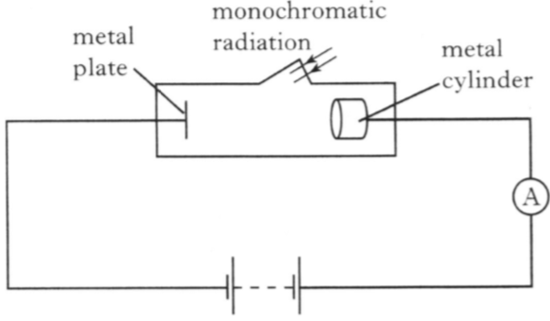
metal plate
metal cylinder
A
 |  | There is a constant potential difference between the metal plate and the metal cylinder.
Monochromatic radiation is directed onto the plate.
Photoelectrons produced at the plate are collected by the cylinder.
The frequency and the intensity of the radiation can be altered independently.
The frequency of the radiation is set at a value above the threshold frequency.
 | (a) | The intensity of the radiation is slowly increased.  Sketch a graph of the current against intensity of radiation. | 1
 | (b) | The metal of the plate has a work function of 3·11 x 10⁻¹⁹ J. The wavelength of the radiation is 400 nm.
 |  | (i) State what is meant by the term work function. | 1
 |  | (ii) Calculate the maximum kinetic energy of a photoelectron. | 4

The Photoelectric Effect
18. |  | A metal plate emits electrons when certain wavelengths of electromagnetic radiation are incident on it.  electromagnetic radiation
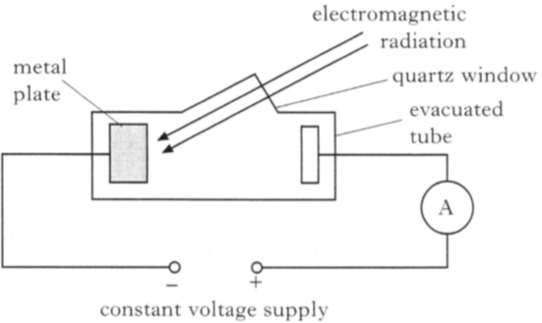
constant voltage supply
+
_
evacuated tube
quartz window
A
metal plate
 |  | When light of wavelength 605 nm is incident on the metal plate, electrons are released with zero kinetic energy.
 | (a) | Show that the work function of this metal is 3·29 x 10⁻¹⁹ J. | 3
 | (b) | The wavelength of the incident radiation is now altered. Photons of energy 5·12 x 10⁻¹⁹ J are incident on the metal plate.
 |  | (i) Determine the maximum kinetic energy of the electrons just as they leave the metal plate. | 1
 |  | (ii) The irradiance of this radiation on the metal plate is now decreased.  State the effect this has on the ammeter reading.  Justify your answer. | 2

The Photoelectric Effect
19. |  | To explain the photoelectric effect, light can be considered as consisting of tiny bundles of energy. These bundles of energy are called photons.
 | (a) | Sketch a graph to show the relationship between photon energy and frequency. | 1
 | (b) | Photons of frequency 6·1 x 10¹⁴ Hz are incident on the surface of a metal.  photons
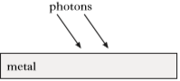
metal
 |  | This releases photoelectrons from the surface of the metal.
The maximum kinetic energy of any of these photoelectrons is
6·0 x 10⁻²⁰ J.
 |  | Calculate the work function of the metal. | 3
 | (c) | The irradiance due to these photons on the surface of the metal is now reduced.
 |  | Explain why the maximum kinetic energy of each photoelectron is unchanged. | 2

The Photoelectric Effect
20. |  | Ultraviolet radiation from a lamp is incident on the surface of a metal.
This causes the release of electrons from the surface of the metal.
ultraviolet radiation
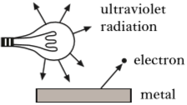
electron
metal
 |  | The energy of each photon of ultraviolet light is 5·23 x 10⁻¹⁹ J.
 |  | The work function of the metal is 2·56 x 10⁻¹⁹ J.
 | (a) | Calculate:
 |  | (i) the maximum kinetic energy of an electron released from this metal by this radiation; | 1
 |  | (ii) the maximum speed of an emitted electron. | 3
 | (b) | The source of ultraviolet radiation is now moved further away from the surface of the metal.  State the effect, if any, this has on the maximum speed on an emitted electron.  Justify your answer. | 2

The Photoelectric Effect
21. |  | A metal plate emits electrons when certain wavelengths of electromagnetic radiation are incident on it.  electromagnetic radiation
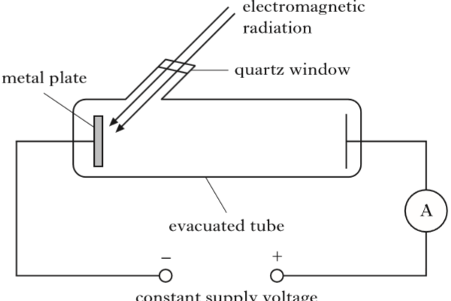
+
A
constant supply voltage
evacuated tube
metal plate
quartz window
_
 |  | The work function of the metal is 2·24 x 10⁻¹⁹ J.
 | (a) | Electrons are released when electromagnetic radiation of wavelength 525 nm is incident on the surface of the metal plate.
 |  | (i) Show that the energy of each photon of the incident radiation is 3·79 x 10⁻¹⁹ J. | 3
 |  | (ii) Determine the maximum kinetic energy of an electron released from the surface of the metal. | 1
 | (b) | The frequency of the incident radiation is now varied through a range of values.  The maximum kinetic energy of electrons leaving the metal plate is determined for each frequency.  A graph of this maximum kinetic energy against frequency is shown.
maximum kinetic energy of electrons (J) |  | 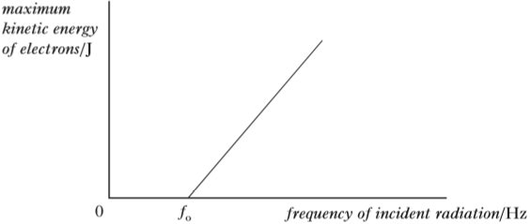  f_{o}  0  frequency of incident radiation (Hz)
 |  | (i) Explain why the kinetic energy of the electrons is zero below the frequency f_{o} . | 1
 |  | (ii) Calculate the value of the frequency f_{o} . | 3
The Photoelectric Effect
22. |  | The following apparatus is set up in a physics laboratory to investigate the photoelectric effect.  incident light  glass tube
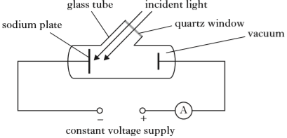
_
+
constant voltage supply
A
vacuum
quartz window
sodium plate
 |  | The work function of sodium is 3·78 x 10⁻¹⁹ J.
 |  | Light of frequency 6·74 x 10¹⁴ Hz is incident on the sodium plate and photoelectrons are emitted.
 | (a) | (i) Calculate the maximum kinetic energy of a photoelectron just as it is emitted from the sodium plate. | 3
 |  | (ii) Calculate the maximum velocity of a photoelectron just as it is emitted from the sodium plate. | 3
 | (b) | The irradiance of this incident light is now decreased.
 |  | Explain how this affects the maximum velocity of a photoelectron just as it is emitted from the sodium plate. | 2

The Photoelectric Effect
23. |  | A student uses a gold-leaf electroscope to investigate the photoelectric effect. A deflection of the gold leaf on the electroscope shows that the metal plate is charged.
The student charges the metal plate on the electroscope and the gold leaf is deflected.
metal plate
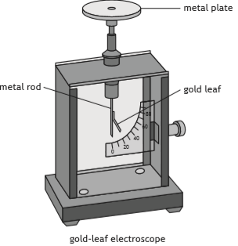
gold-leaf electroscope
metal rod
gold leaf
 | (a) | Ultraviolet light is shone onto the negatively charged metal plate. The gold-leaf electroscope does not discharge. This indicates that photoelectrons are not ejected from the surface of the metal.
 |  | Suggest one reason why photoelectrons are not ejected from the surface of the metal. | 1
 | (b) | The student adjusts the experiment so that the gold-leaf electroscope now discharges when ultraviolet light is shone onto the plate.
 |  | The work function for the metal plate is 6·94 x 10⁻¹⁹ J.
 |  | (i) State what is meant by a work function of 6·94 x 10 ⁻¹⁹ J. | 1
 |  | (ii) The irradiance of the ultraviolet light on the metal plate is reduced by increasing the distance between the gold-leaf electroscope and the ultraviolet light source.  State what effect, if any, this has on the maximum kinetic energy of the photoelectrons ejected from the surface of the metal.  Justify your answer. | 2
The Photoelectric Effect
23. |  | (continued)
 | (c) | The graph shows how the kinetic energy of the photoelectrons ejected from the metal plate varies as the frequency of the incident radiation increases.
 |  | The threshold frequency for the metal plate is 1·05 x 10¹⁵ Hz.
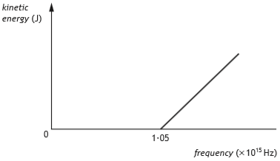
0
1·05
frequency (x 10¹⁵ Hz)
kinetic energy (J)
The metal plate is now replaced with a different metal plate made of aluminium.
The aluminium has a threshold frequency of 0·99 x 10¹⁵ Hz.
 |  | Copy in the above graph then add a line to the graph to show how the kinetic energy of the photoelectrons ejected from the aluminium plate varies as the frequency of the incident radiation increases. | 2
 | (d) | Explain why the photoelectric effect provides evidence for the particle nature of light. | 1

The Standard Model
1. |  | The classical experiment on the scattering of alpha particles from a thin gold foil suggested that
 | A  B  C  D  E | positive charges were evenly distributed throughout the atom  atomic nuclei were very small and positively charged  neutrons existed in the nucleus  alpha particles were helium nuclei  alpha particles were hydrogen nuclei.
2. |  | Compared with a proton, an alpha particle has
 | A  B  C  D  E | twice the mass and twice the charge  twice the mass and the same charge  four times the mass and twice the charge  four times the mass and the same charge  twice the mass and four times the charge.
3. |  | An electron and another particle of identical mass pass through a uniform magnetic field.  Their paths are shown in the diagram.  path of electron
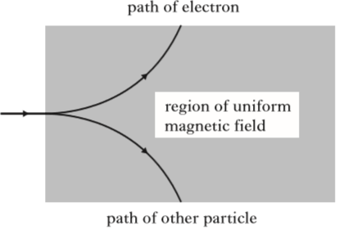
path of other particle
region of uniform magnetic field
 |  | This observation provides evidence for the existence of
 | A  B  C  D  E | neutrinos  antimatter  quarks  protons  force mediating particles.

4. |  | Which of the following lists the particles in order of size from smallest to largest?
 | A  B  C  D  E | helium nucleus; electron; proton  helium nucleus; proton; electron  proton; helium nucleus; electron  electron; helium nucleus; proton  electron; proton; helium nucleus
5. |  | Three students each make a statement about antiparticles.
 |  | I An antiparticle has the same mass as its equivalent particle.
 |  | II An antiparticle has the same charge as its equivalent particle.
 |  | III Every elementary particle has a corresponding antiparticle.
 |  | Which of the statements is/are correct?
 | A  B  C  D  E | I only  II only  I and III only  II and III only  I, II and III
6. |  | A student makes the following statements about Rutherford's model of the atom.
 |  | I The nucleus has a relatively small diameter compared with that of the atom.
 |  | II Most of the mass of the atom is concentrated in the nucleus.
 |  | III The nucleus consists of positive and negative charges.
 |  | Which of these statements is/are correct?
 | A  B  C  D  E | I only  II only  III only  I and II only  I, II and III.

7. |  | The electric field patterns around charged particles Q, R and S are shown.
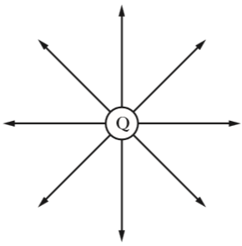
Q
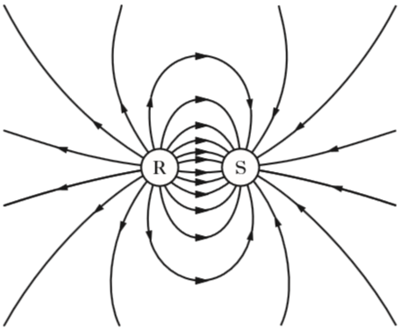
S
R
 |  | Which row in the table shows the charges on particles Q, R and S?
 | A  B  C  D  E | Charge on Q Charge on R Charge on S  positive positive negative  negative negative positive  negative positive negative  negative negative negative  positive positive positive

8. |  | A student makes the following statements about a proton.
I A proton is a fermion.
II A proton is a baryon.
III A proton is a meson.
 |  | Which of these statements is/are correct?
 | A  B  C  D  E | I only  II only  III only  I and II only  I and III only
9. |  | The emission of beta particles in radioactive decay is evidence for the existence of
 | A  B  C  D  E | quarks  electrons  gluons  neutrinos  bosons.
10. |  | A student makes the following statements about sub-nuclear particles.
I The force mediating particles are bosons.
II Gluons are the mediating particles of the strong force.
III Photons are the mediating particles of the electromagnetic force.
 | A  B  C  D  E | I only  II only  I and II only  II and III only  I, II and III

11. |  | One type of hadron consists of two down quarks and one up quark.
 |  | The charge on a down quark is -⅓.
 |  | The charge on an up quark is +⅔.
 |  | Which row in the table shows the charge and type for this hadron?
 | A  B  C  D  E | charge type of hadron  0 baryon  +1 baryon  -1 meson  0 meson  +1 meson
12. |  | An electron is a
 | A  B  C  D  E | boson  hadron  baryon  meson  lepton.
13. |  | How many types of quarks are there?
 | A  B  C  D  E | 8  6  4  3  2

14. |  | A student makes the following statements about the Standard Model.
 |  | I Every particle has an antiparticle.
 |  | II Alpha decay is evidence for the existence of the neutrino.
 |  | III The W-boson is associated with the strong nuclear force.
 |  | Which of these statements is/are correct?
 | A  B  C  D  E | I only  II only  III only  I and II only  I and III only

The Standard Model; Nuclear Reactions
15. | (a) | About one hundred years ago Rutherford designed an experiment to investigate the structure of the atom. He used a radioactive source to fire alpha particles at a thin gold foil target.
 |  | His two assistants, Geiger and Marsden, spent many hours taking readings from the detector as it was moved to different positions between X and Y.
 | alpha particle source | 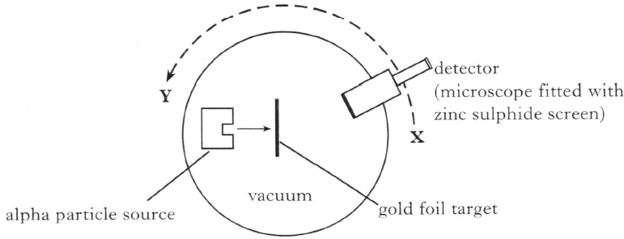  vacuum  gold foil target  detector (microscope fitted with zinc sulphide screen)  Y  X
 |  | (i) Describe how the number of alpha particles detected at X compared with the number detected at Y. | 1
 |  | (ii) State one conclusion Rutherford deduced from the results. | 1
 | (b) | A nuclear fission reaction is represented by the following statement.
 |  | ${}_{\text{92}}^{\text{235}}{ \text{U}}$ + ${}_{\text{0}}^{\text{1}}{ \text{n}}$ ${}_{\text{r}}^{\text{137}}{ \text{Cs}}$ + ${}_{\text{37}}^{\text{s}}{ \text{T}}$ + 4 ${}_{\text{0}}^{\text{1}}{ \text{n}}$
 |  | (i) State whether this is a spontaneous or an induced reaction.  You must justify your answer. | 2
 |  | (ii) Determine the numbers represented by the letters r and s in the above reaction. | 2
 |  | (iii) Use the data booklet to identify the element represented by T. | 1
 |  | (iv) The masses of the nuclei and particles in the reaction are given below.
Particle | Mass (kg)
$${}_{\text{92}}^{\text{235}}{ \text{U}}$$ | 390·219 x 10⁻²⁷
$${}_{\text{r}}^{\text{137}}{ \text{Cs}}$$ | 227·292 x 10⁻²⁷
$${}_{\text{37}}^{\text{s}}{ \text{T}}$$ | 157·562 x 10⁻²⁷
$${}_{\text{0}}^{\text{1}}{ \text{n}}$$ | 1·675 x 10⁻²⁷

 |  | Calculate the energy released in the reaction. | 4
The Standard Model; Particle Accelerators
16. |  | The following diagram gives information on the Standard Model of Fundamental Particles and Interactions.
 |  | 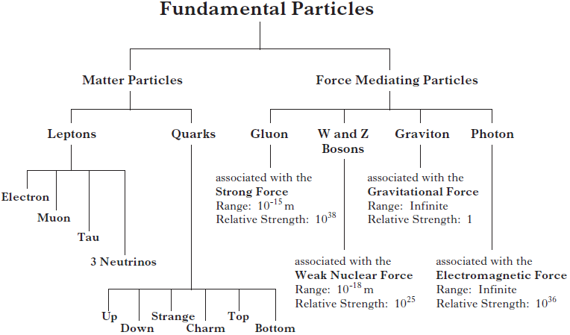
 |  | Use information from the diagram and your knowledge of physics to answer the following questions.
 | (a) | Explain why particles such as leptons and quarks are known as Fundamental Particles. | 1
 | (b) | A particle called the sigma plus (Σ⁺) has a charge of +1. It contains two different types of quark. It has two up quarks each having a charge of +⅔ and one strange quark.
 |  | Determine the charge that the strange quark has. | 1
 | (c) | State which three quarks make up a neutron that has a charge of 0. | 1
 | (d) | In the Large Hadron Collider (LHC) beams of hadrons travel in opposite directions inside a circular accelerator and then collide. The accelerating particles are guided around the collider using strong magnetic fields.
 |  | (i) The diagram shows a proton entering a magnetic field.
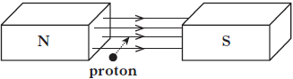
S
N
proton
 |  | State the direction in which this proton is deflected. | 1
 |  | (ii) The neutron is classified as a hadron.  Explain why neutrons are not used for collision experiments in the LHC. | 2
The Standard Model; Special Relativity
17. |  | Physicists study subatomic particles using particle accelerators.
 | (a) | Pions are subatomic particles made up of two quarks.
 |  | There are three types of pion:
π⁺ particles which have a charge of +1;
π⁻ particles which have a charge of -1;
and π⁰ particles which have a zero charge.
 |  | The π⁺ particle is made up of an up quark and an anti-down quark.
 |  | (i) State whether a pion is classed as a baryon or a meson.  Justify your answer. | 2
 |  | (ii) The charge on an up quark is +⅔.  Determine the charge on an anti-down quark. | 1
 |  | (iii) The π⁻ particle is the antiparticle of the π⁺ particle.  State the names of the quarks that make up a π⁻ particle. | 1
 |  | (iv) π⁺ particles have a mean lifetime of 2·6 x 10⁻⁸ s in their own frame of reference.  In an experiment in a particle accelerator, π⁺ particles are accelerated to a velocity of 0·9c.  Calculate the mean lifetime of these π⁺ particles relative to a stationary observer. | 3
 | (b) | Explain how particle accelerators, such as the Large Hadron Collider at CERN, are able to:
 |  | (i) accelerate charged particles; | 1
 |  | (ii) deflect charged particles. | 1

The Standard Model; Problem Solving
18. | (a) | The Standard Model classifies force mediating particles as bosons.  Name the boson associated with the electromagnetic force. | 1
 | (b) | In July 2012 scientists at CERN announced that they had found a particle that behaved in the way that they expected the Higgs boson to behave. Within a year this particle was confirmed to be a Higgs boson.  This Higgs boson had a mass-energy equivalence of 126 GeV.  (1 eV = 1·6 x 10⁻¹⁹ J)
 |  | (i) Show that the mass of the Higgs boson is 2·2 x 10⁻²⁵ kg | 3
 |  | (ii) Compare the mass of the Higgs boson with the mass of a proton in terms of orders of magnitude. | 2

The Standard Model; Special Relativity
19. |  | The following diagram gives information on the Standard model  quarks  neutron  proton  nucleus  electron  atom  matter
 |  | 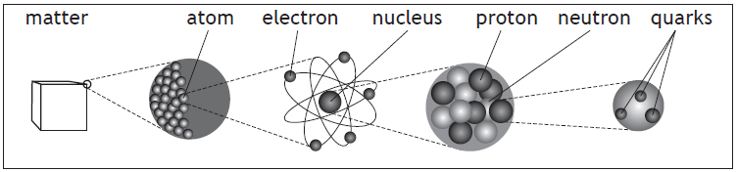
 | (a) | Explain why the proton and neutron are not fundamental particles. | 1
 | (b) | An extract from a data book contains the following information about three types of sigma (Σ) particles. Sigma particles are made up of three quarks.
Particle | Symbol | Quark Content | Charge | Mean Lifetime (s)
sigma plus | Σ⁺ | up up strange | +1e | 8·0 x 10⁻¹¹
neutral sigma | Σ⁰ | up down strange | 0 | 7·4 x 10⁻²⁰
sigma minus | Σ⁻ | down down strange | -1e | 1·5 x 10⁻¹⁰

 |  | (i) A student makes the following statement.  All baryons are hadrons, but not all hadrons are baryons.  Explain why this statement is correct. | 2
 |  | (ii) The charge on an up quark is +⅔e.  Determine the charge on a strange quark. | 1
 | (c) | (i) State the name of the force that holds the quarks together in the sigma (Σ) particle. | 1
 |  | (ii) State the name of the boson associated with this force. | 1
 | (d) | Sigma minus (Σ⁻) particles have a mean lifetime of 1·5 x 10⁻¹⁰ s in their frame of reference.  Σ⁻ are produced in a particle accelerator and travel at a speed of 0·9c relative to a stationary observer.  Calculate the mean lifetime of the Σ⁻ particle as measured by this observer. | 3
The Standard Model; Special Relativity
20. |  | Scientists have recently discovered a type of particle called a pentaquark. Pentaquarks are very short lived and contain five quarks.  A lambda b (Λ_{b}) pentaquark contains the following quarks: 2 up, 1 down, 1 charm, and 1 anticharm quark.
 | (a) | Quarks and leptons are fundamental particles.
 |  | (i) Explain what is meant by the term fundamental particle. | 1
 |  | (ii) State the name given to the group of matter particles that contains quarks and leptons. | 1
 | (b) | The table contains information about the charge on the quarks that make up the Λ_{b} pentaquark.
Type of Quark | Charge
up | + $\frac{\text{2}}{\text{3}}$e
down | - $\frac{\text{1}}{\text{3}}$e
charm | + $\frac{\text{2}}{\text{3}}$e
anticharm | - $\frac{\text{2}}{\text{3}}$e

 |  | Determine the total charge on the Λ_{b} pentaquark. | 2
 | (c) | One theory to explain the structure of the Λ_{b} pentaquark suggests that three of the quarks group together and one quark and the antiquark group together within the pentaquark.  Λ_{b}
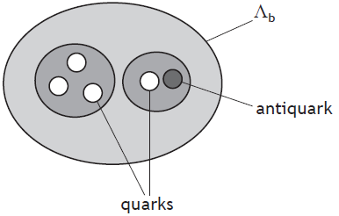
antiquark
quarks
 |  | (i) State the type of particle that is made of a quark-antiquark pair. | 1

20. |  | (continued)
 |  | (ii) The mean lifetime of another quark-antiquark pair is  8·0 x 10⁻²¹ s in its own frame of reference.  During an experiment the quark-antiquark pair is travelling with a velocity of 0·91c relative to a stationary observer.  Calculate the mean lifetime of this quark-antiquark pair relative to the stationary observer. | 3
 | (d) | The Λ_{b} pentaquark has a mass-energy equivalence of 4450 MeV.  One eV is equal to 1·6 x 10⁻¹⁹ J.
 |  | (i) Determine the energy, in joules, of the Λ_{b} pentaquark. | 1
 |  | (ii) Calculate the mass of the Λ_{b} pentaquark. | 3

