## Tutorial 1- Movement in a Magnetic Field

Copy the diagrams below and describe the movement of the particle in the magnetic field.



* 1. Using the same magnetic fields as shown above replace each of the particles with an alpha particle. Describe the motion of the alpha particle due to the force from each field.

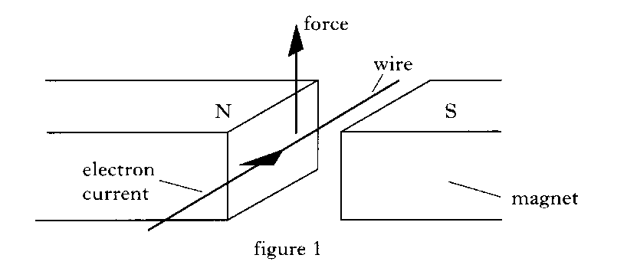

1. 1996 Credit Physics Paper
   * + - 1. A current carrying wire is placed between the poles of a magnet. The direction of the electron current in the wire is as indicated in Figure 1. The conductor experiences an upward force as shown in Figure 1.

Draw a diagram to show the rule that determines the direction of the Force on this wire.

* + - * 1. Figures 2 and 3 show other current carrying wires placed between the poles of the magnets. In each case, copy out the diagrams and indicate on figures 2 and 3 the direction of the force on the wire.

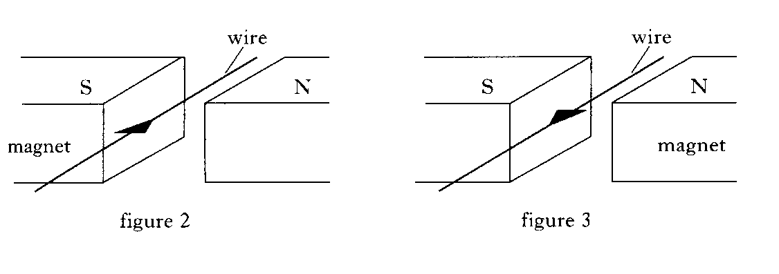

* + - * 1. Figure 4 shows a simple electric motor with a coil WXYZ free to spin about a shaft PQ.

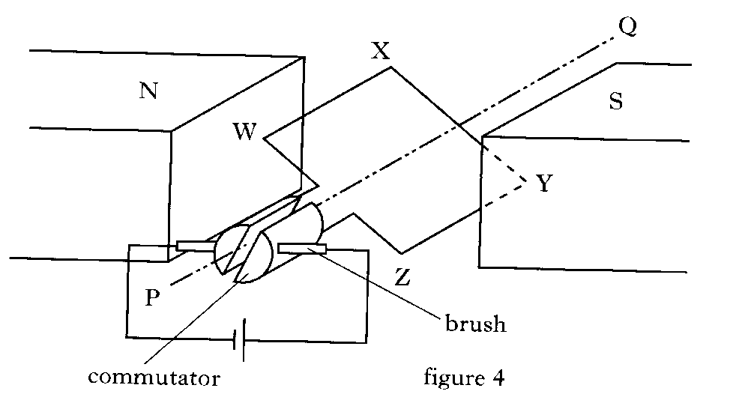

By looking at the diagram and using the conclusions you reached in part b) copy out the diagram and mark on your Figure 4

The direction of the electron current in the coil;

The directions of the forces on the coil;

The direction of the rotation of the coil.

* + - * 1. In commercial motors, explain why;

More than one rotating coil is used;

Field coils rather than permanent magnets are used

1. An electron travels from west to east and passes into in a horizontal magnetic field directed towards the north.
   * + - 1. Draw a labelled sketch to show this situation from above.
         2. State the direction of the force on the electrons in the wire.
2. An electron is directed at 90° (right-angles) to the magnetic field lines of a horseshoe magnet .

The diagram shows the view from above the magnet. State the direction of the magnetic force.



1. The diagram shows from above a 0.1 m straight, horizontal length of metal wire which has been placed perpendicular (at 90°) to a horizontal magnetic field.

State the direction of the force on the electrons in the wire

6. An electron travels from south to north in a horizontal magnetic field directed from east to west.

(a) Draw a labelled sketch to show this situation from above.

(b) State the direction of the force.

1. A proton is placed parallel to a horizontal magnetic field.
   1. Draw a diagram of the set up
   2. State the direction of the force which acts on the proton.

## Tutorial 2 Forces on charged particles

***In the following questions, when required, use the following data:***

***Charge on electron = –1·60 × 10−19 C Mass of electron = 9·11 × 10−31 kg***

***Charge on proton = 1·60 × 10−19 C Mass of proton = 1·67 × 10−27 kg***

1. An electron travelling with a constant velocity enters a region where there is a uniform magnetic field. There is no change in the velocity of the electron. What information does this give about the magnetic field?

2. The diagram shows a beam of electrons as it enters the magnetic field between two magnets.

The electrons will:

A be deflected to the left (towards the N pole)

beam of  
electrons

**N**

**S**

**S**

**N**

B be deflected to the right (towards the S pole)

C be deflected upwards

D be deflected downwards

E have their speed increased without any change in direction.

3. The diagrams show particles entering a region where there is a uniform magnetic field.

Use the terms: *up, down, into the paper, out of the paper, left, right, no change in direction* to describe the deflection of the particles in the magnetic field.

(a)

electron

magnetic field

(b)

magnetic field

alpha particle

(c)

neutron

magnetic field

(d)

proton

magnetic field

electron

magnetic field

(e)

proton

magnetic field

(f)

electron

x

x

x

x

x

x

x

x

x

x

x

x

x

x

x

x

x

x

x

x

x

x

x

x

x

magnetic field

(g)

proton

x

x

x

x

x

x

x

x

x

x

x

x

x

x

x

x

x

x

x

x

x

x

x

x

x

magnetic field

(h)

4. An electron enters a region of space where there is a uniform magnetic field. As it enters the field the velocity of the electron is at right angles to the magnetic field lines.

The energy of the electron does not change although it accelerates in the field.

Use your knowledge of physics to explain this effect.

### Particle Accelerators

1. In an evacuated tube, an electron initially at rest is accelerated through a p.d. of 500 V.

(a) Calculate, in joules, the amount of work done in accelerating the electron.

(b) Calculate the kinetic energy gained by the electron.

(c) Calculate the final speed of the electron.

2. In an electron gun, electrons in an evacuated tube are accelerated from rest through a potential difference of 250 V.

(a) Calculate the energy gained by an electron.

(b) Calculate the final speed of the electron.

3. Electrons in an evacuated tube are ‘fired’ from an electron gun at a screen. The p.d. between the cathode and the anode of the gun is 2000 V. After leaving the anode, the electrons travel at a constant speed to the screen. Calculate the maximum speed at which the electrons will hit the screen.

4. A proton, initially at rest, in an evacuated tube is accelerated between two charged plates A and B. It moves from A, where the potential is 10 kV, to B, where the potential is zero.

Calculate the speed of the proton at B.

5. A linear accelerator is used to accelerate a beam of electrons, initially at rest, to high speed in an evacuated container. The high- speed electrons then collide with a stationary target. The accelerator operates at 2·5 kV and the electron beam current is 3 mA.

(a) Calculate the gain in kinetic energy of each electron.

(b) Calculate the speed of impact of each electron as it hits the target.

(c) Calculate the number of electrons arriving at the target each second.

(d) State a reason for accelerating particles to high speed and allowing them to collide with a target.

6. The power output of an oscilloscope (cathode-ray tube) is estimated to be 30 W. The potential difference between the cathode and the anode in the evacuated tube is 15 kV.

(a) Estimate the number of electrons striking the screen per second.

(b) Calculate the speed of an electron just before it strikes the screen, assuming that it starts from rest and that its mass remains constant.

7. In an oscilloscope electrons are accelerated between a cathode and an anode and then travel at constant speed towards a screen. A p.d. of 1000 V is maintained between the cathode and anode. The distance between the cathode and anode is 5·0 × 10−3 m. The electrons are at rest at the cathode and attain a speed of 1·87 × 107 m s−1 on reaching the anode. The tube is evacuated.

(a) (i) Calculate the work done in accelerating an electron from the cathode to the anode.

(ii) Show that the average force on the electron in the electric field is 3·20 × 10−15 N.

(iii) Calculate the average acceleration of an electron while travelling from the cathode to the anode.

(iv) Calculate the time taken for an electron to travel from cathode to anode.

(v) Beyond the anode the electric field is zero. The anode to screen distance is 0·012 m. Calculate the time taken for an electron to travel from the anode to the screen.

(b) (i) Another oscilloscope has the same voltage but a greater distance between cathode and anode. State whether the speed of the electrons be higher, lower or remain at 1·87 × 107 m s−1? Explain your answer.

(ii) State whether the time taken for an electron to travel from cathode to anode be increased, decreased or stay the same as in (a) (iv)? Explain your answer.

8. In an X-ray tube a beam of electrons, initially at rest, is accelerated through a potential difference of 25 kV. The electron beam then collides with a stationary target. The electron beam current is 5 mA.

(a) Calculate the kinetic energy of each electron as it hits the target.

(b) Calculate the speed of the electrons at the moment of impact with the target assuming that the electron mass remains constant.

(c) Calculate the number of electrons hitting the target each second.

(d) What happens to the kinetic energy of the electrons?

9. Copy the diagram below and sketch the path that (a) an electron, (b) a proton and (c) a neutron would follow if each particle entered the given electric fields with the same velocity. Label each path.

Path of particles

+ + + + + + + + + + +

− − − − − − − − − − −

10. In the following examples identify the charge of particle (positive or negative) which is rotating in a uniform magnetic field. (X denotes magnetic field into page and • denotes magnetic field out of page.)

(a)

X

X

X

X

X

X

X

X

X

X

X

X

X

X

X

X

(a)

(b)

(c)

(d)

X

X

X

X

X

X

X

X

X

X

X

X

X

X

X

X

11. **Answer the following question in your notes jotter as a summary of particle accelerators.** In the following descriptions of particle accelerators, some words and phrases have been replaced by the letters **A** to **R**. Choose the correct word or phrase from the list given for each letter.

In a linear accelerator bunches of charged particles are accelerated by a series of ____**A**____. The final energy of the particles is limited by the length of the accelerator.

This type of accelerator is used in ____**B**____ experiments.

In a cyclotron the charged particles are accelerated by ____**C**____. The particles travel in a ____D____ as a result of a ____**E**____, which is ____**F**____ to the spiral. The radius of the spiral increases as the energy of the particles ____**G**____. The diameter of the cyclotron is limited by the ____**H**____ of the magnet. The resultant energy of the particles is limited by the diameter of the cyclotron and by ____**I**____.

This type of accelerator is used in ____**J**____ experiments.

In a synchrotron bunches of charged particles travel in a ____**K**____ as a result of C shaped magnets whose strength ____**L**____. The particles are accelerated by ____**M**____.

As the energy of the particles increases the strength of the magnetic field is ____**N**____ to maintain the radius of the path of the particles. In synchrotron accelerators the particles can have, in theory, an unlimited series of accelerations as the particles can transit indefinitely around the ring. There will be a limit caused by ____**O**____.

In this type of accelerator particles with ____**P**____ mass and ____**Q**____ charge can circulate in opposite directions at the same time before colliding. This increases the energy of impact. This type of accelerator is used in ____**R**____ experiments.

From the table below choose the correct words or phrases to replace the letters.

|  |  |
| --- | --- |
| *Letter* | *List of replacement word or phrase* |
| **A, C, E, M** | constant magnetic field, alternating magnetic fields, alternating electric fields, constant electric fields |
| **B, J,R** | colliding-beam, fixed-target |
| **D*,* K** | spiral of decreasing radius, spiral of increasing radius, circular path of fixed radius |
| **F** | perpendicular, parallel |
| **G** | decreases, increases |
| **H** | physical size, strength |
| **I, O** | gravitational effects, relativistic effects |
| **L** | can be varied, is constant |
| **N** | decreased, increased |
| **P, Q** | the same, different |