Equations (Higher)
$$s=ut+\frac{1}{2}at^{2}$$ | $$v=u+at$$ | $$v^{2}= u^{2}+2as$$ | $$s=\frac{1}{2}\left(u+v\right)t$$
$$p=mv$$ | $$m_{1}u_{1}+m_{2}u_{2}= m_{1}v_{1}+m_{2}v_{2}$$ |  | $$Ft=mv-mu$$
Equations (N5)
$$d=\overline{v}t$$ | $$s=\overline{v}t$$ | $$W=mg$$ | $$F=ma$$
$$E_{w}=Fd$$ | $$E_{p}=mgh$$ | $$E_{k}=\frac{1}{2}mv^{2}$$ | $$P=Et$$
Equations (Maths)
$$a^{2}+b^{2}=c^{2}$$ | $$sinθ=\frac{opposite}{hypotenuse}$$ | $$cosθ=\frac{adjacent}{hypotenuse}$$ | $$tanθ=\frac{opposite}{adjacent}$$

Key Words |  | Meaning
Vector Addition |  | When combining vectors, always add them nose to tail. Draw a scale diagram on the largest scale use an angle measurer. Or work from components to get one Vector_{vertical}, one Vector _{horizontal}, then use SohCahToa, and Pythagoras Theorem to calculate direction and magnitude of the resultant vector.
Terminal Velocity |  | Terminal Velocity is the maximum velocity an object will reach when in free Fall, this will occur when the Weight is equal in magnitude to the force due to air resistance
Free Fall |  | When an object is in free fall, it will accelerate due to its weight, as its velocity increases the force due to air resistance will also increase. The acceleration will then decrease until it reaches terminal velocity.
Tension |  | Tension is the force experienced at a join between two objects, for example a rope towing a car.
Apparent Weight |  | Apparent weight is the value of weight displayed on a scale. The value of apparent weight can change if it is viewed when accelerating vertically (e.g. in a lift). Apparent weight is measure in Newtons (N)
Collisions |  | A collision is when 2 objects collide together. All collisions follow the law of the conservation of momentum. Momentum and Total Energy conserved
Elastic collision |  | In an elastic collision the objects will ‘bounce off’ each other or not stick together. Prove elastic collision as total kinetic energy must be conserved during the interaction
Inelastic collision |  | In an In-elastic collision the objects will ‘stick together. Kinetic Energy must be lost.
Explosions |  | In an explosion 2 objects will diverge in opposite directions; Conservation of momentum must still apply. (Velocity is a vector, backwards is negative)
Impulse |  | Impulse is the measure of the change in momentum. Impulse is mesure in Newton seconds (Ns)
Momentum | p | Momentum is a measure of an objects mass multiplied by its velocity. It is one of the most important things to consider in collisions. Momentum has the unit kilogram meters per second (kgm s⁻¹)
Impulse |  | Impulse is the measure of the change in momentum. Impulse is measure in Newton seconds (Ns) = Ft = Δp. Make sure you know which object is applying the impulse

Laws | Definition
Conservation of Momentum | In the absence of external forces, the total momentum before a collision must be equal to the total momentum after a collision.
Newton’s 1st | Every object will remain at rest, or at a constant velocity, unless acted upon by an external force
Newton’s 2nd | $$F_{un}=ma$$
Newton’s 3rd | If object a exerts a force on object b, then object b will exert and equal but opposite force on object a

Diagrams
Velocity Time Graph | Acceleration Time Graph |  | Displacement time Graph
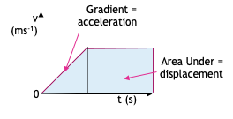 | 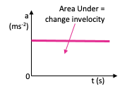 |  | 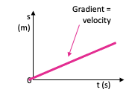
Graphs of Motion |  | Weight on a Slope
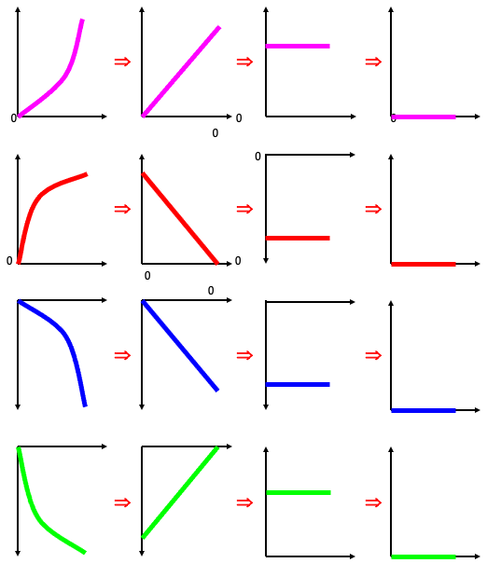 |  | 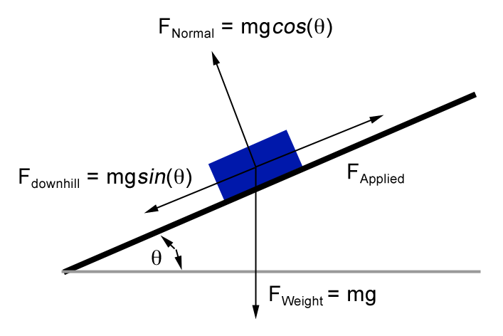
 |  | Forces in a lift
Lift | Apparent weight
Stationary Velocity | = Weight
Constant | = Weight
Accelerating up | > Weight
Accelerating down | < Weight
Decelerating Up | < Weight
Decelerating down | > Weight

Free Fall Graph |  | Force Time Graph
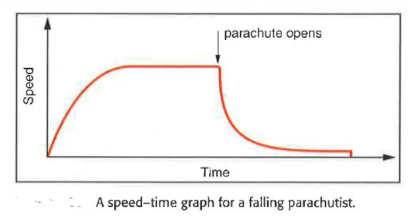 |  | 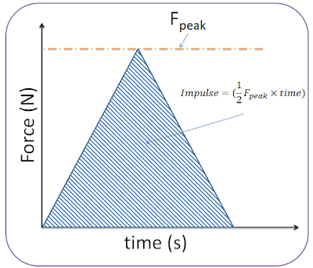
Component vectors
Horizontal component  (if angle given from the horizontal  = $v_{H}= R cos = v_{H}= 25 cos 50 = 16 ms^{-1}$  vertical component  (if angle given from the horizontal  = $v_{v}= R sin = v_{v}= 25 sin 50=19 ms^{-1}$ |  | 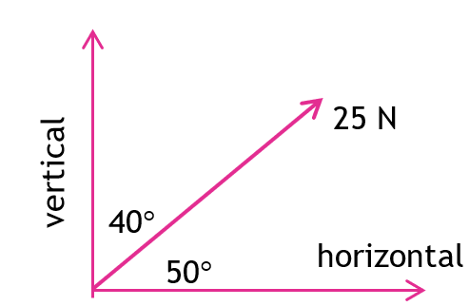

Resolving by Scale Diagram
Take any vector and start adding vectors head to tail, making sure the angles are measured correctly.
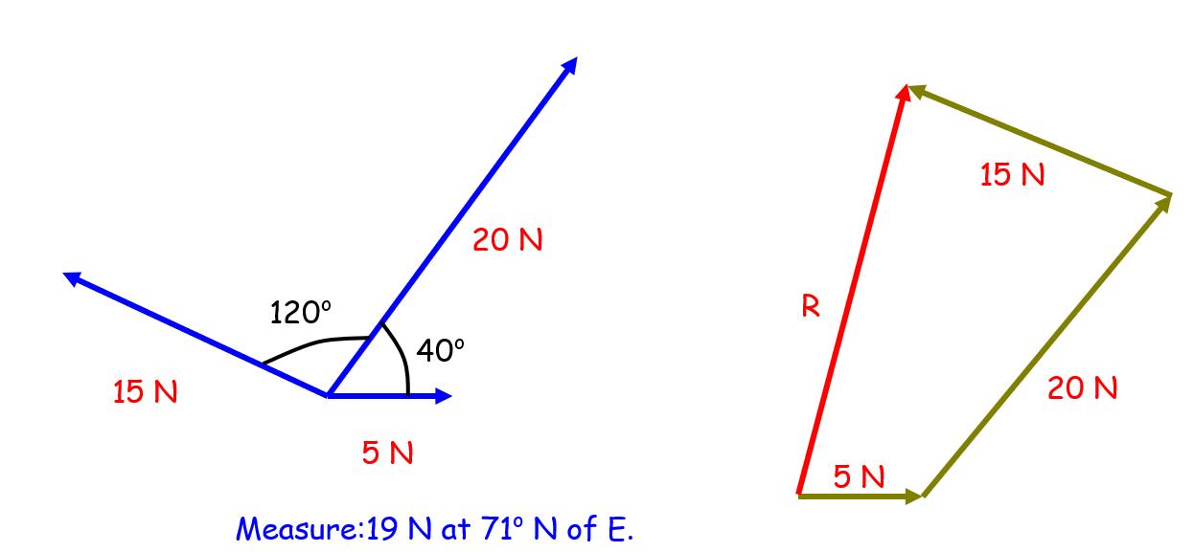

Resolving by components
Break ever vector into components at 90 degrees, making sure you clearly define what is positive and which direction is negative. Then use Pythagoras and SOHCAHTOA to determine the angle from a clear reference point.
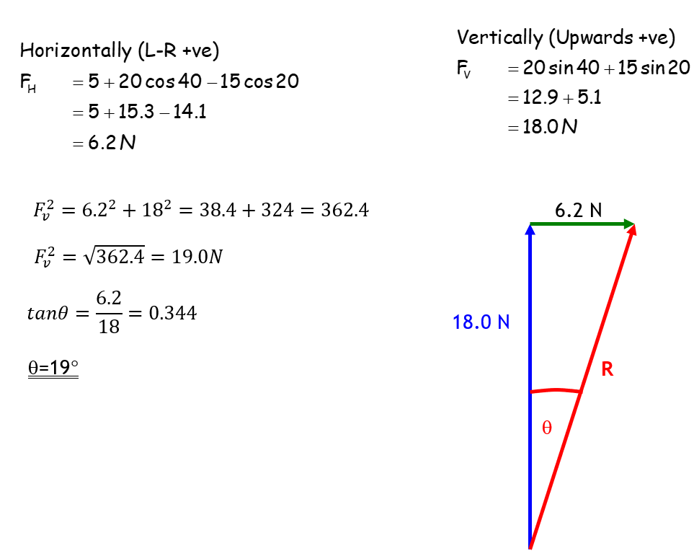

Measure:19 N at 71º N of E.

Our Dynamic Universe 2018 Part 1 by J A Hargreaves
http://thecraftycanvas.com/library/online-learning-tools/physics-homework-helpers/incline-force-calculator-problem-solver/
https://physicsteacher.in/2020/09/01/how-parachute-motion-happen-under-gravity-and-air-drag-with-speed-time-graph/
https://sites.google.com/a/perthgrammar.co.uk/physics/courses/higher/our-dynamic-universe/13-collisions-explosions-and-impulse/135-force-time-graphs

