 | Equations (Also need Equations of motion from ODU 1)
1 | $$F=\frac{GMm}{r^{2}}$$ | $$Force=Universal Constant of gravitation\frac{mass object1× mass object2}{{radius or distance between}^{2}}$$  Measure distance between centre and centre of planets!
2 | $$t^{'}=\frac{t}{\sqrt{1-\frac{v^{2}}{c^{2}}}}$$ | $$mesured time (larger)=\frac{proper time (smaller)}{\sqrt{1-\frac{{speed}^{2}}{{speed of light}^{2}}}}$$
3 | $$l^{'}=l\sqrt{1-\frac{v^{2}}{c^{2}}}$$ | $$mesured length \left(shorter\right)=properlength (longer)\sqrt{1-\frac{{speed}^{2}}{{speed of light}^{2}}}$$
4 | $$f_{o}=f_{s}\left(\frac{v}{v±v_{s}}\right)$$ | $$observed frequency=frequency of the source\left(\frac{speed}{speed±speed of sound}\right)$$
5 | $$v=H_{o}d$$ | $$velocity=Hubble^{'}s comstant × distance$$
6 | $$z=\frac{v}{c}$$ | $$redshift (no units)=\frac{speed}{speed of light}$$
7 | $$z=\frac{λ_{o}-λ_{r}}{λ_{r}}$$ | $$redshift (no units)=\frac{observed wavelength-emmited wavlength}{emmited wavlength}$$
Key Number | Meaning | Key Number | Meaning
6.67×10⁻¹¹ m³ kg⁻¹ s⁻² | Universal gravitational constant | 2.3×10⁻¹⁸ s⁻¹ | Hubble’s Constant

Key Words |  | Meaning
Projectile | An object with a constant horizontal velocity and constant vertical acceleration (provided air resistance is zero). It will follow a curved path. At Higher it may be launched at an angle.
Horizontal and Vertical | When a projectile is launched at an angle you must first use SOHCAHTOA to calculate the vertical and horizontal components of the initial velocity. Use components in equations. If the final velocity is required, combine the 2 components.
Gravitational Field | Any object of mass will feel a force of attraction in a gravitational field. The force of attraction can be calculated using Newton’s Universal law of gravitation (1st Equation)
Satellites | Satellites are objects which orbit a planet. They are in constant freefall towards the planet. Newton’s Cannon is the thought experiment used to explain satellite motion.
Special Relativity | When an object is travelling close to the speed of light, it will experience relativistic effects as noted by an observer. (time dilates, length contracts)
Time Dilatation | Time dilation is the increase in an observed time interval for an object moving relative to an observer, compared to that measured when they are in the stationary frame of reference.
Length Contraction | Length contraction is the shortening of the measured length of an object moving relative to the observer’s frame.
Inertial frame of Reference | An inertial frame of reference is one in which Newton's first law of motion holds, i.e you are travelling at constant velocity or are at rest, relative to another object.
Doppler effect | The Doppler Effect is the apparent change in frequency of a wave when the source and observer are moving relative to each other.
Red Shift  (definition 1) | Redshift, z, of a galaxy is defined as the change in wavelength divided by the original wavelength, and given the symbol z.
Redshift (definition 2) | For galaxies: Redshift is the ratio of the recessional velocity of the galaxy to the velocity of light.
Recessional velocity | The velocity at which galaxies moves away from its observer (normally on Earth)
Hubble’s Law | Hubble’s law states that a galaxies recessional velocity can be calculated by multiplying the distance away from earth by Hubble’s constant. This means that the universe is constantly expanding in all directions.
Expanding Universe | Redshift and Hubble’s law are proof for the expanding universe.
Dark Matter | Evidence supporting the existence of dark matter comes from estimations of the mass of galaxies. Dark matter cannot yet be observed. Explain why some galaxy’s planets all move with high velocity, regardless of distance away from the star. Dark Matter Attracts
Dark Energy | Evidence supporting the existence of dark energy comes from the accelerating rate of expansion of the Universe. Dark energy repels
Big Bang | Evidence for the Big bang = Cosmic Microwave Background Radiation (CMBR), the abundance of helium/hydrogen in the universe, and Olber’s Paradox. When the Universe came into existence and expanded (not exploded)
Black Body | An object that absorbs all incident em-radiation is a blackbody. The greater the temperature of a blackbody, the shorter the peak wavelength.
Stellar temperature | Temperature of stellar objects is related to the distribution of emitted radiation over a wide range of wavelengths. Stars that appear blue tinge have a higher temperature than stars that appear red.

Diagrams
Hubble’s Law- age the Universe | Newtons Cannon allows satellites |  |  | Earth’s Gravitational Field- attracts mass
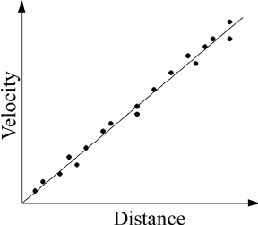  Gradient= Hubble constant or 1/age of the universe | 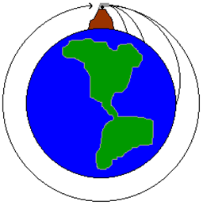 |  |  | 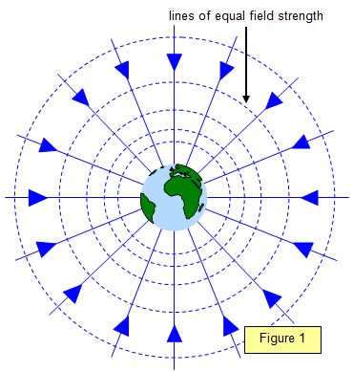
Black Body Radiation |  | Doppler effect
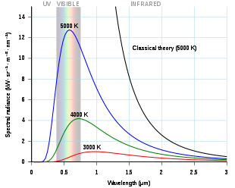 |  | 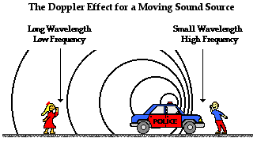Which equation? $f_{o}=f_{s}\left(\frac{v}{v±v_{s}}\right)$  Towards =Take Away Away=Add
Redshift Spectra |  |  | Projectile Initial Component
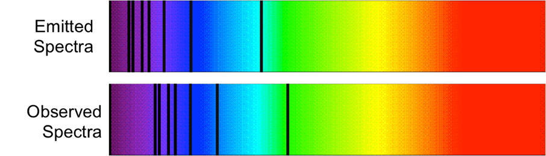 |  |  | If θ given to horizontal  θ  Vertical component  Horizontal component  Resultant  velocity  $v_{H}=Rcos θ$  $$v_{v}=Rsin θ$$  Vertically  su_{v}vat, s=height  Horizontally  sv_{H}t, s=range

https://www.researchgate.net/figure/A-schematic-Hubble-plot-for-a-universe-with-a-constant-Hubble-parameter_fig1_258606466
John Sharkey Flashlearning
https://en.wikipedia.org/wiki/Black_body
https://en.wikipedia.org/wiki/Black_body
https://www.physicsclassroom.com/class/sound/Lesson-3/The-Doppler-Effect-and-Shock-Waves
http://voyages.sdss.org/preflight/light/redshift/

