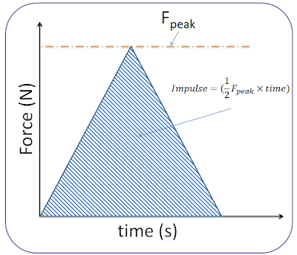

Label a force time graph to solve problems involving impulse.

Relationship between force, time, final and initial momentum.

Show the energy involved in explosions.

Define impulse.

Show the energy interactions in inelastic collisions.

Provide an example of objects interacting in one dimension and solve problem involving momentum.

Define momentum.

Show the energy interactions in elastic collisions.

Use Newton’s 3rd law to explain the motion of objects interacting.

State principle of conservation of momentum.

State principle of conservation of energy.

Relationship between velocity, mass and energy.

Relationship between velocity, mass and momentum.

Collisions, explosions and impulse



