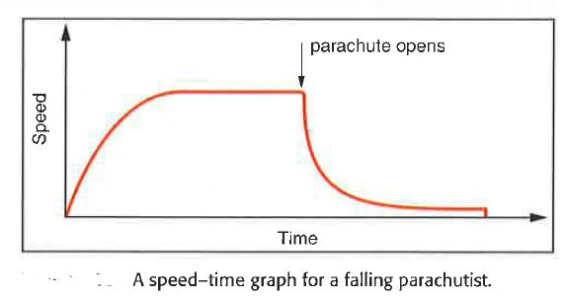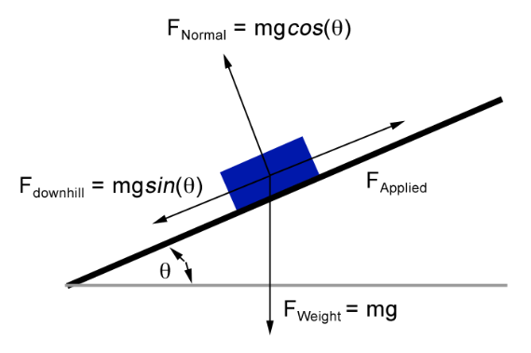

Define vector addition and label forces on diagram.

Define tension.

|  |  |
| --- | --- |
| Lift motion | Apparent weight |
| Stationary | = weight |
| Constant velocity | = weight |
| Accelerating upwards |  |
| Accelerating downwards |  |
| Decelerating upwards |  |
| Decelerating upwards |  |

Complete the table for apparent weight.

Show the forces on a free body diagram for an object in tension.

Define free fall.

Relationship between velocity, mass and energy.

Relationship between mass, energy, g.f.s and height.

State Newton’s 3rd law.

State Newton’s 2nd law.

State Newton’s 1st law.

Draw a v-t graph to show free fall

Forces, energy and power

Relationship between force, work done and distance.

Relationship between force, mass and acceleration.

Relationship between weight, gravitational field strength (g.f.s) and mass.

