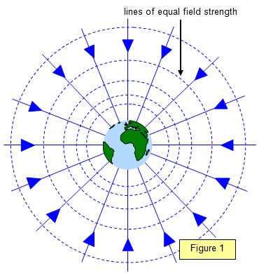

Describe and state Newton’s law of universal gravitation.

State the relationships used to explain the vertical component of a projectile.

State the relationship used to explain the horizontal range of a projectile.

Draw a diagram explaining special relativity.

Define time dilation

Define length contraction

Universal gravitational constant

Earth’s gravitational field attracts mass

Define projectile.

Solve vectors for horizontal and vertical components of projectiles

θ

Vertical component

Horizontal component

Resultant

velocity

https://en.wikipedia.org/wiki/Black_body

Describe Special Relativity.

Describe an intertial frame of reference.

Define satellites in terms of freefall.

State the relationship for time dilation.

State the relationship for length contraction.

Description of an experiment to measure the acceleration of a falling object.

Gravitation and Special relativity

