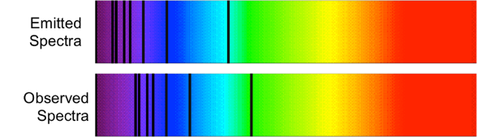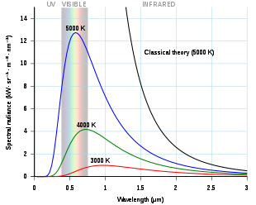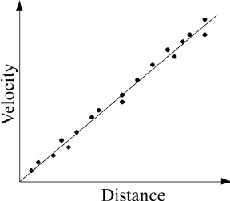

http://voyages.sdss.org/preflight/light/redshift/

https://en.wikipedia.org/wiki/Black_body

John Sharkey Flashlearning

https://www.researchgate.net/figure/A-schematic-Hubble-plot-for-a-universe-with-a-constant-Hubble-parameter_fig1_258606466

https://www.physicsclassroom.com/class/sound/Lesson-3/The-Doppler-Effect-and-Shock-Waves

1.

2.

Black body radiation

Stellar temperature, radiation over different wavelengths

Provide the two definitions of Redshift

1.

2.

3.

What do we use the Hubble-Lemaitre law for?

Describe the evidence for the existence of dark matter

Describe relevance of Newton’s cannon thought experiment

Define the Doppler effect.

Evidence for the big bang

Evidence of dark energy comes from……

The mass of a galaxy can be estimated by……

Leads to the theory of……

Relationship linking axes and gradient of graph

Recessional Velocity

State appropriate relationship involving redshift, observed

wavelength, emitted wavelength, and recessional velocity.

State appropriate relationship involving the observed frequency,

source frequency, source speed and wave speed.

Hubble’s Law and the age of the Universe. Describe the axes and gradient.

Gradient=

Fill in the blanks for the Doppler Effect for a moving sound source

The expanding Universe

