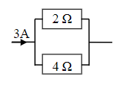

Definition of electromotive force

Definition of potential difference

Definition of power and the three relationships used to calculate power

Complete sources of emf

$$\frac{V_{1}}{V_{2}}=$$

What is relationship Rtotal in series circuits

What is relationship Rtotal in parallel circuits

Current, potential difference, power, and resistance

Calculate the current in the parallel circuit and voltage in the series circuit

Explain Ohms law

What is relationship to solve problems in potential divider circuits.

Definition of resistance

Definition of current

Calculate V across point XY

Complete the circuit rules

