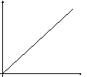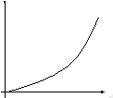

Demonstrate the

use of an appropriate relationship to solve problems involving irradiance and distance from a point source of light.

Name and describe the units in the relationship

*I=Nhf*

What is irradiance?

Describe the experiment to verify the inverse square law for a point source of light

Explain the relationship in the graph

Label the inverse square law graph axes?

Label the inverse square law graph axes?

Label the inverse square law graph axes?



*PASCO TD-8555 THERMAL RADIATION SYSTEM - Manual (Page 13)*. [online] manualsdir.com. Available at: <https://www.manualsdir.com/manuals/340664/pasco-td-8555-thermal-radiation-system-td-8554a-thermal-radiation-system-td-8553-thermal-radiation-system-td-8555-radiation-sensor-td-8554a-radiation-sensor-td-8553-radiation-sensor.html?page=13&original=1>

State appropriate relationship to solve problems involving the irradiance, power, and area.

Inverse square law

