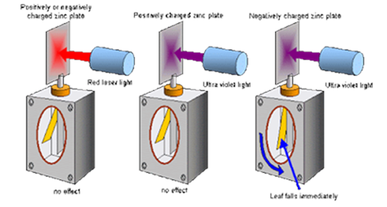

http://schoolphysics.org/age16-19/quantum%20physics/text/Photoelectric_effect/index.html

Insert >, < or = into the terms in the left hand column to satisfy the result in the right hand column

Complete the conclusions below

Calculate: (a) Ek of the electron.

(b) the final speed of the electron.

Name and describe the effect shown in the diagram

An electron is accelerated from rest through a potential difference of 200V.

What is the threshold frequency?

State appropriate relationship to solve problems involving the frequency and energy of a photon.

What is the definition for the work function?

The relationship including velocity, energy and mass?

The relationship including velocity, frequency and wavelength?

What is the charge of an electron?

What is the photoelectric effect evidence of?

|  |  |
| --- | --- |
| **Evidence** | **Conclusion** |
| **UV discharges the zinc plate of an electro-scope which is negatively charged.** |  |
| **Visible radiation, however bright, doesn’t produce the same effect.** |  |

The energy supplied by light or other electromagnetic radiation takes the form of photons of energy, ***hf***. When a photon goes into the metal it is wholly absorbed by a single electron.

|  |  |
| --- | --- |
| If ***hf W*** | no electron emission |
| If ***hf W hf0*** | then the photon is just able to release an electron from its surface without it having any EK (f0 or THRESHOLD FREQUENCY). (hf = W = hf0) |
| If ***hf W*** | then excess energy is given to the freed electron as EK. |

***hf = W + EK***

What is the work function?

Wave-particle duality

