H

Higher Assignment
Guide Sheet B: Capacitance

Current and frequency in a capacitive circuit
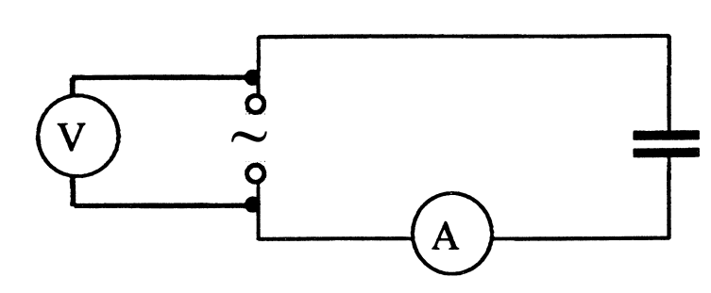

Apparatus
Signal generator, a.c. voltmeter or oscilloscope, a.c. ammeter, 4.7 µF
capacitor

Instructions:
- Connect the circuit as shown in the circuit diagram.
- An oscilloscope may be used in place of the voltmeter.
- Set the output of the signal generator to about 3 V.
- Vary the source frequency and record readings of current and frequency using a range of 100 Hz to 1 kHz.
- Ensure that the supply voltage remains constant.
- Use an appropriate format to show the relationship between current and frequency.
Risk Assessment
- Do not overload the power supply or put too large a voltage across the capacitor
- Check electrical wiring
- Beware of heating in the components

Instructions
- Teachers must exercise their professional responsibility to ensure that the report submitted is the candidate’s own work.
- No more than 8 hours should be spent on the whole assignment.
- A maximum of 2 hours is allowed for the report stage.
- The instructions for candidates outline the requirements for the assignment. must be given to candidates at the outset.
- Teachers must ensure candidates understand the requirements of the task.
- Teachers must not, at any stage, provide candidates with a template or model answers.

Experimental research
- Teachers can supply instructions for the experimental procedure(s).
  - This must not include details of range and interval of measurements, and reference to repeats.
- Teachers are responsible for ensuring that appropriate risk assessment has been carried out and that candidates have guidance on the safe and correct use of equipment.
- Teachers must not provide candidates with experimental data.
- Teachers must not provide a blank or pre-populated table for experimental results.
- Candidates must carry out the experimental work either individually or as part of a small group. (A small group is defined as having two, three or four candidates.)
- Group work may be an appropriate approach in a number of circumstances, for example:
  - to encourage diversity of research topic
  - where experiments are labour- or time-intensive
  - where resources are limited Where candidates work in a group, teachers must ensure every candidate participates in the experimental work.
  - Within the small group, it is acceptable for candidates to share experimental data, but experimental data must not be shared between groups.
- Teachers must not provide feedback to candidates on their data. However, where candidates identify a problem with their results and indicate that they wish to repeat the experiment(s), they may do so.

Mrsphysics takes no responsibility for any health and safety. It is the responsibility of the teacher and student to risk assess any practical activity they complete! It is also the responsibilty of the teacher to check that these experiments meet the specifications. Mrsphysics has done her best to check that these meet the criteria
- Sept 2023

