H

Higher Assignment
Guide Sheet B: Critical Angle

Critical Angle

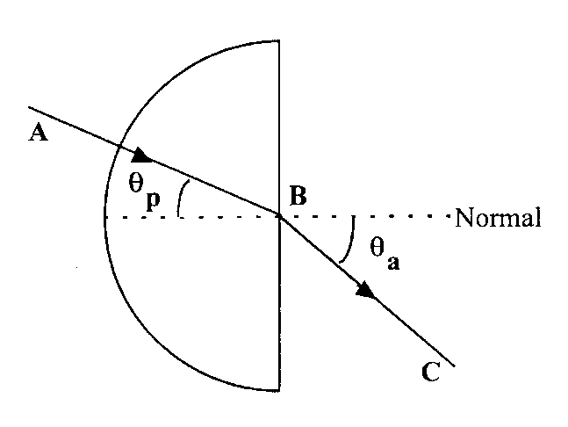
Apparatus
Ray box and single slit, 12 V power supply, semicircular perspex block, sheet of white paper, protractor.

Instructions
- Place the block on the white paper and trace around its outline. Draw in the normal at the midpoint B.
- Draw a line representing the angle θ_{p} = 10°, the line AB in the diagram above.
- Direct the raybox ray along AB and mark in the point C where the ray emerges.
- Draw a line representing the refracted ray, the line BC in the diagram above.
- Measure the angle θ_{a}, the refracted angle in air.
- Use an appropriate format to record your results.
- Repeat for other values of incident angle θ_{p}.
- Determine the critical angle θ_{c} for this perspex block.

Risk Assessment
- Check all electrical cables
- This activity may take some time if done carefully, so the lamps may become hot.
- The base of the block should be frosted or painted with white paint, or total reflection at the base will prevent the path of the ray through the block being visible.
- Be observant to those around you.

Instructions
- Teachers must exercise their professional responsibility to ensure that the report submitted is the candidate’s own work.
- No more than 8 hours should be spent on the whole assignment.
- A maximum of 2 hours is allowed for the report stage.
- The instructions for candidates outline the requirements for the assignment. must be given to candidates at the outset.
- Teachers must ensure candidates understand the requirements of the task.
- Teachers must not, at any stage, provide candidates with a template or model answers.

Experimental research
- Teachers can supply instructions for the experimental procedure(s).
  - This must not include details of range and interval of measurements, and reference to repeats.
- Teachers are responsible for ensuring that appropriate risk assessment has been carried out and that candidates have guidance on the safe and correct use of equipment.
- Teachers must not provide candidates with experimental data.
- Teachers must not provide a blank or pre-populated table for experimental results.
- Candidates must carry out the experimental work either individually or as part of a small group. (A small group is defined as having two, three or four candidates.)
- Group work may be an appropriate approach in a number of circumstances, for example:
  - to encourage diversity of research topic
  - where experiments are labour- or time-intensive
  - where resources are limited Where candidates work in a group, teachers must ensure every candidate participates in the experimental work.
  - Within the small group, it is acceptable for candidates to share experimental data, but experimental data must not be shared between groups.
- Teachers must not provide feedback to candidates on their data. However, where candidates identify a problem with their results and indicate that they wish to repeat the experiment(s), they may do so.

Mrsphysics takes no responsibility for any health and safety. It is the responsibility of the teacher and student to risk assess any practical activity they complete! It is also the responsibilty of the teacher to check that these experiments meet the specifications. Mrsphysics has done her best to check that these meet the criteria
- Sept 2023

