H

Higher Assignment
Guide Sheet B: Determining g

Determining ‘g’.
The emphasis of this practical is the relationship between s and t
Apparatus
Release mechanism (may be electromagnetic), Trip switch (hinged flap), Power supply, low voltage, DC Switch, SPDT Ball bearing ball, steel, Retort stand and boss head, Electronic timer, Leads, 4 mm
Instructions:
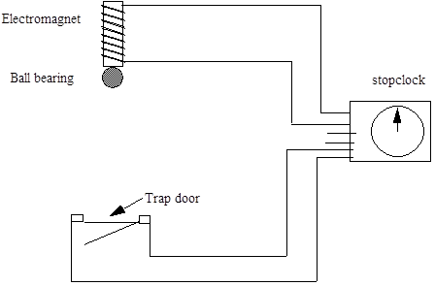

- Set up the apparatus as shown in the diagram. You may need to adjust the distance of fall and the point at which the ball strikes the flap.
- Arrange the timer so that it starts when the electromagnet is switched off and stops when the hinged flap opens.
- Check that the flap does open when the ball strikes it. You may need to make the distance of fall larger, or move the flap so that the ball strikes it further from the hinge.
- Measure the distance h from the bottom of the ball to the hinged flap. Be careful to avoid parallax error in this measurement.
- Change the starting height and repeat the procedure.
- Present your results.

Risk Assessment
- Be sure masses cannot land on feet or shatter and cause bits to become projectiles which could go into eyes or skin.
- Placing a buffer at the end of the drop so not to damage equipment.
- Do an electrical safety check by observing all the wires.
- Make sure the vehicle cannot become a trip hazard or land on feet, toes etc.
- Be observant to those around you.
- Do not block exits with the apparatus.

Instructions
- Teachers must exercise their professional responsibility to ensure that the report submitted is the candidate’s own work.
- No more than 8 hours should be spent on the whole assignment.
- A maximum of 2 hours is allowed for the report stage.
- The instructions for candidates outline the requirements for the assignment. must be given to candidates at the outset.
- Teachers must ensure candidates understand the requirements of the task.
- Teachers must not, at any stage, provide candidates with a template or model answers.

Experimental research
- Teachers can supply instructions for the experimental procedure(s).
  - This must not include details of range and interval of measurements, and reference to repeats.
- Teachers are responsible for ensuring that appropriate risk assessment has been carried out and that candidates have guidance on the safe and correct use of equipment.
- Teachers must not provide candidates with experimental data.
- Teachers must not provide a blank or pre-populated table for experimental results.
- Candidates must carry out the experimental work either individually or as part of a small group. (A small group is defined as having two, three or four candidates.)
- Group work may be an appropriate approach in a number of circumstances, for example:
  - to encourage diversity of research topic
  - where experiments are labour- or time-intensive
  - where resources are limited Where candidates work in a group, teachers must ensure every candidate participates in the experimental work.
  - Within the small group, it is acceptable for candidates to share experimental data, but experimental data must not be shared between groups.
- Teachers must not provide feedback to candidates on their data. However, where candidates identify a problem with their results and indicate that they wish to repeat the experiment(s), they may do so.

Mrsphysics takes no responsibility for any health and safety. It is the responsibility of the teacher and student to risk assess any practical activity they complete! It is also the responsibilty of the teacher to check that these experiments meet the specifications. Mrsphysics has done her best to check that these meet the criteria
- Sept 2023

