H

Higher Assignment
Guide Sheet B: Determining ‘h’

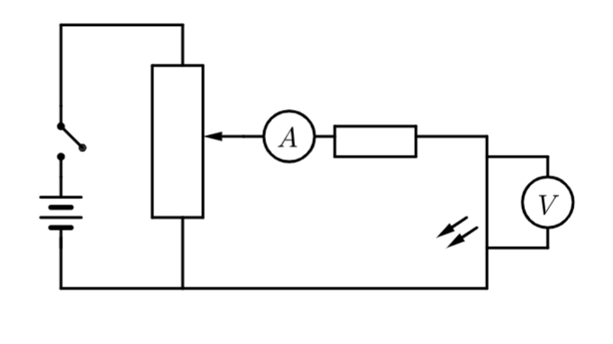
Determining ‘h’.
Apparatus
Set of 5 LEDs of different, known wavelengths, 6 V or 9 Vcell, 1 kΩ potentiometer, 330 Ω resistor, voltmeter, ammeter, connectin g wires
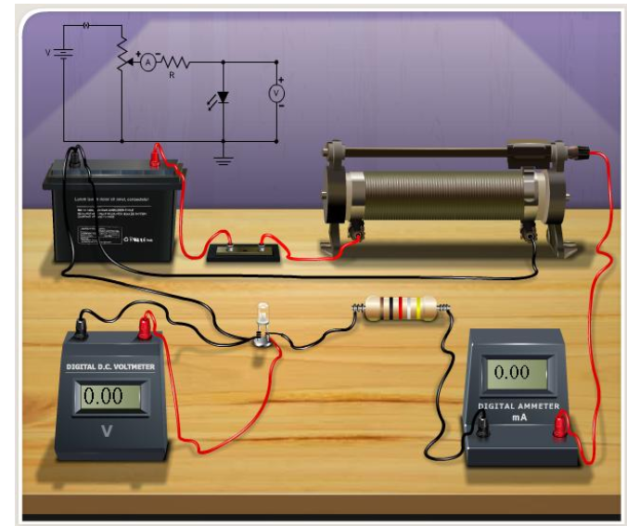
Instructions:
- Set up the circuit as shown in the diagram DO NOT USE A CAR BATTERY.
- Connect one of the LEDs to the 330 Ω resistor. The longer wire of the LED must attach to the positive.
- Connect the voltmeter across the LED, place the ammeter next to the LED.
- Slowly increase the potential difference across the LED by adjusting the potentiometer until a reading appears on the ammeter, the LED should just begin to glow. It is recommended to darken the room when attempting to measure the LED brightness.
- Record the potential difference at which this happens. Go backwards and forwards past the point at which the current just begins to pass through the LED, and the LED just begins to glow, a few times to locate switch on voltage as accurately as possible,.
- Repeat Step 4 for all the other LEDs. Always turn the potentiometer dial so that it is at a maximum resistance before changing LEDs so the initial voltage across each LED is 0 V.

Risk Assessment
- Do not stare directly at a brightly lit LED.
- Do an electrical safety check on all the wires and connections.
- Be observant to those around you.
- Beaware of equipment that can get hot.
- Do not block exits with the apparatus.

Instructions
- Teachers must exercise their professional responsibility to ensure that the report submitted is the candidate’s own work.
- No more than 8 hours should be spent on the whole assignment.
- A maximum of 2 hours is allowed for the report stage.
- The instructions for candidates outline the requirements for the assignment. must be given to candidates at the outset.
- Teachers must ensure candidates understand the requirements of the task.
- Teachers must not, at any stage, provide candidates with a template or model answers.

Experimental research
- Teachers can supply instructions for the experimental procedure(s).
  - This must not include details of range and interval of measurements, and reference to repeats.
- Teachers are responsible for ensuring that appropriate risk assessment has been carried out and that candidates have guidance on the safe and correct use of equipment.
- Teachers must not provide candidates with experimental data.
- Teachers must not provide a blank or pre-populated table for experimental results.
- Candidates must carry out the experimental work either individually or as part of a small group. (A small group is defined as having two, three or four candidates.)
- Group work may be an appropriate approach in a number of circumstances, for example:
  - to encourage diversity of research topic
  - where experiments are labour- or time-intensive
  - where resources are limited Where candidates work in a group, teachers must ensure every candidate participates in the experimental work.
  - Within the small group, it is acceptable for candidates to share experimental data, but experimental data must not be shared between groups.
- Teachers must not provide feedback to candidates on their data. However, where candidates identify a problem with their results and indicate that they wish to repeat the experiment(s), they may do so.

Mrsphysics takes no responsibility for any health and safety. It is the responsibility of the teacher and student to risk assess any practical activity they complete! It is also the responsibilty of the teacher to check that these experiments meet the specifications. Mrsphysics has done her best to check that these meet the criteria
- Sept 2023

