H

Higher Assignment
Guide Sheet A: Capacitor

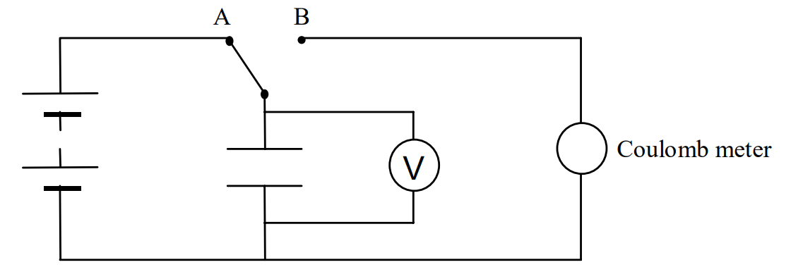
Instructions:
- Discharge the capacitor by shorting with connecting lead.
- Connect the circuit and set the switch to charge the capacitor as shown in the diagram.
- Allow enough time for the capacitor to charge fully.
- Set the switch to B to fully discharge the capacitor through the coulomb meter.
- Repeat for other charging voltages.
- Use an appropriate format to show the relationship between charge and voltage.

