H

Higher Assignment
Guide Sheet B: Capacitance

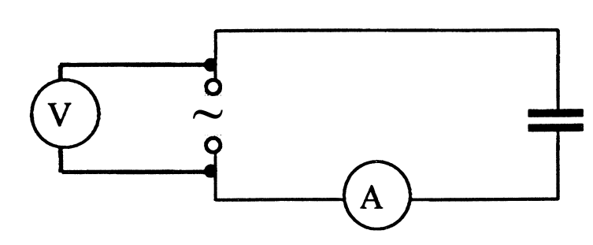

Instructions:
- Connect the circuit as shown in the circuit diagram.
- An oscilloscope may be used in place of the voltmeter.
- Set the output of the signal generator to about 3 V.
- Vary the source frequency and record readings of current and frequency using a range of 100 Hz to 1 kHz.
- Ensure that the supply voltage remains constant.
- Use an appropriate format to show the relationship between current and frequency.

