H

Higher Assignment
Guide Sheet: Wheatstone Bridge

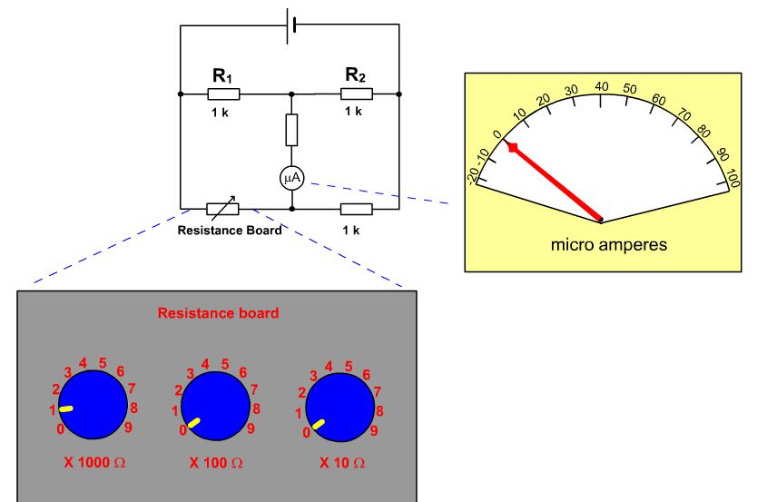
Instructions:

- Set up the Wheatstone Bridge using 1000 Ω resistors.
- The resistance box should be set to vary the resistance below and above 1000 Ω.
- The bridge has now to be unbalanced by a known small amount and the reading on the voltmeter or ammeter noted.
- Plot a graph of the out-of-balance resistance v current or voltage

