H

Higher Assignment  
Guide Sheet A: Acceleration down slope



**Determine the effect of angle on the acceleration**

ruler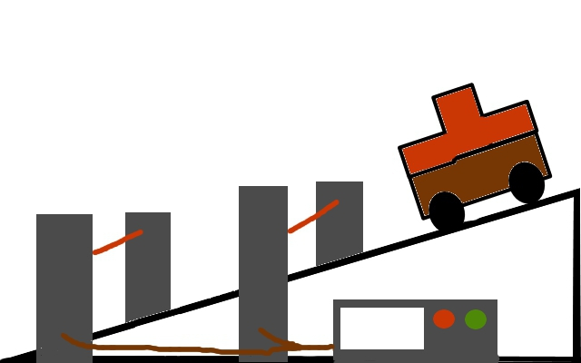

**Instructions:**

* Set up the apparatus as shown in the diagram.
* Measure the width of the mask.
* Measure the angle of the slope
* After selecting the acceleration programme, allow the trolley to run down the track.
* Repeat for a range of values.
* Use an appropriate format to find the relationship between the angle of slope and the acceleration.