H

Higher Assignment  
Guide Sheet B: Acceleration down slope

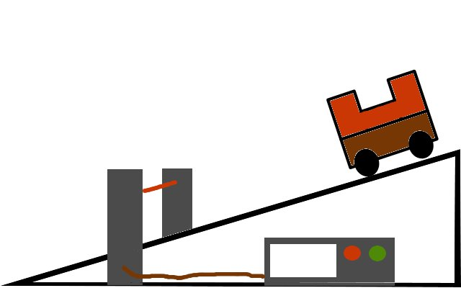

**Instructions:**

* Set up the apparatus as shown in the diagram.
* Measure the width of the masks, they should be equal.
* Measure the angle of the slope
* After selecting the acceleration programme, allow the trolley to run down the track.
* Repeat for a range of values
* Present the results to show how the angle of the slope affects the acceleration.