H

Higher Assignment
Guide Sheet B: Critical Angle

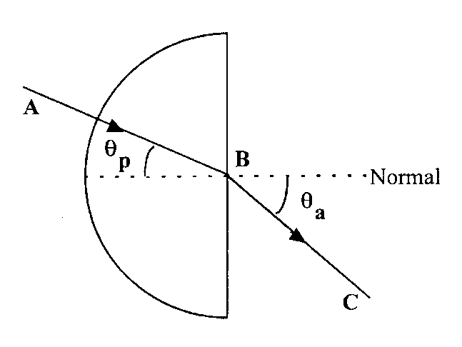
Instructions
- Place the block on the white paper and trace around its outline. Draw in the normal at the midpoint B.
- Draw a line representing the angle θ_{p} = 10°, the line AB in the diagram above.
- Direct the raybox ray along AB and mark in the point C where the ray emerges.
- Draw a line representing the refracted ray, the line BC in the diagram above.
- Measure the angle θ_{a}, the refracted angle in air.
- Use an appropriate format to record your results.
- Repeat for other values of incident angle θ_{p}.
- Determine the critical angle θ_{c} for this perspex block.

