H

Higher Assignment
Guide Sheet A: Determining g

Instructions:
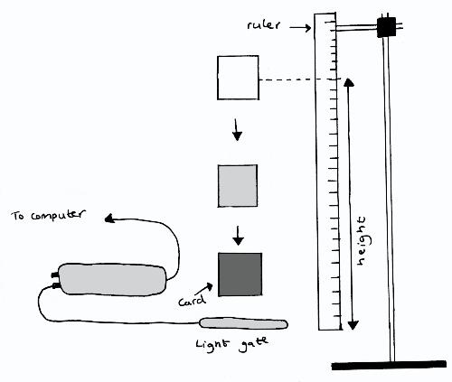
- Measure the card thickness dropping through the light gate.
- Hold the card above the light gate and next to the ruler so that its height above the gate may be measured carefully.
- Release the card so that it cuts through the light beam; a velocity measurement should appear in the table on the screen.
- Change the starting height and repeat the procedure.
- Present your results.

