H

Higher Assignment
Guide Sheet B: Determining ‘h’

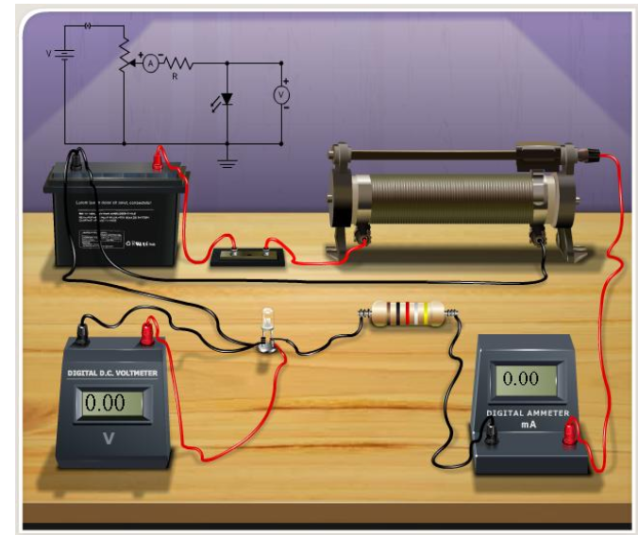
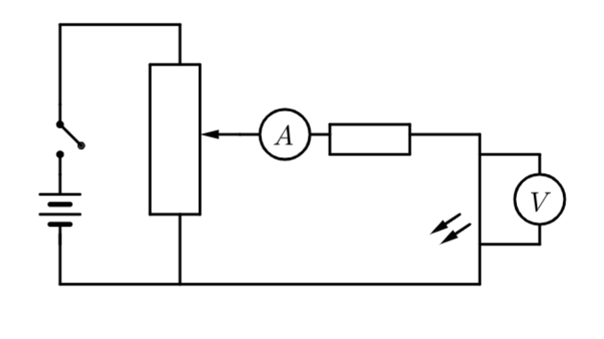
Instructions:
- Set up the circuit as shown in the diagram DO NOT USE A CAR BATTERY.
- Connect one of the LEDs to the 330 Ω resistor. The longer wire of the LED must attach to the positive.
- Connect the voltmeter across the LED, place the ammeter next to the LED.
- Slowly increase the potential difference across the LED by adjusting the potentiometer until a reading appears on the ammeter, the LED should just begin to glow. It is recommended to darken the room when attempting to measure the LED brightness.
- Record the potential difference at which this happens. Go backwards and forwards past the point at which the current just begins to pass through the LED, and the LED just begins to glow, a few times to locate switch on voltage as accurately as possible,.
- Repeat Step 4 for all the other LEDs. Always turn the potentiometer dial so that it is at a maximum resistance before changing LEDs so the initial voltage across each LED is 0 V.

