H

Higher Assignment
Guide Sheet A: Determining ‘h’

Instructions:
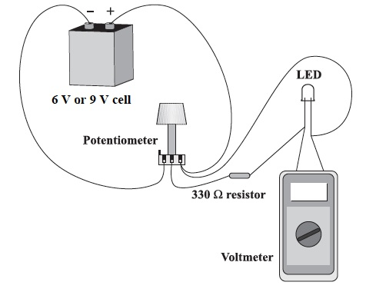
- Orient the potentiometer so that the terminals are pointing toward you. Turn the knob fully clockwise. Connect the negative terminal of the battery to the left-hand terminal of the potentiometer and the positive terminal of the battery to the right-hand terminal of the potentiometer, as shown in the diagram.
- Connect one of the LEDs to the 330 Ω resistor using a wire. Connect both of these components to the central and right-hand terminals of the potentiometer, with the longer wire of the LED attached to the right-hand terminal, as shown in the diagram.
- Connect the voltmeter across the LED.
- Slowly increase the potential difference across the LED by turning the potentiometer dial until the LED just begins to glow. It is recommended to darken the room when attempting to measure the LED brightness.
- Record the potential difference at which this happens. Go backwards and forwards past the point at which the LED just begins to glow a few times to locate it as accurately as possible.
- Repeat Step 4 for all the other LEDs. Always turn the potentiometer dial fully clockwise before changing LEDs so the initial voltage across each LED is 0 V.

