Equations
$$V_{rms}=\frac{V_{Peak}}{\sqrt{2}}$$ | $$root mean squared voltage=\frac{peak voltage}{\sqrt{2}}$$
$$I_{rms}=\frac{I_{Peak}}{\sqrt{2}}$$ | $$root mean squared current=\frac{peak current}{\sqrt{2}}$$
$$E=V+Ir$$ | $$electromotive force=potential difference+(current ×internal resistance)$$
$$E=V+V_{L}$$ | $$electromotive force=potential difference+"lost" volts$$
$$C=QV$$ | $$capacitance=charge × potential difference$$
$$E=\frac{1}{2}QV=\frac{1}{2}CV^{2}=\frac{1}{2}\frac{Q^{2}}{C}$$ |  |  | $$where:E is energy, Q is Charge, V is potential difference,$$  $$and C is capacitance$$
$$T=\frac{1}{f}$$ |  | $$P=IV=I^{2}R=\frac{V^{2}}{R}$$ |  |  | $$R_{t}=R_{1}+R_{2}…$$
$$\frac{1}{R_{t}}=\frac{1}{R_{1}}+\frac{1}{R_{2}}…$$ |  | $$V_{2}=\left(\frac{R_{2}}{R_{1}+R_{2}}\right)V_{s}$$ |  | $$\frac{V_{1}}{V_{2}}=\frac{R_{1}}{R_{2}}$$ | $$V=IR$$
Key Words | Meaning
Alternating current | A current which changes direction and instantaneous value with time. E.g. Mains voltage produces an r.m.s. voltage of 230 V and frequency of 50 Hz
Direct Current | D.C. – a current where the electrons always flow in the same direction. E.g. the current from a cell or battery is D.C.
r.m.s. | root mean squared – used to give a value of potential difference or current from an A.C. supply which provides the same power as the equivalent quoted D.C V and I .
EMF | Electromotive force – the energy supplied to each coulomb of charge passing through the source. This can only be measured when the current drawn is 0 A i.e. placing a voltmeter across the (open source)
Internal Resistance | Charge gives up some of its energy passing through the cell. This is due to the internal resistance of the cell and accounts for the lost energy in a power source.
TPD | Terminal Potential Difference - the energy transferred by each coulomb of charge passing through the external circuit.
Lost Volts | Lost Volts is the difference between the EMF and TPD of a source when connected to a circuit. It is dependent on current and internal resistance.
Short Circuit Current | The short circuit current is the maximum current an electrical source can supply. It occurs when the external resistance in zero.
Capacitor | A capacitor is a component used to store electrical charge. Capacitors contain 2 plates, one positively, and the other negatively charged. Energy is stored between the plates.
Capacitance | Capacitance is the charge stored per volt, with unit the Farad (F)
Band Theory | When many atoms interact together in a solid, the energy levels of discrete atoms will interact, forming energy bands.
Conduction Band | Electrons with energies in the conduction band a free to move through the solid. (producing an electric current)
Valence Band | The outermost band that contains electrons, this band can be full or partially full.
Semiconductor | A semiconductor is a material that can act as a conductor in the right conditions. It will have a small band gap
Conductor | A material that conducts electricity. Conduction and valence band overlap.
Insulator | A material that does not conducts electricity. Large Band Gap.
Doping | When a semiconductor (grp 4) is grown with an impurity (different type of atom grp 3 or 5). This causes the conduction to increase.
n-type | A material doped with an impurity that gives a free electron (grp 5 material). The extra electrons occupy levels close to the conduction band so can easily be excited into the conduction band. Overall charge on n type material 0
p-type | A material doped with an impurity with one less electron (grp 3). Absence of an electron can be thought of as a positive charge. Absences of electrons appear just above the valence band, electrons can be excited to these, increasing conduction.
p-n Junction | The place where p-type and n-type materials come in contact.
Forward Bias | A diode can conduct if it s the barrier potential is lowered. The energy band will be split with the band moving closer together. Connect p-type to + , n-type to -
Reverse Bias | The barrier potential is higher. electrons can’t move between the conduction band of the n-type and conduction of p-type. Has the effect of increasing the potential difference of the barrier region. Connect n-type to + and p-type to -
LED | Light emitting diode. p-n junction that when forward bias will emit photons in the visible range when electrons fall from conduction to valence band at the junction. Photoconductive mode
Solar Cell | a p-n junction that will produce a potential difference when photons are absorbed. No bias. Photovoltaic mode
Although p-type and n-type semiconductors have different charge carriers, they are still both overall neutral (as any electron in its shell is ‘equalized’ by a proton in the nucleus).

Diagrams
RMS |  | Internal Resistance |  |  |  |  |  | Capacitor energy
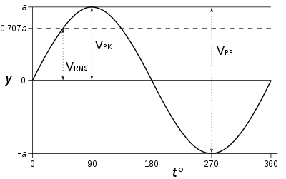 |  | 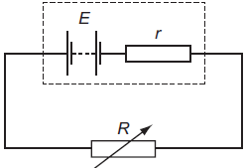 |  |  |  |  |  | 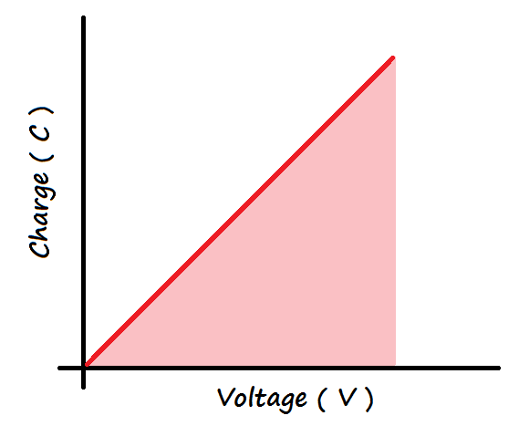  Energy
EMF graphs and how to use them to find E, r, short circuit I etc
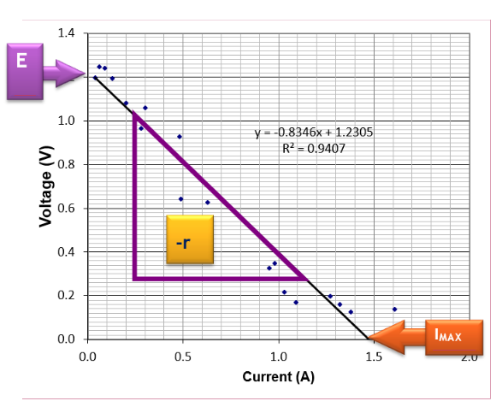 |  |  |  | 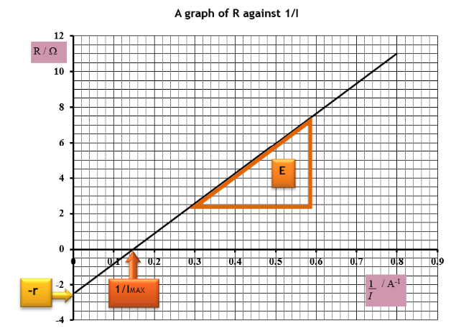
Lost volts v Resistance for capacitor |  | Charging a capacitor D.C. |  |  |  |  |  | The instant switch closed
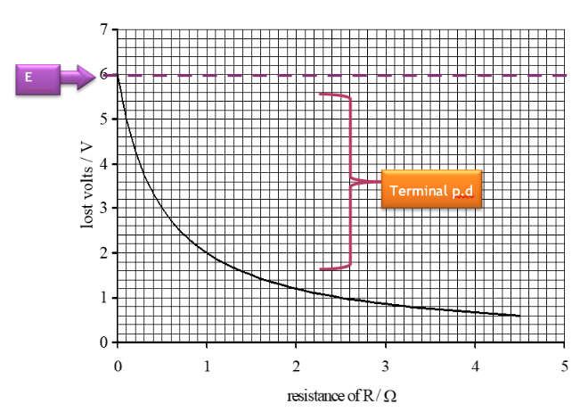 |  | R_{R} = The resistance of the resistor remains constant throughout the charging process. Switch open, capacitor holds no charge:  I= 0A,  Rc = 0 Ω,  Vc = 0 V,  Qc= 0 C |  |  |  |  |  | Rc = 0 Ω,  Vc = 0 V,  V_{R}=V_{s},  Qc= 0 C
thereafter |  | As the capacitor charges
- I decreases as charge builds up on the capacitor  - Vc increases, Qc increases, V_{R} decreases  - one plate of the capacitor becomes positively charged one plate of the capacitor becomes negatively charged |  |  |  | When fully charged I = 0 A, Vc = Vs V_{R}= 0 V
Capacitor Charge and Discharge Graphs³ |  |  | Charging I depends of C and R
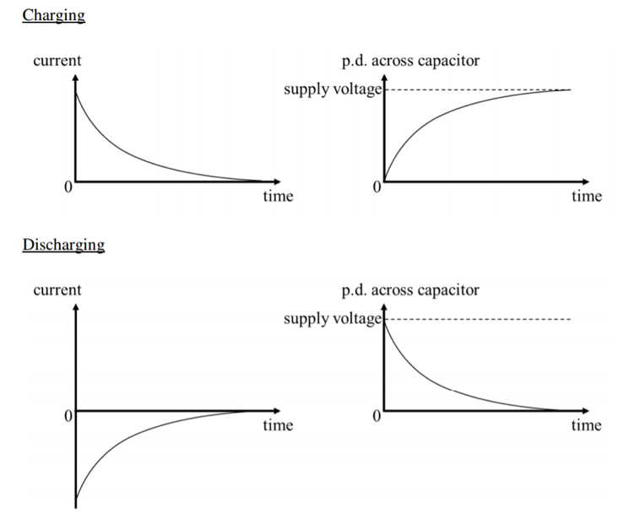 |  |  | 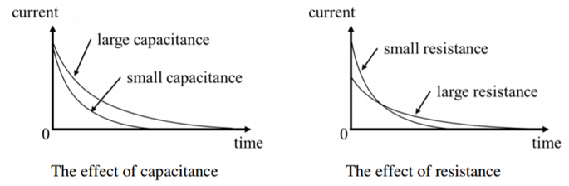
 |  |  | Band Theory (NB Fermi level not required)
 |  |  | 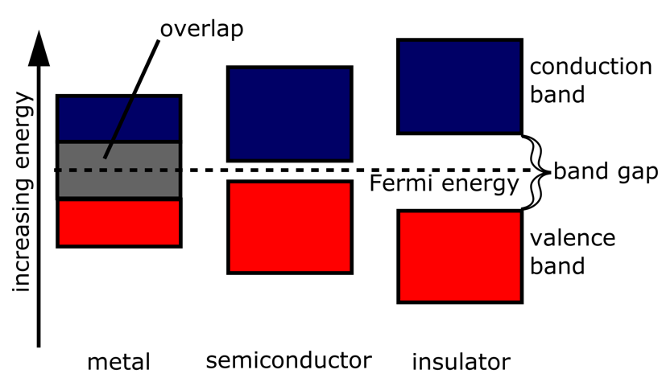
Forward Bias⁵
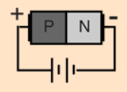  connections for forward bias | 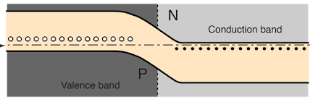 |  |  |  |  |  | Forward bias reduces the electric field; reverse bias increases the electric field in the p-n junction.
In a semiconductor, the gap between the valence band and conduction band is smaller and at room temperature there is sufficient energy to move electrons from the valence band into the conduction band allowing some conduction. An increase in temperature increases the conductivity of a semiconductor.
LEDs and solar cells |  |  |  |  |  | Reverse Bias
LEDs =forward biased p-n junction diodes, emit photons. The forward bias p.d.across the junction electrons move from the conduction band of the n-type semiconductor towards the conduction band of the p- type semiconductor. Electrons ‘fall’ from conduction band into the valence band either side of the junction ⇒photons. Solar cells p-n junctions no bias. p.d. produced when photons are absorbed. (photovoltaic effect) Absorption of photons gives energy to ‘raise’ electrons from the valence band to the conduction band. The p-n junction causes the electrons in the conduction band to move towards the n-type semiconductor and a p.d. is produced across the solar cell. |  |  |  |  |  | 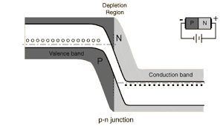

https://en.wikipedia.org/wiki/Root_mean_square
http://physics-ref.blogspot.com/2019/03/a-battery-with-emf-e-and-internal.html
https://www.physicsscotland.co.uk/classes/higher-physics-cfe/capacitors
https://energyeducation.ca/encyclopedia/Band_gap
http://hyperphysics.phy-astr.gsu.edu/hbase/Solids/pnjun2.html

